Exhibitor Technology Guide
Reinvent the Toilet Fair 2012

Table of Contents

Exhibit Number | Lead Organization(s) | Project Title | Page Numbers
1 | AGI Manufacturing, DCI Automation, Synapse Product Development, and Beaumont Design Inc. | Fecal Sludge Omni-Ingestor | 4-5
5 | American Standard Brands | Improved latrine pans for pour-flush systems | 6-7
8 | Loowatt Ltd. | An energy-producing, waterless toilet system | 8-9
9 | LIVVON LLC | A high-efficiency sanitary toilet with sewage treatment | 10-11
10 | Frontier Environmental Technology | A self-mixing biogas generator | 12-13
11 | International Water Management Institute | Developing fortified fertilizer pellets from human waste | 14-15
12 | Institute for Residential Innovation (IResl) | Sewage Containment and Mineralization device (SeCoM) | 16-19
13 | London School of Hygiene and Tropical Medicine | Tiger Toilet & Black Soldier Fly Larvae Collection System | 20-21
14 | University of Colorado Denver | Bioelectric Toilet | 22-23
15 | American Environmental Systems, Inc. | Developing chemicals to self-clean and disinfect toilets | 24-25
16 | University College London | Modeling the next generation of sanitation systems | 26-27
17 | Delft University of Technology | A toilet that converts human waste to fuel gas | 28-29
18 | Ghana Sustainable Aid Project | The Microflush Biofil Toilet | 30-31
19 | Swiss Federal Institute of Aquatic Science and Technology (EAWAG) | Diversion for safe sanitation | 32-33
 | Swiss Federal Institute of Aquatic Science and Technology (EAWAG) | Promoting sanitation and nutrient recovery through urine separation | 34-35
20 | University of KwaZulu-Natal | A community bathroom block that recovers clean water, nutrients, and energy | 36-37
21 | Loughborough University | A toilet that produces biological charcoal, minerals, and clean water | 38-39
22 | Oklahoma State University | A device that sterilizes fecal sludge | 40-41
23 | Fundación In Terris | The Earth Auger Toilet: Innovation in waterless sanitation (el taladro de la tierra) | 42-43
24 | University of Toronto | A toilet that sanitizes feces and urine to recover resources and energy | 44-45
25 | University of California Berkeley | Safe sludge project | 46-47
26 | Plymouth Marine Laboratory | A vortex bioreactor that processes fecal sludge and wastewater | 48-49
27 | North Carolina State University | A device to improve pit latrine emptying | 50-51

Exhibit Number | Lead Organization(s) | Project Title | Page Numbers
28 | National University of Singapore | A urine-diverting combustion toilet | 52-53
29 | Fontes Foundation | Urban sanitation solutions for high-use, flooded, and difficult-to-serve areas | 54-55
30 | California Institute of Technology | A solar-powered toilet that generates hydrogen and electricity | 56-57
31 | re:char | Converting human waste to biological charcoal | 58-59
32 | Southern Illinois University | A wind-driven sanitation system | 60-61
33 | Shijiazhuang University of Economics | On-site fecal sludge extraction and disposal system | 62-63
34 | Rice University | A solar steam sterilizer to treat human waste | 64-65
35 | Stanford University and Climate Foundation | A sanitation system that converts human waste into biological charcoal | 66-67
 | Columbia University | Fecal sludge fed biodiesel plants - the next generation urban sanitation facility | 68-69

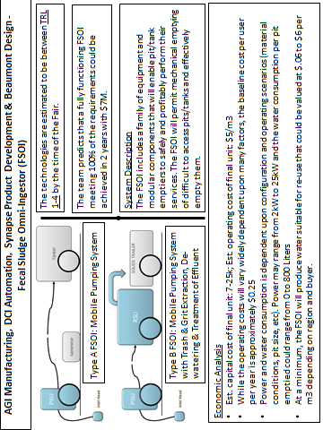
Exhibitor 1

AGI Manufacturing, DCI Automation, Synapse Product Development
Project Management: Beaumont Design

Technology target (e.g. Reinvented Toilet, FS processing, Pit Extraction) | Pit Extraction & Pre-processing | Omni-Ingestor Criteria
Project Title | Fecal Sludge Omni-Ingestor | Omni-Ingestor
BMGF funding mechanism (RTTC, GCE, Contract, other) | Contract | All
Project Start Date | 10/2011 | 07/2011
Remaining time in funding cycle | 5 months for P2 | N/A
Processes and Technologies
Chemical engineering processes | Yes | Yes
Mechanical engineering | Yes | Yes
Biological process | No | No
Key technology component | Pumping, Dewatering, Disinfection | N/A
Consumable
- Water/user | Potentially for dilution and pumping | For personal hygiene, no flushing
- Electricity/user | Via diesel generator | Off grid
- Others | Potentially compressed air, hydraulic, vacuum | 0
Limitations |  | Off grid
Waste to be processed off-site | Fecal Solids | None
Waste dumped / infiltrated in soil | None that is untreated | None
Revenue stream
Energy recovered produced/user (kw/h) | Unknown | N/A
Water recovered/user | Unknown | N/A
Nutrient/fertilizer recovered/user (g or L) | Unknown | N/A
Estimated revenue/user/day ($) | N/A | N/A
Total revenue /user/day ($) | N/A
Smell and odors control measures | N/A | No smell, no flies
Technology Readiness Level |  | N/A
At time of RTT Fair | Varies 1-4 | N/A
Estimated at end of funding Phase | 4-5 | 5 to 6 (not in original RFP)
Cost
Estimated time to produce fully functioning prototype (TRL 7) | Varies by subsystem – 5 months | N/A
Estimated cost to produce fully functioning prototype (TRL 7) | Varies by subsystem | N/A
Estimated capital cost of final toilet | N/A | N/A
Estimated lifetime | 10-20 years | >5 years
Estimated total cost/user/day ($) (without revenue) | N/A | 0.01 – 0.05
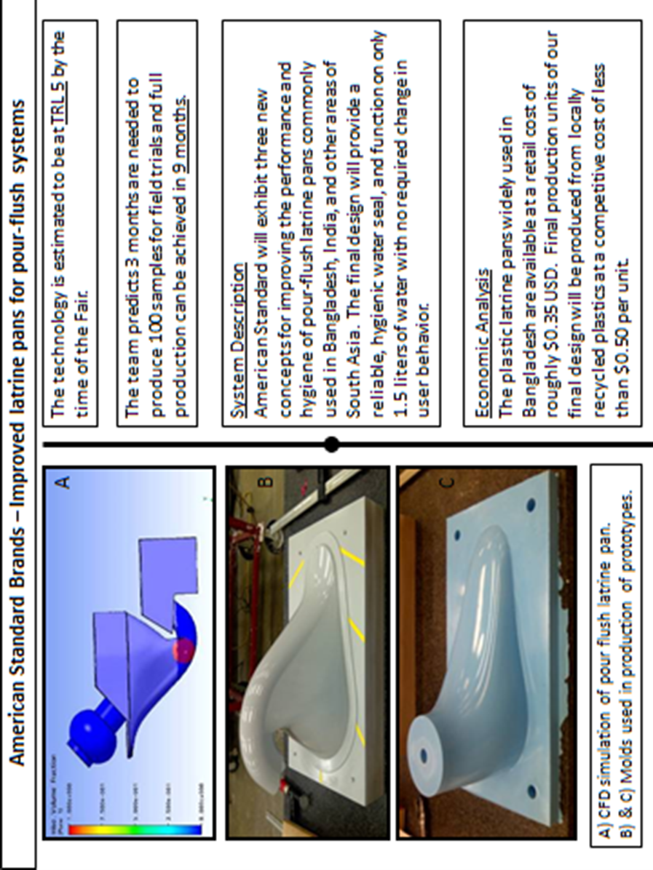
Exhibitor 5

American Standard Brands

Technology target (e.g. Reinvented Toilet, FS processing, Pit Extraction) | Short-term Sanitary Improvement | RTTC Criteria
Project Title | Improved latrine pans for pour-flush systems | Reinvent the Toilet Challenge
BMGF funding mechanism (RTTC, GCE, Contract, other) | Contract | All
Project Start Date | 03/2012 | 07/2011
Remaining time in funding cycle | 9 months | N/A
Processes and Technologies
Chemical engineering processes | No | Yes
Mechanical engineering | Yes | Yes
Biological process | No | No
Key technology component | Fluid mechanics | N/A
Consumable
- Water/user | 1.5liters/use | For personal hygiene, no flushing
- Electricity/user | 0 | Off grid
- others | 0 | 0
Limitations |  | Off grid
Waste to be processed off-site | 0% | None
Waste dumped / infiltrated in soil | 100% | None
Revenue stream
Energy recovered produced/user (kw/h) | 0 | N/A
Water recovered/user | 0 | N/A
Nutrient/fertilizer recovered/user (g or L) | 0 | N/A
Estimated revenue/user/day ($) | 0 | N/A
Total revenue /user/day ($) | 0
Smell and odors control measures | Hygienic water seal | No smell, no flies
Technology Readiness Level |  | N/A
At time of RTT Fair | 5 | N/A
Estimated at end of funding Phase | 8 | 5 to 6 (not in original RFP)
Cost
Estimated time to produce fully functioning prototype (TRL 7) | 12 months | N/A
Estimated cost to produce fully functioning prototype (TRL 7) | $200,000 | N/A
Estimated capital cost of final toilet | $6.00 (with slab & rings) | N/A
Estimated lifetime | >3yrs | >5 years
Estimated total cost/user/day ($) (without revenue) | $0.006 | 0.01 – 0.05

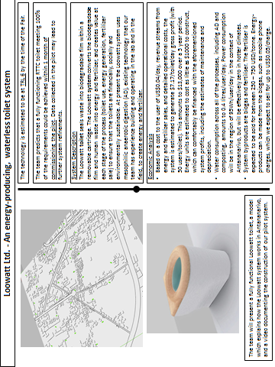
Exhibitor 8

Loowatt Ltd.
Technology target | Reinvented Toilet, FS management | RTTC Criteria
Project Title | An energy-producing, waterless toilet system | Reinvent the Toilet Challenge
BMGF funding mechanism | GCE | All
Project Start Date | 07/2011 | 07/2011
Remaining time in funding cycle | 6 months | N/A
Processes and Technologies
Chemical engineering processes | No | Yes
Mechanical engineering | Yes | Yes
Biological process | No | No
Key technology component | Toilet | N/A
Consumable
- Water/user | No | Personal hygiene, no flushing
- Electricity/user | No | Off grid
- Others | Biodegradable film, toilet paper | 0
Limitations |  | Off grid
Waste to be processed off-site | Digestate to fertilizer | None
Waste dumped / infiltrated in soil | None | None
Revenue stream
Energy recovered produced/user (kw/h) | 0.23 kwh/user/day | N/A
Water recovered/user | N/A | N/A
Nutrient/fertilizer recovered/user (g or L) | 530g | N/A
Estimated revenue/user/day ($) | $ 0.21 (USD) | N/A
Total revenue /user/day ($) | $ 0.21 (USD)
Smell and odors control measures | Contained and odorless | No smell, no flies
Technology Readiness Level |  | N/A
At time of RTT Fair | TRL 6 | N/A
Estimated at end of funding Phase | TRL 7 | 5 to 6 (not in original RFP)
Cost
Estimated time to produce fully functioning prototype (TRL 7) | 1 month | N/A
Estimated cost to produce fully functioning prototype (TRL 7) | $700 | N/A
Estimated capital cost of final toilet | $60 | N/A
Estimated lifetime | 5 years + | >5 years
Estimated total cost/user/day ($) (without revenue) | $0.04 | 0.01 – 0.05
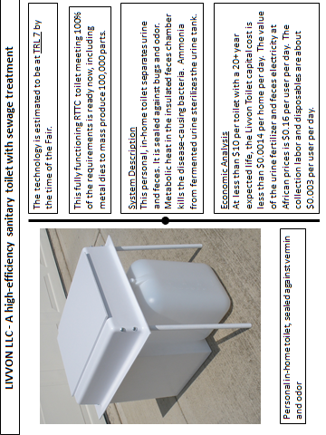
Exhibitor 9

LIVVON LLC

Technology target | Reinvented Toilet | RTTC Criteria
Project Title | A high-efficiency, sanitary toilet with sewage treatment | Reinvent the Toilet Challenge
BMGF funding mechanism (RTTC, GCE, Contract, other) | GCE | All
Project Start Date | May 1, 2011 | 07/2011
Remaining time in funding cycle | 0 | N/A
Processes and Technologies
Chemical engineering processes | Sterilization by Heat and Ammonia | Yes
Mechanical engineering | Structures, Fluid Mechanics, Heat transfer | Yes
Biological process | Metabolic Heat | No
Key technology component | Insulated Fece Chamber | N/A
Consumable
- Water/user | 0 | Personal hygiene, no flushing
- Electricity/user | 0 | Off grid
- Others | 0 | 0
Limitations | None | Off grid
Waste to be processed off-site | Feces & Urine | None
Waste dumped / infiltrated in soil | None | None
Revenue stream
Energy recovered produced/user (kwh) | 0.2 kwh/day | N/A
Water recovered/user | 0.3 Liter/day | N/A
Nutrient/fertilizer recovered/user (g or L) | 0.5 Liter/day | N/A
Estimated revenue/user/day ($) | 0 | N/A
Total revenue /user/day ($) | $0.16/day
Smell and odors control measures | Toilet Seals and Ozone | No smell, no flies
Technology Readiness Level | 7 | N/A
At time of RTT Fair | 7 | N/A
Estimated at end of funding Phase | 7 | 5 to 6 (not in original RFP)
Cost
Estimated time to produce fully functioning prototype (TRL 7) | 0 | N/A
Estimated cost to produce fully functioning prototype (TRL 7) | 0 | N/A
Estimated capital cost of final toilet | $10 | N/A
Estimated lifetime | 20 years | >5 years
Estimated total cost/user/day ($) (without revenue) | $0.0014 | 0.01 – 0.05
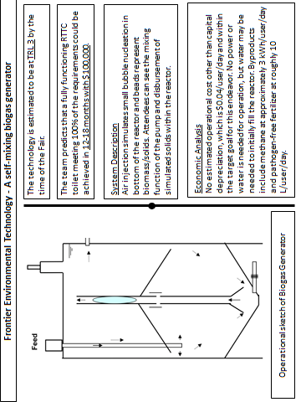
Exhibitor 10
Frontier Environmental Technology

Technology target | FS processing | RTTC Criteria
Project Title | A self-mixing biogas generator | Reinvent the Toilet Challenge
BMGF funding mechanism (RTTC, GCE, Contract, other) | GCE | All
Project Start Date | 11/2011 | 07/2011
Remaining time in funding cycle | 11 months | N/A
Processes and Technologies
Chemical engineering processes | No | Yes
Mechanical engineering | Yes | Yes
Biological process | Yes | No
Key technology component | Self-Actuating Mixer | N/A
Consumable
- Water/user | None required for flushing; only start-up | For personal hygiene, no flushing
- Electricity/user | Net energy generator; none required | Off grid
- Others |  | 0
Limitations | Temperature-dependent | Off grid
Waste to be processed off-site | None | None
Waste dumped / infiltrated in soil | None; produces nutrient-rich, pathogen-free fertilizer | None
Revenue stream
Energy recovered produced/user (kWh) | 3 kWh/day | N/A
Water recovered/user | N/A | N/A
Nutrient/fertilizer recovered/user (g or L) | 10 L | N/A
Estimated revenue/user/day ($) | 0.35 | N/A
Total revenue /user/day ($) | 0.35
Smell and odors control measures | None required | No smell, no flies
Technology Readiness Level
At time of RTT Fair | 3 | N/A
Estimated at end of funding Phase | 5 | 5 to 6 (not in original RFP)
Cost
Estimated time to produce fully functioning prototype (TRL 7) | 12-18 months field testing; 30-45 days fabrication time | N/A
Estimated cost to produce fully functioning prototype (TRL 7) | $100,000 | N/A
Estimated capital cost of final toilet/unit | $2000 – mass production | N/A
Estimated lifetime | 30 years or more | >5 years
Estimated total cost/user/day ($) (without revenue) | 0.04 – capital deprecation  0 – operation cost | 0.01 – 0.05

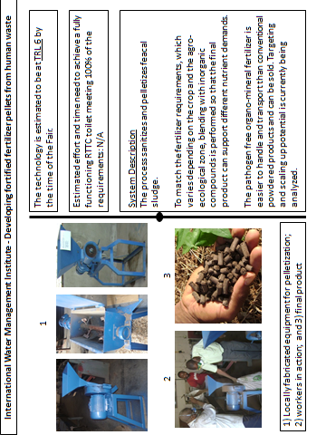
Exhibitor 11

International Water Management Institute

Technology target (e.g. Reinvented Toilet, FS processing, Pit Extraction) | FS processing | RTTC Criteria
Project Title | Developing fortified fertilizer pellets from human waste | Reinvent the Toilet Challenge
BMGF funding mechanism (RTTC, GCE, Contract, other) | GCE | All
Project Start Date | 05/2011 | 07/2011
Remaining time in funding cycle | 3 months | N/A
Processes and Technologies
Chemical engineering processes | Yes | Yes
Mechanical engineering | Yes | Yes
Biological process | Yes | No
Key technology component | Fertilizer (Fortifert); Pelletizer | N/A
Consumable
- Water/user | N/A | For personal hygiene, no flushing
- Electricity/user | N/A | Off grid
- others | Cassava starch: 0.01-0.03 kg per kg of feacal fertilizer | 0
Limitations |  | Off grid
Waste to be processed off-site | None | None
Waste dumped / infiltrated in soil | None | None
Revenue stream
Energy recovered produced/user (kw/h) | N/A | N/A
Water recovered/user | N/A | N/A
Nutrient/fertilizer recovered/user (g or L) | N/A | N/A
Estimated revenue/user/day ($) | N/A | N/A
Total revenue /user/day ($) | N/A
Smell and odors control measures | N/A | No smell, no flies
Technology Readiness Level |  | N/A
At time of RTT Fair | 6 | N/A
Estimated at end of funding Phase | 6 | 5 to 6 (not in original RFP)
Cost
Estimated time to produce fully functioning prototype (TRL 7) | N/A | N/A
Estimated cost to produce fully functioning prototype (TRL 7) | N/A | N/A
Estimated capital cost of final toilet | N/A | N/A
Estimated lifetime | Variable | >5 years
Estimated total cost/user/day ($) (without revenue) | N/A | 0.01 – 0.05

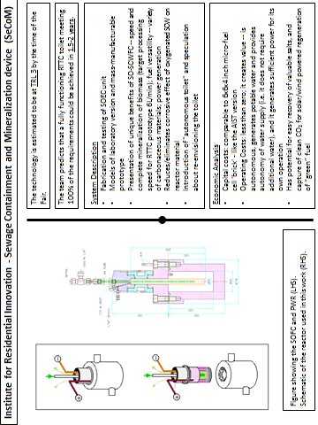
Exhibitor 12
Institute for Residential Innovation (IResI)

Technology target (e.g. Reinvented Toilet, FS processing, Pit Extraction) | Feasibility Study | RTTC Criteria
Project Title | Sewage Containment and Mineralization Device (SeCoM) | Reinventing the Toilet Challenge
BMGF funding mechanism (RTTC, GCE, Contract, other) | GCE | All
Project Start Date | Nov 1, 2011 | 07/2011
Remaining time in funding cycle | 9 months | N/A
Processes and Technologies
Chemical engineering processes | Yes | Yes
Mechanical engineering | Yes | Yes
Biological process | No | No
Key technology component | Solid Oxide - SuperCritical Water Fuel Cell | N/A
Consumable
- Water/user | Zero -- autonomous device | For personal hygiene, no flushing
- Electricity/user | Zero -- autonomous device | Off grid
- others | Zero | 0
Limitations | Will not process bones | Off grid
Waste to be processed off-site | None | None
Waste dumped / infiltrated in soil | None | None
Revenue stream
Energy recovered produced/user (kw/h) | ~2,000kJ | N/A
Water recovered/user | Full recovery | N/A
Nutrient/fertilizer recovered/user (g or L) | Full recovery of mineral salts only | N/A
Estimated revenue/user/day ($) | n/a | N/A
Total revenue /user/day ($) | n/a
Smell and odors control measures | None needed -- only CO₂/N₂ released | No smell, no flies
Technology Readiness Level | N/A | N/A
At time of RTT Fair | N/A | N/A
Estimated at end of funding Phase | 5-6 | 5 to 6 (not in original RFP)
Cost
Estimated time to produce fully functioning prototype (TRL 7) | N/A | N/A
Estimated cost to produce fully functioning prototype (TRL 7) | N/A | N/A
Estimated capital cost of final toilet | N/A | N/A
Estimated lifetime | 10yrs, but with some replacement parts | >5 years
Estimated total cost/user/day ($) (without revenue) | $ <0.01 | 0.01 – 0.05

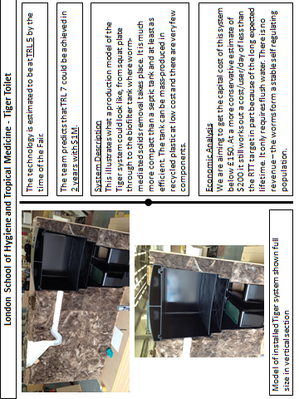
Exhibitor 13

London School of Hygiene and Tropical Medicine

Technology target (e.g. Reinvented Toilet, FS processing, Pit Extraction) | Latrine replacement | RTTC Criteria
Project Title | Tiger Toilet | Reinvent the Toilet Challenge
BMGF funding mechanism (RTTC, GCE, Contract, other) | Other | All
Project Start Date | July 2009 | 07/2011
Remaining time in funding cycle | None | N/A
Processes and Technologies
Chemical engineering processes | No | Yes
Mechanical engineering | Yes | Yes
Biological process | Yes | No
Key technology component | Biofilter | N/A
Consumable
- Water/user | Yes, flushing, 2l/user | For personal hygiene, no flushing
- Electricity/user | None | Off grid
- Others | Support matrix ( eg coir) | 0
Limitations | Excessive water influx | Off grid
Waste to be processed off-site | None | None
Waste dumped / infiltrated in soil | Treated effluent only | None
Revenue stream
Energy recovered produced/user (kw/h) | N/A | N/A
Water recovered/user | None | N/A
Nutrient/fertilizer recovered/user (g or L) | N/A | N/A
Estimated revenue/user/day ($) | N/A | N/A
Total revenue /user/day ($) | N/A
Smell and odors control measures | Lid on tank; water seal on pour flush toilet | No smell, no flies
Technology Readiness Level |  | N/A
At time of RTT Fair | 5 | N/A
Estimated at end of funding Phase | 5 | 5 to 6 (not in original RFP)
Cost
Estimated time to produce fully functioning prototype (TRL 7) | 2 years | N/A
Estimated cost to produce fully functioning prototype (TRL 7) | $1m | N/A
Estimated capital cost of final toilet ( for family of 10) | $200 | N/A
Estimated lifetime | > 10 yr | >5 years
Estimated total cost/user/day ($) (without revenue) | 0.005 | 0.01 – 0.05

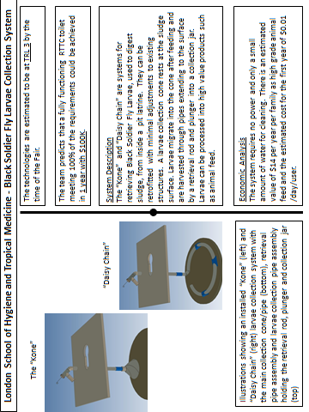
Exhibitor 13
London School of Hygiene and Tropical Medicine

Technology target | Longer lasting pit latrines | RTTC Criteria
Project Title | Black soldier fly larvae collection system | Reinvent the Toilet Challenge
BMGF funding mechanism (RTTC, GCE, Contract, other) | Other | All
Project Start Date | July 2009 | 07/2011
Remaining time in funding cycle | None | N/A
Processes and Technologies
Chemical engineering processes | No | Yes
Mechanical engineering | Yes | Yes
Biological process | Yes | No
Key technology component | Larval retrieval mechanism | N/A
Consumable
- Water/user | Only for cleaning | For personal hygiene, no flushing
- Electricity/user | None | Off grid
- Others | None | 0
Limitations | None so far | Off grid
Waste to be processed off-site | None | None
Waste dumped / infiltrated in soil | None | None
Revenue stream
Energy recovered produced/user (kw/h) | None | N/A
Water recovered/user | None | N/A
Nutrient/fertilizer recovered/user (g or L) | None | N/A
High Grade Animal Feed ( larval protein) | 14kg /yr/family
Estimated revenue/user/day ($) | $0.01 | N/A
Total revenue /user/day ($) | $0.01
Smell and odors control measures | No smell no flies  ( larvae suppress odours and egg laying by other flies) | No smell, no flies
Technology Readiness Level |  | N/A
At time of RTT Fair | TRL 3 | N/A
Estimated at end of funding Phase | TRL 3 | 5 to 6 (not in original RFP)
Cost
Estimated time to produce fully functioning prototype (TRL 7) | 1 year | N/A
Estimated cost to produce fully functioning prototype (TRL 7) | $100K | N/A
Estimated capital cost of final toilet | $15-20 | N/A
Estimated lifetime | >10 year | >5 years
Estimated total cost/user/day ($) (without revenue) | 0.01 ( based on 1 year, 5 people per family) | 0.01 – 0.05

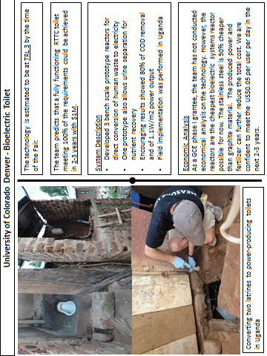
Exhibitor 14

University of Colorado Denver

Technology target | Fecal Sludge processing | RTTC Criteria
Project Title | Bioelectric Toilet | Reinventing the Toilet Challenge
BMGF funding mechanism (RTTC, GCE, Contract, other) | GCE phase I/round 7 | All
Project Start Date | 11/2011 | 07/2011
Remaining time in funding cycle |  | N/A
Processes and Technologies
Chemical engineering processes | No | Yes
Mechanical engineering | No | Yes
Biological process | Yes | No
Key technology component | Microbial Electrochemistry | N/A
Consumable
- Water/user | No water needed | For personal hygiene, no flushing
- Electricity/user | Produce electricity | Off grid
- Others | Stabilize sludge | 0
Limitations | N/A | Off grid
Waste to be processed off-site | None | None
Waste dumped / infiltrated in soil | None | None
Revenue stream
Energy recovered produced/user (kw/h) | 50 W/m3 | N/A
Water recovered/user | Urine recovery | N/A
Nutrient/fertilizer recovered/user (g or L) | 0.5 L/user | N/A
Estimated revenue/user/day ($) | N/A | N/A
Total revenue /user/day ($) | N/A
Smell and odors control measures | No smell, no flies | No smell, no flies
Technology Readiness Level |  | N/A
At time of RTT Fair | 3 | N/A
Estimated at end of funding Phase | 4-5 | 5 to 6 (not in original RFP)
Cost
Estimated time to produce fully functioning prototype (TRL 7) | 2-3 years | N/A
Estimated cost to produce fully functioning prototype (TRL 7) | N/A | N/A
Estimated capital cost of final toilet | N/A | N/A
Estimated lifetime | 10-15 years | >5 years
Estimated total cost/user/day ($) (without revenue) | Less than 0.03, but not focused on this Phase I GCE study | 0.01 – 0.05

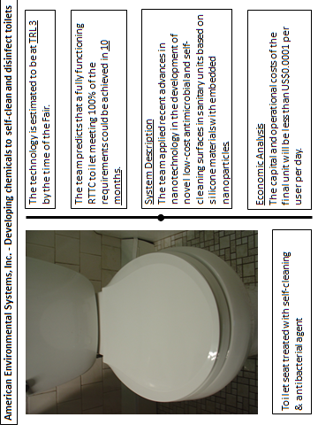
Exhibitor 15

American Environmental Systems, Inc.
Technology target (e.g. Reinvented Toilet, FS processing, Pit Extraction) | Reinvented toilet | RTTC Criteria
Project Title: | Developing chemicals to self-clean and disinfect toilets | Reinvent the Toilet Challenge
BMGF funding mechanism (RTTC, GCE, Contract, other) | GCE | All
Project Start Date | 11/2011 | 07/2011
Remaining time in funding cycle |  | N/A
Processes and Technologies
Chemical engineering processes | Yes | Yes
Mechanical engineering |  | Yes
Biological process | Yes | No
Key technology component | Hydrophobic coating | N/A
Consumable
- Water/user | Minimum to clean | For personal hygiene, no flushing
- Electricity/user | No | Off grid
- others | 0 | 0
Limitations | None | Off grid
Waste to be processed off-site | None | None
Waste dumped / infiltrated in soil | None | None
Revenue stream
Energy recovered produced/user (kw/h) | N/A | N/A
Water recovered/user | N/A | N/A
Nutrient/fertilizer recovered/user (g or L) | N/A | N/A
Estimated revenue/user/day ($) | N/A | N/A
Total revenue /user/day ($)
Smell and odors control measures | No smell, microbial free | No smell, no flies
Technology Readiness Level | 3 | N/A
At time of RTT Fair | 3 | N/A
Estimated at end of funding Phase | 4 | 5 to 6 (not in original RFP)
Cost
Estimated time to produce fully functioning prototype (TRL 7) | N/A | N/A
Estimated cost to produce fully functioning prototype (TRL 7) | N/A | N/A
Estimated capital cost of final toilet | N/A | N/A
Estimated lifetime | >2 | >5 years
Estimated total cost/user/day ($) (without revenue) | 0.001 – 0.01 | 0.01 – 0.05

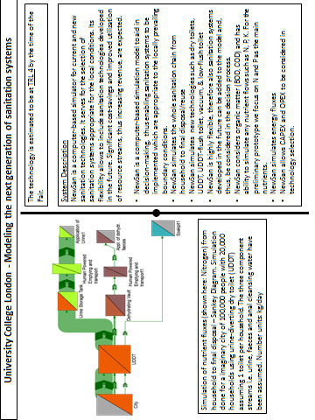
Exhibitor 16

University College London

Technology target (e.g. Reinvented Toilet, FS processing, Pit Extraction) | Computer simulation model | RTTC Criteria
Project Title | Modeling the next generation of sanitation systems ⁽¹⁾ | Reinvent the Toilet Challenge
BMGF funding mechanism (RTTC, GCE, Contract, other) | GCE (Round 7) | All
Project Start Date | 01/11/2011 | 07/2011
Remaining time in funding cycle | 10 months | N/A
Processes and Technologies
Chemical engineering processes | No | Yes
Mechanical engineering | No | Yes
Biological process | No | No
Key technology component | Simulation model | N/A
Consumable
- Water/user | N/A | For personal hygiene, no flushing
- Electricity/user | Power supply for computer | Off grid
- others | N/A | 0
Limitations | Need a computer | Off grid
Waste to be processed off-site | N/A | None
Waste dumped / infiltrated in soil | N/A | None
Revenue stream
Energy recovered produced/user (kw/h) | N/A | N/A
Water recovered/user | N/A | N/A
Nutrient/fertilizer recovered/user (g or L) | N/A | N/A
Estimated revenue/user/day ($) | N/A | N/A
Total revenue /user/day ($) | N/A
Smell and odors control measures | N/A | No smell, no flies
Technology Readiness Level |  | N/A
At time of RTT Fair | TRL4 | N/A
Estimated at end of funding Phase | TRL6 | 5 to 6 (not in original RFP)
Cost
Estimated time to produce fully functioning prototype (TRL 7) | 1 year | N/A
Estimated cost to produce fully functioning prototype (TRL 7) | USD 100,000.00⁽²⁾ | N/A
Estimated capital cost of final toilet | N/A | N/A
Estimated lifetime | > 5 years | >5 years
Estimated total cost/user/day ($) (without revenue) | N/A | 0.01 – 0.05

Notes:
- This project develops and demonstrates a simulation system which supports the selection of sanitation technologies appropriate to the locally prevailing boundary conditions. These also include Next-generation sanitation systems and help to promote them. Significant cost-savings and improved utilization of resource streams, thus increasing revenue, are expected from the appropriate selection of sanitation technologies which will be enabled by the simulator.
- Additional funds will be required for data sampling, field testing, and model refinement.

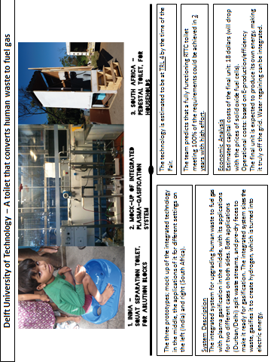
Exhibitor 17

Delft University of Technology
Technology target | Reinvented toilet; plus conceptual overall sanitation system | RTTC Criteria
Project Title | A toilet that converts human waste to fuel gas | Reinvent the Toilet Challenge
BMGF funding mechanism (RTTC, GCE, Contract, other) | RTTC | All
Project Start Date | 09/2011 | 07/2011
Remaining time in funding cycle | 2 months | N/A
Processes and Technologies
Chemical engineering processes | Yes | Yes
Mechanical engineering | Yes | Yes
Biological process | No | No
Key technology component | Plasma gasification, SOFC | N/A
Consumable
Water/user | For personal hygiene, cleaning | For personal hygiene, no flushing
Electricity/user | Off the grid | Off the grid
Others |  | 0
Limitations | Enough input needed (700 persons) | Off grid
Waste to be processed off-site | None | None
Waste dumped / infiltrated in soil | None | None
Revenue stream
Energy recovered produced/user (kw/h) | N/A | N/A
Water recovered/user | N/A | N/A
Nutrient/fertilizer recovered/user (g or L) | N/A | N/A
Estimated revenue/user/day ($) | 0,035 India/0,05 SA | N/A
Total revenue /user/day ($) | N/A
Smell and odors control measures | Reduced | No smell, no flies
Technology Readiness Level |  | N/A
At time of RTT Fair | 4 | N/A
Estimated at end of funding Phase | 4,5 | 5 to 6 (not in original RFP)
Cost
Estimated time to produce fully functioning prototype (TRL 7) | 2/3 years | N/A
Estimated cost to produce fully functioning prototype (TRL 7) | N/A | N/A
Estimated capital cost of final toilet | < 10.000 euro | N/A
Estimated lifetime | 10 years | >5 years
Estimated total cost/user/day ($) (without revenue) | 0.05 | 0.01 – 0.05

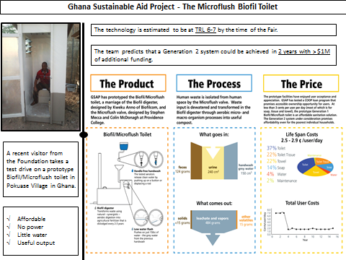
Exhibitor 18

Ghana Sustainable Aid Project

Technology target | Reinvented Toilet | RTTC Criteria
Project Title | Microflush Biofil Toilet | RTTC
BMGF funding mechanism | GCE | All
Project Start Date | 05/2011 | 07/2011
Remaining time in funding cycle |  | N/A
Processes and Technologies
Chemical engineering processes | Yes, biochemical | Yes
Mechanical engineering | Yes, Microflush valve & Biofil digester | Yes
Biological process | Yes, Biofil digestion | No
Key technology component | Integrated systems | N/A
Consumable
- Water/user | 150 cc/use for hand washing and reuse for flushing | For personal hygiene, no flushing
- Electricity/user | Off grid | Off grid
- Others | N/A | 0
Limitations | Off grid | Off grid
Waste to be processed off-site | None | None
Waste dumped / infiltrated in soil | Solids – none  Liquid filtrate including urine & vapor – 484 cc/use | None
Revenue stream
Energy recovered produced/user (kw/h) | N/A | N/A
Water recovered/user | Hand wash water reused for 150 cc flush | N/A
Nutrient/fertilizer recovered/user (g or L) | 15 g | N/A
Estimated revenue/user/day ($) | N/A | N/A
Total revenue /user/day ($) | N/A
Smell and odors control measures | No odor, no flies | No smell, no flies
Technology Readiness Level |  | N/A
At time of RTT Fair | TRL 6 – TRL 7 | N/A
Estimated at end of funding Phase | TRL 6 – TRL 7 (Phase I); TRL 8 – TRL 9 (if Phase II proposal is successful) | 5 to 6 (not in original RFP)
Cost
Estimated time to produce fully functioning prototype (TRL 7) | Generation 1 Biofil/Microflush prototypes have already been produced | N/A
Estimated cost to produce fully functioning prototype (TRL 7) | Generation 1 prototype development ~$100,000 and now costs $1200/30 user facility  Generation 2 development costs will exceed $1M | N/A
Estimated capital cost of final toilet | Generation 1 $1200 for 30 user toilet;  Generation 2 target cost is < $500 | N/A
Estimated lifetime | >10 years | >5 years
Estimated total cost/user/day ($) (without revenue) | Generation 1: Life span costs 0.025 – 0.029/user/day more than half of which is for soap, tissue and towel. | 0.01 – 0.05

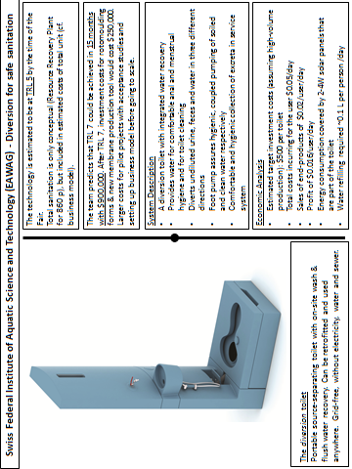
Exhibitor 19

Swiss Federal Institute of Aquatic Science and Technology (EAWAG)
Technology target | Reinvented toilet; plus conceptual overall sanitation system | RTTC Criteria
Project Title | Diversion for safe sanitation | RTT Challenge
BMGF funding mechanism | RTTC | All
Project Start Date | 07/2011 | 07/2011
Remaining time in funding cycle | Until end of July 2012 | N/A
Processes and Technologies¹… | …in the toilet unit
Chemical engineering processes | Yes (electrolysis) | Yes
Mechanical engineering | Yes (ultrafiltration) | Yes
Biological process | Yes (passive process to prevent clogging & avoid maintenance) | No
Key technology component | Flushed dry toilet with source separation and on-site water recovery (ultrafiltration followed by electrolysis) | N/A
Consumable
- Water/user | Water recovery requires refilling of 0.1L/user/day due to system losses. 6-8 L clean water/p/day is available | For personal hygiene, no flushing
- Electricity/user | Off grid; solar panels with 0.4-0.8 W/user (2-4W/toilet for aeration and electrolysis) | Off grid
- Others | Chlorine if desired | 0
Limitations | Off grid | Off grid
Waste to be processed off-site | Dry feces and urine to be processed in a nearby Resource Recovery Plant (RRP)². Logistics possible at $0.01/user/day | None
Waste dumped / infiltrated in soil | None | None
Revenue stream
Energy recovered produced/user (kw/h) | ~ 0 (use energy from feces for urine treatment) | N/A
Water recovered/user | ~1L of distilled water/user/day possible | N/A
Nutrient/fertilizer recovered/user | Max.: 8 gN/user/d; 1 gP/user/d; 4 gK/user/d | N/A
Estimated revenue/user/day ($) | $0.02/user/day (only the value of nutrients) | N/A
Total revenue /user/day ($) | Total profit: $0.016/user/day
Smell and odors control measures | Toilet lid, normal improved ventilation; separated feces & urine reduce smell | No smell, no flies
Technology Readiness Level |  | N/A
At time of RTT Fair | TRL 5 | N/A
Estimated at end of funding Phase | TRL 5 | 5 to 6 (not in original RFP)
Cost
Estimated time to produce TRL 7 | 15 months is possible | N/A
Estimated cost to produce TRL 7 | ≈ 900,000 US$ (incl. own funding in kind) | N/A
Estimated capital cost of final toilet | $500 (mass production!) | N/A
Estimated capital cost of RRP (860 users) | $27500 (mass prod.!) | N/A
Estimated lifetime for toilet, resp. RRP | 10 years, resp. 20 years | >5 years
Estimated total cost/user/day ($) (without revenue) | $0.05/user/day (only with mass production!) | 0.01 – 0.05

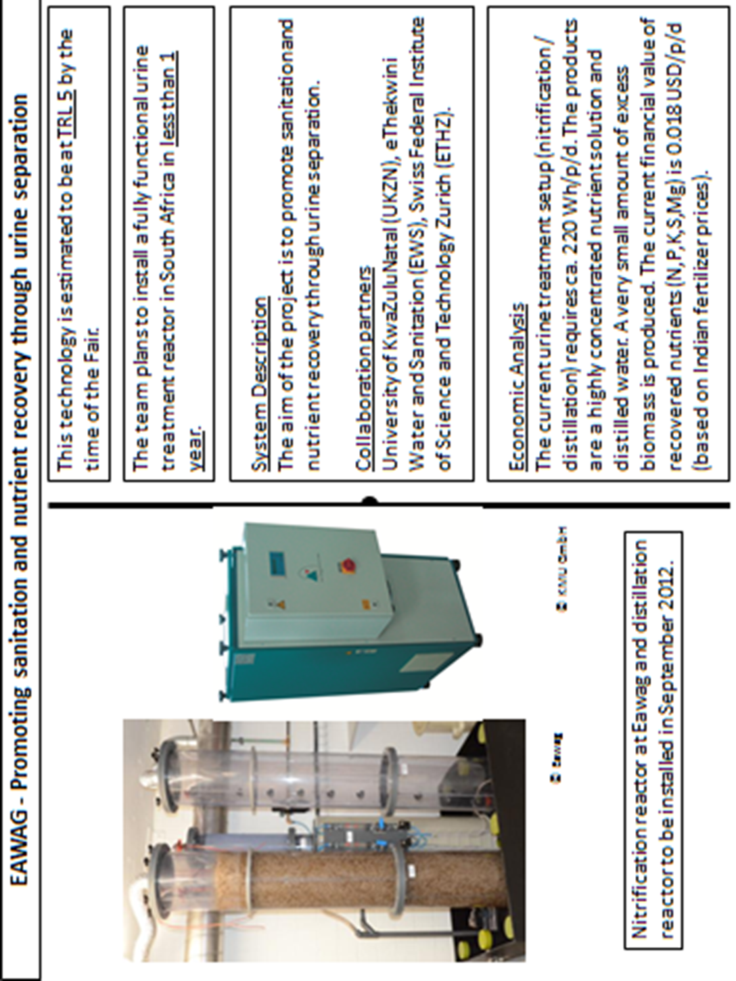
Swiss Federal Institute of Aquatic Science and Technology (EAWAG)
Technology target | Management and processing of source-separated urine | RTTC Criteria
Project Title | Promoting sanitation and nutrient recovery through urine separation | RTTC
BMGF funding mechanism | Global development grant | All
Project Start Date | 09/2010 | 07/2011
Remaining time in funding cycle | 2 years | N/A
Processes and Technologies
Chemical engineering processes | Evaporation, mineral precipitation, electrolysis | Yes
Mechanical engineering | Urine collection and transport | Yes
Biological process | Nitrification | No
Key technology component | Nutrient recovery as a highly concentrated solution (nitrification/evaporation) | N/A
Consumable
- Water/user | No | For personal hygiene, no flushing
- Electricity/user | Ca. 220 Wh/p/d (only nitrification/distillation) | Off grid
- others | Optional for complete ammonia oxidation: limestone (30 g/pers/d)  (nitrification/distillation) | 0
Limitations | Requires collection scheme and semi-decentralized treatment facilities. | Off grid
Waste to be processed off-site | A very small amount of excess sludge and possibly distilled water are waste products | None
Waste dumped / infiltrated in soil | Excess sludge and distilled water | None
Revenue stream
Energy recovered produced/user (kWh) | None from urine | N/A
Water recovered/user | Nearly all water in urine: about 1.25 L/p/d (Udert et al. 2006) | N/A
Nutrient/fertilizer recovered/user (g or L) | With nitrification/evaporation nearly all nutrients in urine.  If all urine per person is collection, no losses occur during collection and the person is well-nourished: 10 gN/p/d, 1 gP/p/d, 2.5 gK/p/d, 1.5 gS/p/d, 0.13 gMg/p/d (Udert et al. 2006) | N/A
Estimated revenue/user/day ($) | Based on fertilizer values in India (N,P,K,S,Mg) Sakthivel et al. 2012):  0.018 USD/p/d (without possible revenue for distilled water and Ca) | N/A
Total revenue /user/day ($) | Selling fertilizer and distilled water is unlikely to cover the costs of collection and treatment.
Smell and odors control measures | The smell of stored urine is not a problem, if the storage tank is properly closed. If UDDT is properly operated: feces will dry quickly and not smell. | No smell, no flies
Technology Readiness Level |  | N/A
At time of RTT Fair | TRL 5 | N/A
Estimated at end of funding Phase | TRL 7 | 5 to 6 (not in original RFP)
Cost
Estimated time to produce fully functioning prototype (TRL 7) | 1.5 years | N/A
Estimated cost to produce fully functioning prototype (TRL 7) | for about 200 people:  80,000 USD | N/A
Estimated capital cost of final toilet | N/A | N/A
Estimated lifetime | >10 years | >5 years
Estimated total cost/user/day ($) (without revenue) | N/A | 0.01 – 0.05

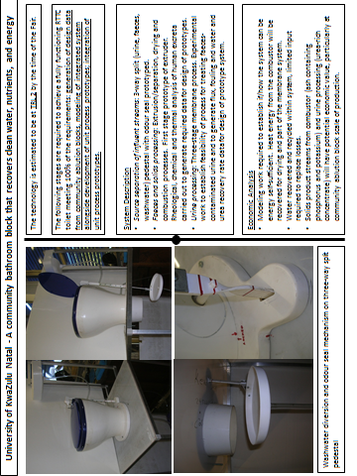
Exhibitor 20

University of KwaZulu-Natal

Technology target (e.g. Reinvented Toilet, FS processing, Pit Extraction) | Reinvented Toilet | RTTC Criteria
Project Title | A community bathroom block that recovers clean water, nutrients, and energy | Reinvent the Toilet Challenge
BMGF funding mechanism (RTTC, GCE, Contract, other) | RTTC | All
Project Start Date | 20/06/2011 | 07/2011
Remaining time in funding cycle | Phase 1 end 30/09/2012 | N/A
Processes and Technologies
Chemical engineering processes | Yes | Yes
Mechanical engineering | Yes | Yes
Biological process | No | No
Key technology component | N/A | N/A
Consumable
- Water/user | Handwash water diverted for toilet bowl cleaning; no water seal requirement | For personal hygiene, no flushing
- Electricity/user | External electricity supply still required to power unit processes | Off grid
- others | Membrane cleaning agents or replacement cartridges | 0
Limitations | Conceptual integrated system is off grid, has no requirement for off-site processing of waste or dumping to soil. Project is several stages back from this, producing data required for design of the individual unit processes. | Off grid
Waste to be processed off-site | See above | None
Waste dumped / infiltrated in soil | See above | None
Revenue stream
Energy recovered produced/user (kw/h) |  | N/A
Water recovered/user |  | N/A
Nutrient/fertilizer recovered/user (g or L) |  | N/A
Estimated revenue/user/day ($) |  | N/A
Total revenue /user/day ($)
Smell and odour control measures | Bowl seal underneath pedestal (when pedestal not in use) together with airflow from pedestal towards combustor. Rapid movement of faecal material away from pedestal area to processing. | No smell, no flies
Technology Readiness Level |  | N/A
At time of RTT Fair | 1 | N/A
Estimated at end of funding Phase | 1 | 5 to 6 (not in original RFP)
Cost
Estimated time to produce fully functioning prototype (TRL 7) |  | N/A
Estimated cost to produce fully functioning prototype (TRL 7) |  | N/A
Estimated capital cost of final toilet |  | N/A
Estimated lifetime | > 5 years, in a community ablution block environment | >5 years
Estimated total cost/user/day ($) (without revenue) |  | 0.01 – 0.05

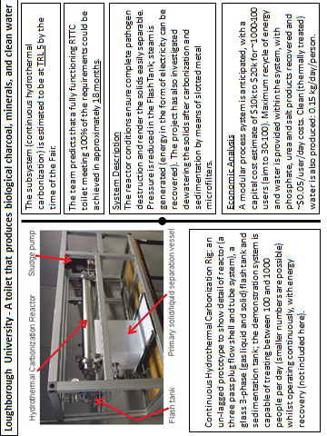
Exhibitor 21

Loughborough University

Technology target (e.g. Reinvented Toilet, FS processing, Pit Extraction) | Reinvented Toilet | RTTC Criteria
Project Title | A toilet that produces biological charcoal, minerals, and clean water | Reinvent the Toilet
BMGF funding mechanism (RTTC, GCE, Contract, other) | RTTC | All
Project Start Date | 07/2011 | 07/2011
Remaining time in funding cycle | N/A | N/A
Processes and Technologies
Chemical engineering processes | Yes | Yes
Mechanical engineering | Yes | Yes
Biological process | No | No
Key technology component | Continuous Hydrothermal Carbonization | N/A
Consumable
- Water/user | Recycled | For personal hygiene, no flushing
- Electricity/user | Minimal, off grid | Off grid
- others | none | 0
Limitations |  | Off grid
Waste to be processed off-site | None | None
Waste dumped / infiltrated in soil | None | None
Revenue stream
Energy recovered produced/user (kw/h) | 0.7 kJ/h per person | N/A
Water recovered/user | 0.15 kg per day per person | N/A
Nutrient/fertilizer recovered/user (g or L) | 10 grams per person per day | N/A
Estimated revenue/user/day ($) | TBD | N/A
Total revenue /user/day ($) | TBD
Smell and odors control measures | No smell, no flies | No smell, no flies
Technology Readiness Level |  | N/A
At time of RTT Fair | 5 | N/A
Estimated at end of funding Phase | 5 (At the end of phase 1)  7 (October 2013)  8 (May 2014)  9( End of 2014) | 5 to 6 (not in original RFP)
Cost
Estimated time to produce fully functioning prototype (TRL 7) | 12 months( from November 2012) | N/A
Estimated cost to produce fully functioning prototype (TRL 7) | $650k | N/A
Estimated capital cost of final toilet | $10-20k | N/A
Estimated lifetime | >5 years | >5 years
Estimated total cost/user/day ($) (without revenue) | ~0.05 | 0.01 – 0.05

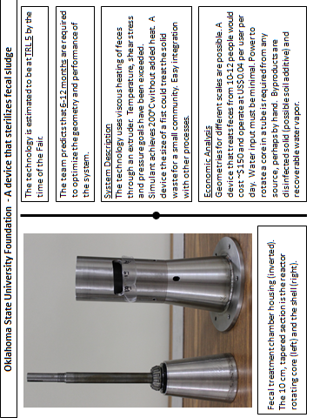
Exhibitor 22

Oklahoma State University
Technology target | Reinvented toilet | RTTC Criteria
Project Title | A device that sterilizes fecal sludge | Reinvent the Toilet Challenge
BMGF funding mechanism (RTTC, GCE, Contract, other) | GCE | All
Project Start Date | 05/2011 | 07/2011
Remaining time in funding cycle | 11/2012 | N/A
Processes and Technologies
Chemical engineering processes | Reactor Design Methods | Yes
Mechanical engineering | Friction Viscous Heating | Yes
Biological process | No | No
Key technology component | Auger rotation in a shell | N/A
Consumable
- Water/user | None | For personal hygiene, no flushing
- Electricity/user | Maybe some, but off grid | Off grid
- Others |  | 0
Limitations | Screening if grit/sand | Off grid
Waste to be processed off-site | None | None
Waste dumped / infiltrated in soil | Dry solid possible | None
Revenue stream
Energy recovered produced/user (kw/h) | Possible, burning residue | N/A
Water recovered/user | Possible, not measured | N/A
Nutrient/fertilizer recovered/user (g or L) | All solid recovered | N/A
Estimated revenue/user/day ($) | Not yet known | N/A
Total revenue /user/day ($) | Not yet known
Smell and odors control measures | Dried solid should help | No smell, no flies
 | But benefit unconfirmed
Technology Readiness Level |  | N/A
At time of RTT Fair | TRL 5 | N/A
Estimated at end of funding Phase | TRL 6 | 5 to 6 (not in original RFP)
Cost
Estimated time to produce fully functioning prototype (TRL 7) | 6-9 months | N/A
Estimated cost to produce fully functioning prototype (TRL 7) | With solar panel & car battery - $150-180/unit | N/A
Estimated capital cost of final toilet | $170-200/unit | N/A
Estimated lifetime | >5 for parts; ~3 battery | >5 years
Estimated total cost/user/day ($) (without revenue) | 10-12 people to achieve $0.04/user/day | 0.01 – 0.05

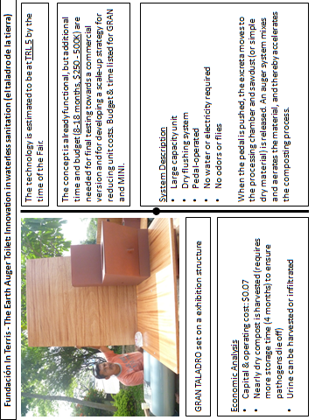
Exhibitor 23

Fundacion in Terris
Technology target (e.g. Reinvented Toilet, FS processing, Pit Extraction) | Reinvented Toilet | RTTC Criteria
Project Title | The Earth Auger Toilet: Innovation in waterless sanitation | Reinvent the Toilet Challenge
BMGF funding mechanism (RTTC, GCE, Contract, other) | Grand Challenges Explorations | All
Project Start Date | 05/2011 | 07/2011
Remaining time in funding cycle | 4 months (untill 11/2012) | N/A
Processes and Technologies
Chemical engineering processes | No | Yes
Mechanical engineering | Yes | Yes
Biological process | Yes | No
Key technology component | Yes | N/A
Consumable
- Water/user | No flushing. | For personal hygiene, no flushing
- Electricity/user | Off grid | Off grid
- others | Compost producing | 0
Limitations | Off grid | Off grid
Waste to be processed off-site | Not waste, compost production | None
Waste dumped / infiltrated in soil | Both possible with urine: infiltration or storage | None
Revenue stream
Energy recovered produced/user (kw/h) | N/A | N/A
Water recovered/user | N/A | N/A
Nutrient/fertilizer recovered/user (g or L) | 120 g /user /day | N/A
Estimated revenue/user/day ($) | 0,02 US $ /user /day | N/A
Total revenue /user/day ($) | N/A
Smell and odors control measures | No smell, no flies | No smell, no flies
Technology Readiness Level |  | N/A
At time of RTT Fair | 5 | N/A
Estimated at end of funding Phase | 6 | 5 to 6 (not in original RFP)
Cost
Estimated time to produce fully functioning prototype (TRL 7) | 18 months | N/A
Estimated cost to produce fully functioning prototype (TRL 7) | $ 500K | N/A
Estimated capital cost of final toilet | $150 | N/A
Estimated lifetime | >5 years | >5 years
Estimated total cost/user/day ($) (without revenue) | 0.07 – 0.10 | 0.01 – 0.05

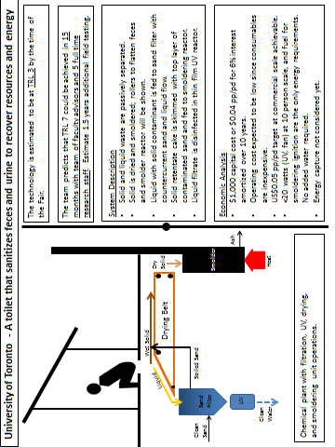
Exhibitor 24

University of Toronto
Technology target (e.g. Reinvented Toilet, FS processing, Pit Extraction) | Reinvented toilet | RTTC Criteria
Project Title | A toilet that sanitizes feces and urine to recover resources and energy | Reinvent the Toilet Challenge
BMGF funding mechanism (RTTC, GCE, Contract, other) | RTTC | All
Project Start Date | 07/2011 | 07/2011
Remaining time in funding cycle | 1 month in Phase 1; 15 months in Phase 2 | N/A
Processes and Technologies
Chemical engineering processes | Yes | Yes
Mechanical engineering | Yes | Yes
Biological process | No | No
Key technology component | Drying/crusting, smoldering, sand filtration, UV disinfection | N/A
Consumable
- Water/user | Estimated 2 L/user per day wash water for personal hygiene – accounted for in technology, but not essential for technology function. | For personal hygiene, no flushing
- Electricity/user | 1.5 Watts/user (15 W UV lamp for 10 users). Anticipate using off grid power such as solar. | Off grid
- Others | Fuel for ignition of smoldering reaction | 0
Limitations | Off grid. | Off grid
Waste to be processed off-site | None | None
Waste dumped / infiltrated in soil | None | None
Revenue stream
Energy recovered produced/user (kw/h) | Have not tried to capture yet. | N/A
Water recovered/user | UV disinfected liquid can be recovered if needed. Estimate 2L /user per day. | N/A
Nutrient/fertilizer recovered/user (g or L) | Have not considered possible ash recovery yet. | N/A
Estimated revenue/user/day ($) | Not considered yet. | N/A
Total revenue /user/day ($) | Not considered yet.
Smell and odors control measures | Preliminary work with smoldering unit shows promise for controlling odor and visible smoke. | No smell, no flies
Technology Readiness Level |  | N/A
At time of RTT Fair | TRL 3
Estimated at end of funding Phase | TRL 3 at end of phase 1; TRL 7 at end of phase 2. | 5 to 6 (not in original RFP)
Cost
Estimated time to produce fully functioning prototype (TRL 7) | 15 months | N/A
Estimated cost to produce fully functioning prototype (TRL 7) | $750,000 (current estimate, pending final phase 2 proposal) | N/A
Estimated capital cost of final toilet | $1,000 | N/A
Estimated lifetime | 5 to 10 years | >5 years
Estimated total cost/user/day ($) (without revenue) | Expect < $0.05 when manufactured at scale | 0.01 – 0.05

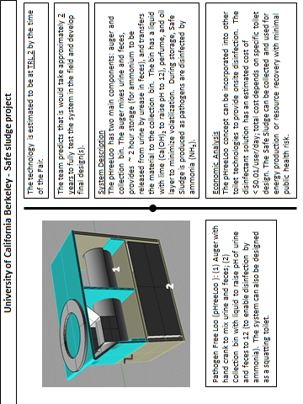
Exhibitor 25

University of California Berkeley
Technology target (e.g. Reinvented Toilet, FS processing, Pit Extraction) | FS processing | RTTC Criteria
Project Title | Safe Sludge Project | Reinvent the Toilet Challenge
BMGF funding mechanism (RTTC, GCE, Contract, other) | GCE | All
Project Start Date | 05/2011 | 07/2011
Remaining time in funding cycle | 05/2013 | N/A
Processes and Technologies
Chemical engineering processes | Yes | Yes
Mechanical engineering | Yes | Yes
Biological process | Yes | No
Key technology component | Auger | N/A
Consumable
- Water/user | Minimal | For personal hygiene, no flushing
- Electricity/user | Off grid | Off grid
- others | Lime (Ca(OH)₂), perfume, oil barrier | 0
Limitations | Off grid | Off grid
Waste to be processed off-site | Partially on-site | None
Waste dumped / infiltrated in soil | None | None
Revenue stream
Energy recovered produced/user (kw/h) | N/A | N/A
Water recovered/user | N/A | N/A
Nutrient/fertilizer recovered/user (g or L) | N/A | N/A
Estimated revenue/user/day ($) | N/A | N/A
Total revenue /user/day ($) | N/A
Smell and odors control measures | Perfume, oil barrier | No smell, no flies
Technology Readiness Level | 2 | N/A
At time of RTT Fair | 2 | N/A
Estimated at end of funding Phase | 3 | 5 to 6 (not in original RFP)
Cost
Estimated time to produce fully functioning prototype (TRL 7) | N/A | N/A
Estimated cost to produce fully functioning prototype (TRL 7) | N/A | N/A
Estimated capital cost of final toilet | N/A | N/A
Estimated lifetime | N/A | >5 years
Estimated total cost/user/day ($) (without revenue) | < $0.01/user/day for disinfectant solution | 0.01 – 0.05

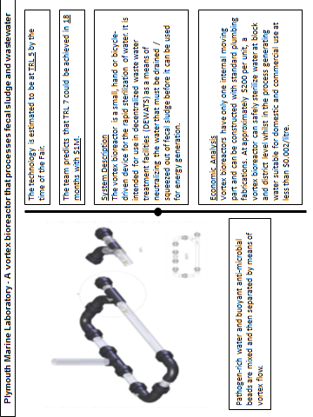
Exhibitor 26
Plymouth Marine Laboratory

Technology target | FS energy recovery | RTTC Criteria
Project Title | A vortex bioreactor that processes fecal sludge and waste water | Reinvent the Toilet Challenge
BMGF funding mechanism (RTTC, GCE, Contract, other) | GCE Round 7 | All
Project Start Date | 11/2011 | 07/2011
Remaining time in funding cycle | 1 month | N/A
Processes and Technologies
Chemical engineering processes | No | Yes
Mechanical engineering | Yes | Yes
Biological process | Yes | No
Key technology component | Anti-microbial beads in vortex flow | N/A
Consumable
- Water/user | None | For personal hygiene
- Electricity/user | None | Off grid
- Others | None | 0
Limitations | None | Off grid
Waste to be processed off-site | Dewatered FS | None
Waste dumped / infiltrated in soil | None | None
Revenue stream
Energy recovered produced/user (kw/h) | N/A | N/A
Water recovered/user | Complete recovery of water | N/A
Nutrient/fertilizer recovered/user (g or L) | Not known | N/A
Estimated revenue/user/day ($) | Not known | N/A
Total revenue /user/day ($) | Not known
Smell and odors control measures | No smells | No smell, no flies
Technology Readiness Level |  | N/A
At time of RTT Fair | TRL5 | N/A
Estimated at end of funding Phase | TRL5 | 5 to 6 (not in original RFP)
Cost
Estimated time to produce fully functioning prototype (TRL 7) | 12-18 months | N/A
Estimated cost to produce fully functioning prototype (TRL 7) | $1m | N/A
Estimated capital cost of final toilet | N/A | N/A
Estimated lifetime | 5-8 years | >5 years
Estimated total cost/user/day ($) (without revenue) | Not yet known | 0.01 – 0.05

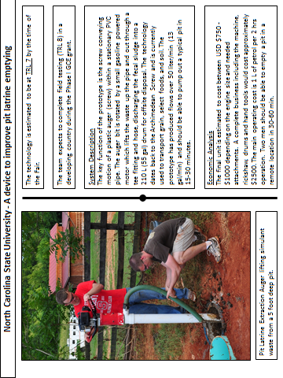
Exhibitor 27

North Carolina State University

Technology target | Pit Extraction | RTTC Criteria
Project Title | A device to improve pit latrine emptying | Reinvent the Toilet Challenge
BMGF funding mechanism (RTTC, GCE, Contract, other) | GCE | All
Project Start Date | 10/2011 | 07/2011
Remaining time in funding cycle | 10 months | N/A
Processes and Technologies
Chemical engineering processes | No | Yes
Mechanical engineering | Yes | Yes
Biological process | No | No
Key technology component | Auger (Screw Conveyor) | N/A
Consumable
- Water/user | Only for Clean-up (does not need to be potable) | For personal hygiene, no flushing
- Electricity/user | None | Off grid
- Others | Gas (petrol) for engine (small amount) | 0
Limitations |  | Off grid
Waste to be processed off-site | Yes (only designed for pit extraction not treatment) | None
Waste dumped / infiltrated in soil | None | None
Revenue stream
Energy recovered produced/user (kw/h) | N/A | N/A
Water recovered/user | N/A | N/A
Nutrient/fertilizer recovered/user (g or L) | N/A | N/A
Estimated revenue/user/day ($) | N/A | N/A
Total revenue /user/day ($) | N/A
Smell and odors control measures | N/A | No smell, no flies
Technology Readiness Level |  | N/A
At time of RTT Fair | 7 | N/A
Estimated at end of funding Phase | 8 | 5 to 6 (not in original RFP)
Cost
Estimated time to produce fully functioning prototype (TRL 7) | Completed by fair (11 months) | N/A
Estimated cost to produce fully functioning prototype (TRL 7) | ~$900 for one Prototype and all attachments | N/A
Estimated capital cost of final toilet | $750 - $1000 (depending on size) | N/A
Estimated lifetime | >5 years | >5 years
Estimated total cost/user/day ($) (without revenue) | ~ $1/d for equipment + $1-2/d for petrol. Can empty 5-10 pits/d | 0.01 – 0.05
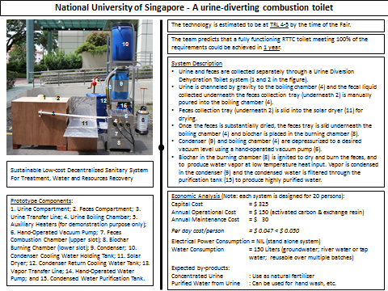
Exhibitor 28

National University of Singapore

Technology target | Reinvented Novel Toilet system including feces processing, concentration of urine and water recovery | RTTC Criteria
Project Title | A urine-diverting combustion toilet | RTTC
BMGF funding mechanism | RTTC | All
Project Start Date | 6 June 2011 | 07/2011
Remaining time in funding cycle | 2 ½ months (until 30 September 2012) | N/A
Processes and Technologies
Chemical engineering processes | Yes | Yes
Mechanical engineering | Yes | Yes
Biological process | No | No
Key technology component | Urine Diversion Dehydration Toilet Bowl; Urine Boiling Chamber; Biochar Combustion Chamber; Feces Combustion Chamber; Gravity Driven Condenser; Solar Dryer; Hand-Operated Pump; and Hand-Operated Vacuum Pump | N/A
Consumables
- Water/user | Yes (Groundwater, river water or tap Water) | For personal hygiene, no flushing
- Electricity/user | No (for real prototype; but required for demonstration of prototype at the Fair) | Off grid
- Others | Biochar for drying and burning of feces, and heating of urine and fecal liquid; Activated carbon and exchange resin (if highly purified water is desired) | 0
Limitations |  | Off grid
Waste to be processed off-site | None | None
Waste dumped / infiltrated in soil | None (Note: ash will be produced from the burning of feces and biochar) | None
Revenue stream
Energy recovered produced/user | Nil | N/A
Water recovered/user | 0.4 L/user/per day | N/A
Nutrient/fertilizer recovered/user (g or L) | Concentrated urine as fertilizer for agriculture application; Ash from combustion of feces and biochar. | N/A
Estimated revenue/user/day ($) | Nil (if not considering monetary equivalent gained from recovered water and fertilizer) | N/A
Total revenue /user/day ($) | Nil (if not considering monetary equivalent gained from recovered water and fertilizer)
Smell and odors control measures | May emit minor odor from urine and feces before and during processing | No smell, no flies
Technology Readiness Level |  | N/A
At time of RTT Fair | 4 to 5 | N/A
Estimated at end of funding Phase | 4 to 5 | 5 to 6 (not in original RFP)
Cost
Estimated time to produce fully functioning prototype (TRL 7) | 1 year (About 1 year is required to optimize urea removal from product water, fine tune and optimize the 1st prototype particularly the combustion stove and purified water production; biochar production from feces will be explored) | N/A
Estimated cost to produce fully functioning prototype (TRL 7) | US$6,000.00 | N/A
Est. capital cost of final toilet | US$325 (for mass production) | N/A
Estimated lifetime | 6 Years | >5 years
Estimated total cost/user/day ($) (without revenue) | US$0.047 per person per day (based on 20 persons for each system and includes O&M cost) | 0.01 – 0.05

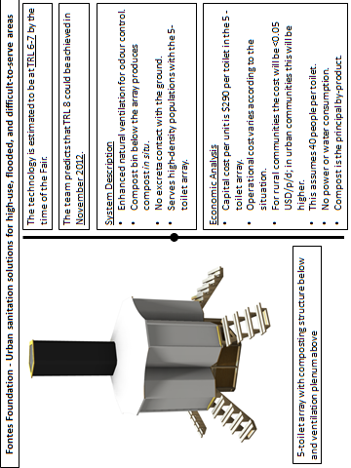
Exhibitor 29

Fontes Foundation

Technology target |  | RTTC Criteria
Project Title | Urban sanitation solutions for high-use, flooded, and difficult to serve areas | Reinvent the Toilet Challenge
BMGF funding mechanism (RTTC, GCE, Contract, other) | GCE | All
Project Start Date | May 1st 2011 | 07/2011
Remaining time in funding cycle | 3 months | N/A
Processes and Technologies
Chemical engineering processes |  | Yes
Mechanical engineering | Ventilation and air flow | Yes
Biological process | Thermophilic composting | No
Key technology component | Enhanced ventilation and low-cost structure | N/A
Consumable | Sugarcane bagasse or other
- Water/user | No water | For personal hygiene, no flushing
- Electricity/user | No electricity | Off grid
- Others | Carbon material for composting | 0
Limitations | None | Off grid
Waste to be processed off-site | No | None
Waste dumped / infiltrated in soil | No | None
Revenue stream
Energy recovered produced/user (kw/h) | N/A | N/A
Water recovered/user | N/A | N/A
Nutrient/fertilizer recovered/user (g or L) | To be determined | N/A
Estimated revenue/user/day ($) |  | N/A
Total revenue /user/day ($) | To be determined
Smell and odors control measures | Enhanced passive ventilation | No smell, no flies
Technology Readiness Level |  | N/A
At time of RTT Fair | TRL 6/7 | N/A
Estimated at end of funding Phase | TRL 8/9 | 5 to 6 (not in original RFP)
Cost
Estimated time to produce fully functioning prototype (TRL 7) | In operation | N/A
Estimated cost to produce fully functioning prototype (TRL 7) | In operation, actual costs | N/A
Estimated capital cost of final toilet | $1,450 USD/five-toilet array | N/A
Estimated lifetime | 3 years, could be extended | >5 years
Estimated total cost/user/day ($) (without revenue) | N/A | 0.01 – 0.05

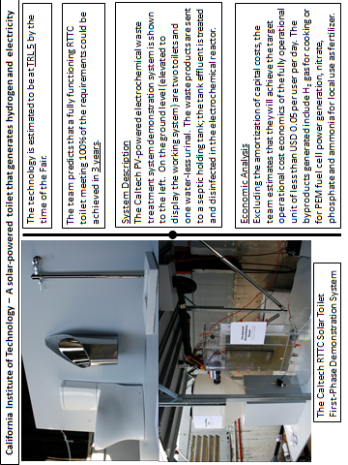
Exhibitor 30

California Institute of Technology
Technology target | Reinvented toilet; plus conceptual overall sanitation system | RTTC Criteria
Project Title | A solar-powered toilet that generates hydrogen and electricity | Reinvent the Toilet Challenge
BMGF funding mechanism GCE, | RTTC | All
Project Start Date | 1 July 2011 | 07/2011
Remaining time in funding cycle | 2 months | N/A
Processes and Technologies
Chemical engineering processes | Yes | Yes
Mechanical engineering | Yes | Yes
Biological process | Yes, septic tank | No
Key technology component | PV-powered electrochemical reactor. | N/A
Consumable | None
- Water/user | Water recycled through waste treatment system | For personal hygiene, no flushing
- Electricity/user | No | Off grid
- Others |  | 0
Limitations | Processing time (6 hours) | Off grid
Waste to be processed off-site | None | None
Waste dumped / infiltrated in soil | Water and Sediment Recycle through system. | None
Revenue stream
Energy recovered produced/user (kw-h)  H2 $0.012 per day per capita  (includes the cost of separation) | Hydrogen recovery and use for hot water heating and PEM power generation, 0.024 kW-h/person/day (86 kJ/day) | N/A
Water recovered/user | Yes, 90% | N/A
Nutrient/fertilizer recovered/user (g or L)  N $0.0014 per day per capita  P $0.03 per day per capita  (includes the cost of separation) | Yes, compost, nitrate, ammonia, urea (2.8 g/L total N) from urine & feces, phosphorus, 9.5 g/day. | N/A
Estimated revenue/user/day ($) |  | N/A
Total revenue /user/day ($)
Smell and odors control measures | Self-contained with Disinfection, Self-cleaning toilet sea | No smell, no flies
Technology Readiness Level |  | N/A
At time of RTT Fair | 5 | N/A
Estimated at end of funding Phase | 5 | 5 to 6 (not in original RFP)
Cost
Estimated time to produce fully functioning prototype (TRL 7) | 15 months | N/A
Estimated cost to produce fully functioning prototype (TRL 7) | $50,000 including variations in design and construction | N/A
Estimated capital cost of final toilet facility | $1500 - $2000 | N/A
Estimated lifetime | 15 – 20 years | >5 years
Estimated total cost/user/day ($) (without revenue) | $0.03 per user per day | 0.01 – 0.05
Exhibitor 31
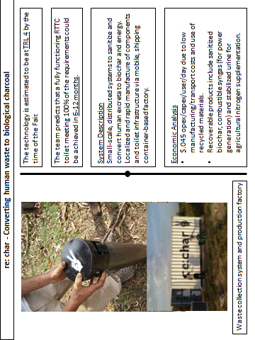
Exhibitor 31

re:char
Technology target | Reinvented Toilet | RTTC Criteria
Project Title | Converting human waste to biological charcoal | Reinvent the Toilet Challenge
BMGF funding mechanism (RTTC, GCE, Contract, other) | GCE | All
Project Start Date | 11/2011 | 07/2011
Remaining time in funding cycle | 3 months | N/A
Processes and Technologies
Chemical engineering processes | Yes | Yes
Mechanical engineering | Yes | Yes
Biological process | No | No
Key technology component | No | N/A
Consumable
- Water/user | None | For personal hygiene, no flushing
- Electricity/user | Off grid | Off grid
- Others | Waste biomass | 0
Limitations | Off-grid | Off grid
Waste to be processed off-site | None | None
Waste dumped / infiltrated in soil | None | None
Revenue stream
Energy recovered produced/user (kw/h) |  | N/A
Water recovered/user | 1-2 kg biochar | N/A
Nutrient/fertilizer recovered/user (g or L) | 1-2 L stabilized urine | N/A
Estimated revenue/user/day ($) | $.50 | N/A
Total revenue /user/day ($) | $2-4
Smell and odors control measures | No smell, no flies | No smell, no flies
Technology Readiness Level |  | N/A
At time of RTT Fair | 4 | N/A
Estimated at end of funding Phase | 7 | 5 to 6 (not in original RFP)
Cost
Estimated time to produce fully functioning prototype (TRL 7) | 3-6 months | N/A
Estimated cost to produce fully functioning prototype (TRL 7) | $200,000 | N/A
Estimated capital cost of final toilet | $100 | N/A
Estimated lifetime | >5 years | >5 years
Estimated total cost/user/day ($) (without revenue) | $.045 | 0.01 – 0.05

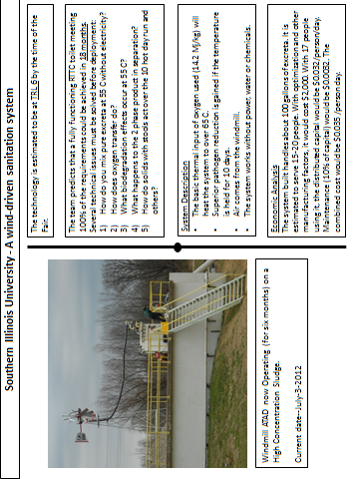
Exhibitor 32

Southern Illinois University
Technology target | Reinvented toilet | RTTC Crit.
Project Title | A wind-driven sanitation system | RTTC
BMGF funding mechanism | GCE6 | All
Project Start Date | 05/2011 | 07/2011
Remaining time in funding cycle | 5 months | N/A
Processes & Technology
Chemical engineering processes | Yes | Yes
Mechanical engineering | Yes | Yes
Biological process | Yes | No
Key technology component | Performance of Windmill ATAD To Human Excreta in the system to real weather conditions. | N/A
Consumable
- Water/user | A drop to keep system clean, generating gallons/day of sanitized treated, low pathogen water. With the manpower to use a hand pump, it can be recycled to make the flush toilet a “green technology.” | For personal hygiene, no flushing
- Electricity/user | None | Off grid
- others | None | 0
Limitations | The lack of literature discussing aerobic systems with very high densities and ability to mix and degrade the excreta without dilution -Ph 2 studies. | Off grid
Waste to be processed off-site | No. Products Water and Solids will be virtually void of pathogens, allowing many farm and agricultural uses | None
Waste dumped / infiltrated in soil | High temps and residence times of system make this a valued product; device sanitizes water & solids which are usable for any agricultural purpose according to the USEPA. | None
Revenue stream
Energy recovered produced/user(kw/h) | Hot water at 140 degrees. Est. total biological energy for the current pilot (100 gal) is 2.05 kw/hr. Total system excreta heat produced is near zero. Most generated heat from system with aqueous stream and hot, off gas air. | N/A
Water recovered/user | A “clean” supplement possible ability to use flush toilets and irrigation; ideal for future studies in converting to potable water | N/A
Nutrient/fertilizer recovered/user(g or L) | Calculation based on 15 individuals.10 gal/day (37.9 l, or2.5 l/person) at pilot plant is estimated to generate 20% total solids or 0.5 l | N/A
Estimated revenue/user/day($) | If this water has a value of $0.1/l and the solids may have a value of $.1/l  The revenue pp/day would be $ 0.25. | N/A
Total revenue/user/day($) | For 15 users, the revenue is $0.25/user/day
Smell and odors control measures | No smell or foam at pilot plant, the technology has increased ammonia. USEPA technology produces a product with no vectors. | No smell, no flies
TRLs |  | N/A
At time of RTT Fair | 5 | N/A
Est. at end of funding Phase | 8 | 5 to 6
Cost
Est. time to produce fully functioning prototype | (TRL 7) Running in the field since January, 2010 | N/A
Estimated cost to produce fully functioning prototype | (TRL 7)Parts have not been used on direct excreta, need one yr of research. Design, build and deploy in a year. Designed as a production unit, not a prototype | N/A
Estimated capital cost of final toilet | With an experiment tested information, an engineering analysis making close evaluations, look for cheaper parts and designs and the economies of scale of materials needed, and assuming that it will become competitive, Est. at $1500/ unit. A unit will serve from 15-25 people and the per capita cost is $100. | N/A
Estimated lifetime | 10 years | >5 years
Est. total cost/user/day ($) (without revenue) | First cost=$1500/Cost per year=$150/365 days Per Year=$0.4/15 users= $0.027 | 0.01 – 0.05

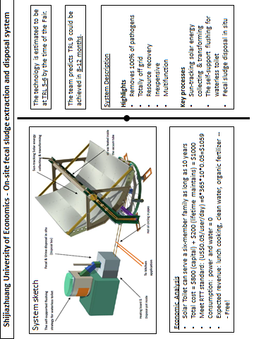
Exhibitor 33

Shijiazhuang University of Economics

Technology target | Reinvented Toilet | RTTC Criteria
Project Title | On-site fecal sludge extraction and disposal system | Reinvent the Toilet Challenge
BMGF funding mechanism (RTTC, GCE, Contract, other) | GCE-7 | All
Project Start Date | 11/2011 | 07/2011
Remaining time in funding cycle | 4 Months | N/A
Processes and Technologies
Chemical engineering processes | No | Yes
Mechanical engineering | Yes | Yes
Biological process | No | No
Key technology component |  | N/A
Consumable
- Water/user | 0 | For personal hygiene, no flushing
- Electricity/user | 0/ (~15w, by self supported solar cell) | Off grid
- Others | 0 | 0
Limitations | Totally off grid | Off grid
Waste to be processed off-site | Waste processed in situ | None
Waste dumped / infiltrated in soil | No | None
Revenue stream
Energy recovered produced/user (kw/h) | 1~2 kw/h (from solar energy) | N/A
Water recovered/user | 1~2 liter | N/A
Nutrient/fertilizer recovered/user (g or L) | 200g fertilizer user/day | N/A
Estimated revenue/user/day ($) | ＞0.1 per user/day | N/A
Total revenue /user/day ($) | ＞0.1
Smell and odors control measures | No files | No smell, no flies
Technology Readiness Level |  | N/A
At time of RTT Fair | 5 to 6 | N/A
Estimated at end of funding Phase | 6 to 7 | 5 to 6 (not in original RFP)
Cost
Estimated time to produce fully functioning prototype (TRL 7) | 3~6Month | N/A
Estimated cost to produce fully functioning prototype (TRL 7) | 300K~700K( 700K Include some tooling & mold etc) | N/A
Estimated capital cost of final toilet | ~700$ (mass production) | N/A
Estimated lifetime | 7~10 years | >5 years
Estimated total cost/user/day ($) (without revenue) | 0.01~0.02 | 0.01 – 0.05

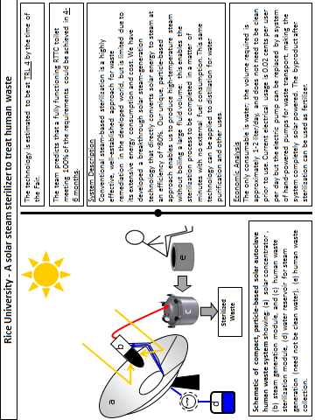
Exhibitor 34

Rice University

Technology target (e.g. Reinvented Toilet, FS processing, Pit Extraction) | FS treatment | RTTC Criteria
Project Title | A solar steam sterilizer to treat human waste | Reinvent the Toilet Challenge
BMGF funding mechanism (RTTC, GCE, Contract, other) | GCE | All
Project Start Date | 11/2011 | 07/2011
Remaining time in funding cycle | Until 04/2013 | N/A
Processes and Technologies
Chemical engineering processes | Yes | Yes
Mechanical engineering | Yes | Yes
Biological process | No | No
Key technology component | Yes | Yes
Consumable
- Water/user | For steam production | For personal hygiene, no flushing
- Electricity/user | To operate pump (ultimately hand pump may be used) | Off grid
- others |  | 0
Limitations | None | Off grid
Waste to be processed off-site | No | None
Waste dumped / infiltrated in soil | Byproduct may be used for fertilization | None
Revenue stream
Energy recovered produced/user (kw/h) | Possibly | N/A
Water recovered/user | Possibly | N/A
Nutrient/fertilizer recovered/user (g or L) | Yes | N/A
Estimated revenue/user/day ($) | N/A | N/A
Total revenue /user/day ($) | N/A
Smell and odors control measures | Enclosed processing system | No smell, no flies
Technology Readiness Level |  | N/A
At time of RTT Fair | 3 | N/A
Estimated at end of funding Phase | 5 | 5 to 6 (not in original RFP)
Cost
Estimated time to produce fully functioning prototype (TRL 7) | N/A | N/A
Estimated cost to produce fully functioning prototype (TRL 7) | N/A | N/A
Estimated capital cost of final toilet | N/A | N/A
Estimated lifetime | >5 years | >5 years
Estimated total cost/user/day ($) (without revenue) | 0.02 | 0.01 – 0.05

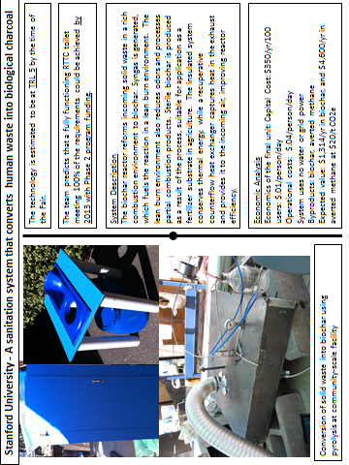
Exhibitor 35

Stanford University
Technology target (e.g. Reinvented Toilet, FS processing, Pit Extraction) | Stanford / Climate Foundation | RTTC Criteria
Project Title | A sanitation system that converts human waste into biological charcoal | Reinventing the Toilet Challenge
BMGF funding mechanism (RTTC, GCE, Contract, other) | RTTC | All
Project Start Date | 07/2011 | 07/2011
Remaining time in funding cycle |  | N/A
Processes and Technologies
Chemical engineering processes | Yes | Yes
Mechanical engineering | Yes | Yes
Biological process | No | No
Key technology component | N/A | N/A
Consumable
- Water/user | None | Personal hygiene, no flush
- Electricity/user | Off grid | Off grid
- Others | 0 | 0
Limitations | Off grid | Off grid
Waste to be processed off-site | None | None
Waste dumped / infiltrated in soil | None | None
Revenue stream
Energy recovered produced/user (kw/h) | Up to 1 MJ/day/person | N/A
Water recovered/user |  | N/A
Nutrient/fertilizer recovered/user (g or L) | 36 gram/day/person | N/A
Estimated revenue/user/day ($) | 0.036 | N/A
Total revenue /user/day ($) | 0.05
Smell and odors control measures | No smell, no flies | No smell, no flies
Technology Readiness Level |  | N/A
At time of RTT Fair |  | N/A
Estimated at end of funding Phase | TRL-5 | 5 to 6 (not in original RFP)
Cost
Estimated time to produce fully functioning prototype (TRL 7) |  | N/A
Estimated cost to produce fully functioning prototype (TRL 7) |  | N/A
Estimated capital cost of final toilet |  | N/A
Estimated lifetime | >5 years | >5 years
Estimated total cost/user/day ($) (without revenue) | .05 | 0.01 – 0.05

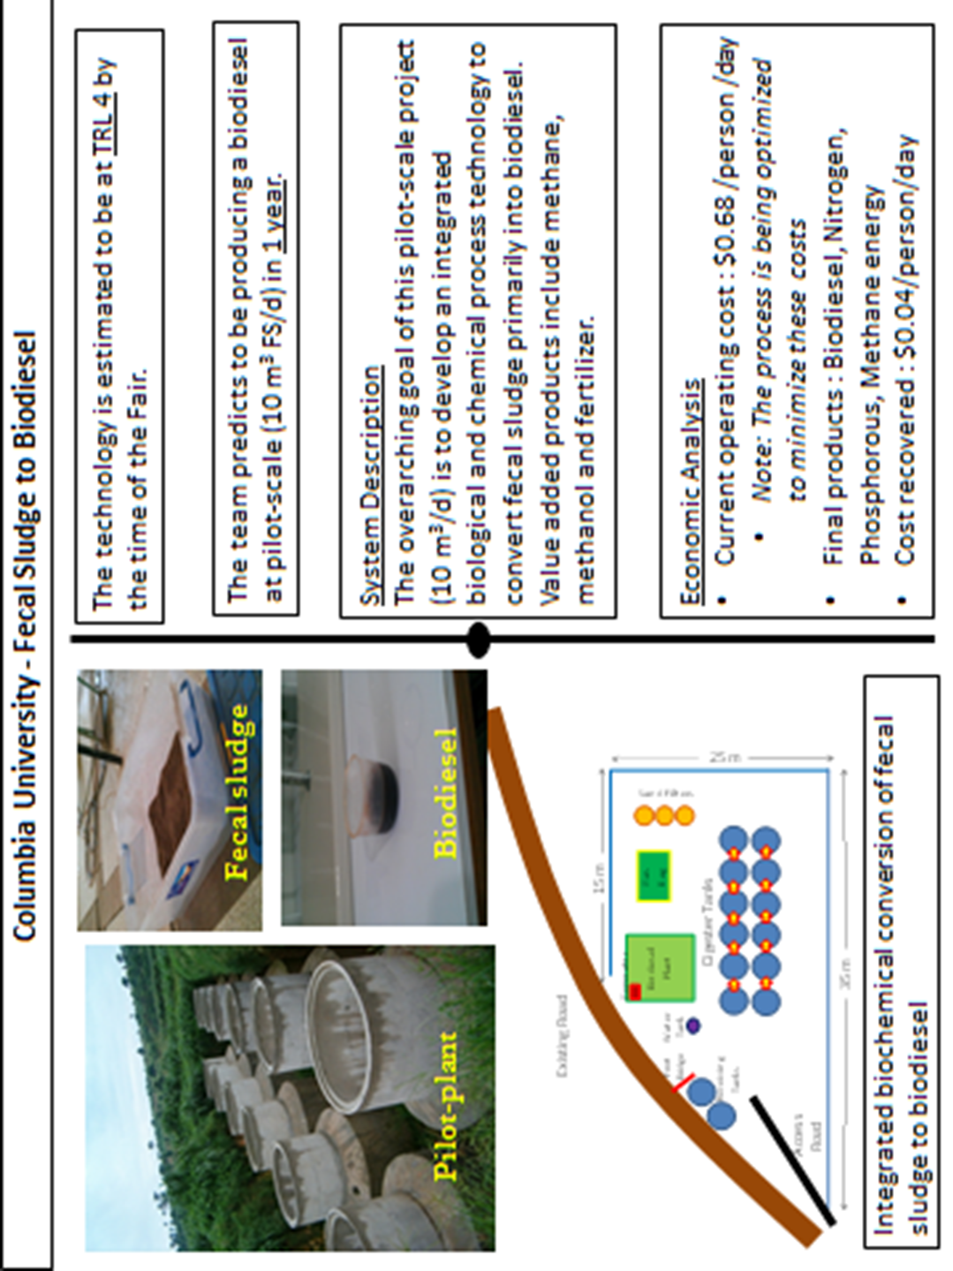
Columbia University

Technology target (e.g. Reinvented Toilet, FS processing, Pit Extraction) | FS processing | RTTC Criteria
Project Title | Fecal sludge fed biodiesel plants – the next generation urban sanitation facility | Reinvent the Toilet Challenge
BMGF funding mechanism (RTTC, GCE, Contract, other) | Other, Global Development | All
Project Start Date | 6/2011 | 07/2011
Remaining time in funding cycle | 12 months | N/A
Processes and Technologies
Chemical engineering processes | Yes | Yes
Mechanical engineering |  | Yes
Biological process | Yes | No
Key technology component | Chemical biodiesel production with biological fermentation and methanogenesis | N/A
Consumable
- Water/user | For chemical washing | For personal hygiene, no flushing
- Electricity/user | For running the chemical and biological process reactors | Off grid
- others | Chemicals for biodiesel production and extraction | 0
Limitations | Chemical costs | Off grid
Waste to be processed off-site | None | None
Waste dumped / infiltrated in soil | None | None
Revenue stream
Energy recovered produced/user (kw/h) | N/A – biodiesel recovery | N/A
Water recovered/user | 2 L/user/d | N/A
Nutrient/fertilizer recovered/user (g or L) | 25 kg N/d, 1.5kg P/d | N/A
Estimated revenue/user/day ($) | $0.04 | N/A
Total revenue /user/day ($) | $0.04
Smell and odors control measures | No smell or odor | No smell, no flies
Technology Readiness Level |  | N/A
At time of RTT Fair | 4 | N/A
Estimated at end of funding Phase | 8 | 5 to 6 (not in original RFP)
Cost
Estimated time to produce fully functioning prototype (TRL 7) | Twelve months | N/A
Estimated cost to produce fully functioning prototype (TRL 7) | $500,000  Not for the toilet but for the reactor system | N/A
Estimated capital cost of final toilet | N/A | N/A
Estimated lifetime | > 10-15 years | >5 years
Estimated total cost/user/day ($) (without revenue) | $0.68  Not for toilet but for the reactor system producing biodiesel | 0.01 – 0.05

The toilet is mechanical and innovative. The team is designing and building anaerobic digesters with the toilet, but for the purposes of this form they are considering anaerobic digestion as a preexisting technology (which is both chemical and biological).
Digestate is produced onsite with the toilet (with 90% pathogen reduction) and transported a short distance for further processing into marketable fertilizer.
These values are produced by the Loowatt system.
This level is applied to the toilet only.
The toilet, at volume production (100K+) of internal components, with local manufacture and assembly of supporting components.
The team is defining this cost as the price the user pays per toilet visit in our current financial model

