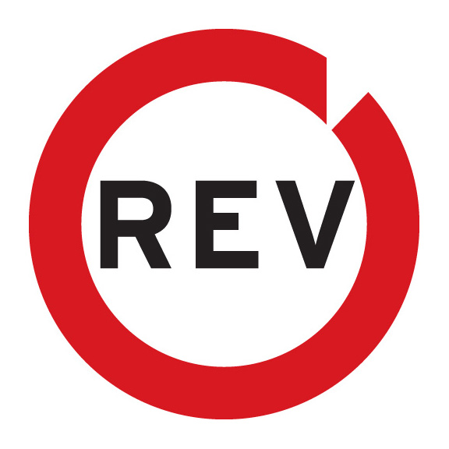

Creative Team:
Roberto Alcazar, Executive Creative Director
Henry Alvarez, Creative Director
Marc Duran Rojas: Copywriter

Account Team:
Jennifer Perez, Account Director
Vanessa Ponce, Account Executive

Public Relations Team:
Diana Heald, Account Supervisor
Diana Palacios, Account Executive

Studio:
Razorhead Music

Composer:
Carlo Nicolau

