B&O PLAY LAUNCHES COMPACT PORTABLE HIFI SYSTEM
FEATURING APPLE AIRPLAY FOR WIRELESS MUSIC STREAMING

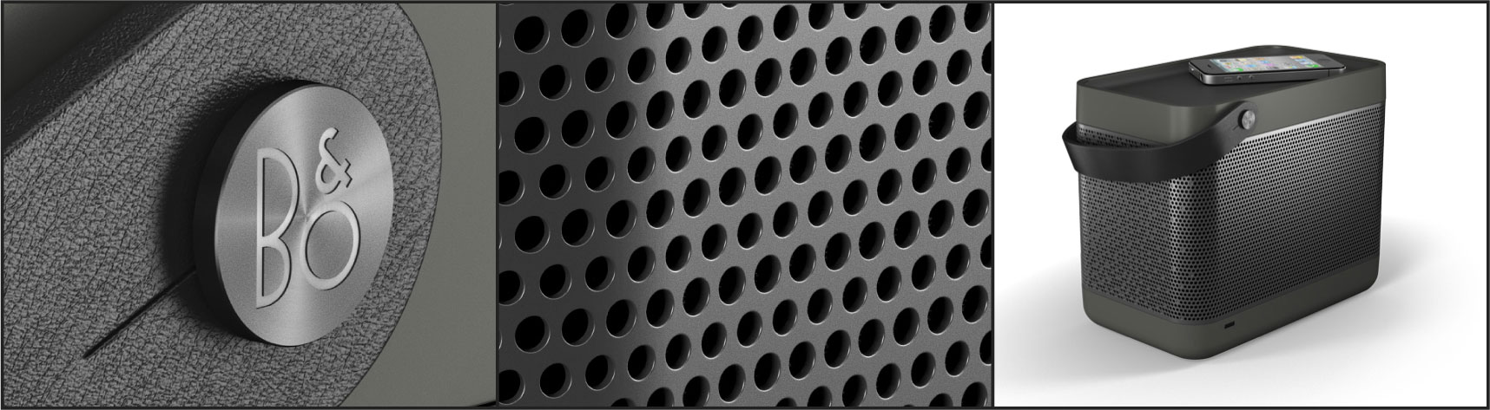

Copenhagen, Denmark / Las Vegas, Nevada - January 10, 2012

Bang & Olufsen, the global provider of luxury, integrated audio-video solutions and services, and B&O PLAY, the company’s new brand geared towards a more playful and portable product portfolio, are announcing its first product offering, the Beolit 12 portable music system. Beolit 12 will defy industry standards with its cutting-edge sound quality, flexible application and distinct, compact design.

Beolit 12 is designed by Danish designer, Cecilie Manz and it follows a design language that is a direct reflection of its use: convenient, robust and casual. Beolit 12 follows the success of the BeoSound 8 sound system for iPad/iPod/iPhone docking, with a combination of excellent sound performance, distinct design and craftsmanship, and portable wireless operation.

“With its unsurpassed sound performance and striking design, we believe Beolit 12 will resonate with both Bang & Olufsen enthusiasts and now a new and wider customer demographic, due to its convenience, price point and fashion-forward style” states Tue Mantoni, CEO Bang & Olufsen. “We believe it bridges a gap in the market by delivering a high quality listening experience and still having the convenience of playing music from ones portable digital device or smart phone.”

Beolit 12 features Apple’s AirPlay technology. It allows you to play music wirelessly from your iPod, iPhone, iPad, Mac or PC when connected to your wireless network. It is designed to be genuinely portable and has a built-in power supply and a rechargeable battery. The power cord packs neatly away inside the system when not in use. The rechargeable battery has capacity to charge an iPhone or other connected device and play back music for up to 8 hours at normal sound levels.

“By combining Bang & Olufsen’s 86 years of experience in sound and acoustic technology and advances with the latest wireless technology, Beolit 12 allows the user to play pristine music from their digital devices,” states Henrik Taudorf Lorensen, Vice President B&O PLAY. “We have packaged all of this technology in a compact solution and wrapped it in a beautiful hand-assembled aluminium casing which can be moved around freely with no cables by simply grabbing the leather-strap.”

Beolit 12 is a tribute to Bang & Olufsen’s ever-popular transistor Beolit radios from the 1960’s, and similar to its early predecessors, it presents a compact form, yet a robust sound reproduction. Also, despite its relatively small size, the Beolit 12 offers a best in class portable sound experience. Its 120 Watts digital Class D power amplifier system individually drives two 2” tweeters and a 4” woofer to deliver powerful, accurate sound performance that comfortably fills a middle sized room. The sound system is designed and tuned by the same sound engineers that delivered the award winning BeoLab 5 high-end speakers from Bang & Olufsen.

Attention to detail has always been a Bang & Olufsen signature competency, and this is reiterated under the B&O PLAY brand. Material choice and craftsmanship are no exceptions here: An Italian full-grain leather carrying strap is diagonally mounted for stability when the unit is carried around, and the solid aluminium speaker grill wraps smoothly around the unit, making the speaker fabric visible behind the grill to allow for different discrete colour options. The top of the unit, with its volume, power and network controls has a non-slip rubber insert, so you can safely place your mobile device here while charging or playing.
The Beolit 12 represents the company’s move into a new range of products designed specifically for a new generation of mobile, digital, quality-conscious customers. With a recommended consumer price of EUR 699 in Europe and $799 in the USA, the Beolit is the most affordable sound system from the Bang & Olufsen company in many years, and therefore the company believes its sales volume will surpass the ever-popular BeoSound 8 figures.

“Once people listen to their portable music through the Beolit 12, they will wonder why they ever did it any other way”, states Tue Mantoni, Global CEO of Bang & Olufsen.
Beolit 12 will begin to arrive in Bang & Olufsen showrooms globally, Bang & Olufsen online store(s), and select Apple stores (including Apple Online store) in late January 2012 in the dark grey option. Additional colors will include yellow, blue, and light grey, and those will arrive in showrooms this Spring 2012.
For more information visit www.beoplay.com
Public Relations Contact:

Monica Gartner
PR Consultant
Bang & Olufsen America, Inc.
847 590 4920
mcy@bang-olufsen.dk

Technical Specifications
DESIGNER | Cecilie Manz
DIMENSION W x H x D/WEIGHT | 23.0 x 15.0 x 18.8 cm/2.8 kg
MATERIAL(S) | Painted plastic and anodised aluminium
COLOUR(S) | Cabinet: grey, dark grey  Grill: silver, dark grey  Fabric: light grey, dark grey, blue and yellow  Leather strap: Black, natural-coloured
POWER CONSUMPTION | Typical(AirPlay+ charging): 12 W  charging: 7 W  airplay: 6 W  standby: 0.5. W
POWER SUPPLY | 100-240 V +10/-15 %, 50-60 Hz
BATTERY | Built-in, rechargeable with built-in heat protection circuit  up to 8 hours playback, with network disabled  up to 4 hours playback, with network enabled
CHARGING TIME | Max. 8 hours
OPERATING CONDITIONS | Temperature: 10-40° C  Humidity: 20-80%
CABINET PRINCIPLE | Sealed box
EFFECTIVE FREQUENCY RANGE* | 35.4 - 23,200 Hz
POWER AMPLIFIER(S) | 1 x Bass: 60 W/4 Ohm Class D  2 x Midrange/treble: 30 W/8 Ohm Class D
DRIVER(S) | 1 x 4" Woofer  2 x 2" Full range
Connections | 1 x USB iPod/iPhone/iPad connector  1 x Line-in (for iPod/iPhone or MP3 players)  1 x Ethernet 10/100Mb  Wireless  USB connection for charging  - 1000 mA on Apple devices  - 500 mA on non-Apple devices
Features | Apple AirPlay  Network connectivity via Ethernet or Wireless (WLAN 802.11 b/g - 2.4 GHz)  iPod®/MP3 player (audio playback via line-in)
Accessories | 1 x 0.5 m cable with mini-jack connection

B&O PLAY offers premium audio and visual equipment for the digital generation. B&O PLAY celebrates outstanding craftsmanship, cutting edge design, excellent performance and a playful approach to modern life, in a perfect balance of performance and style.
Bang & Olufsen was founded in Struer, Denmark, in 1925 by Peter Bang and Svend Olufsen, two innovative, young engineers devoted to high quality audio reproduction. Since then, the brand has become an icon of performance and design excellence through its long-standing craftsmanship tradition and the strongest possible commitment to high-tech research and development.
Still at the forefront of domestic technology, Bang & Olufsen has extended its comprehensive experience with integrated audio and video solutions for the home to other areas such as the hospitality and automotive industries in recent years. Consequently, its current product range epitomizes seamless media experiences in the home as well as in the car and on the move.
For more information on Bang & Olufsen, please visit www.bang-olufsen.com.
Images are available free of charge from the Bang & Olufsen media centre:
http://mediacenter.bang-olufsen.dk.
If you are a first-time visitor, please follow the instructions and register as a new user.

iPod, iPhone and iPad are trademarks of Apple Inc., registered in the U.S. and other countries.

