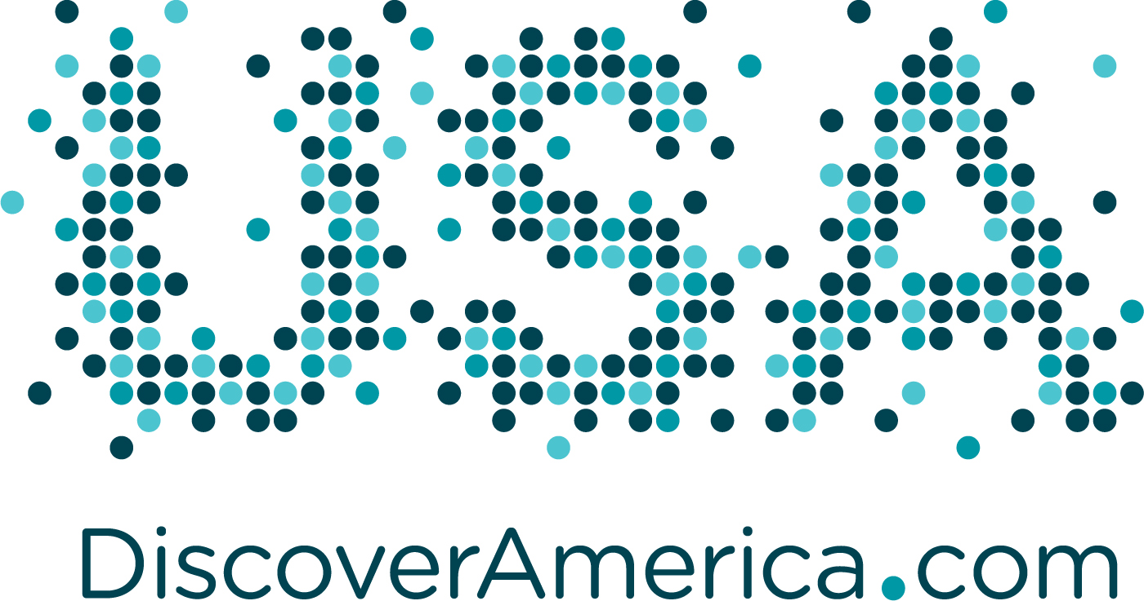
FOR IMMEDIATE RELEASE

Brand USA and jwt Launch America’s First Global Marketing Campaign to Attract International Travelers

NEW YORK – April 23, 2012 – Brand USA, the new tourism marketing entity responsible for promoting the United States to world visitors, and JWT today unveiled the United States’ first-ever comprehensive marketing campaign. Developed by JWT, the campaign showcases the diversity of experiences available in the U.S., inviting visitors to “Discover this land, like never before.”

“For more than 200 years, people have been coming to America, but we have never officially invited the world to visit,” said Bob Jeffrey, Chairman and CEO of JWT Worldwide. “To deliver America’s first tourism campaign, we developed a powerful message that taps into people’s emotions, reminding them what they love most about America – the diversity, pop culture, optimistic spirit and larger than life presence – and are inviting them to see it, hear it and feel it in a new way. We are excited to be part of this historic moment, as America competes for international travelers to drive tourism in the U.S., a mission we are extremely passionate about supporting.”

Before creating the campaign, JWT set out to understand the existing perceptions of the U.S. around the world. JWT discovered that people love: the freedom America makes them feel; think everything is larger than life in the U.S.; feel unity in the diversity; and see it is a land where anything is possible. These insights helped inform JWT’s approach to bringing Brand USA to life through the lens of foreign visitors.

“Our goal is nothing short of rekindling the world’s love affair with the U.S. – the place, the spirit and the dream,” said Brand USA CEO Jim Evans. “We want to spread America’s message of welcome around the world and invite travelers to experience the limitless possibilities the United States has to offer. So we asked ourselves, ‘how can we best speak to multiple countries, across countless languages and cultures?’ We found the answer lays in the only truly universal language—music.”

Grammy-award winning singer/songwriter Rosanne Cash, daughter of American music legend Johnny Cash, composed an original song, “Land of Dreams,” to serve as the heart of the campaign. Initial advertisements feature Cash playing the song under New York’s Brooklyn Bridge, accompanied by musicians from home and abroad united in their love for this country.

Brand USA will employ a fully integrated marketing strategy designed by JWT, using a mix of :60, :20 and :15 second television spots, as well as digital, billboard and print advertisements along with a robust online presence and social media strategy to reach potential visitors. Facebook, Twitter and YouTube pages will showcase country specific promotions and engagements and the newly re-launched website DiscoverAmerica.com will act as visitors’ information portal for trip planning. Additionally, DiscoverAmerica.com will feature three brand ambassadors’ journeys in the U.S. New ambassadors will continue to be added as the campaign rolls out in other markets.

The first wave of advertising launches in-market on May 1st in the United Kingdom, Japan and Canada, with a media budget of $12.3 million for the first three months. Subsequent campaign waves will include Brazil and South Korea, to be followed soon after by other markets under consideration, which include China, India, Germany, Mexico, India and Australia.

Brand USA also launched a new consumer website, www.discoveramerica.com, which includes interactive features, and a wide selection of U.S. destinations to explore. The website aims to help potential visitors imagine their visit to the United States by showcasing 250 vibrant and distinct experiences that can only be found in the United States of America. The website features destinations both large and small, iconic and lesser-known, from all geographical regions. The site highlights not only the destinations, but more specifically, the experiences a traveler might have – for instance, Memphis barbecue, the scenic Hana Highway in Maui or baseball Spring Training in Florida. The 250 featured experiences and their descriptions were licensed from the best-selling book, 1,000 Places to See in the United States and Canada Before You Die by Patricia Schultz. On the home page, in addition to viewing the tiles, visitors can connect with Brand USA through Facebook and other social media channels, as well as search for destinations by city, state, region and category of experience. A free download of the “Land of Dreams” song featured in the campaign is available at www.discoveramerica.com.

A long form version of the commercial (2:30) will be available for viewing on Discover America’s You Tube channel.

As part of its marketing efforts, Brand USA will extend invitations to musical artists from around the world to come perform their music in their favorite U.S. cities and towns, profiling their trips and favorite things about the U.S. online and through social media.

Brand USA was created as a result of the U.S. Travel Promotion Act, federal legislation passed in March 2010, which established a public-private partnership between the travel industry and the U.S. government dedicated to increasing international visitation to the U.S. through marketing and promotional efforts to drive job creation and spur economic growth. According to the U.S. Travel Association, the average overseas visitor to the United States spends $4,000 per trip, and 35 incremental overseas visitors supports one new U.S. job.
About JWT
JWT is the world’s best-known marketing communications brand. Headquartered in New York, JWT is a true global network with more than 200 offices in over 90 countries employing nearly 10,000 marketing professionals. JWT consistently ranks among the top agency networks in the world and continues its dominant presence in the industry by staying on the leading edge—from producing the first-ever TV commercial in 1939 to developing award-winning branded content for brands such as Smirnoff, Macy’s, Ford and HSBC. JWT’s creative philosophy of making things inspired by the world enables the agency to forge deep relationships with clients including Bayer, Bloomberg, Cadbury, Diageo, DTC, Ford, HSBC, Johnson & Johnson, Kellogg’s, Kimberly-Clark, Kraft, Nestlé, Nokia, Rolex, Royal Caribbean, Schick, Shell, Unilever, Vodafone and many others. JWT’s parent company is WPP (NASDAQ: WPPGY).

About Brand USA
Brand USA was established by the Travel Promotion Act in 2010 to spearhead the nation's first global marketing effort to promote the United States as a premier travel destination and communicate U.S. entry/exit policies and procedures. Formed as the Corporation for Travel Promotion, the public-private entity began operations in May 2011 and does business as Brand USA. Brand USA works in close partnership with the travel industry to maximize the economic and social benefits of travel. Through its call-to-action—DiscoverAmerica.com—Brand USA inspires travelers to explore the United States of America’s boundless possibilities. For industry or partner information about Brand USA, visit www.TheBrandUSA.com. For information about exceptional and unexpected travel experiences in the United States, please visit Brand USA’s consumer website at www.DiscoverAmerica.com.

Social Media Channels
Facebook:
U.S. – http://www.facebook.com/DiscoverAmerica
UK – http://www.facebook.com/DiscoverAmericaUK
Canada – http://www.facebook.com/DiscoverAmericaCA
Japan – http://www.facebook.com/DiscoverAmericaJP

Twitter:
U.S. – https://twitter.com/#!/discoveramerica
UK – https://twitter.com/#!/discoverusaUK
Canada – https://twitter.com/#!/discoverusaCA
Quebec – https://twitter.com/#!/discoverusaQC
Japan – https://twitter.com/#!/discoverusaJP

YouTube: http://www.youtube.com/DiscoverAmerica

Pinterest: http://pinterest.com/discoveramerica

Contacts:

Erin Johnson

+1 (212) 210-7243
erin.johnson@jwt.com

Anaka Kobzev
+1 (212) 210-8691 or +1 (646) 361-5897
anaka.kobzev@jwt.com

