

VTech Electronics’ Switch & Go Dinos™

Brok the Brachiosaurus™ Fact Sheet

For the first time in VTech Electronics’ history, two of boys most popular toys – dinosaurs and vehicles – have been brought together to create a unique 2-in-1 play experience with VTech Electronics’ Switch & Go Dinos™, designed specifically for boys ages 3 - 8 years old. Switch & Go Dinos features an entire line of seven durable, unique and collectable dinosaur toys, including four starter toys. Each toy transforms from a dinosaur to a vehicle and back again in a few simple steps, providing two dynamic toys for the price of one.

Each Switch & Go Dino is designed and built for durability and comes equipped with an LCD screen for customized animation, dinosaur and vehicle sound effects and educational dinosaur facts. These features combine to bring each Switch & Go Dino to life, offering kids a personalized, immersive and enriching play experience.

Meet Brok the Brachiosaurus™
Easygoing and rugged, with the personality to reflect it, Brok the Brachiosaurus is the ultimate dinosaur vehicle!

Equipped with a motorized neck and legs that move up and down while rolling across the floor, Brok the Brachiosaurus is pretty easygoing, but don’t get on his bad side! With the press of the action button, Brok will make dramatic dinosaur sounds, and say more than 40 phrases like, “I'm large and in charge!” or an educational fact, including, “The name Brachiosaurus means arm-lizard.” Boys can customize Brok by selecting from six animated dinosaur faces on the LCD screen.

Within 6-7 simple steps, Brok easily transforms into a vehicle. In this form, Brok can interact with other Switch & Go dinosaur vehicles, as he serves as a car carrier equipped with a launch pad to send vehicles flying. Brok also comes with an included smaller race car that launches a flying dinosaur when sent down his ramp. In this mode, Brok makes vehicle sounds, and says up to 30 expressions like, “Keep on truckin’,” and, “Saddle up partner,” among others. Six animated driver faces are available for customization.

The entire Switch & Go Dinos line – including Sliver the T-Rex, T-Don the Pteranodon, Tonn the Stegosaurus and Horns the Triceratops (SRP: $15.99), and Brok the Brachiosaurus (SRP: $49.99), Span the Spinosaurus (SRP: $29.99) and Attila the Ankylosaurus (SRP: $24.99) – is now available at www.VTechKids.com and on-shelf at all major retailers.

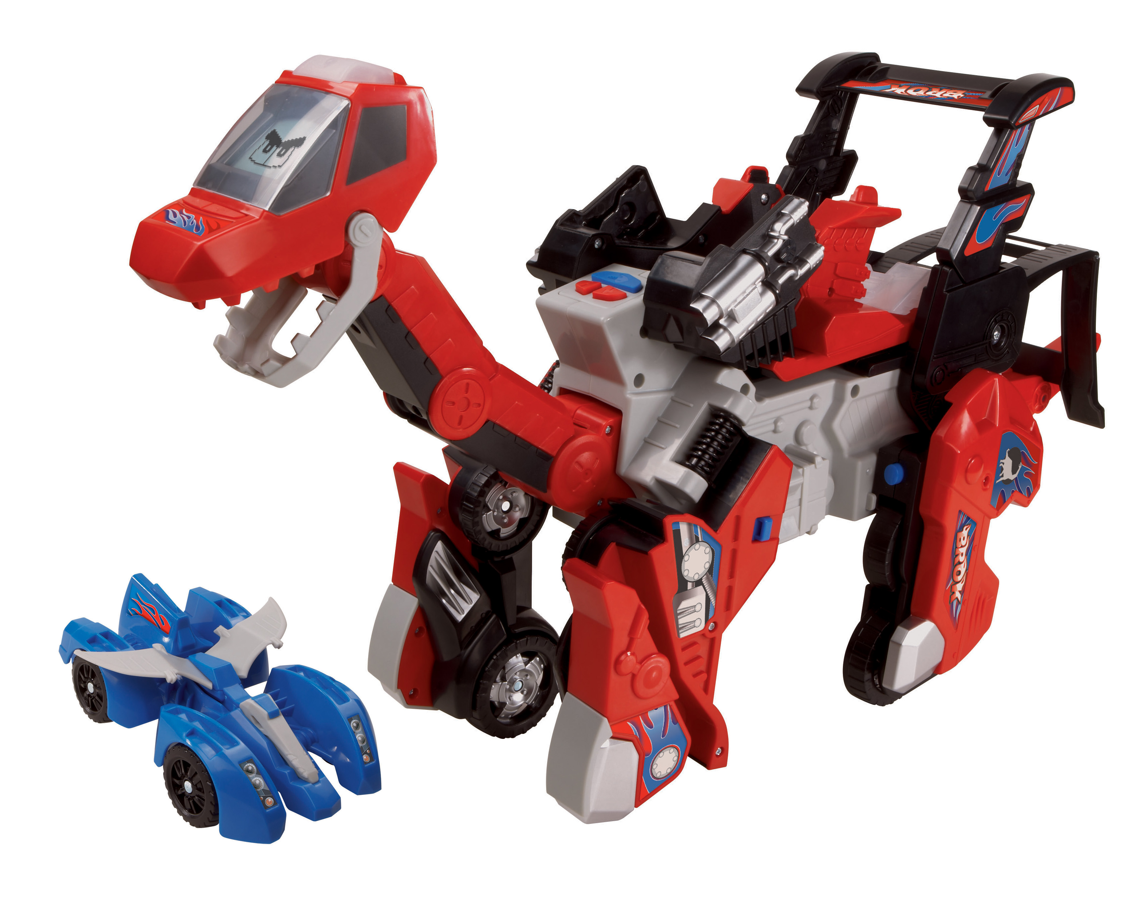
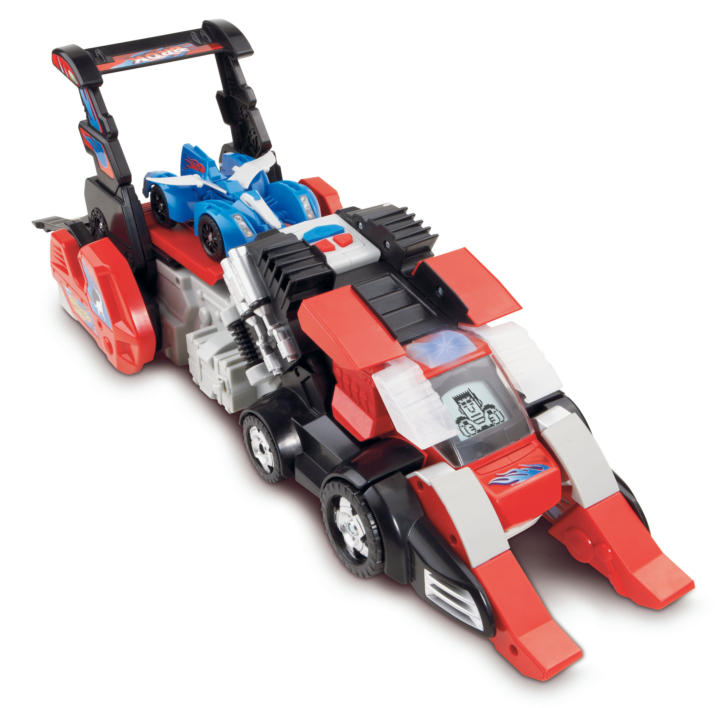

Brok in Dinosaur Mode Brok in Vehicle Mode

About VTech
VTech, the creator of the Electronic Learning Products (ELP) category and the award-winning V.Smile TV Learning System, is a world leader of age-appropriate learning toys. Since 1980, VTech has been developing high-quality, innovative educational products that enrich children’s development, from birth to preteen, through fun and smart play.

VTech Electronics North America, LLC is based in Arlington Heights, Ill. VTech Electronics Ltd. is headquartered in Hong Kong with distribution throughout North America, Europe and Asia.

For more information on VTech’s additional product lines, visit www.vtechkids.com, www.facebook.com/VTechtoys on Facebook or follow @VTechToys on Twitter. For press information, please contact Jennifer Kron at 312-729-4040 or jkron@golinharris.com. Also, be sure to follow our ultimate Switch & Go Dino, Brok the Brachiosaurus, on Twitter @Broksays.

