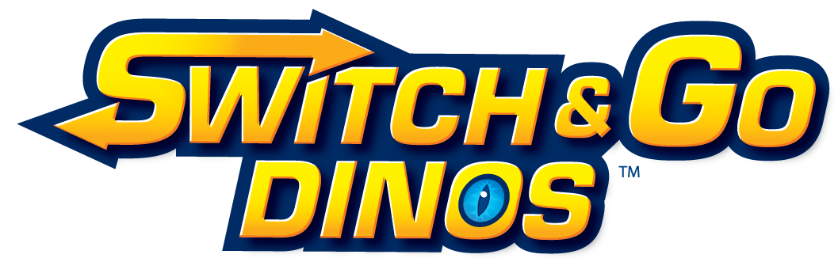

VTech Electronics’ Switch & Go Dinos™

Starter Switch & Go Dinos Fact Sheet

For the first time in VTech Electronics’ history, two of boys most popular toys – dinosaurs and vehicles – have been brought together to create a unique 2-in-1 play experience with VTech Electronics’ Switch & Go Dinos™, designed specifically for boys ages 3 - 8 years old. Switch & Go Dinos features an entire line of seven durable, unique and collectable dinosaur toys, including four starter toys. Each toy transforms from a dinosaur to a vehicle and back again in a few simple steps, providing two dynamic toys for the price of one.

Each Switch & Go Dino is designed and built for durability and comes equipped with an LCD screen for customized animation, dinosaur and vehicle sound effects and educational dinosaur facts. These features combine to bring each Switch & Go Dino to life, offering kids a personalized, immersive and enriching play experience.

Meet the Starter Switch & Go Dinos
The four starter Switch & Go Dinos are Sliver the T-Rex™, T-Don the Pteranodon™, Tonn the Stegosaurus™ and Horns the Triceratops™. Each of them is customizable with three animated dinosaur and three animated vehicle faces.

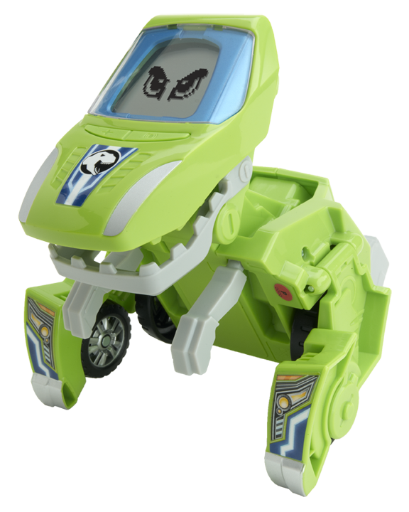
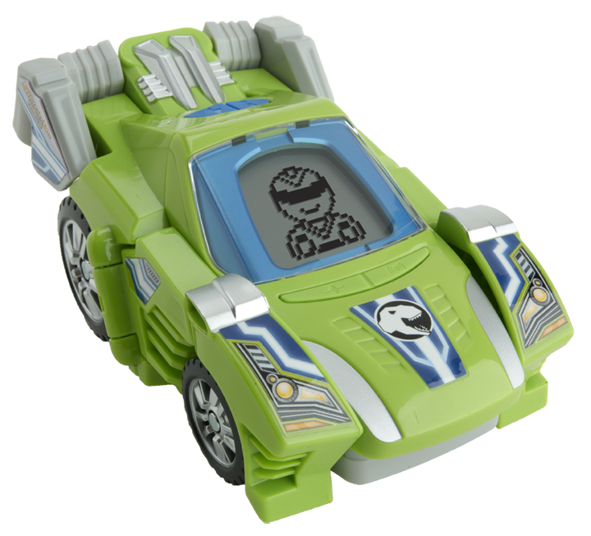
- Aggressive and arrogant, Sliver the T-Rex thinks he’s the best out there and will let kids know it as he shouts this fact, “The name T-Rex means king of the tyrant lizards!” Sliver makes dramatic dinosaur and vehicle sounds and says more than 10 phrases in each mode.

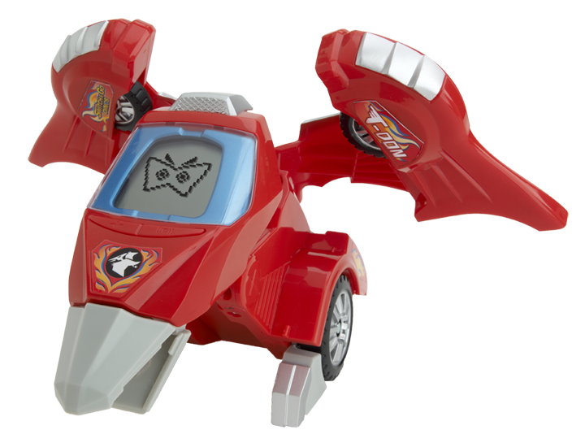
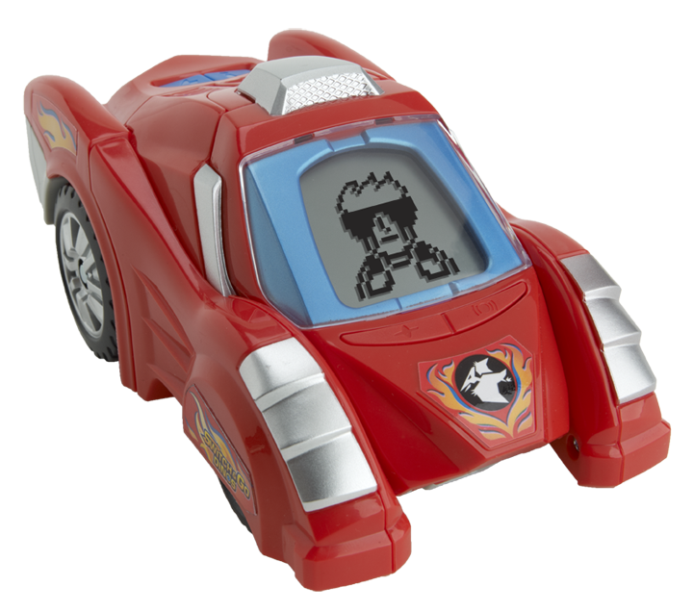
- Fast and adventurous, T-Don the Pteranodon loves to show off his flying skills, and can be heard saying things like, “It's a bird! It's a plane! It's T-Don the Pteranodon! Ha ha! That's me!” T-Don makes exciting dinosaur and vehicle sounds and says more than 10 phrases in each mode.

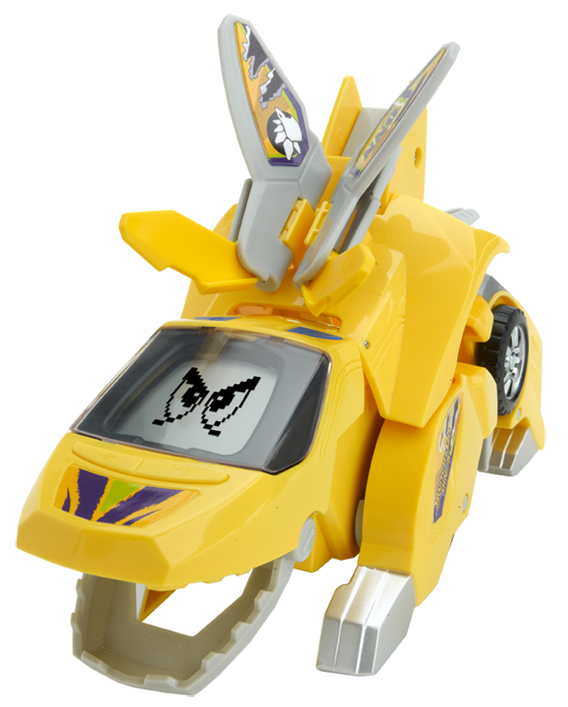
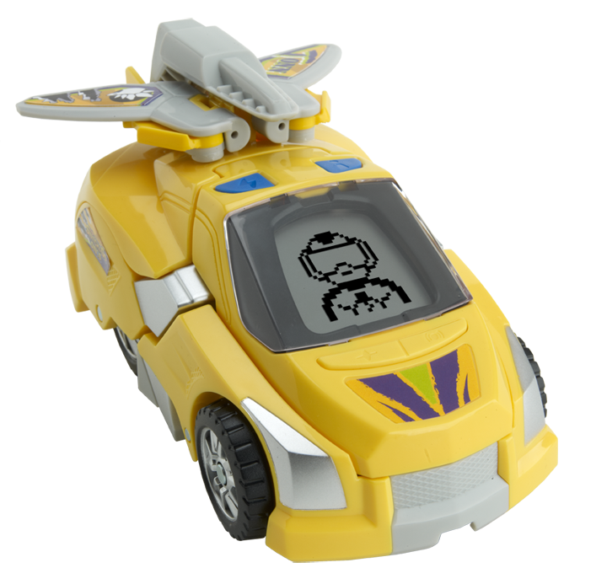

- Fun-loving and cheerful, Tonn the Stegosaurus is the life of the party and always in a good mood. He shares fun facts like, “I’m a quadruped. I walk on four legs. And I walk slooowww.” Tonn makes thrilling dinosaur and vehicle sounds and says more than 10 phrases in each mode.

-more-
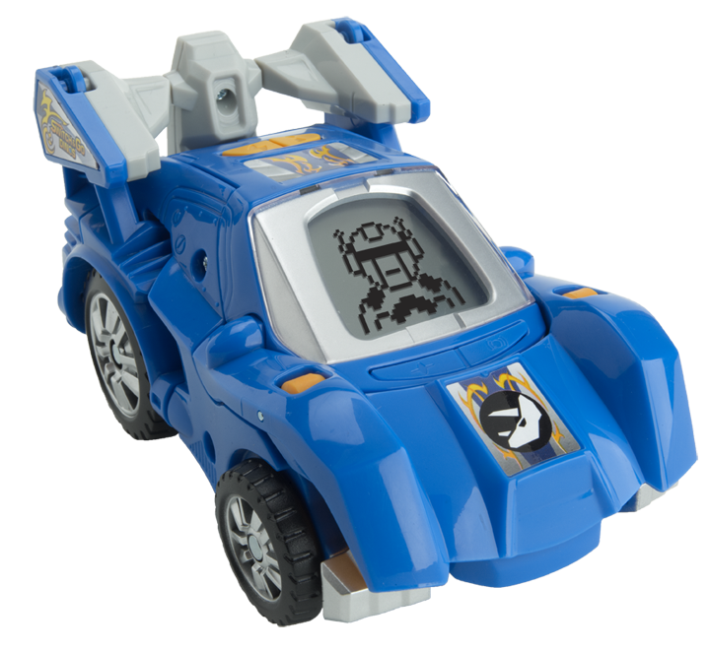
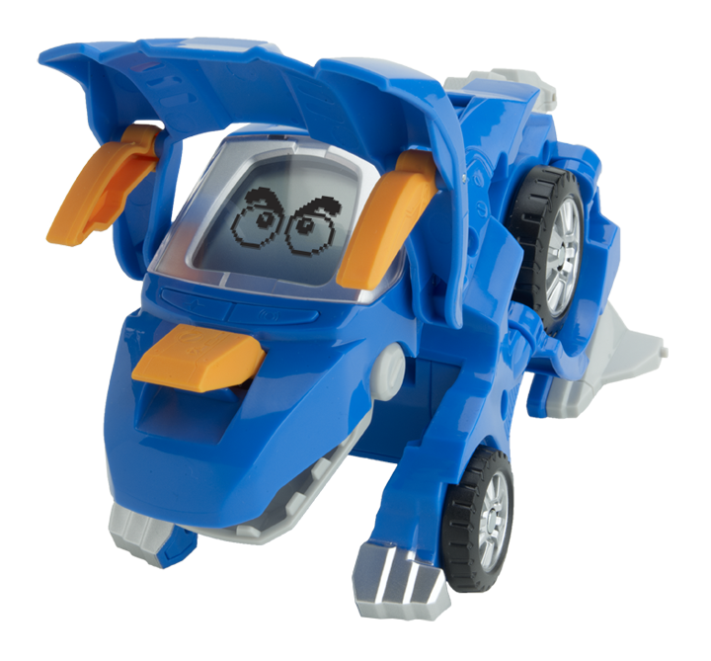
- Strong, stubborn and tough, Horns the Triceratops never backs down. His favorite phrase is, “No pain, no gain!” Horns says more than 10 phrases in each mode.

The entire Switch & Go Dinos line – including Sliver the T-Rex, T-Don the Pteranodon, Tonn the Stegosaurus and Horns the Triceratops (SRP: $15.99), and Brok the Brachiosaurus (SRP: $49.99), Span the Spinosaurus (SRP: $29.99) and Attila the Ankylosaurus (SRP: $24.99) – is now available at www.VTechKids.com and on-shelf at all major retailers.

About VTech
VTech, the creator of the Electronic Learning Products (ELP) category and the award-winning V.Smile TV Learning System, is a world leader of age-appropriate learning toys. Since 1980, VTech has been developing high-quality, innovative educational products that enrich children’s development, from birth to preteen, through fun and smart play.

VTech Electronics North America, LLC is based in Arlington Heights, Ill. VTech Electronics Ltd. is headquartered in Hong Kong with distribution throughout North America, Europe and Asia.

For more information on VTech’s additional product lines, visit www.vtechkids.com, www.facebook.com/VTechtoys on Facebook or follow @VTechToys on Twitter. For press information, please contact Jennifer Kron at 312-729-4040 or jkron@golinharris.com. Also, be sure to follow our ultimate Switch & Go Dino, Brok the Brachiosaurus, on Twitter @Broksays.

