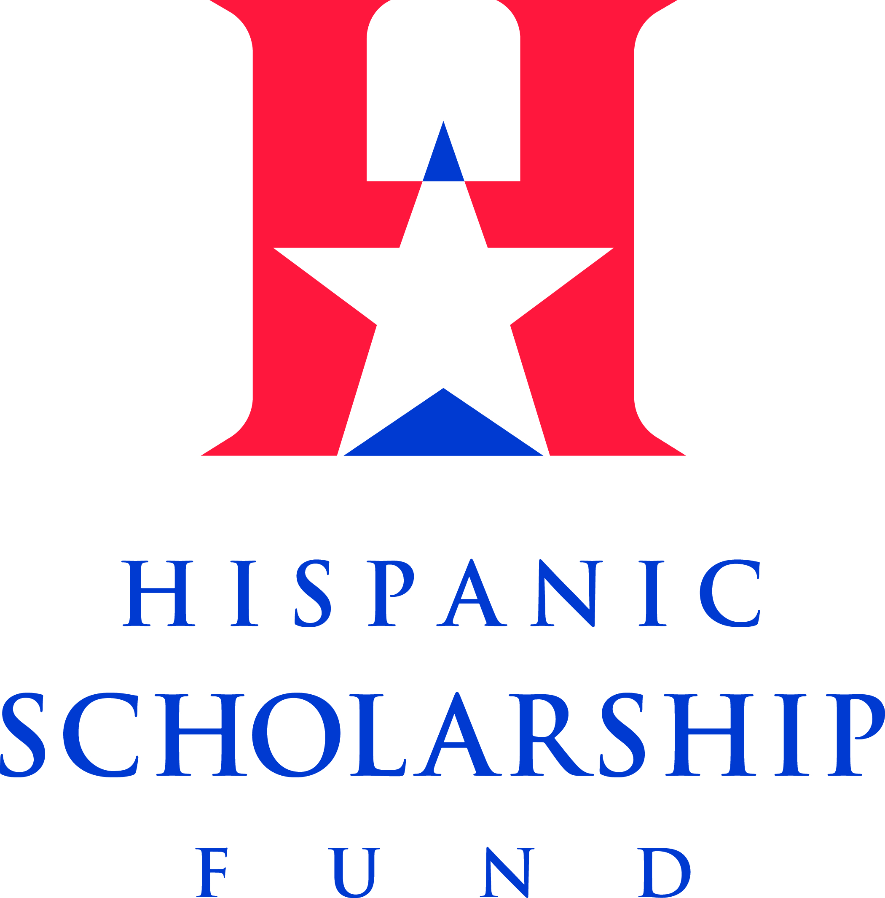

THE HISPANIC SCHOLARSHIP FUND
ALUMNI HALL OF FAME
2012 INDUCTEE BIOS

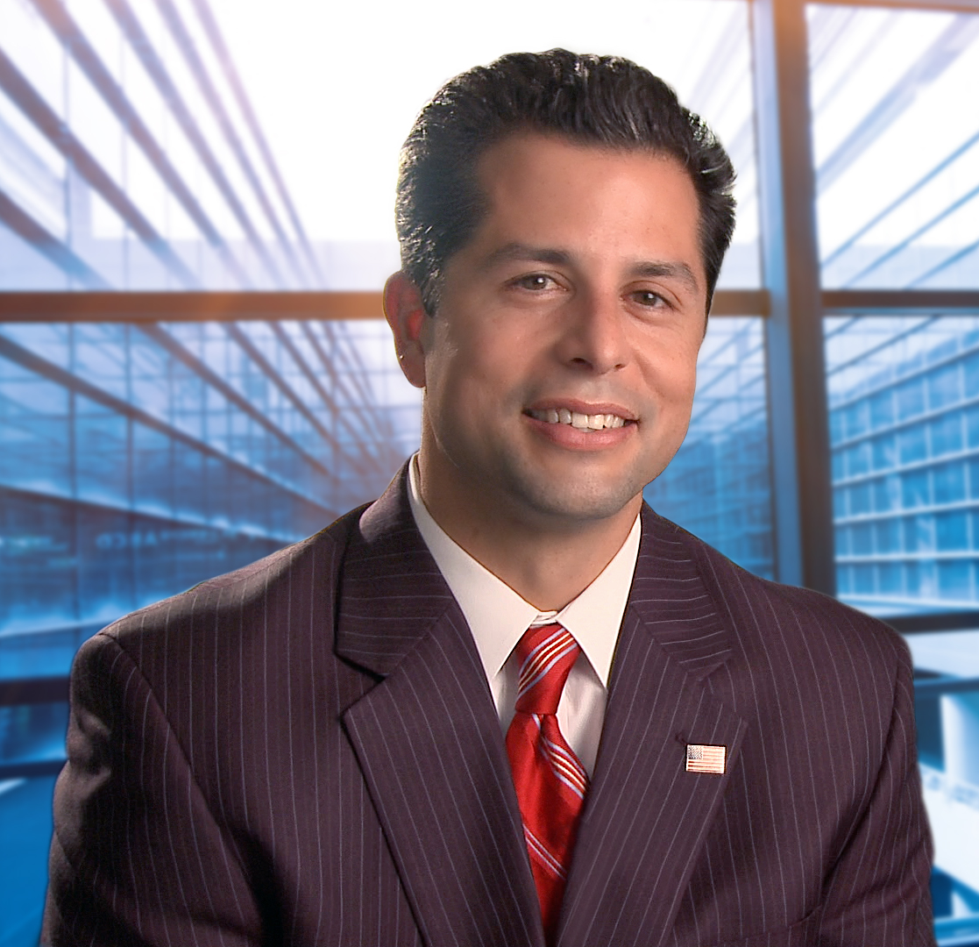
Cyrus Amado Salazar
Director of Equal Opportunity
United States Air Force

Cyrus Salazar grew up in rural southern New Mexico where opportunities for success did not present themselves often. He was the first member of his family to enter college which inspired his two sisters, as well as his mother, to enroll at the local community college. He worked at the local electric cooperative to save money to enter community college and pursue his educational dreams. Funding his education was another challenge. Once in college, Cyrus focused most of his attention to his studies, which left little time for work. He earned scholarships to the main campus of New Mexico State University at Las Cruces. Receiving an HSF scholarship assisted him financially and inspired him to achieve his goals and invest in his own community.

Mr. Salazar has been a leader throughout his academic career. He was a model student as he mentored others and continued to give back to high school students who were less fortunate and believed that college was not an option. He has spoken at many conferences and shared his successes from starting at a community college to ultimately earning a Master’s degree.

He currently serves as the Equal Opportunity Program Manager for the United States Air Force. In this role, he develops and administers Air Force-wide policy regarding military and civilian requirements for over 300,000 Airmen. His duties include developing and overseeing policy guidance for complaint processing, EO training, and climate assessments. Mr. Salazar also serves as an adjunct faculty to teach portions of the EEO and alternative dispute resolution (ADR) curriculum at the Defense Equal Opportunity Management Institute and at the Ira C. Eaker School at Maxwell AFB. Lifelong learning has always been a tenet of his philosophy and he continues to seek out opportunities to learn, teach, mentor, and train others. Mr. Salazar served a twelve month tour in Baghdad as an advisor to the Iraq Ministry of Interior (MoI). In this role as an advisor to the MoI, he supported several initiatives such as the integration of Kurdistan MoI with the Iraq MoI, tracking of Sons and Daughters of Iraq, and tracked numbers of police recruits, accessions, and martyrs.

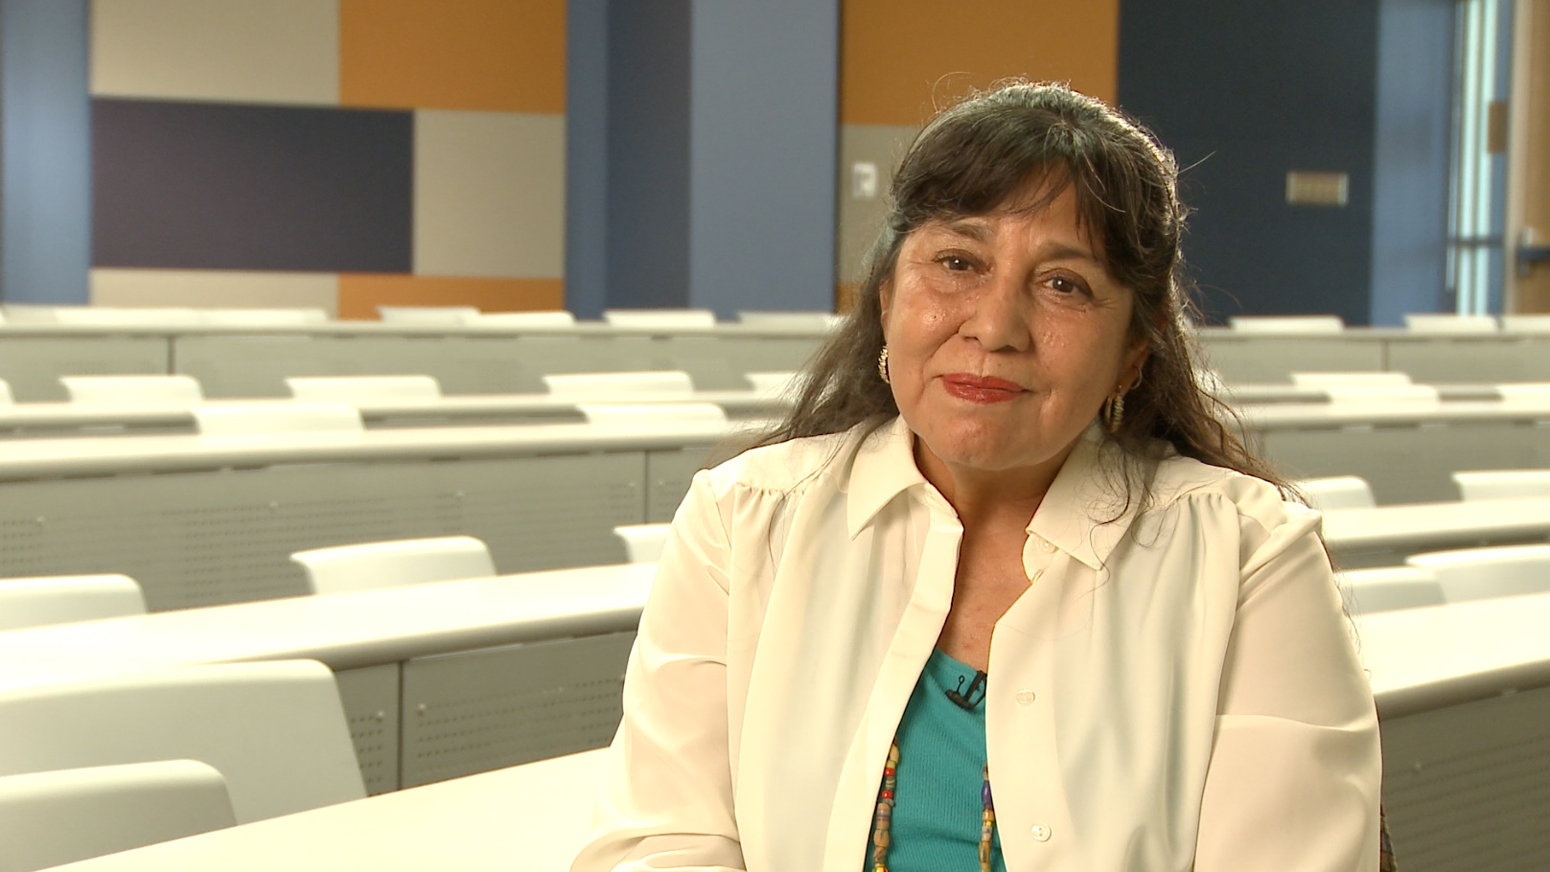

Dr. Yolanda Garcia Romero
Professor of History
North Lake College

Dr. Yolanda Romero grew up in the face of discrimination at a time when Mexican Americans were not highly looked upon by society. Her family was her biggest supporter, and though they may not have had the means or knowledge to support her, they knew that education was the only way to a better life. HSF also had a role in her success by believing in her and her capabilities and providing her with the necessary financial assistance to achieve her goals.

Early on she stood out among her peers by excelling academically and giving back to the community in the face of adversity. Challenging a society that told her she could not achieve her goals, Dr. Romero earned her PhD from Texas Tech University, becoming the first Mexican American woman to earn her PhD in History from a Texas institution. Today, she is a Professor of History at North Lake College in Texas. Through her role as a professor and advisor, Dr. Romero gives back to her community on a daily basis. She places a great value in giving back to the community which demonstrates her steadfast commitment to helping others.

Teaching and advising the campus chapter of Phi Theta Kappa has given her the platform to empower students, many who are from a similar background. She believes in the investment she is making in her students, knowing that education is essential to the growth and strength of our country. She sets high expectations for her students, encouraging them to not only excel academically, but also in their communities. She teaches her students that serving their communities is not what the community can do for them, but about what they can do for the community.

Dr. Romero’s own involvement in the community starts with her role at North Lake College. Due to her involvement in the community and dedication to her students, Dr. Romero has earned several awards and recognitions. Students nominated her for the Visions Campaign Award, recognizing her as someone who provided exemplary service to the community. She was chosen out of 100 women nationwide. Shortly after receiving this honor, she was nominated for the Texas Women’s Hall of Fame and recently became the recipient of North Lake’s first ever Woman of the Year award. These select awards show the profound respect that students, faculty and community members alike have for Dr. Romero and her commitment to higher education and the community.

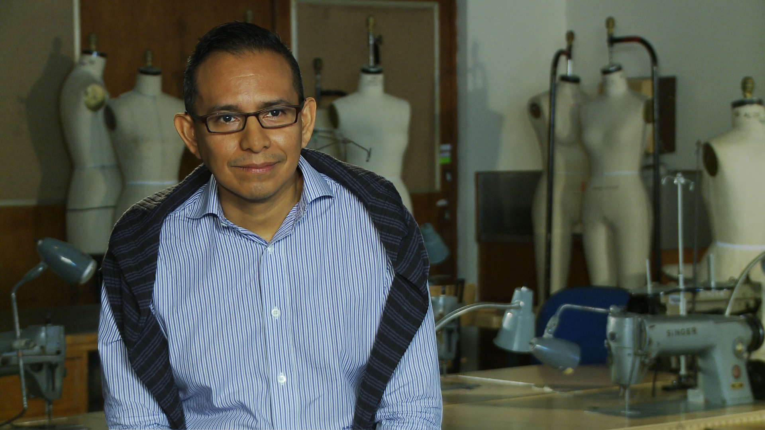

José P. Chan
MIT Sloan Fellow in Innovation and Global Leadership – SM Class of 2013
Adjunct Professor – Parsons the New School for Design

José Chan was born and raised in the Bronx, New York. His father had to work two jobs to support his family and between the ages of 12-18, José would help his father by mopping and sweeping the floors, collecting garbage and cleaning the windows of his building. Through his experiences with his father he built a strong work ethic that would later help him balance his school work and his job. He has consistently shown his strong work ethic by working to advance his knowledge of design, apparel, business and management through his undergraduate and graduate degrees.

José began his career at the Fashion Institute of Technology and finished his BS degree in the Textile and Apparel Management Program at Cornell University. He also pursued his MBA in Finance several years later at the Simon Graduate School of Business at the University of Rochester and was the 1st Simon School MBA exchange student to study at the Hong Kong University of Science and Technology. His combination of degrees in design and business has allowed him to gain broad professional experience in the luxury apparel industry. Despite the economic downturn and the volatility of the apparel industry, José has constantly reinvented himself in order to succeed and further his career. He has held positions in buying, design, marketing, merchandising, planning, production and most recently general management. In addition, he is fluent in Spanish, Italian and has studied French and Mandarin. Formerly the Director of Retail Outlets and Planning for Roberto Cavalli, José has spent 20 years in the luxury goods sector having worked at Isaac Mizrahi Couture, Loro Piana, Louis Vuitton Moet Hennessey and Compagnie Financière Richemont S.A.

Aside from José’s passion for the fashion industry, he also values his community including his family, alumni organizations, members of his church congregation and his extended family in México and Guatemala. He has volunteered at homeless shelters throughout the New York City area and has also tutored children from Harlem. Before entering business school, José served in the 1st Cohort of the New York City Teaching Fellows for a year, teaching bilingual mathematics to Latino and African American children in the South Bronx. His current volunteer efforts are concentrated on mentoring HSF students as well as undergraduate students at several universities such as the Fashion Institute of Technology, Columbia University, Cornell University and others. José is committed to sharing his belief in the power of higher education as he continues to give back to the communities that made an important impact on his life.

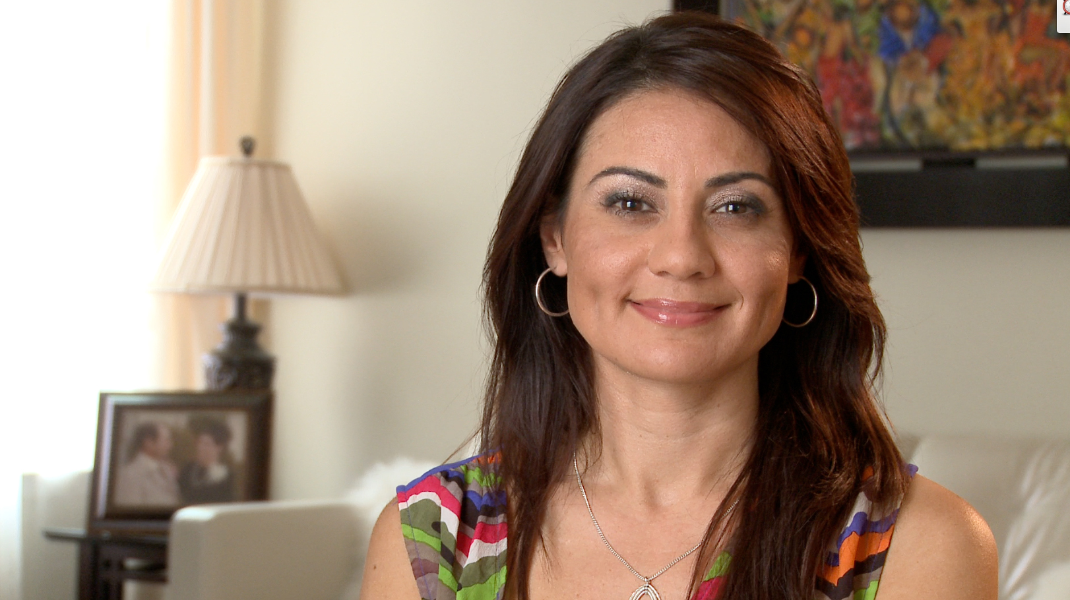

Mónica Gil
Senior Vice President – Public Affairs & Government Relations
The Nielsen Company

Mónica’s education has allowed her to become one of the youngest executives at Nielsen, increasing Nielsen’s visibility and credibility with the Hispanic community. She has helped lead and shape the company’s strategy for connecting effectively with Nielsen’s newest consumers, to increase awareness and trust of the Nielsen brand. She works extensively with news, media, elected officials and Nielsen’s businesses in her role as Senior Vice President of Public Affairs and Government Relations. Mónica also manages Nielsen’s national Hispanic/Latino Strategic Outreach and the company’s education and philanthropy initiatives. A few years ago, Mónica was selected to receive the prestigious Chairman’s Award, a rare recognition that is given to only five individuals out of 30,000 Nielsen employees. This award recognized Mónica’s integrity and significant accomplishments. Mónica donated the $10,000 award, to a small, local program in her hometown of Santa Barbara called “Put it Back,” demonstrating her continued support and dedication to the Hispanic community.

Mónica is an active contributor of time, money and mind to the community she cherishes. Her role at Nielsen involves identifying and determining the organizations and causes that Nielsen will invest in the community. She not only performs exceptionally in her role at Nielsen, but Mónica actively supports the community in her personal life as well. Her belief in giving back to the community and never forgetting her roots can be attributed to not only her higher education, but also to the belief HSF placed in her when awarding her a scholarship.

As the youngest daughter of 12, financial obstacles were ever present in her path to a higher education. Along with the financial obstacles, her father was also disabled and the family carried the burden of his care as well. The strain was felt on a daily basis by her family, but there was enormous amount of love and support that made up for the lack of financial means. Scholarships and investments in her future from outside organizations, allowed Mónica to overcome these obstacles. The obstacles did not stop there, as Mónica struggled to find self-confidence and a place in a society that marginalized lower-income, immigrant families. However, due to the potential that these outside scholarships and organizations had in her, Mónica was able to find her confidence and self-esteem and rise above the challenges. The challenges gave her strength, experience and knowledge to harness her own power, making her one of Nielsen’s brightest rising stars.



Gilbert Cisneros Jacki Cisneros
President & Co-founder Vice President & Co-founder
The Gilbert & Jacki Cisneros Foundation The Gilbert & Jacki Cisneros Foundation

Gilbert & Jacki Cisneros’ dedication to philanthropy began when they purchased a winning California Mega Millions lottery ticket in 2010. They founded the Gilbert & Jacki Cisneros Foundation, an organization dedicated to increasing the number of college degrees within the Hispanic community through scholarship, parent education and community outreach.

The Cisneros’ devotion to philanthropy initially began with donations to their alma maters, The George Washington University and University of Southern California, to endow scholarships for Hispanic students. This was followed by endowing a scholarship with the Navy Supply Corps Foundation. They soon partnered with the Hispanic Scholarship Fund and the city of Pico Rivera, California to create Generation First Degree Pico Rivera, with the goal of putting a college degree in every Hispanic household in the city. This journey led them to form The Gilbert and Jacki Cisneros Foundation in 2010.

Prior to creating the foundation, Gilbert worked at Frito-Lay as Shipping and Distribution manager and Manufacturing manager. He also served as a Supply Officer in the U.S. Navy, completing both a Mediterranean and a Western Pacific Deployment. He was awarded the Navy Commendation Medal, Navy Achievement Medal, the National Defense Medal, and the Armed Forces Expeditionary Medal. He received a Naval Reserve Officer Training Corps scholarship and graduated with a B.A. in Political Science from The George Washington University. He also holds an MBA from Regis University.

Jacki previously worked as an Assignment editor at the local NBC station in Los Angeles and while covering a local lottery story, she quickly realized her husband had purchased the winning ticket for $266 million. Prior to KNBC, she also worked at KCOP and the local CBS station KCBS, in addition to the nationally syndicated show EXTRA. During her 18 years in news and entertainment she covered a variety of stories including local elections, earthquakes, missing Oscars, the Robert Blake trial, red carpet movie premieres and several undercover investigations. She is also a two time Emmy Award winner. Jacki is a graduate of the University of Southern California’s Annenberg School of Communication.

Procter & Gamble
Corporate Honoree

2012 HSF ALUMNI HALL OF FAME

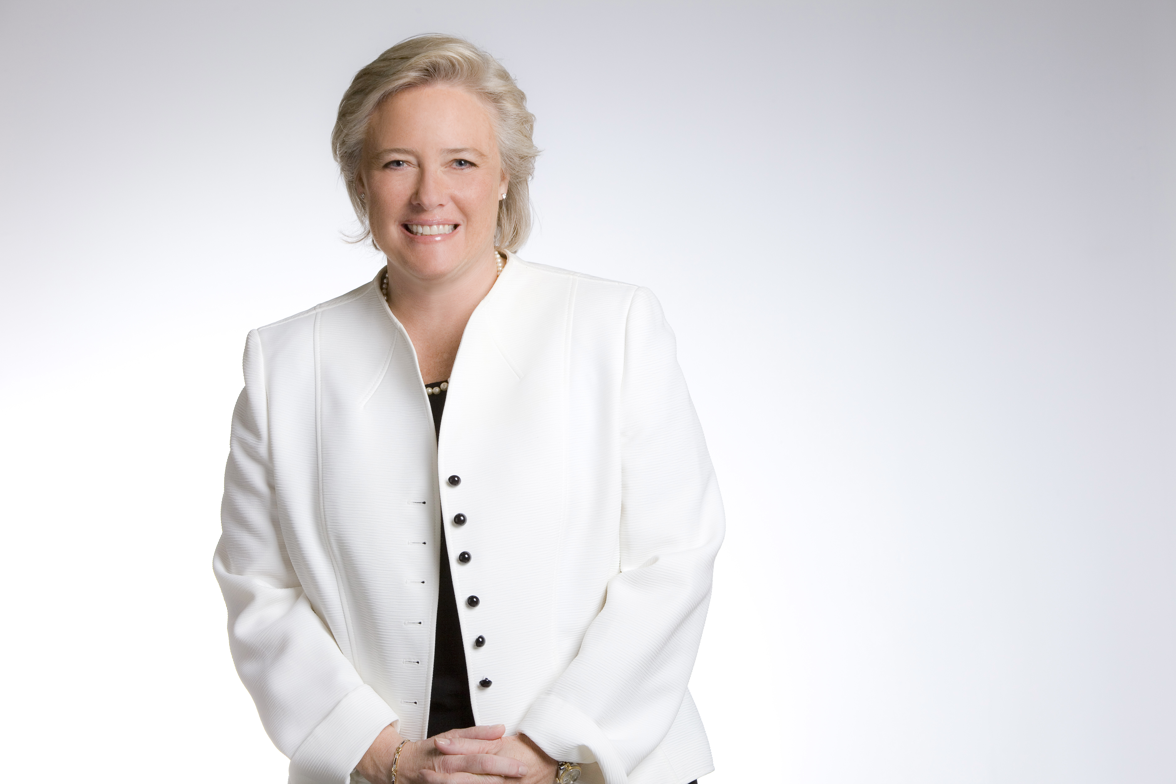

Melanie L. Healey
Group President North America
Accepting on the company’s behalf:

Diversity and Inclusion is more than a strategy at P&G. It is part of our DNA and all we do. We see the power of diversity and want to realize its full potential by leveraging the unique strengths and talents of our employees.

Just as our consumers are global and diverse, so are our employees. By design, we work to ensure that our leadership has a broad and global perspective. And we recruit top talent from diverse backgrounds and cultures around the world. Our employees need to reflect the diverse markets and consumers we serve.

P&G’s support of HSF is one of the ways in which we aim to make a difference in the lives of our consumers and build a pool of diverse talented professionals who can grow into future leaders, not only for our business, but also for our society. At P&G we share HSF’s passion to support the advancement of our Latino community on the road to success. That is why for more than 30 years P&G has partnered with HSF, contributing to HSF’s vision of a college degree in every Latino household. Our commitment to HSF comes both in the form of philanthropy and the personal involvement of our employees and executives.

We are proud of what HSF and P&G have accomplished together, and have seen the fruit of the many programs the company has supported - from STEM (Science, Technology, Engineering and Math) scholarships to town hall meetings, and Steps-for-Success Saturdays to the most recent edition of Destination University - a bilingual resource designed to guide students and parents through the educational process, from middle school to college.

Our company is proud to continue our long-standing relationship and partnership with HSF, so that we can give deserving Latinos the best educational foundation, which coupled with hard work, determination, and resilience, can help them become solid pillars of our community for generations to come.

