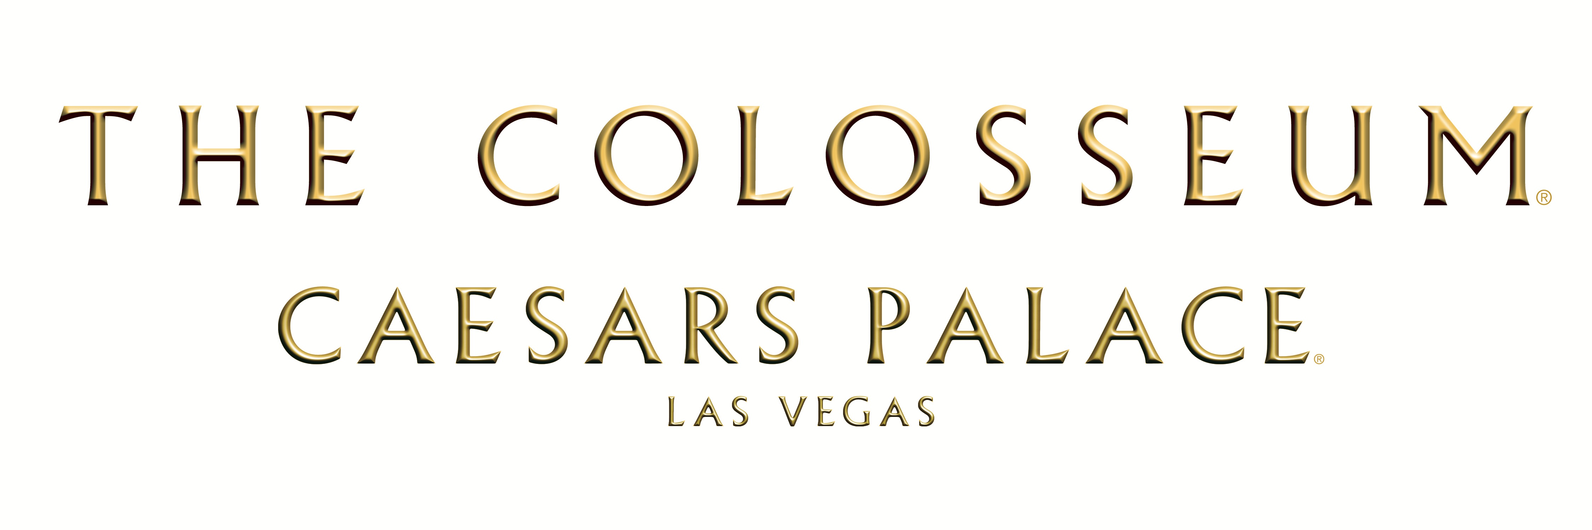

SHANIA TWAIN TURNS DREAMS INTO REALITY AS HER CREATION

SHANIA: STILL THE ONE AT THE COLOSSEUM AT CAESARS PALACE

IS SET TO DEBUT DEC. 1

LAS VEGAS (Nov. 14, 2012) – Shania Twain, international superstar and one of the world’s best-selling female artists of all time, has been busy preparing for the Dec. 1 premiere of her highly anticipated new Las Vegas production SHANIA: STILL THE ONE at The Colosseum at Caesars Palace. As the premiere rapidly approaches, demand for tickets remains strong. In addition the Dec. 2012 debut run, 14 additional performances for spring 2013 are currently on sale.

Show dates are:

Dec. 2012: 1, 2, 5, 6, 8, 9, 11, 12, 14, 15
March 2013: 19, 20, 23, 24, 26, 27, 29, 30
April 2013: 2, 3, 5, 6, 9, 10

Prices range from $55 to $250, plus applicable fees, and may be purchased by calling 800-745-3000, online at www.shaniainvegas.com or www.thecolosseum.com and in person at The Colosseum at Caesars Palace Box Office, open daily from 10 a.m. to 10 p.m. PT. For groups of 10 or more, call 1-866-574-3851.

SHANIA: STILL THE ONE, developed by Show Creator and Executive Producer Shania Twain, produced by AEG Live and directed by Raj Kapoor, will take fans on a spectacular journey through the various stages of Shania's life and career in an unforgettable evening filled with music, multi-sensory and visual experiences, fashion and the unexpected. “Shania wants her fans to share her spirit and passion in 4D and this show will capture the essence, soul and inspirations of Shania and her timeless music and lyrics brought to life with extraordinary beauty and powerfully intense visuals,” said Show Director, Raj Kapoor. “Shania’s creative world will be an immersive fusion of music, fantasy, spectacle and the fragile beauty of nature all brought together in a night of unforgettable entertainment.”

"My first step in creating the show was writing out the song list, building my ideas from there. I wanted to keep the hits at the heart of it all while weaving elements of surprise throughout the experience,” said Shania. “My vision is to bring the atmosphere of each song alive through multi- dimension sensory and share the journey of my life and career with the audience from a unique perspective. The Colosseum theatre is heaven for an artist and the opportunity to collaborate with such a brilliant team is making my dream show a reality.”

Show Creator / Executive Producer – Shania Twain
An amazing and accomplished singer and songwriter Shania Twain is a phenomenon. With more than 75 million albums sold worldwide, she is the top-selling female country artist of all time; has multi-platinum album sales in 32 countries; has the eighth-biggest selling album of all time in the U.S. and 18 top ten songs, eight of which reached #1. Since the beginning of her recording career, the multi-talented five-time Grammy Award winning artist has been deeply involved with the artistic and creative direction of her imaging, iconic music videos and sold out tours including her “Come on Over” tour in 1998 and the“Up!” tour which became one of the highest grossing tours in 2004. With her latest creation STILL THE ONE, Shania is sinking her teeth into the show’s production taking her artistic and creative diversity to new heights.

Show Director – Raj Kapoor
A director, producer, dancer and visionary, Raj Kapoor is a creative talent whose imaginative work has been seen on stages around the world. He creates live experiences that inspire and excite and has worked with a list of who’s who in Hollywood including Carrie Underwood, Michael Jackson, Eminem, Usher, Rihanna, Nikki Minaj, David Guetta, DeadMau5, N.E.R.D., Mary J Blige, Maroon 5, Tony Bennett, Katy Perry, Paul McCartney, Kid Rock, Dr. Dre, Snoop Dogg, the Dixie Chicks, Josh Groban, Selena Gomez, Beach Boys and Britney Spears. Kapoor specializes in creating custom tailored productions with cutting edge choreography, impeccable styling, high-concept design and staging, state-of-the- art special effects and will interweave his unique version of story-telling to Shania’s overall creative vision of the show.

Production Designer – Michael Cotten
Michael Cotten’s unparalleled expertise in production design, theatrical staging, animation, electronic music, and graphic arts has garnered him a clientele that includes many of the world’s top performers and productions. Cotten designed the “History” tour for Michael Jackson in 1997 and when Jackson began planning his “This Is It” return to the stage for London’s O2 Dome in 2009 he again enlisted the talents of Cotten to design the extravaganza. Cotten is no stranger to Las Vegas and has lent his production and architectural talents to the city of Las Vegas with the “Sirens of TI” and Gloria Estefan’s “Live and Unwrapped” at Caesars Palace.

Costumier – Marc Bouwer
The creator of custom costumes, Marc Bouwer, will take Shania’s unforgettable fashion sense to play a major role in the telling of the show. After arriving in NYC from South Africa, he met fashion legend Halston. Under Halston, Bouwer refined his skills and became a master draper. Draping soon became the hallmark of Bouwer’s career—a distinction later dubbed “athletic glamour” by industry purveyors and international press. Marc’s innate sensibility, keen eye, and talent have landed him on the pages of revered international fashion publications and into the hearts of the world’s most glamorous and watched women. Marc Bouwer Couture has graced the cover of Harper’s Bazaar, Oprah, Cosmopolitan, In Style, Vanity Fair, Glamour, Vibe Magazine and has a dream list of clientele that includes Angelina Jolie, Beyonce Knowles, Charlize Theron, Emily Blunt, Eva Longoria, Halle Berry, Heidi Klum, Jennifer Lopez, Oprah Winfrey, Portia Di Rossi, Sarah Jessica Parker, and many more.

Lighting Designer – Peter Morse
Peter Morse has designed lighting and directed staging for concerts, theater, videos, and feature films for the past 35 years. He has worked with some of the greatest names in the industry - from Barbra Streisand to Bette Midler - yet he continues to inspire new generations of fans with his work creating awe-inspiring lighting for Madonna, Christina Aguilera, Ricky Martin, Usher and countless others.

For additional show and ticket information, visit www.shaniainvegas.com or www.thecolosseum.com or follow updates from The Colosseum at Caesars Palace on Twitter @Colosseum@CP.

# # #

For more information:

MEDIA CONTACTS

Caesars Entertainment

Kelly Frey

702-872-8472

kfrey@caesars.com

The Colosseum at Caesars Palace/AEG Live
Christi Nelson
702-866-1451
cnelson@aeglive.com

Sandbox Entertainment/Shania Twain
Kelly Russell
615-915-5454
Kelly@sandboxmgmt.com

Michelle Loosbrock
Jeff Wagner Agency
702-287-4130
michelle@jeffwagneragency.com

