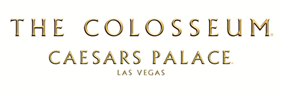
SHANIA: STILL THE ONE
Musical Cast
Will Hollis - Music Director
BAND AND VOCALS
Cory Churko - Band Leader, Guitars, Fiddle
JD Blair - Drums
Hardy Hemphill - Keys, Utility
Andy Cichon – Bass
Jason Mowery - Fiddle, Utility
Justin Schipper - Steel, Utility
Josh Gooch - Lead Guitars
Mandy Andreasen - Cello / Strings
Jennifer Eriksson - Violin / Strings
Andrea Whitt - Viola / Strings
Carrie Ann Brown – Background Vocals
Ryan Kowarsky - Background Vocals
Dan Kowarsky - Background Vocals

MALE DANCERS - Devin Walker, Adrian Lee, Paul Benshoof, Oskar Rodriguez

