|  |  |  |
| --- | --- | --- |
| G:\Art, Photos, Logos, Movies, etc\logos\Hyundai_Chrome_Blue_Stacked.jpg | Hyundai Motor America 3200 Park Center Drive, Costa Mesa, CA 92626  TEL: 714-965-3000 FAX: 714-378-1008 MEDIA WEBSITE: hyundainews.com CORPORATE WEBSITE: hyundai.com | NewsBureauLogo |
|  | FOR IMMEDIATE RELEASE |  |

Contacts: Miles Johnson Jim Trainor

(734) 337-2227 (714) 594-1629

(714) 366-1048 (cell) (714) 316-6421 (cell)

#### [milesjohnson@hmausa.com](mailto:milesjohnson@hmausa.com) [jtrainor@hmausa.com](mailto:jtrainor@hmausa.com)

# HYUNDAI UNVEILS VELOSTER C3 ROLL TOP CONCEPT

# AT 2012 LOS ANGELES AUTO SHOW

**Three-Door Convertible Coupe Combines Dual-Function Retractable Roof with Customizable Urban Design**

**HIGHLIGHTS OF VELOSTER C3 ROLL TOP CONCEPT**

* Based on the Veloster’s three-door coupe design
* Dual-function convertible roof that rolls backwards and forwards
* Tailgate replaces hatchback for added utility
* Custom fixed-gear bicycle-inspired design
* Repurposed skateboards line cargo floor
* Repurposed industrial truck tarps create convertible soft top

**LOS ANGELES, Nov. 28, 2012** – Smart design meets urban style as Hyundai unveiled its Veloster C3 Roll Top concept during a press conference at the Los Angeles Auto Show today. Expanding on the qualities that have made the Veloster a sales success, the C3 (which stands for Convertible 3-door) combines open-air freedom with the style of a coupe and the functionality of a tailgate. The Veloster’s efficient coupe design with hidden passenger-side third door introduces an innovative dual-function roll top and tailgate, adding unique utility to a convertible.

“We were inspired by the proverb ‘A rolling stone gathers no moss,” said Chris Chapman, chief designer, Hyundai Design North America. “The Veloster C3 Roll Top concept offers the ‘no strings attached’ freedom of a roll top convertible and customizable utility that fits an everyday to a play day dual lifestyle.”

**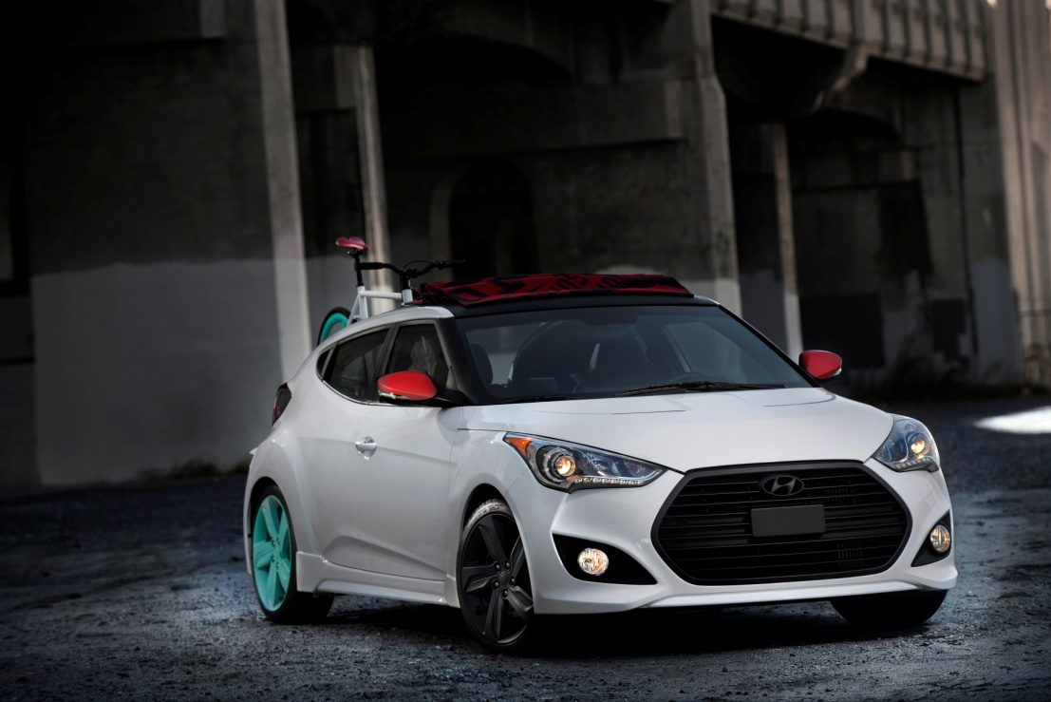**

**DUAL PERSONALITIES = ENHANCED UTILITY**

Designed by Hyundai Design North America, the Veloster C3 Roll Top concept offers a distinctive canvas roof that opens to the rear or windshield of the vehicle. The cleverly designed dual-function power-retractable roof combined with the tailgate gives the C3 a dual personality. In convertible mode with the top rolled back, the C3 is a free spirit for driving along the Pacific Coast Highway. Roll the top forward, open the tailgate, fold the rear seats and the C3 goes into recreation mode - perfect for surfing, biking or kayaking.

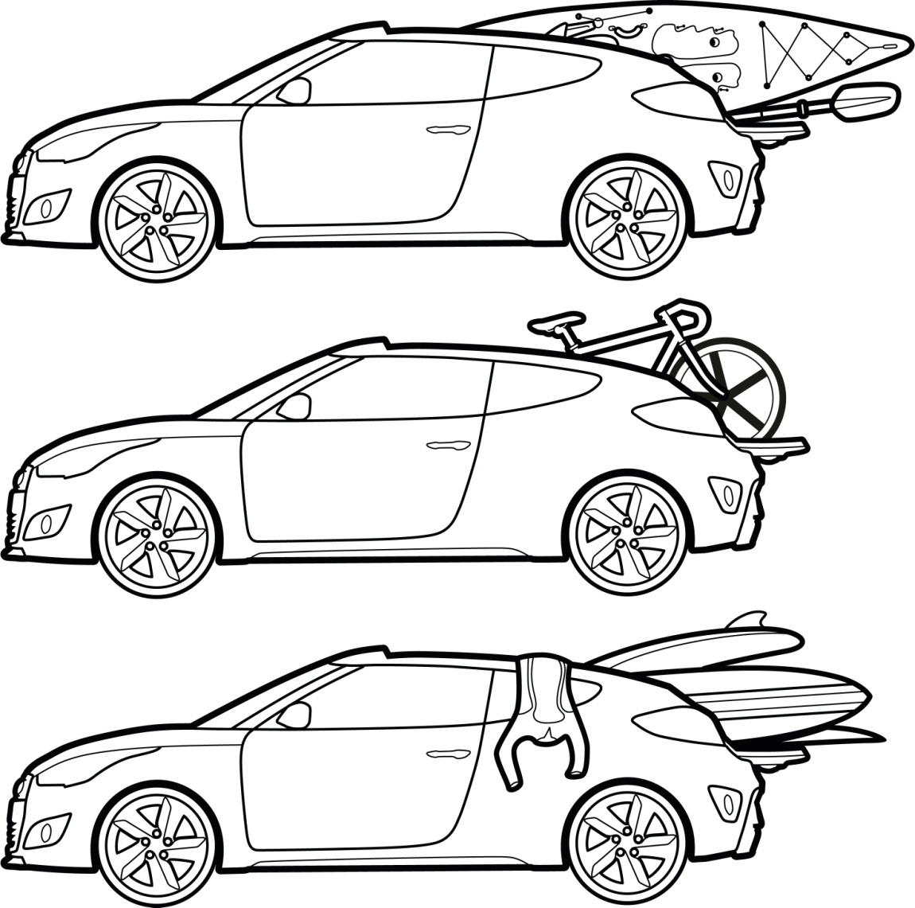

From Zuma to Sunset, stash boards in the back and go from surfing at the beach with friends to cruising the streets of downtown Los Angeles with the top down in seconds. The simple top is the perfect answer to the dual lifestyle and is completely customizable.

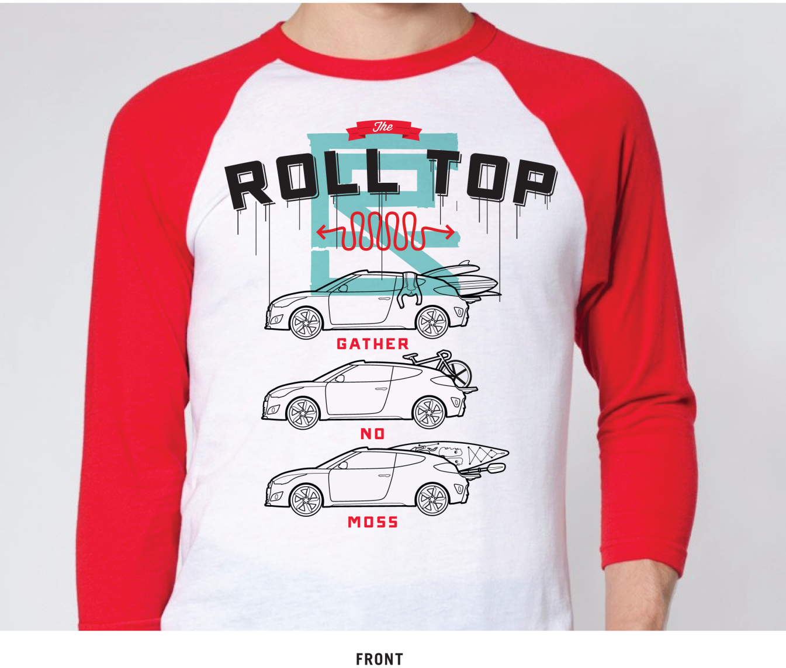

**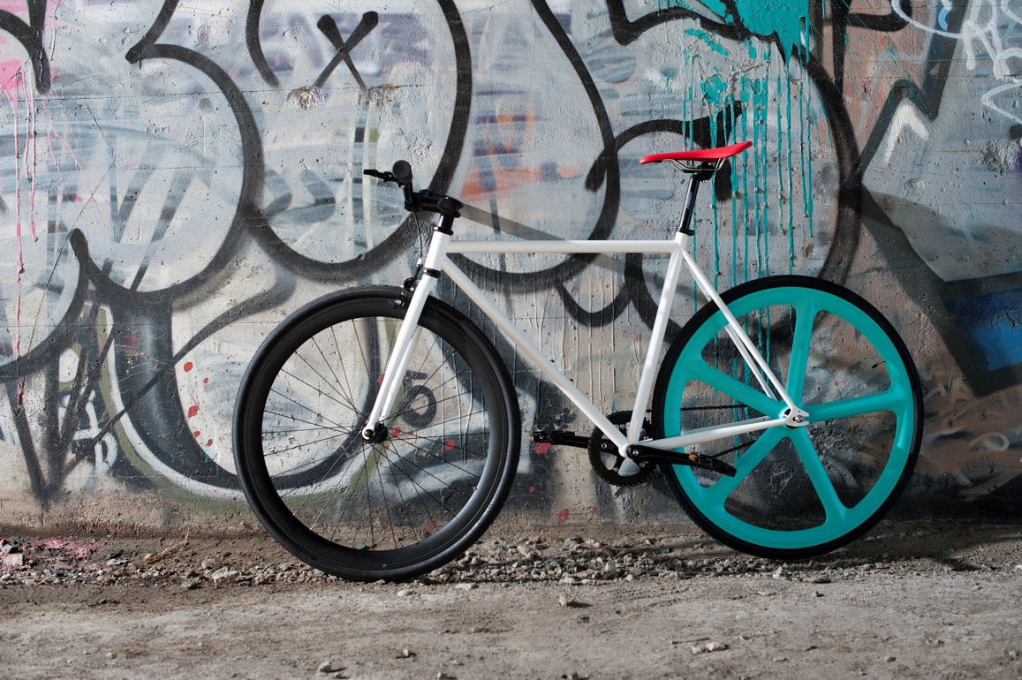**

**FIXIE BIKE INSPIRATION**

Fixed gear bikes, or “fixies,” moved from trendy accessories for hipsters and into the bicycling mainstream. In most urban areas one can’t turn a corner without running into a group of riders zipping along the road or practicing tricks in a park. These colorful bikes are minimalistic with only a single speed and no brakes. They are also completely customizable to fit any ones style. From hand built wheels to color coordinated saddles and handlebars, half the bike is built by the customer and the other half by the manufacturer.

The C3 offers the same experience with a simple, yet highly efficient and stylish design. All of the exterior modifications are low cost. Change the mirror caps and color of the rear wheels against the neutral white body and the C3 can take on an all new look. A driver can change the look quickly and easily. The relationship between car and driver completely changes when the modifications are done by the individual.

The color palette chosen for the Veloster C3 Roll Top concept was influenced by the emerging fixed gear bicycle culture. The design team felt the C3 needed an urban color combination. During the process color combinations on a dozen fixie bikes were looked at before deciding on the red, white, black and teal scheme.

**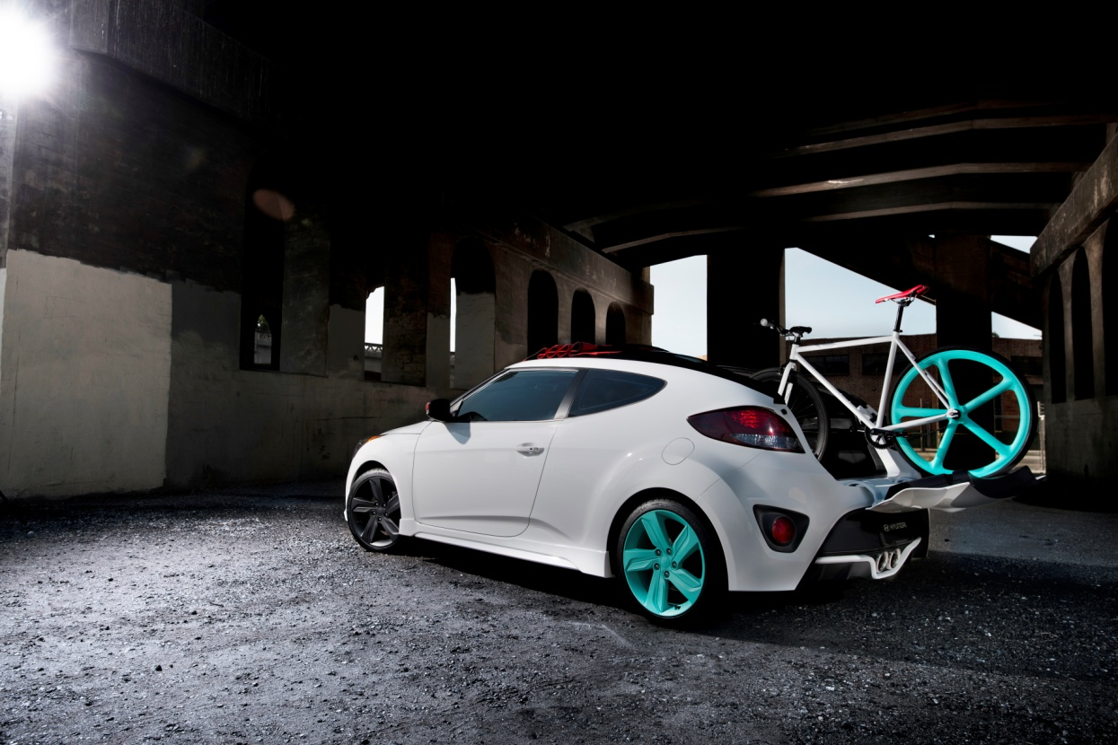**

The high gloss white paint of the C3 is contrasted by a flat black spoiler, glass close out and convertible top rails. The rear reflector bezels, license plate pocket and badge are also flat black. Upfront flat red mirror housings offset the flat black front wheels, fog lamp bezels, front grille and badging. Flat teal rear wheels, red reflectors and smoked taillights complete the look.

The Veloster C3 Roll Top concept base design also features the following:

* Large free flowing circular exhaust pipes
* Robust intake manifold sound
* Big, bold hexagonal front grille
* Sculpted side skirts
* Diffuser vents in the lower rear fascia
* 18-inch wheels with chrome inserts
* Eight individual headlight LED accents

**SUSTAINABLE DESIGN**

Continuing with the urban theme, repurposed materials are used throughout the Veloster C3 Roll Top concept for added character and one-of-a-kind design. The convertible red soft top is inspired by billboard advertising found on rolling soft side trailers. An industrial billboard truck tarp with a black “The C3 Roll Top” statement logo was created, then repurposed and stitched together to create a unique graphic roll top. Red was chosen as a statement color to highlight the functionality of the roll top as well as match the black and red mirror housings, taillights and red rear reflectors.

Inside the C3, broken and old skate board decks are repurposed and artistically line the cargo floor creating a unique mosaic.

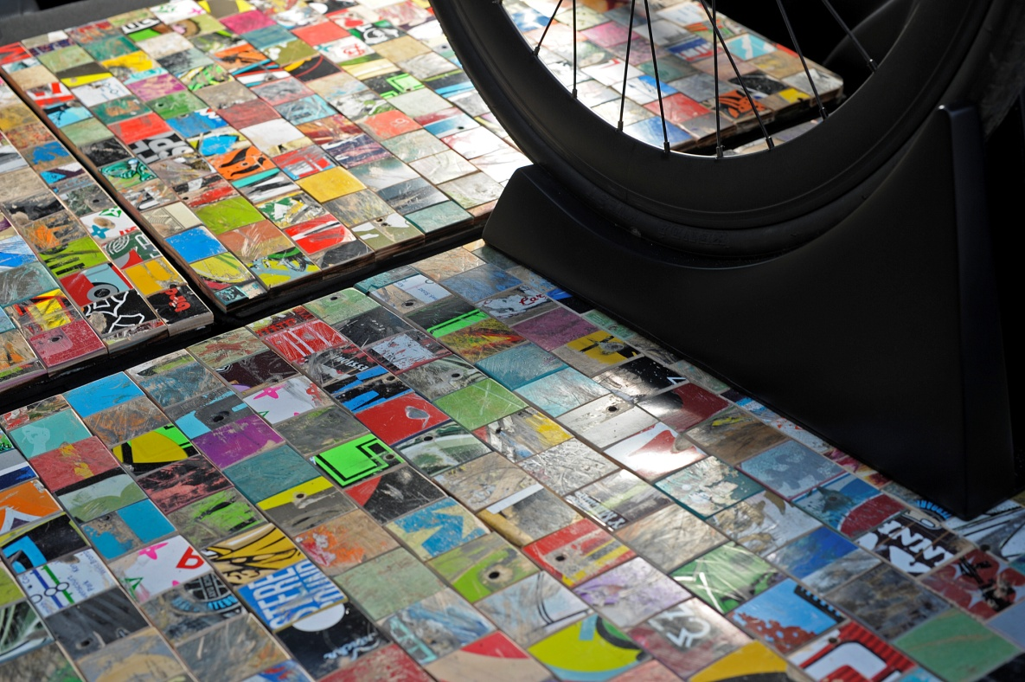

“We visit several shows and events like the International Contemporary Furniture Fair (ICFF) in New York City every year to find new, exciting and interesting materials,” said Liz Curran, Hyundai color and trim expert from Hyundai Design North America. “This year we uncovered Art of Board, a company that makes hand cut tiles from 100 percent recycled skate decks. The decks are very durable and repurposed into art, shelves, benches and chairs. Every scratch, scrape and gouge is kept intact – adding character and making them truly original and each with its own story. They’re alive with texture, shape and color.”

C3 features tiles from more than 20 skate boards on the cargo floor and rear seatbacks. Skateboard grip tape also lines the inside of the tailgate and accents the soft top when rolled forward. The black with red interior accents follow the same color scheme as the retractable roof and are highlighted by red stitching, red bolsters and a red C3 logo in the front seats.

**TWIN-SCROLL TURBOCHARGER AND GDI TECHNOLOGY** A 1.6-liter turbocharged GDI four-cylinder engine powers the Veloster C3 concept and produces 201 horsepower at 6,000 rpm and 195 lb-ft of torque from 1,750 – 4,500 rpm with regular fuel. Hyundai’s 1.6-liter Gamma turbocharged engine features a twin-scroll turbocharger that when combined with the GDI system, results in instantaneous power delivery.

**HYUNDAI MOTOR AMERICA**

Hyundai Motor America, headquartered in Costa Mesa, Calif., is a subsidiary of Hyundai Motor Co. of Korea. Hyundai vehicles are distributed throughout the United States by Hyundai Motor America and are sold and serviced through more than 820 dealerships nationwide. All Hyundai vehicles sold in the U.S. are covered by the [Hyundai Assurance](http://www.hyundaiassurance.com/) program, which includes the 5-year/60,000-mile fully transferable new vehicle warranty, Hyundai’s 10-year/100,000-mile powertrain warranty, and five years of complimentary Roadside Assistance.

For more details on Hyundai Assurance, please visit [www.HyundaiAssurance.com](http://www.hyundaiassurance.com/)

Please visit our media website at [www.hyundainews.com](http://www.hyundainews.com) and our blog at [www.hyundailikesunday.com](http://www.hyundailikesunday.com)

Hyundai Motor America on [Twitter](http://twitter.com/hyundai) | [YouTube](http://www.youtube.com/hyundai) | [Facebook](http://www.facebook.com/Hyundai)

###