For Immediate Release Contact: Tractenberg & Co.
Christina Calbi Jackie Sands
212.929.7979
NEW BURT’S BEES® HOLIDAY GIFTING COLLECTION

The Natural Choice for Everyone on Your List Lemon Butter Cuticle Cream. Tinted Lip Balm. Coconut Foot Cream. Everyone has a beloved favorite Burt’s Bees product. Whether they covet lush lips or head-to-toe hydration, there’s a set filled to the brim with natural necessities to do the trick. Each joyful kit makes the perfect green gift inside and out, from the naturally nourishing ingredients in every formula to the chic embellished gift box that houses each set—no wrapping paper necessary.

Gifts that Love the Earth Created from 60% post-consumer recycled paperboard (our highest PCR content yet), the packaging lets you spread good cheer and show your support for the environment. The increase in recycled packaging content over Burt’s Bees’ gifting program in 2011 represents an additional 15 tons of curbside paper-based recycling that was repurposed into beautiful gifts.
PRODUCT | BENEFITS/KEY INGREDIENTS | MSRP
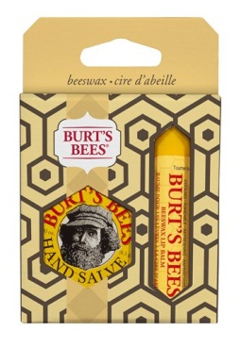  Burt’s Bees® Basics  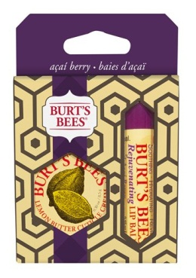  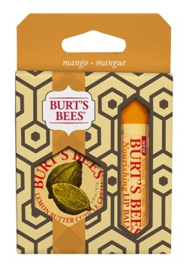  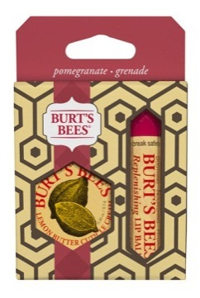 | This pairing of Burt’s Bees Basics makes the perfect stocking stuffer. Each gift set contains one lip balm paired with one mini-hand care product.  Burt’s Bees® Basics comes in four variations:  - Lemon Butter Cuticle Cream and Rejuvenating Lip Balm with Açaí Berry  - Mini Hand Salve and Beeswax Lip Balm  - Lemon Butter Cuticle Cream and Nourishing Lip Balm with Mango Butter  - Lemon Butter Cuticle Cream and Replenishing Lip Balm with Pomegranate Oil  Burt’s Bees® Basics contains the following products:  - Lemon Butter Cuticle Cream (Travel Size) – Softens cuticles with Sweet Almond Oil and Cocoa Seed Butter, and soothes brittle nails with Vitamin E and Sunflower Oil  - Rejuvenating Lip Balm with Açaí Berry – Açaí berry for a healthy infusion of Vitamins A, C, D, and E, antioxidants and moisturizing Omega Oils  - Hand Salve (Travel Size) – Moisturizes rough, dry hands with botanical oils and Beeswax  - Beeswax Lip Balm – Beeswax conditions skin, while antioxidant Vitamin E moisturizes  - Nourishing Lip Balm with Mango Butter – Smoothes and nourishes with Mango Butter  - Replenishing Lip Balm with Pomegranate Oil – Hydrates and revitalizes lips with antioxidant-rich Pomegranate Oil | $4.99  $5.49 – $6.49 value
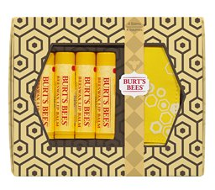  Burt’s Bees® Lip Balm Quartet  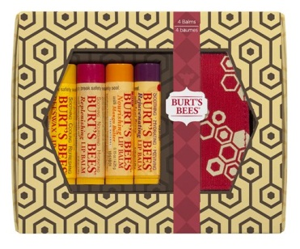  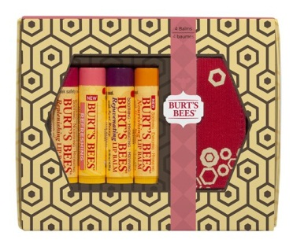 | The Burt’s Bees® Lip Balm Quartet is the ideal gift for the loyal Burt’s Bees lip balm lover. It contains four Burt’s Bees Lip Balms, as well as a bonus soft-sided, key ring pouch that holds up to two lip balms. The removable, printed outer sleeve reveals a beautiful, embossed box with lid, making this gift truly ready to give with no wrapping paper necessary.  Burt’s Bees® Lip Balm Quartet comes in three variations:  - Four Beeswax Lip Balms  - Beeswax Lip Balm, Rejuvenating Lip Balm with Açaí Berry, Replenishing Lip Balm with Pomegranate Oil and Nourishing Nourishing Lip Balm with Mango Butter  - Replenishing Lip Balm with Pomegranate Oil, Refreshing Lip Balm with Pink Grapefruit, Rejuvenating Lip Balm with Açaí Berry and Nourishing Lip Balm with Mango Butter  Burt’s Bees® Quartets contains the following products:  - Beeswax Lip Balm – Beeswax conditions skin, while antioxidant Vitamin E moisturizes  - Rejuvenating Lip Balm with Açaí Berry – Açaí berry for a healthy infusion of Vitamins A, C, D, and E, antioxidants and moisturizing Omega Oils  - Replenishing Lip Balm with Pomegranate Oil – Hydrates and revitalizes lips with antioxidant-rich Pomegranate Oil  - Nourishing Lip Balm with Mango Butter – Smoothes and nourishes with Mango Butter  - Refreshing Lip Balm with Pink Grapefruit – Nourishes with Vitamin C and E from Pink Grapefruit Seed Oil | $9.99  $12 value
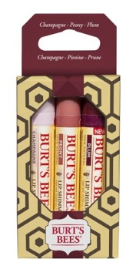  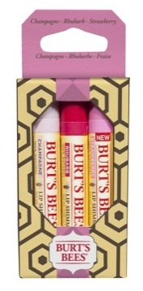  Burt’s Bees® Lip Shimmers | This season, give the gift of shimmer! The Burt’s Bees® Lip Shimmers gift offers a combination of three radiant shades chosen for mixing and layering that are sure to bring holiday cheer to the stylish girl-on-the-go.  Burt’s Bees® Lip Shimmers comes in two variations:  - Champagne, Rhubarb and Strawberry  - Champagne, Peony and Plum  Burt’s Bees® Lip Shimmers contain these key natural ingredients:  - Shea Butter helps hydrate and moisturize dry lips leaving them feeling soft and smooth  - Antioxidant-rich blend of Fruit Seed Oils helps smooth and moisturize for healthy-looking skin  - Peppermint Oil brings the same refreshing, cooling tingle as the classic Beeswax Lip Balm | $9.99  $15 value
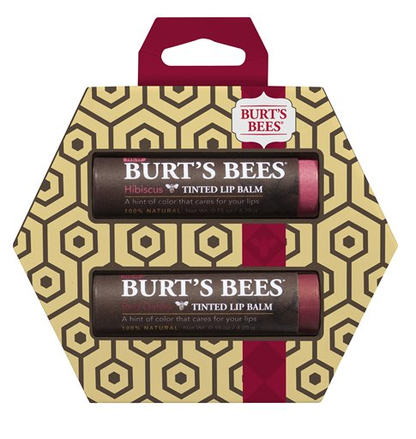  Burt’s Bees® Tinted Lip Balm Duo  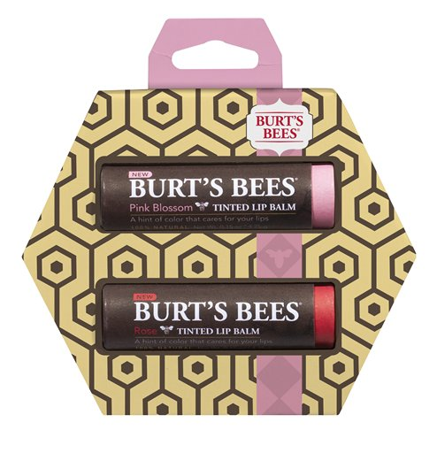 | Each of these Tinted Lip Balm Duos offers two of the most popular Tinted Lip Balm shades, chosen to match for everyday wearability and make lips blossom under the mistletoe.  Two variations:  - Rose and Pink Blossom  - Red Dahlia and Hibiscus  Burt’s Bees® Tinted Lip Balm Duo contains the following products:  - Tinted Lip Balm – Nourishes with Shea Butter and Botanical Waxes | $9.99  $14 value
Burt’s Bees® Head to Toe Gift Set  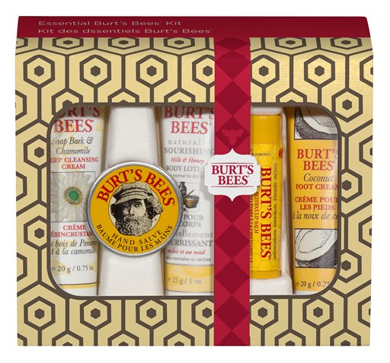 | Shower your loved ones with festive cheer with the Burt’s Bees® Head to Toe Gift Set, which has a gentle and nourishing Burt’s Bees product for every inch!  Burt’s Bees® Head to Toe Gift Set contains the following travel-sized products:  - Soap Bark & Chamomile Deep Cleansing Cream – Removes dirt, oil and make-up with Soap Bark, and helps moisturize and soften skin with Aloe Vera, Chamomile and Echinacea  - Hand Salve – Moisturizes rough, dry hands with botanical oils and Beeswax  - Naturally Nourishing Milk & Honey Body Lotion – Nourishes with Milk, Honey, Vitamin E, Coconut and Grape Seed Oils  - Coconut Foot Cream – Revives and rejuvenates dry feet with Coconut Oil, and refreshes with Rosemary and Peppermint Extracts  - Beeswax Lip Balm (Full Size) – Beeswax conditions skin, while antioxidant Vitamin E moisturizes | $12.99
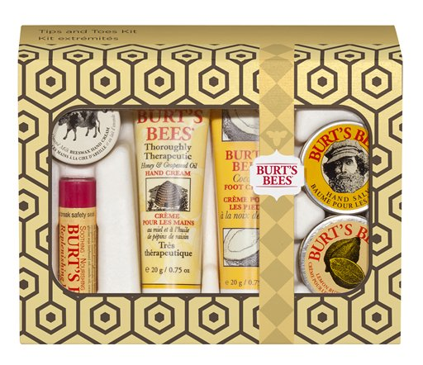  Burt’s Bees® Tips and Toes Gift Set | Treat tired feet and fingers to some special pampering this season with this ultimate do-it-yourself Tips and Toes Gift Set.  Burt’s Bees® Tips and Toes Gift Set contains the following travel-sized products:  - Almond Milk Beeswax Hand Cream – Moisturizes dry hands with Sweet Almond Oil and Vitamin E, and conditions skin with Beeswax  - Thoroughly Therapeutic Honey & Grapeseed Oil Hand Cream – Provides daily therapy for extremely dry hands with honey, jojoba oil and rosemary extract  - Coconut Foot Cream – Revives and rejuvenates dry feet with Coconut Oil, and refreshes with Rosemary and Peppermint Extracts  - Lemon Butter Cuticle Cream – Softens cuticles with Sweet Almond Oil and Cocoa Seed Butter, and soothes brittle nails with Vitamin E and Sunflower Oil  - Hand Salve – Moisturizes rough, dry hands with botanical oils and Beeswax  - Replenishing Lip Balm with Pomegranate Oil (Full Size) – Nourishes with Vitamin C and E from Pink Grapefruit Seed Oil | $12.99
Burt’s Bees® Essential Burt’s Bees Gift Set  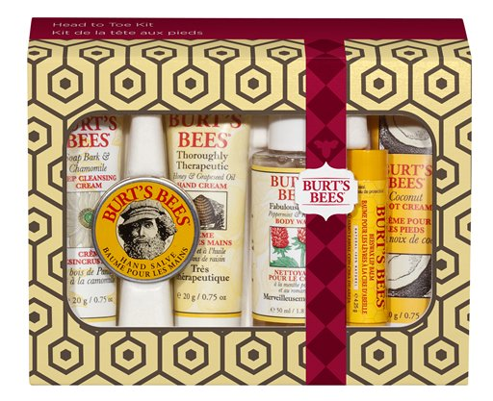 | Indulge those around you with a luxurious gift set that will protect against dry, winter skin with all the time-tested Burt’s Bees Essentials.  The Essential Burt’s Bees Gift Set contains the following travel-sized products:  - Soap Bark & Chamomile Deep Cleansing Cream – Removes dirt, oil and make-up with Soap Bark, and helps moisturize and soften skin with Aloe Vera, Chamomile and Echinacea  - Thoroughly Therapeutic Honey & Grapeseed Oil Hand Cream – Provides daily therapy for extremely dry hands with honey, jojoba oil and rosemary extract  - Hand Salve – Moisturizes rough, dry hands with botanical oils and Beeswax  - Fabulously Fresh Body Wash – Rejuvenates with peppermint and rosemary  - Coconut Foot Cream – Revives and rejuvenates dry feet with Coconut Oil, and refreshes with Rosemary and Peppermint Extracts  - Beeswax Lip Balm (Full Size) – Beeswax conditions skin, while antioxidant Vitamin E moisturizes | $9.99
Burt’s Bees® Naturally Nourishing Gift Set  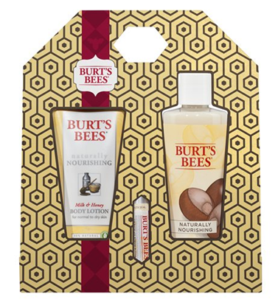 | This trio of ultra-hydrating Burt’s Bees items comes in a carry-along tote that will rest perfectly under any tree.  Burt’s Bees® Naturally Nourishing Gift Set contains the following products:  - Naturally Nourishing Milk & Honey Body Lotion – Nourishes with Milk, Honey, Vitamin E, Coconut and Grape Seed Oils  - Naturally Nourishing Milk & Honey Body Wash – Smoothes skin with Milk and Shea Butter, rich in essential fatty acids and vitamins  - Ultra Conditioning Lip Balm with Kokum Butter – Replenishes skin with Kokum, Cocoa and Shea Butters. Hypo-allergenic with no added flavors or fragrances | $14.99  $19 value
Burt’s Bees® Travel Basics Gift Set  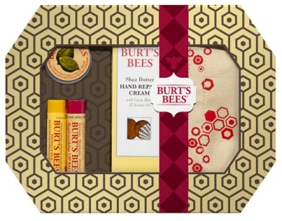 | Bring your Burt’s with you wherever you go! The Travel Basics Gift Set comes with a zippered cosmetics bag to tote your favorite Burt’s products as you span the globe.  Burt’s Bees® Travel Basics Gift Set contains the following products:  - Beeswax Lip Balm – Beeswax conditions skin, while antioxidant Vitamin E moisturizes  - Replenishing Lip Balm with Pomegranate Oil – Hydrates and revitalizes lips with antioxidant-rich Pomegranate Oil  - Lemon Butter Cuticle Cream (Travel Size) – Softens cuticles with Sweet Almond Oil and Cocoa Seed Butter, and soothes brittle nails with Vitamin E and Sunflower Oil  - Shea Butter Hand Repair Cream – Moisturizes and softens with Shea Butter and botanical oils | $14.99  $22 value
Burt’s Bees® Best of Burt’s Gift Set  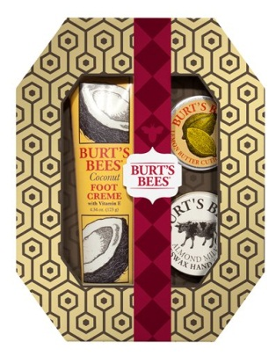 | Surprise someone special with a bundle of the most popular Burt’s Bees products.  Burt’s Bees® Best of Burt’s Gift Set contains the following products:  - Coconut Foot Cream – Revives and rejuvenates dry feet with Coconut Oil, and refreshes with Rosemary and Peppermint Extracts  - Lemon Butter Cuticle Cream – Softens cuticles with Sweet Almond Oil and Cocoa Seed Butter, and soothes brittle nails with Vitamin E and Sunflower Oil  - Almond Milk Beeswax Hand Cream – Moisturizes dry hands with Sweet Almond Oil and Vitamin E, and conditions skin with Beeswax | $14.99  $24 value
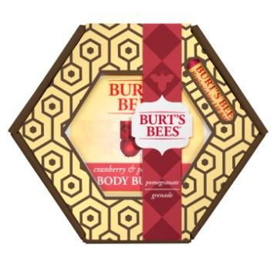  Burt’s Bees® Body Butter & Balm Gift Set  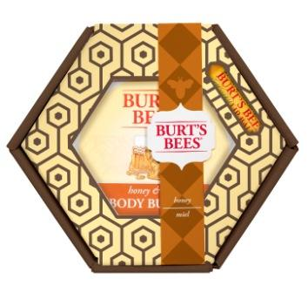 | This luscious gift set pairs one full-sized body butter with a matching flavored lip balm.  Two variations:  - Pomegranate  - Honey  Burt’s Bees® Body Butter & Balm Gift Sets contain the following products:  - Cranberry & Pomegranate Body Butter – Shields skin from environmental stress with Pomegranate Oil, and hydrates with Cocoa and Jojoba Butters  - Replenishing Lip Balm with Pomegranate Oil – Hydrates and revitalizes lips with antioxidant-rich Pomegranate Oil  - Honey & Shea Body Butter – Moisturizes with Shea Butter, and softens with Honey and Sweet Almond Oil  - Honey Lip Balm – Helps nourish dry lips with Honey and Vitamin E | $12.99  $16 value
Burt’s Bees® Burt’s Bees Favorites – Pomegranate Gift Set  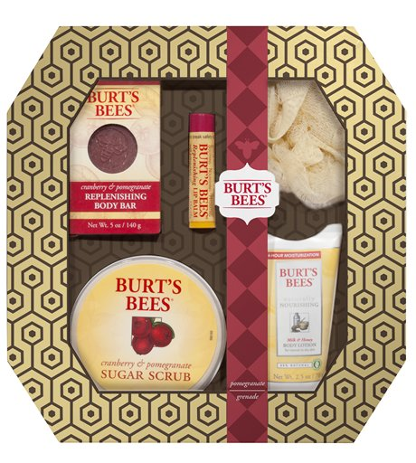 | This gift set boasts some of the most beloved Burt’s Bees pomegranate products, which you can enjoy with a signature Burt’s Bees Spa Pouf included for indulgent pampering.  Burt’s Bees® Pomegranate Gift Set contains the following products with these key natural ingredients:  - Cranberry & Pomegranate Sugar Scrub – Polishes and conditions with exfoliating Sugar Crystals, Pomegranate Oil, Cranberry Seed and Shea Butter  - Cranberry & Pomegranate Replenishing Body Bar – Conditions skin with Cranberry Extract (a superior emollient with Omegas 3,6 and 9) and Pomegranate Seeds  - Replenishing Lip Balm with Pomegranate Oil – Hydrates and revitalizes lips with antioxidant-rich Pomegranate Oil  - Naturally Nourishing Milk & Honey Body Lotion – Nourishes with Milk, Honey, Vitamin E, Coconut and Grape Seed Oils | $19.99  $26 value

Burt’s Bees has been offering distinctive earth-friendly, natural personal care products for 25 years. From a beekeeper’s backyard in Maine to the leading edge of natural, Burt’s Bees knows natural body care solutions from head-to-toe. The company creates products for total skin health that keep The Greater Good™ top of mind.
No petrochemicals, phthalates, parabens or sodium lauryl sulfate. Not tested on animals.

Burt’s Bees® Holiday Gift Collection will be available starting October 2012 at select natural, grocery, drug, and mass retailers, and via www.burtsbees.com.



