LG Ultra HD TV (84LM9600)

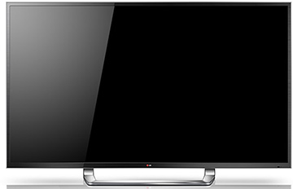
- Newest HD Technology: With Ultra High-Definition displays, consumers will have the sharpest, most lifelike picture available and a much-needed detail boost, especially for displays over 65-inches, with the most comfortable 3D experience via LG CINEMA 3D technology.

- Upscaling Content: LG’s consumers will be able to take any content and upscale it to Ultra Definition. LG’s Resolution Upscaler Plus up-scales any content to 4K, offering limitless content for viewing.

- CINEMA 3D: LG’s proprietary Film Patterned Retarder (FPR), or passive, 3D technology brings the theater experience into the home, providing consumers a comfortable 3D viewing experience that is truly cinematic. This also allows for consumers to use 3D glasses that are more comfortable, affordable and easier to use than active-shutter.

- Smart TV Access: LG offers premium content from providers like Netflix, Hulu Plus, VUDU and many others, as well as a one-stop shop for 3D content (called the LG 3D Zone) and more than 1,000 applications in the LG App store.

- Cinematic Sound: LG’s 2.2-channel sound system provides a lavish audio experience with 10 speakers and 2 subwoofers built directly into the set.

- Additional Information
    - Model Number: 84LM9600
    - MSRP: $19,999

Contacts:
Ted Maass
312.397.6014
ted.maass@lg-one.com

