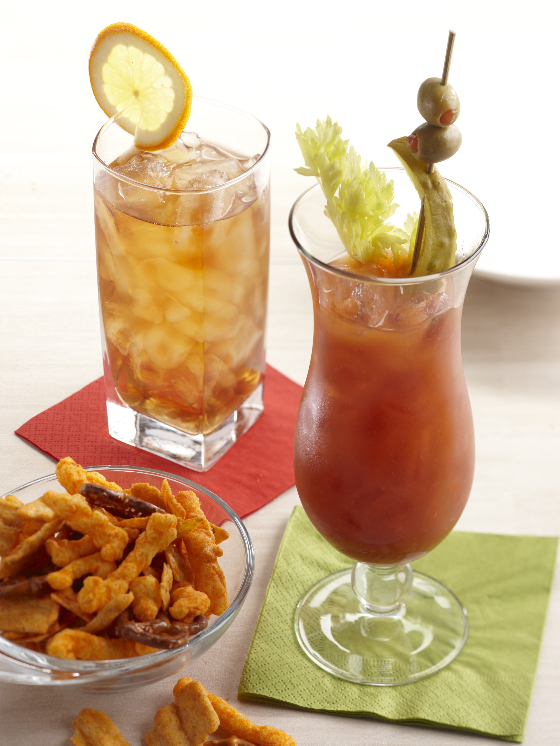

Royal Maple Tea
Makes 8 servings
Prep: 30 minutes

10 cups water
8 tea bag
1 navel orange
4 whole cloves
Sugar
1½ cups whisky, Crown Royal® Maple Finished Flavored Whisky
Ice cubes
8 orange slices and/or wedges

1. In a large saucepan bring the water to a boil. Remove from heat add tea bags, 3 wide strips of peel from orange, and cloves. Let steep for 4 minutes. Remove tea bags, orange peel, and cloves. Let steep for 4 minutes. Remove tea bags, orange peel, and cloves. Sweeten to taste. Allow to come to room temperature.
2. Juice navel orange and add to tea with whisky, Transfer to a large container. Transfer tea, ice cubes, and orange slices to tailgate.
3. Fill large glasses with ice, top with tea, and garnish with orange slices.
Recipe courtesy of Sandra Lee, The Magazine© January/February 2013 issue

