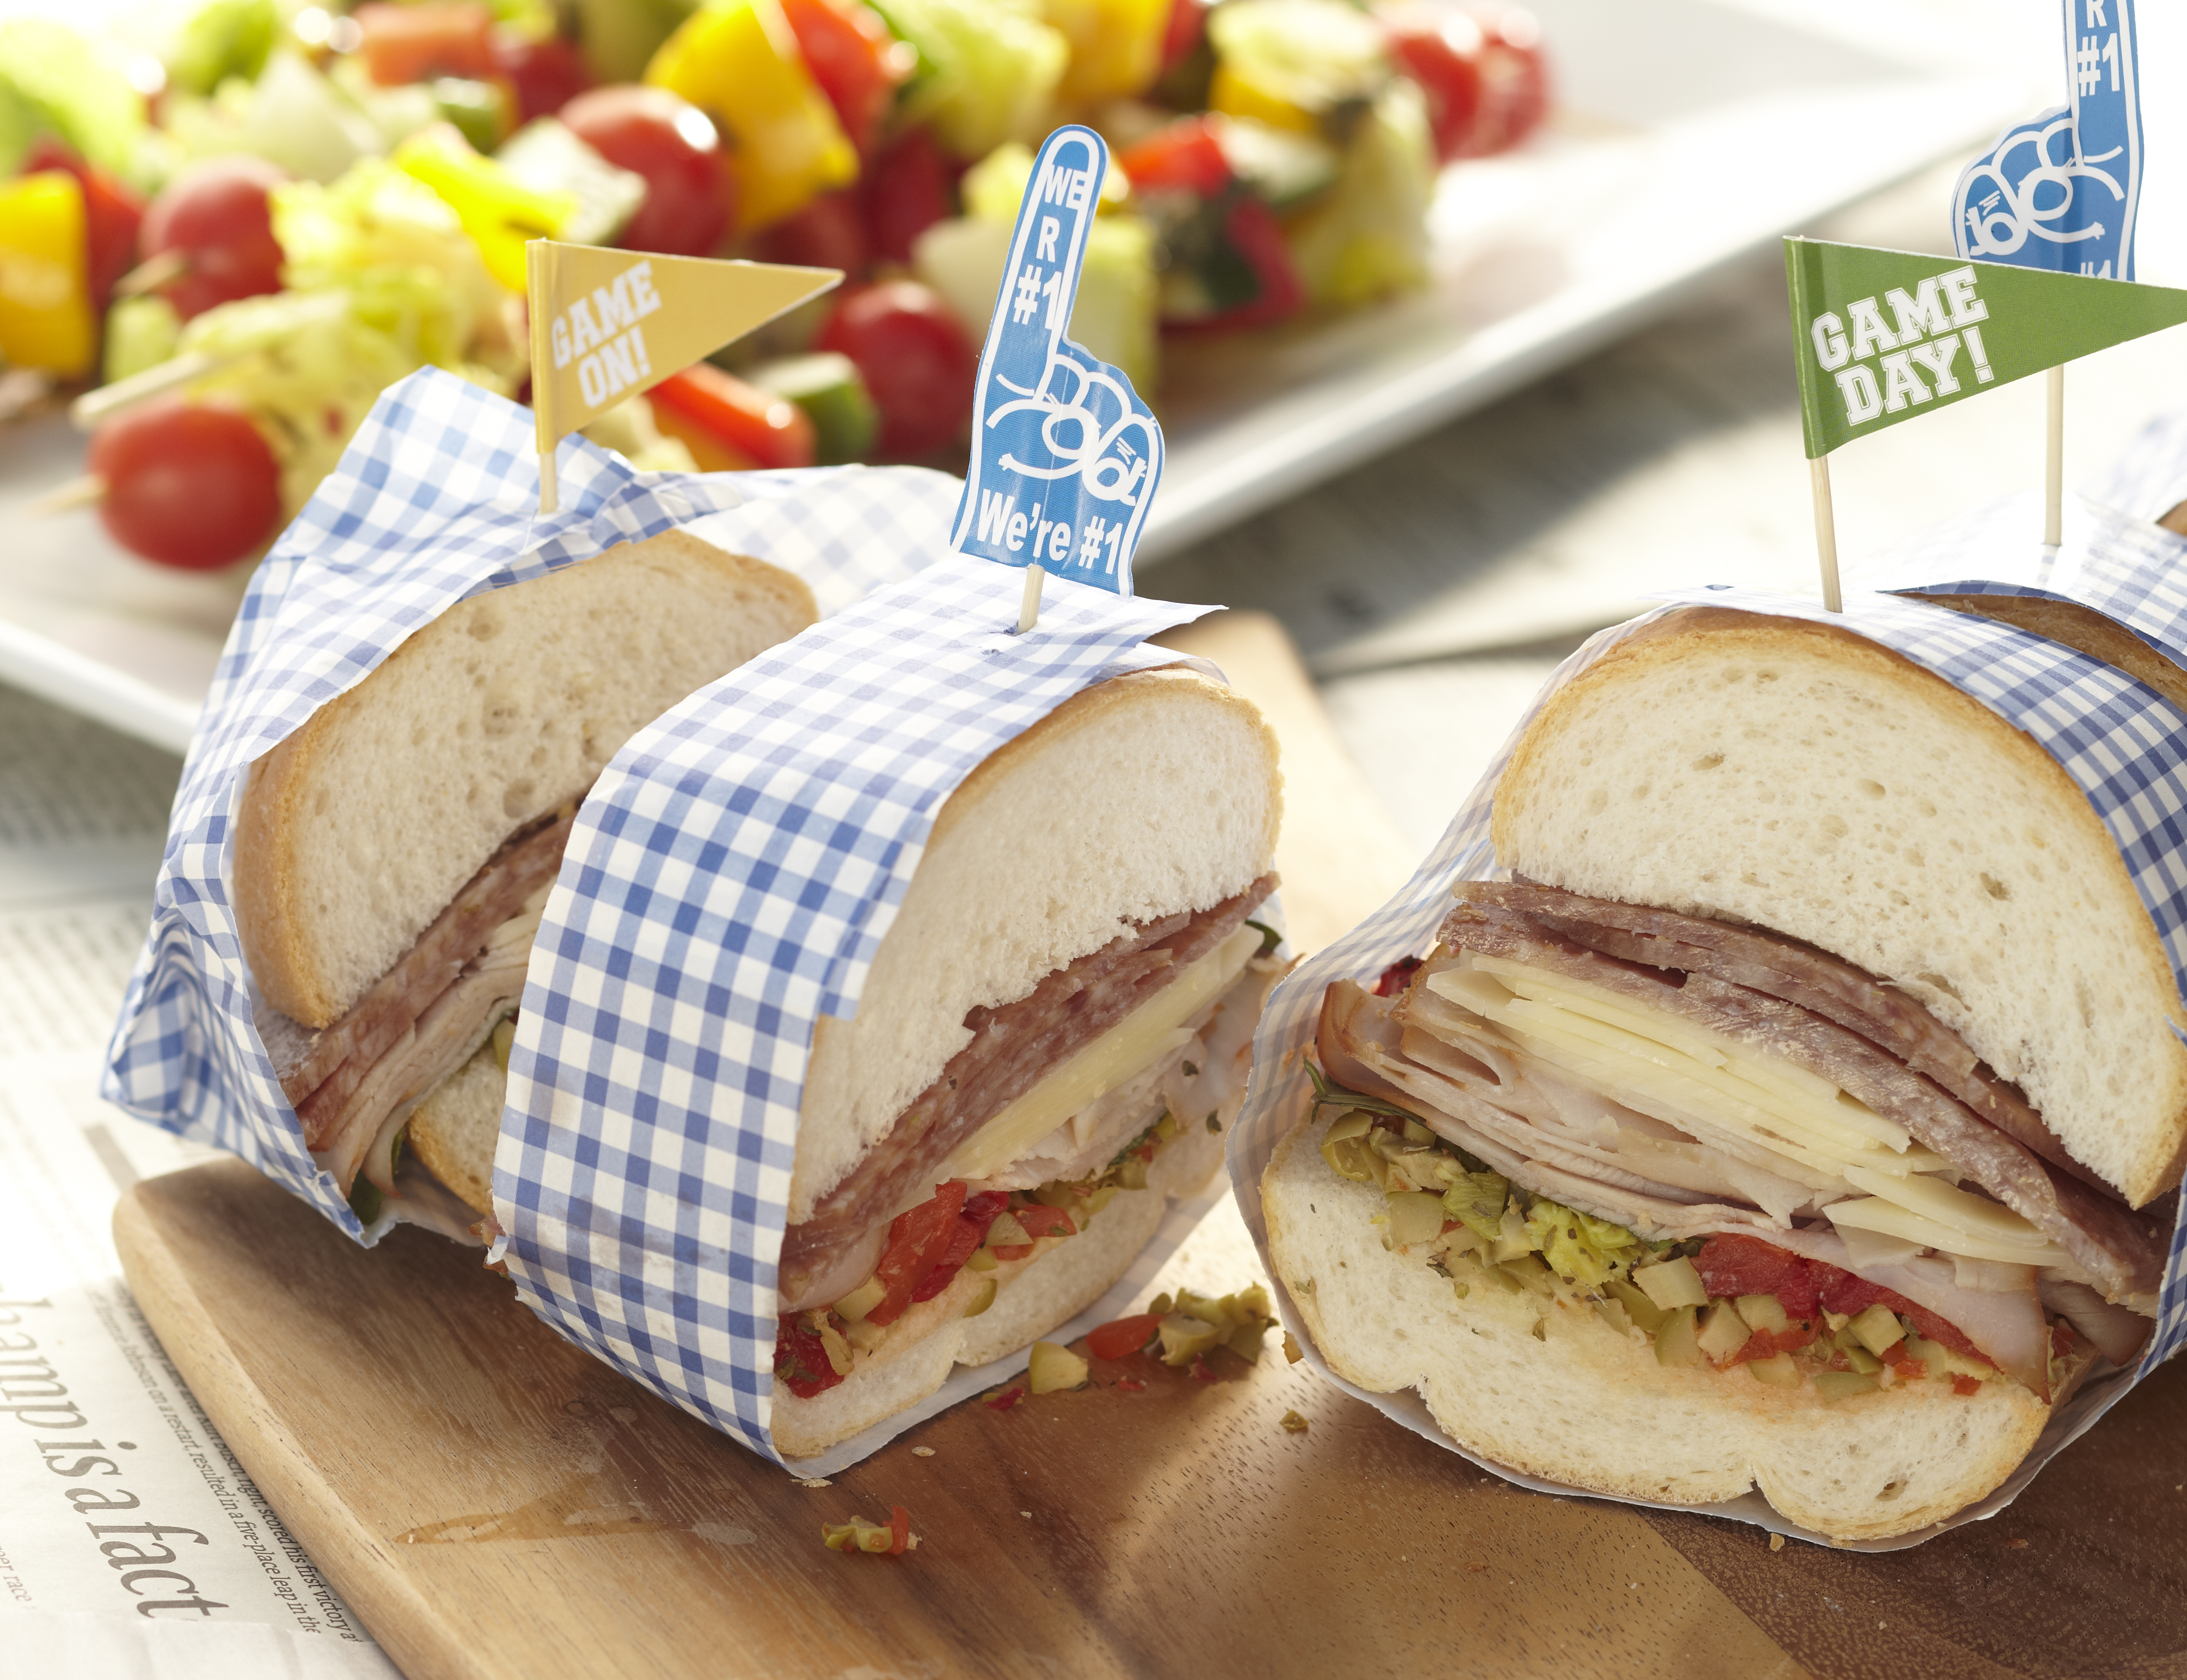

Super Subs
Makes 8 servings
Prep: 30 minutes, Chill: up to
24 hours, Grill: 15 minutes
1 Italian-style loaf of bread (12 to 14 inches long)
1 cup chopped pimiento-stuffed green olives
¼ cup chopped pepperoncini
1½ teaspoons Italian seasoning
1/2 cup fresh basil leaves
½ cup roasted red peppers, cut into strips
½ pound sliced baked ham
½ pound sliced provolone cheese
1/2 pound sliced genoa salami
8 5- to 6-inch wooden picks or skewers
- Cut bread in half horizontally. Place bottom of loaf cut side up on a large piece of foil. Spread chopped olives and pepperoncini over bread. Sprinkle with Italian seasoning.
- Layer with basil, red peppers, ham, cheese, and salami. Add loaf top. Wrap tightly with foil and refrigerate for up to 1 day.
- Transfer to tailgate. Place the sandwich on a medium grill and cook for about 15 minutes until heated through and cheese is melted, turning occasionally. (Or serve cold.) 4. Remove foil. Secure the sandwich with wooden picks. Cut between picks into 8 servings.

