

AmLactin® Cerapeutic™ Restoring Body Lotion Facts

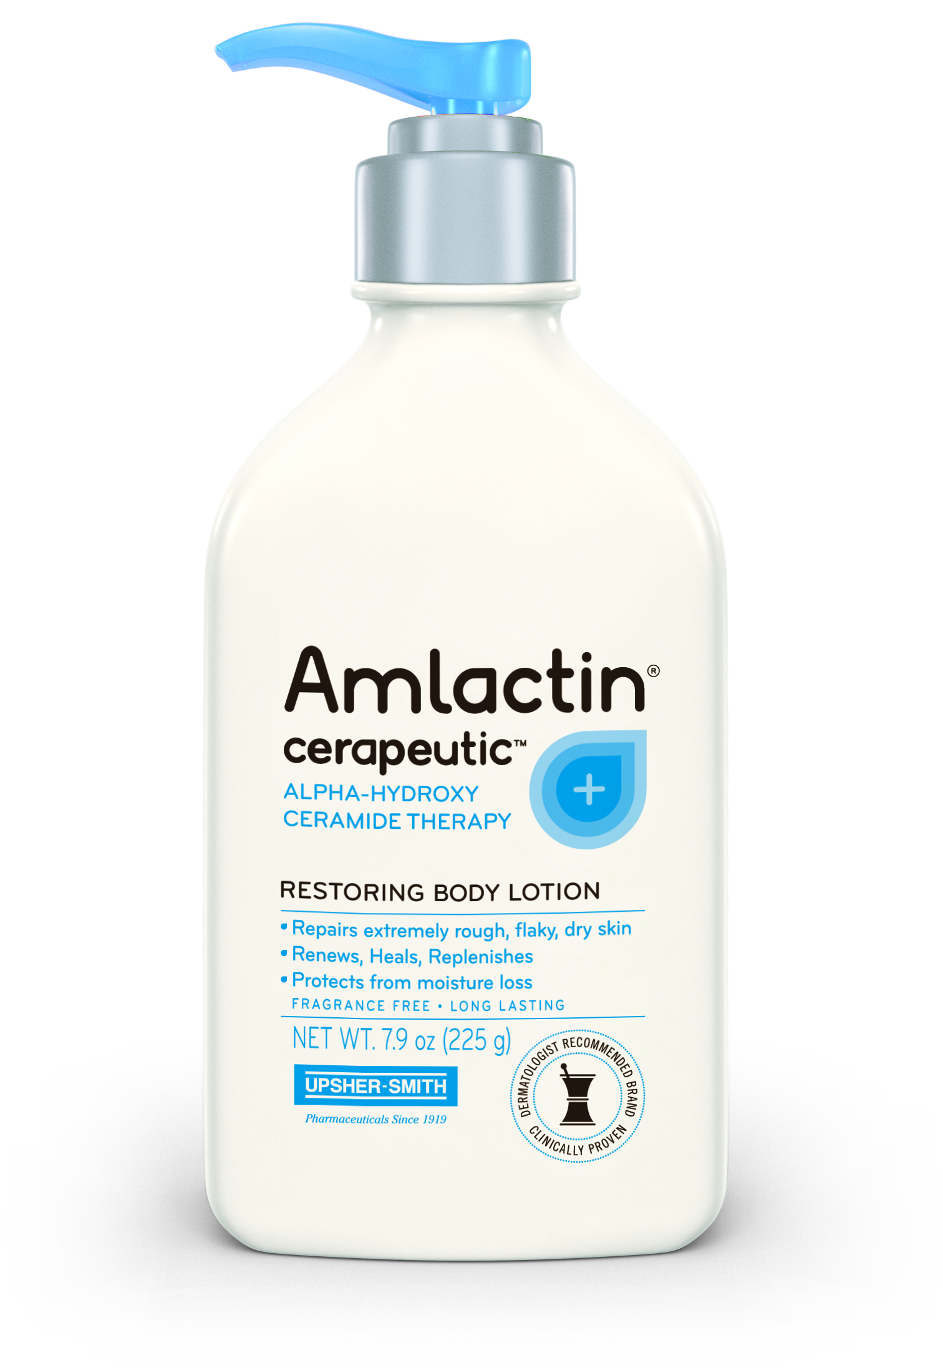
- AmLactin® Cerapeutic™ Restoring Body Lotion is designed to repair extremely rough, flaky, dry skin. This restoring formula with clinically proven, intensely hydrating, patented, triple action ULTRAPLEX® gently exfoliates while three essential ceramides quickly strengthen the skin’s protective moisture barrier for noticeably softer, more resilient skin.

- Ceramides are naturally found in the skin’s vulnerable, outer layer and help retain moisture. Dry skin may lack ceramides and as a result, the skin’s protective moisture barrier may be vulnerable to drying environmental and lifestyle factors, age-related dry skin, and irritants. Applying ceramides to the skin topically can help replenish the skin’s vulnerable, moisture barrier.

- Repairs extremely rough, flaky, dry skin.

- AmLactin® Cerapeutic™ is a pumpable lotion with the patented ULTRAPLEX® formula that provides fast acting, long-lasting relief for extremely rough, flaky, dry skin.

- AmLactin® Cerapeutic™ Restoring Body Lotion is available in a 7.9 oz bottle at the suggested retail price of $18.99. It is available at the drugstore.com™ website and select Walgreens and Wal-Mart stores nationwide.

About AmLactin® Alpha-Hydroxy Skin Care

- AmLactin® products contain alpha-hydroxy acids (AHAs), derived from lactic acid, to exfoliate and hydrate the skin. AHAs also act as humectants that help draw water to the skin so it looks and feels soft and smooth.

- AmLactin® products work deep within the skin and offer long-lasting moisture retention for real comfort.

- AmLactin® is the #1 moisturizer brand recommended by dermatologists and podiatrists.^{1,2}

- AmLactin® Alpha-Hydroxy Skin Care is ideal for managing dry skin and the dry skin associated with common skin conditions, like Keratosis Pilaris.

- AmLactin® Alpha-Hydroxy Skin Care includes AmLactin® Moisturizing Body Lotion, AmLactin® Cerapeutic™ Restoring Body Lotion, AmLactin® Ultra Hydrating Body Cream, and AmLactin® Foot Cream.

- For more information about AmLactin® Alpha-Hydroxy Skin Care, please visit amlactin.com.

- Users of AmLactin® products should refer to individual product labels for directions and cautions.

Sunburn Alert: This product contains an alpha-hydroxy acid (AHA) that may increase your skin’s sensitivity to sunburn. Be sun smart: use sunscreen, wear protective clothing, and limit sun exposure while using this product and for a week afterward.
107719.01

