
New Worry-Free Carbon Monoxide Alarms last up to twice as long as other models

Product Description
Kidde Worry-Free carbon monoxide (CO) alarms offer 10 years of continuous detection from the leading cause of accidental poisoning deaths in America – carbon monoxide. The UL-listed alarms are the first and only models to contain a 10-year sensor as well as a sealed-in lithium battery proven to power the alarm for a decade. These two state-of-the-art technologies combine to create a premier level of protection. Homeowners have peace of mind knowing their CO alarm is always on, and they never have to be hassled by low-battery chirps or replacement. Until now, a CO sensor operated for five to seven years, based on the manufacturer. The Worry-Free alarms last nearly twice as long as the average model.

Long-Life Sealed Lithium Battery: Why It’s Needed
Each year, fire departments respond to an average of 72,000 CO poisoning incidents, according to the National Fire Protection Association. Known as the ‘silent killer,’ carbon monoxide is odorless, tasteless and invisible. The only safe way to detect it is with a working CO alarm. Industry surveys find approximately half of U.S. homes have a carbon monoxide alarm installed, most of those are battery-operated. A recent survey conducted on behalf of Kidde found homeowners’ number one fire safety complaint is a low battery chirp.

Benefits of Worry-Free Carbon Monoxide Alarm
- Goodbye late night low battery chirps: The sealed lithium battery is tamper proof and provides 10 years of continuous power, meaning no low battery chirps or battery replacement
- Longest Sensor Life Available: Carbon monoxide sensor is proven effective for 10 years –
nearly twice as long as some models
- Money Savings: no batteries to buy and replace every six months, save up to $40 over the life of
the alarm
- Quick and Easy Installation: simply slide the alarm onto the mounting bracket and it activates automatically. Place on a desk, shelf, table or the wall.
- It’s Always On: 24 hr/day, 7 day/week protection from CO
- End of Life Hush Button: After 10 years of power, the alarm will sound a warning to indicate it needs replacing. The hush button will temporarily silence the warning for up to three days.

Overall Product Line Features
- UL Listed – tested by an independent nonprofit testing agency to ensure it meets the US standard
- 85 decibel alarm – loud enough to wake the average sleeping adult
- Nighthawk electro-chemical sensor, which is proven to be the world’s most accurate based on claims by major manufacturers
- Test-Reset Button tests the alarm circuitry and horn, resets memory after alarm has sounded
- End-of-life signal chirps every 30-45 seconds when alarm needs to be replaced – approximately 10 years after power
- Deactivation switch disables the alarm and makes the batteries safe for disposal once the unit has reached the end of its 10-year life
- Tamper resistant feature prohibits a disabled alarm from being placed back onto the mounting bracket
- 10-Year Limited Warranty lasts the life of the alarm

Availability:
Two models of the Kidde Worry-Free Carbon Monoxide Alarm will be available at The Home Depot as of March 2013. Suggested retail prices range from $40 to $50.
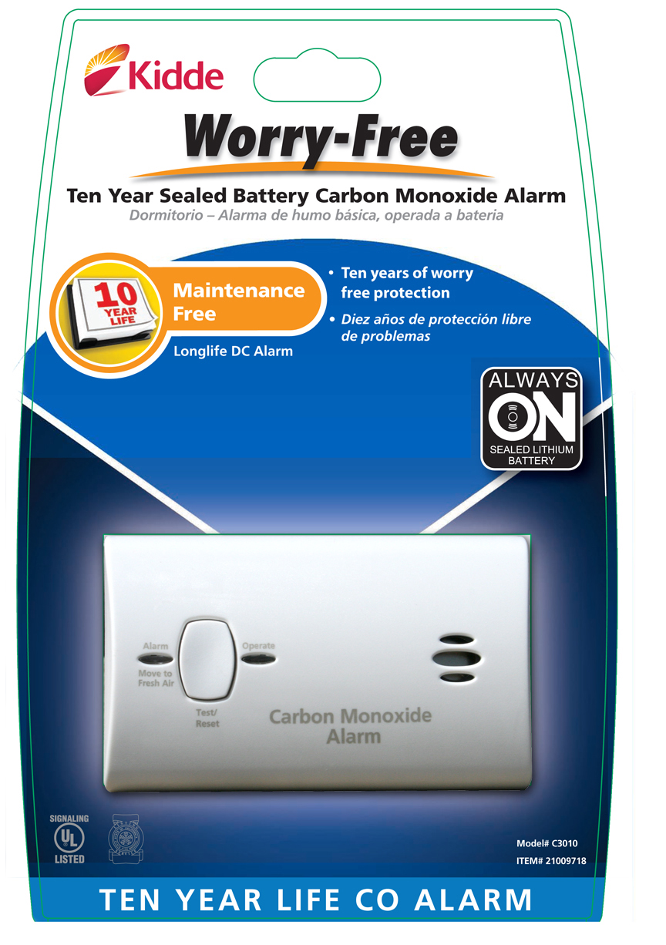

Kidde Worry-Free Sealed Battery Carbon Monoxide Alarm
- 10-year Nighthawk sensor
- 10-year sealed-in power supply
- MSRP: $39.97

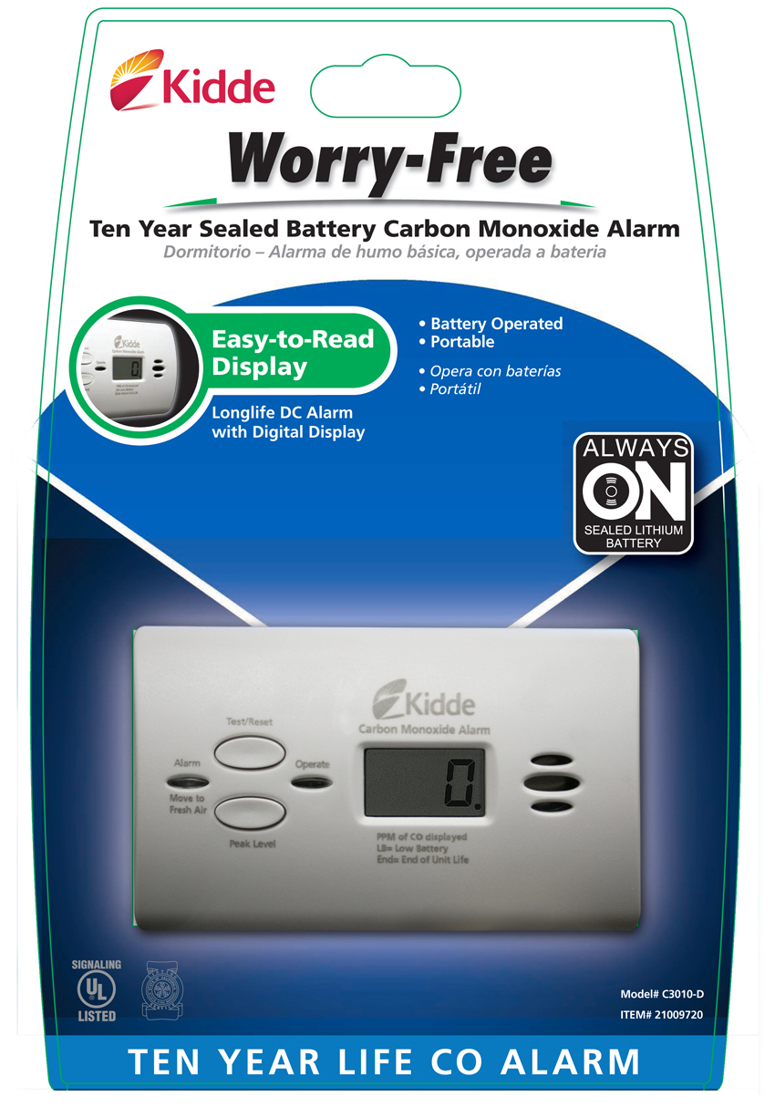
Kidde Worry-Free Sealed Battery
Carbon Monoxide Alarm with Digital Display
- Digital Display Screen clearly shows the level of CO in that room and updates the reading every 15 seconds
- Peak-Level Memory records the highest level of CO present (knowing the CO level in the home can help emergency personnel determine treatment)
- 10-year Nighthawk sensor
- 10-year sealed-in power supply
- Provides CO readings in your home up to 999 PPM and sounds a warning when dangerous levels are detected
- MSRP: $49.97

CO Alarm Placement & Maintenance
Below are recommendations on the optimal placement of your CO alarms:
- Install at least one CO alarm on every level of the home and in sleeping areas.
- Because CO weighs about the same as air, a CO alarm can be placed on the wall, a table, or plugged into an electrical outlet Note: Combination smoke/CO alarms must be placed on a ceiling or wall due to the fact that smoke rises.
- Make sure CO alarms are at least 15 feet away from fuel-burning appliances to prevent
false alarms.
- Don’t cover or obstruct the unit.
- Test the CO alarm monthly.

