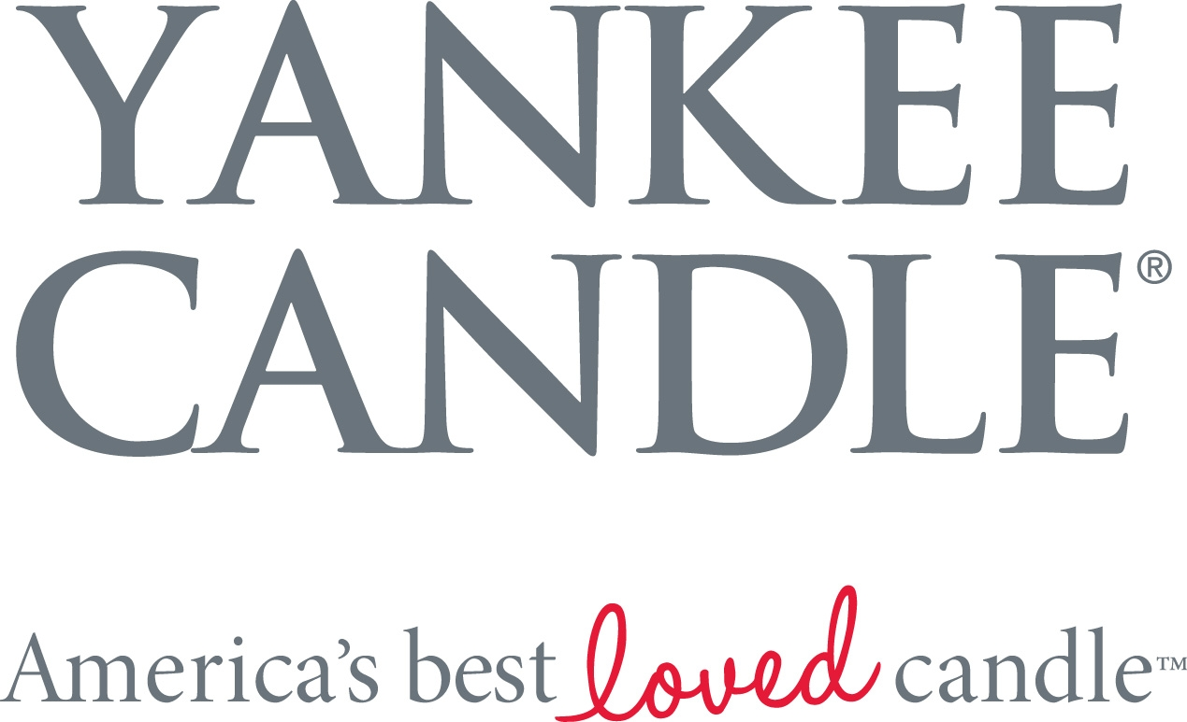

FALL 2013 NEW FRAGRANCES

OVERVIEW
Yankee Candle® offers six new fragrances for fall 2013 that embrace the sweet simplicity of the quiet moments that make up the season. These new, relaxing scents remind us of indulging in a delectable treat while curling up in a soft, cozy sweater, and welcoming the season with the colors, scents and sights associated with fall.

AVAILABILITY: July – December 2013

PRICING: $27.99 MSRP – Large Tumbler Candle or Jar Candle; $24.99 MSRP – Medium Jar Candle; $15.99 MSRP – Small Tumbler Candle; $10.99 MSRP – Small Jar Candle; $1.99 MSRP – Tarts® Wax Melt or Samplers® Votive Candle

FRAGRANCES
November Rain™ – A quiet interlude of the season is reflected in this airy, refreshing mix of watery leaf notes, warm amber and crisp brisk air.

Lake Sunset™ – The serene beauty of the sun’s golden rays as they dip into still blue waters, calling to mind the musky descent of nightfall.

Vanilla Chai – It’s the perfect accompaniment to “me” time – a supremely satisfyingly rich and spicy recipe of ginger, cinnamon and vanilla.

Salted Caramel – Sweet surrender is yours with our luscious gourmand confection of burnt sugar, sea salt, and smooth vanilla caramel.

Cozy Sweater™ – Ooh, there’s nothing quite as comfy as curling up in a sweater, soft as a flower petal, with warm touches of musk and patchouli.

Pumpkin Wreath (Retail Stores Only) – An open invitation… the welcoming aroma of fall pumpkins infused with earthy oak wood, hearty cinnamon bark and clove.
ONLINE PRESENCE
www.yankeecandle.com
@TheYankeeCandle
Facebook/TheYankeeCandleCompany
YouTube/YankeeCandleCompany
Instagram/TheYankeeCandleCompany
Pinterest/TheYankeeCandle

DISTRIBUTION
- 557 Yankee Candle® retail stores across the U.S.
- Wholesale customers (e.g. specialty retailers and gift shops)
- Online/Yankee Candle® website
- Yankee Candle® flagship stores

MEDIA CONTACTS
Karyn Martin Karen Woods
451 Marketing The Yankee Candle Company, Inc.
kmartin@451marketing.com kwoods@yankeecandle.com
617-462-0108 413-665-8306 x4391
###

