JNA Awards 2013: Wallace Chan to receive “Outstanding Contribution Award”

HONG KONG, 25 July, 2013 – JNA (Jewellery News Asia), organiser of the JNA Awards, is delighted to announce that Wallace Chan is the recipient of the “Outstanding Contribution Award” to the jewellery industry. The accolade will be presented to Chan at an awards ceremony and gala dinner scheduled for 12 September at The Grand Hyatt, Hong Kong.

Chan is the first recipient to be honoured at the JNA Awards for “Outstanding Contribution of the Year”.

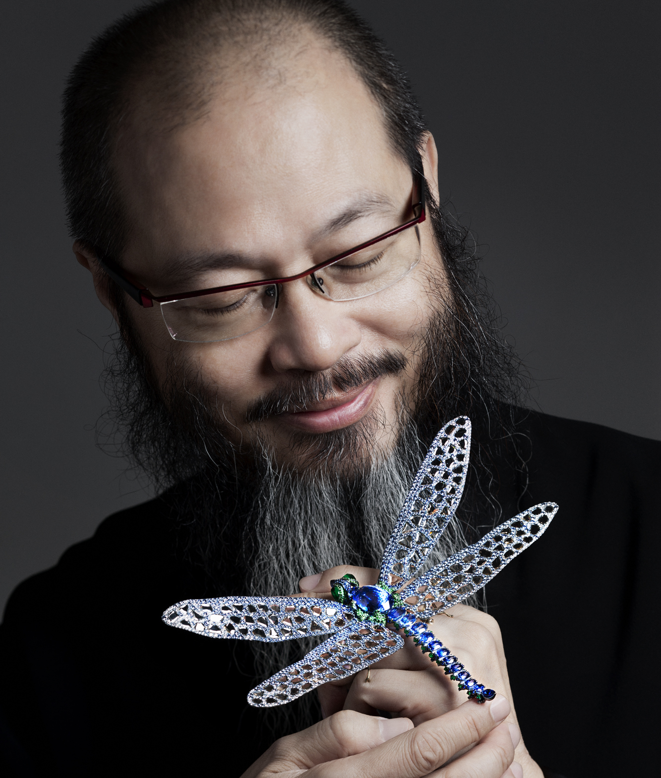
Letitia Chow, Chair of the JNA Awards judging panel, said: “Wallace has made his mark in the global jewellery industry with his unique insight and creativity, which translate into a collection of amazing masterpieces. His accomplishments have not only put his name on the world map, but have brought Asian designs in the forefront of the artistry world.

“Globally recognised as a top fine jewellery artist and master craftsman, Chan, with his great talent and painstaking hardwork, constantly makes innovative designs and manufacturing breakthroughs,” Chow added.

Commenting on the Award, Chan said: “Efficiency comes from diligence, and success depends on forethought. I believe that for any industry to be efficient and successful, it is important to be devoted to one’s craft, and at the same time, be brave enough to innovate. Thank you for this Award. This prestigious recognition serves as a great encouragement for me to further push my creative boundaries.”
Wallace Chan

A celebrated artist, sculptor, jewellery designer and master craftsman, Chan has a distinguished career that spans nearly three decades.

He has made a significant impact on the global haute joaillerie scene following his spectacular debut at the Biennale des Antiquaires in Paris in 2012. To date, he is the only Asian artist invited to the Biennale. As a Chinese jewellery master, he brought to the Biennale the essence of Oriental philosophy and Chinese culture, opening up a profound dialogue between cultures.

Raised in Hong Kong, Chan spent his youth mastering Eastern sculptural designs and techniques, and Western lapidary art. In the mid-1980s, he invented the “Wallace Cut” – a crystal-carving technique that includes elements of cameo, intaglio and gem-faceting. Following eight years of research in titanium and metal alloy, casting and smelting techniques, he unveiled his revolutionary mastery of titanium in jewellery-making in Europe in 2007.

Chan has been invited to showcase his collections in high-profile and prestigious exhibitions in China, the US, Germany, Italy, Switzerland, Russia, Singapore, Japan and Taiwan. The German jewellery industry has even given him the title “carving genius,” in deference to his unique talent.

The JNA Awards is an industry-wide event that honours and recognises excellence and achievement in the global jewellery trade with an Asian focus. The event will be held on the sidelines of the September Hong Kong Jewellery & Gem Fair, which will run from 11 to 17 September.

The second annual edition of the JNA Awards is led by Rio Tinto Diamonds and Chow Tai Fook as Headline Partners, with Gubelin, Israel Diamond Institute, KARP Group, Robert Wan Tahiti and the Shanghai Diamond Exchange as Honoured Partners.
The awards ceremony and gala dinner is a ticketed event by application only. Interested parties can submit their request by logging on to www.JNAawards.com.

Notes for Editors:

- About JNA

JNA, first published in 1983, is the flagship magazine of UBM Asia’s Jewellery Group. The publication is a leader in providing the latest industry updates and in-depth reports, covering the international jewellery trade with an Asian insight. Following its success, the publication launched its online edition in June 2011.

- About the Headline Partners

2.1 Rio Tinto Diamonds (www.riotintodiamonds.com)
As one of the largest producers of rough diamonds in the world, Rio Tinto Diamonds enjoys an important presence in the international diamond market through its 100 percent control of the Argyle mine, 60 percent of the Diavik mine, 78 percent interest in the Murowa mine and an advanced diamond project in India. Rio Tinto Diamonds’ productions are sorted and prepared for sale at its sales and marketing headquarters in Antwerp, Belgium, supported by a network of representative offices in Hong Kong, Mumbai and New York. Rio Tinto Diamonds maintains an extensive industry intelligence network and a high level of customer and product support. The company also believes in supporting consumer confidence in diamonds and plays an active role in addressing key industry issues around product integrity and sustainable development. Rio Tinto Diamonds is a founding member of the Responsible Jewellery Council, the not-for-profit organisation established to reinforce consumer confidence in the jewellery industry.

2.2 Chow Tai Fook Jewellery Group Limited (www.chowtaifook.com)
Chow Tai Fook Jewellery Group Limited (Chow Tai Fook), listed on the Main Board of the Stock Exchange of Hong Kong in 2011, is today’s largest jeweller by market capitalisation in the world. With a heritage and long-standing reputation spanning more than 80 years, the iconic brand “Chow Tai Fook” is recognised for its trustworthiness and authenticity, and renowned for its product design, quality and value. Chow Tai Fook has an extensive retail network with over 1,800 points of sale spanning 400 cities in Greater China, Singapore and Malaysia, and a rapidly growing presence in e-commerce. Chow Tai Fook’s fundamentals and growth dynamics are strong, and it aspires to become the world’s most trusted Asian jewellery brand.

- About the Honoured Partners

3.1 Gubelin (www.gubelin.com)
Since 1854, Gubelin has stood for the highest standards in jewellery and gemstones. With its wide range of selected gems and signature jewellery collections, the family-owned business has established its presence in Switzerland’s premier locations including Lucerne, Zurich, Basel, Bern, Lugano, St. Moritz and Geneva. Gubelin runs its first boutique in Asia at the famous Starhill Gallery in Kuala Lumpur, Malaysia. At the head of the business, now in its sixth generation, stands Raphael Gübelin. Besides the jewellery retail stores and the Gubelin Ateliers, the corporate group also operates the Gubelin Gem Lab, a world-renowned scientific gemstone laboratory with its headquarters in Switzerland and an office in Hong Kong. As head of the company, Raphael Gübelin is continuing his father’s business philosophy and nurturing the company’s traditional values of genuineness, purity, exclusivity, quality and authenticity.

3.2 Israel Diamond Institute
The Israel Diamond Institute (IDI) Group of Companies is a non-profit, public interest company that represents all organisations and institutions involved in Israel’s diamond industry. Israel is one of the world’s leading diamond centres, and the Israeli diamond industry has an illustrious and impressive history dating back to the late 1930s. IDI works for the benefit of Israel’s diamond industry. Its responsibilities include marketing and public relations, build-up of R&D capabilities, rough sources promotion, professional development and training, publication of professional literature and security consultancy. IDI is also responsible for industry participation in major trade fairs around the world, organising Israeli Diamond Pavilions, receptions, press conferences and other events at these fairs. IDI operates a representative office in Hong Kong, which fosters trade relations with Asian markets.

3.3 KARP Group (www.karpgroup.com)
With over four decades of experience and expertise in the diamond trade, KARP caters to international luxury brands. Apart from being a DTC Sightholder, the group is recognised as an “institution” in the industry, using the most technologically advanced manufacturing systems in the business. KARP manufactures a huge array of products, from 0.005-carat goods to stones weighing 10 carats and above. It excels in the production of certified fine makes, fancy-cut goods and fancy coloured diamonds. The manufacturer is one of the few companies that has achieved up to 5-micron precision in diamond manufacturing.

3.4 Robert Wan Tahiti
Based in Papeete, Tahiti, the Robert Wan Group is a global brand that focuses its activities around the culture of Tahitian pearls. The Group is represented in Europe, Hong Kong, Mainland China, Japan, the Middle East and Oceania. The brand represents the culmination of Robert Wan’s vision to create timeless exquisite pearl jewellery, from elegant chokers and sautoirs of gem-quality pearls from his farms in South Marutea. One of the industry pioneers, Robert Wan is known as the “Emperor of Pearls.”

3.5 Shanghai Diamond Exchange
The Shanghai Diamond Exchange is the only transaction platform authorised by the State Council for the import and export of diamonds in mainland China. It is a member of the World Federation of Diamond Bourses.

4. About UBM Asia
Owned by UBM plc listed on the London Stock Exchange, UBM Asia operates in 18 market sectors with headquarters in Hong Kong and subsidiary companies across Asia. We have over 240 products including trade fairs, conferences, trade publications, B2B/B2C portals and virtual event services. As Asia’s leading exhibition organiser and the biggest commercial organiser in China, India and Malaysia, we stage the leading events of their kind across the region. Our 200 events, 24 publications and 16 vertical portals serve over 1,000,000 quality exhibitors, visitors, conference delegates, advertisers and subscribers from all over the world with high-value face-to-face business-matching events, quality and instant market news and industry trends, and round-the-clock online trading networks and sourcing platforms. We have 1,000 staff in 21 major cities across Asia, stretching from Japan to Turkey.
5. About UBM plc
UBM plc is a leading global company. We inform markets and bring the world’s buyers and sellers together at events, online and in print, and provide them with the information they need to do business successfully. We focus on serving professional commercial communities, from doctors to game developers, from journalists to jewellery traders, and from farmers to pharmacists around the world. Our 6,600 staff in more than 31 countries are organised into specialist teams that serve these communities, helping them to do business effectively and efficiently.
6. About UBM Awards
UBM Awards and Partnerships is UBM plc’s awards organiser and producer. Based in London, UBM Awards and Partnerships specialises in end-to-end delivery of cross-sector awards programmes and bespoke events worldwide. UBM Awards and Partnerships organises more than 30 awards and bespoke events annually including the UK’s National Business Awards and National Sales Award.

For more information, contact:

JNA
UBM Asia (Hong Kong)
+852-2516-1630
enquiries@jnaawards.com

