EMBARGOED UNTIL JAN.13 AT 4:25PM ET

 | Hyundai Motor America  3200 Park Center Drive, Costa Mesa, CA 92626  TEL: 714-965-3000 FAX: 714-378-1008  MEDIA WEBSITE: HyundaiNews.com CORPORATE WEBSITE: HyundaiUSA.com | 

Contacts: Derek Joyce Jim Trainor
(714) 594-1728 (714) 594-1629
(714) 376-6653 (mobile) (714) 316-6421 (mobile)

djoyce@hmausa.com jtrainor@hmausa.com

ALL-NEW 2015 HYUNDAI GENESIS DEBUTS AT NORTH AMERICAN INTERNATIONAL AUTO SHOW WITH FLUIDIC SCULPTURE 2.0 DESIGN
AND HTRAC® AWD CAPABILITY
New, Ultra-rigid Rear-drive Platform Adds More Precise Vehicle Dynamics, Superior Passenger Safety and Multi-mode AWD Availability
Automatic Emergency Braking, Head’s-up Display, Blind-Spot Detection, Cabin CO₂ Sensor and Lane-Keep Assist Added to Suite of Active Safety Features
Second-generation Blue Link® Telematics and Infotainment Suite to Debut

DETROIT, Jan. 13, 2014 – Today Hyundai introduced its all-new 2015 Genesis at the North American International Auto Show in Detroit, marking the highly-anticipated launch of its second-generation premium sedan. The groundbreaking original Genesis model won the prestigious North American Car of the Year accolade at its introduction in 2009.
The 2015 Genesis represents a bold step forward for Hyundai, continuing to build upon its successful strategy of marketing its premium models under the Hyundai brand umbrella, rather than a costly separate luxury brand sales channel. The new Genesis is incredibly well-equipped in every configuration, offering even more content than the first-generation Genesis, with a compelling starting price below $40,000. This additional content includes a generous suite of standard safety and convenience features, unsurpassed in its class. For the first time in a Hyundai sedan, a sophisticated AWD system will be offered, known as HTRAC®, significantly broadening Genesis appeal in Snowbelt regions throughout the U.S. The new Genesis will be built at Hyundai’s Ulsan, Korea plant, with U.S. sales beginning in the spring.
“Hyundai is proud to bring our next-generation Genesis sedan to eager U.S. consumers in just a few short months,” said Mike O’Brien, vice president of corporate and product planning, Hyundai Motor America. “Market expectations for the new Genesis are understandably high, and we’re confident the Genesis’ combination of superb dynamics, bold design, class-leading safety and driver-focused technologies will exceed those expectations by a large margin.”

FLUIDIC SCULPTURE 2.0
Since its 2009 debut on the Sonata sedan, Hyundai’s Fluidic Sculpture design philosophy has been continually enhanced and refined, progressively influencing every model in the Hyundai line-up. The all-new Genesis will be the first Hyundai to embody Fluidic Sculpture 2.0, the second-generation of this convention-shattering design theme.
Fluidic Sculpture 2.0 encapsulates a trio of main design elements: fluid aesthetics, the modern Hyundai look, and a premium ambience. Fluidic forms are still present but with a more refined and precise presentation. This latest design philosophy is adaptable to a wider range of vehicle types and sizes, from CUVs to premium-luxury flagships. The all-new Sonata sedan, to debut later this year, will also clearly manifest the Fluidic Sculpture 2.0 design philosophy.

EXTERIOR DESIGN
The 2015 Hyundai Genesis expresses a truly modern design through distinctive exterior styling with a sleek, upscale appearance. Evoking a premium feel, the design cues display a new Hyundai family aesthetic: simple and harmonious design with refined fluidic elements. The design features the modern Hyundai look, with a striking hexagonal front grille as a key geometric element, a dynamic crease accent running along the flanks of the car, and a dynamic rear design. Design surfaces convey a kinetic elegance, relying more on voluminous body sections than surface details to create dramatic forms. Proportions demonstrate a long dash-to-axle length, longer wheelbase and shorter overhangs than its predecessor. These proportions clearly convey the performance rear-drive configuration beneath the sheetmetal.
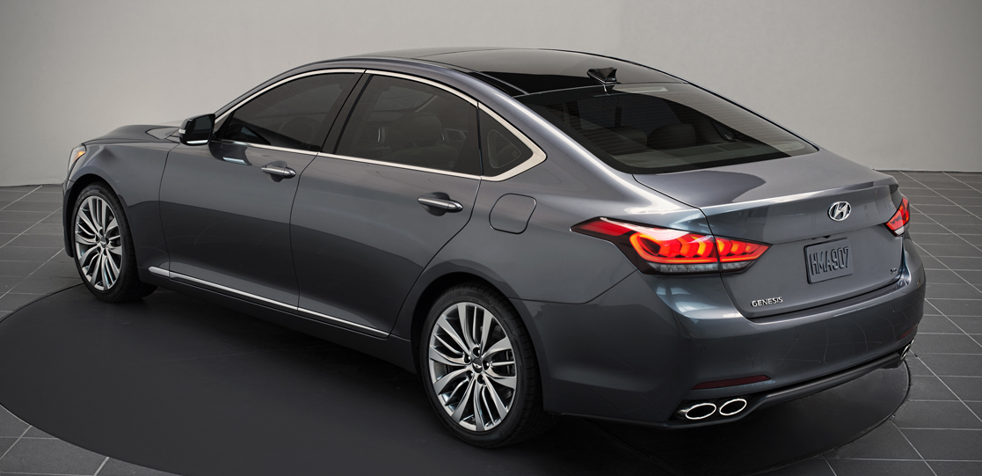

The single-frame 3D-hexagonal grille ensures the front end of the all-new Genesis is not only striking, depicted in semi-gloss chrome, but also encompasses available HID headlamps, LED indicators and fog lamps. In profile, the Genesis daylight opening is more expressive, with fluid lines and blended surfaces, a sleek C-pillar helping to emphasize the sporty styling. The rear of the all-new Genesis benefits from a sculptural aesthetic with jeweled, full-LED taillamps.
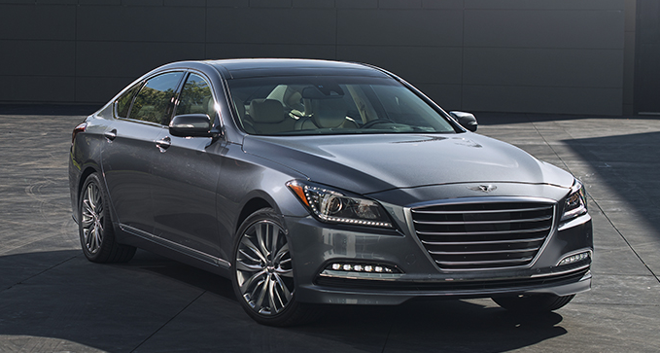

INTERIOR DESIGN
The cabin layout of all-new Genesis has been designed to benefit all occupants with a spacious, comfortable ambience. The simplification of the switchgear and instrument panel ensures an intuitive layout and open feel. This user-centric design has sought to connect the various interior parts effectively, particularly the center stack with the console, upper-instrument panel and B-pillar with the headliner. Genesis displays ultra-precise fit and finish, with ergonomic seat design and a generous, natural feel. Particular design attention has been paid to the storage of practical items such as mobile electronics of all shapes and sizes, along with the flexibility of the cup holders.
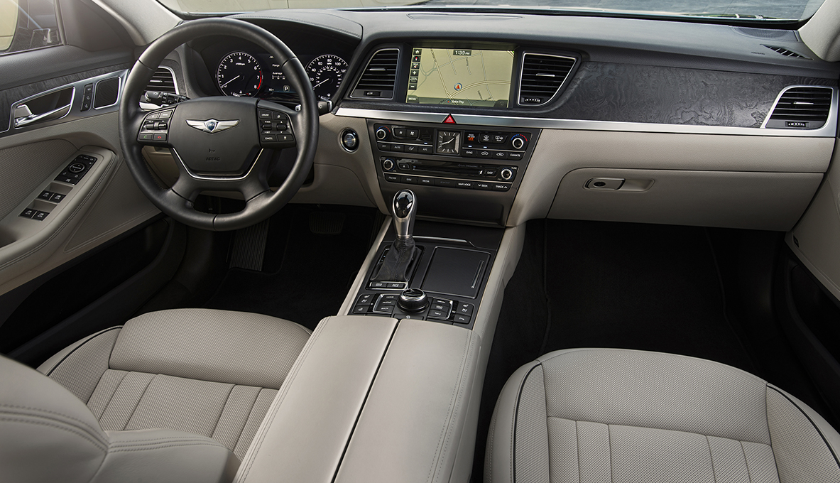

Total interior volume is an impressive 123.0 cubic feet, an advantage over key competitors. As part of this spacious interior design, the Genesis provides best-in-class front headroom and rear shoulder room.

 | Hyundai Genesis | Cadillac CTS | Lexus  GS | Infiniti  M | BMW  5-series | M-B  E-Class
Total Interior Volume (cu. ft.) | 123.0 | 110.7 | 113.3 | 118.5 | 116.0 | 113.1

Hyundai interior design principles – safety, intuitiveness and simplicity – guided the Genesis design team in redesigning all primary controls to deliver maximum ease of use. The steering wheel design and grip has been improved and onboard switchgear was redesigned; a number of switches previously found on the center console of the original Genesis were relocated and reshaped on the Genesis. Further ergonomic improvements to ensure ease of reach and control have been meticulously evaluated and executed using a specially-designed laboratory tool created to measure occupant operational force for ergonomics.
A new design pattern has been introduced to decrease relative interior reflections and brighten dashboard surfaces, while high-grade materials such as genuine aluminum and matte-finish wood are available. Cohesion between the center fascia and audio controls has been ensured through a streamlined design, making the two separate sections appear as one. To ensure a luxurious feel, Genesis was intensely scrutinized for its use of materials, with extensive analysis of the relationship of different materials, their texture and color coordination.
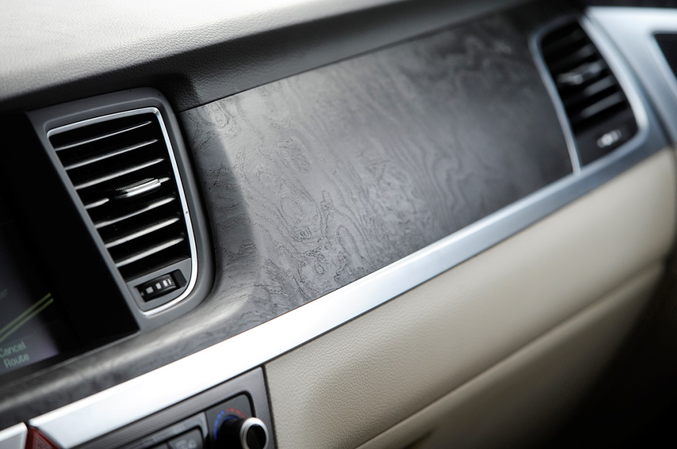

Driver and passenger posture are optimized using enhanced seat pad density, improved seat support technologies, such as adjustable driver’s seat power bolsters and seat cushion extension. Genesis seats offer 12-way power front seats, including 4-way power lumbar, heated front seats with available ventilation, as well as available heated rear seats. Seat materials and stitching quality have been enhanced with the introduction of double, rather than single stitching. The redesigned driver’s seat incorporates new functionality, with an available new air-pressure pump and controller valve, providing seatback bolster adjustment through individual air-cells located in the seat. With a total operating time under 8-seconds, the Genesis benefits from both a faster activation process and greater range of adjustment than many competitive rivals.
New interior-focused features for Genesis include available manual rear side sunshades for enhanced occupant comfort. Genesis passengers are also sure to appreciate the enhanced perspective of their surroundings via the new available panoramic sunroof.

NEW ULTRA-RIGID PLATFORM WITH AVAILABLE AWD
The 2015 Hyundai Genesis receives a redesigned platform to accommodate its new available HTRAC® AWD system, using no shared components with its previous generation. The platform employs even more ultra-high-strength steel, now over 50 percent of total platform composition. The benefits of strategic use of high-strength steel are immediately evident in 16 percent stiffer torsional rigidity and 40 percent stiffer bending rigidity compared with the highly-acclaimed first-generation architecture. As a result, the new Genesis is stiffer in both torsional and bending rigidity than the BMW 5-series.
Body and mounting point stiffness are also improved on the Genesis. Ensuring a smooth ride over rough roads was a top development focus, achieved by a more robust connecting structure, extensive laser welding, reinforced body and chassis mounting points, new hot stamping and dipping techniques for the B-pillar and roof sides, and an increased amount of high-strength steel in the chassis. Front shock towers are made of aluminum, and a diamond-shaped strut bar maximizes front structure rigidity for precise steering response. Front seat frames were also strengthened for greater rigidity.

PERFORMANCE CHASSIS
Fully leveraging this new, stiffer chassis is an all-new rear multi-link suspension, with newly optimized 5-link geometry and increased suspension travel for a broader envelope of both dynamic performance and ride comfort. Lateral suspension stiffness and overall ride comfort refinement were top priorities in its dynamic development. The fully-independent, 5-link front and rear suspension designs have increased stiffness compared with the original Genesis, with increased front and rear suspension travel, for greater wheel articulation and bump absorption over a variety of road surfaces. The reduction in camber angles when turning at speed results in improved steering feel, 23 percent less tire tilt, and increased lateral grip. New 18-inch and 19-inch alloy wheels are stronger and resist deflection forces for more precise suspension response to changing road surfaces.
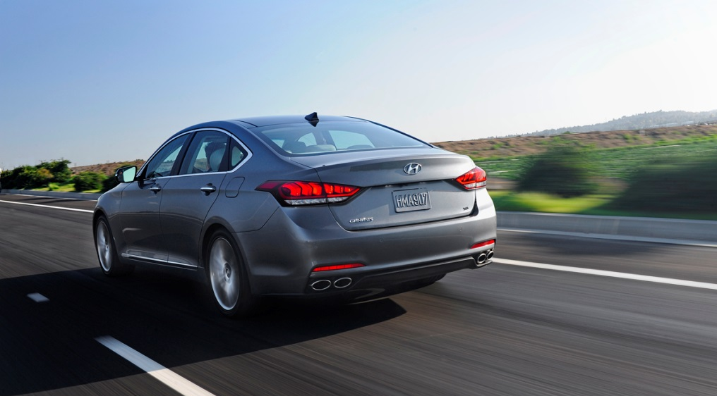
A Continuous Damping Control (CDC) suspension, available on the Genesis 5.0, helps increase control of body motions and body roll, allowing sportier roadholding to be complemented with a more comfortable ride character. Independent roll control characteristics are achieved using separate tuning controls: Normal mode helps provide superior ride comfort, while Sport mode helps increase damping forces for enhanced dynamic precision and control. Handling and roadholding also benefit from a well-balanced 52/48 ratio of front-to-rear weight distribution.
In addition, special focus was given to the development of Rack-mounted Motor Driven Electric Power Steering (R-MDPS), with a Variable Gear Ratio (VGR), helping to provide high-speed stability and more direct feel at low and medium speeds. These driving qualities are attained while retaining the incremental fuel economy benefits of an electric system over the higher parasitic losses of hydraulic systems.

NEW HTRAC® AWD AVAILABILITY
The 2015 Hyundai Genesis is offered with a choice of rear-wheel-drive or new HTRAC® All-Wheel-Drive (AWD) configurations. The new HTRAC AWD system was developed as a multi-mode system, providing an electronic, variable-torque-split clutch with active torque control between the front and rear axles. The system is very lightweight at 165 lbs.
The driver-selectable HTRAC Normal and Eco modes help provide confident control in all-weather conditions. The Sport setting gives a more agile feel by sending more available torque to the rear wheels, for a sporty rear-drive dynamic feel when desired. Further, to maximize efficiency, the system can direct more available torque to the rear wheels during steady-state highway cruising for reduced drivetrain frictional losses and noise. This system has a wider range of torque distribution variability than many competitive systems and has been tuned to variable conditions such as straight-line acceleration, medium- and high-speed cornering, and hill-starts. All modes are programmed in concert with Genesis’ Intelligent Drive Mode select.

DYNAMIC CHASSIS DEVELOPMENT AND TESTING
In addition to extensive on-the-road and laboratory testing, circuit-based testing of the Genesis took place in Germany, Korea and Hyundai’s California Proving Ground in the U.S. High g-force assessment of the new HTRAC AWD system was completed at the Korea International Circuit in Yeongam, the venue for one round of the Formula One World Championship. Durability and high-performance handling driving tests took place on the Nürburgring Nordschleife circuit in Germany to precisely calibrate Genesis ride, braking and handling characteristics. Furthermore, Hyundai engineers collaborated with top dynamics experts such as Lotus Engineering to further validate the performance capability of the Genesis.

MOST POWERFUL HYUNDAI V8 ENGINE
The heart of the Genesis 5.0 is the award-winning 5.0-liter Tau V8 engine producing 420 horsepower at 6,000 rpm and 383 lb. ft. of torque at 5,000 rpm. The Tau V8 engine family has been named to Ward’s prestigious Ten Best Engines list three times. With high-pressure direct injection for impressive power, low emissions and superb efficiency, this latest version of the Tau V8 benefits from an optimized intake runner length, enhanced timing chain for reduced friction and NVH, low-torque exhaust manifold, increased compression ratio and upgraded multiple-injection mapping. These enhancements combine to produce a flatter torque curve at lower rpm for even better driveability.
 | Genesis  5.0  5.0L V8 | Mercedes E550  4.6L V8 Turbo | Cadillac CTS  3.6L V6 | Infiniti M56  5.6L V8 | Audi  A6 3.0T  3.0L V6 SC
Horsepower (SAE) | 420@6000 | 402@5000 | 420@5750 | 420@6000 | 310@5500
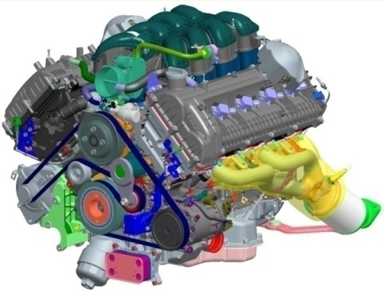
5.0-liter Direct Injection Tau V8 engine
The Tau’s high 11.8:1 compression ratio increases thermal efficiency and output. The Tau also has a rigid bed plate for improved block rigidity and lower NVH (Noise, Vibration, and Harshness), as well as camshaft carriers and a roller timing chain to improve valvetrain stability.
Even more, this V8 offers Dual Continuously Variable Valve Timing (D-CVVT), a tuned variable induction system, and low-friction coatings on piston skirts. This Tau engine will also run on regular fuel with only a small reduction in peak power, and no negative driving effects, whenever desired.
The Tau 5.0-liter V8 is mated to an eight-speed automatic transmission. This Hyundai-developed transmission offers enhanced shift logic and speed, better acceleration, sport-mode mapping, shifting smoothness, and transmission efficiency. All eight-speed transmissions include SHIFTRONIC® manual shift capability with conveniently-located steering wheel paddle shifters to enhance shifting ease during spirited driving.
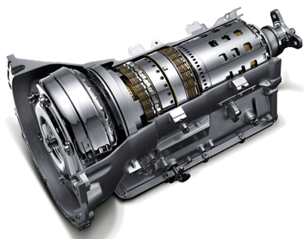
Hyundai-developed eight-speed automatic transmission

DIRECT-INJECTED LAMBDA 3.8-LITER ENGINE
The Genesis 3.8-liter direct-injected Lambda engine has also been further optimized to deliver a flatter overall torque curve at low rpm for enhanced driveability. Thoroughly improved for the new Genesis, this engine includes a three-stage variable intake system, triangular-pattern fuel injector for improved combustion, an air-gap exhaust manifold for better NVH, and an upgraded cylinder block with a variable-vane 2-stage oil pump for reduced parasitic losses. In keeping with its 5.0-liter V8 sibling, the Genesis 3.8-liter Lambda engine utilizes direct-injection and produces 311 horsepower at 6,000 rpm and 293 lb.-ft. of torque at 5,000 rpm. It also has a high compression ratio of 11.5:1 for greater thermal efficiency. The Lambda engine will run on regular fuel with only a small reduction in peak power, and no negative driving effects, whenever desired by the owner.
 | Genesis 3.8  3.8L V6 | Lexus GS  3.5L V6 | Mercedes E350  3.5L V6 | Cadillac CTS  2.0L Turbo | Audi  A6 2.0T  2.0L Turbo | BMW 535i  3.0L Turbo
Horsepower (SAE) | 311@6000 | 306@6400 | 302@6500 | 272@5500 | 220@4450 | 300@5800

The 3.8-liter engine also has Dual Continuously Variable Valve Timing (D-CVVT), variable induction, an all-aluminum block and heads, steel timing chain and iridium-tipped spark plugs. Besides horsepower and torque gains, direct-injection technology produces a significant reduction in emissions.
All 3.8-liter engines are coupled to the same eight-speed automatic transmission design as the Genesis 5.0. This Hyundai-developed transmission offers enhanced shift logic and speed, better acceleration, sport-mode mapping, shifting smoothness, and transmission efficiency. All eight-speed transmissions include SHIFTRONIC® manual shift capability with ergonomically-placed paddle shifters for spirited driving with manual shifting.

SAFETY TECHNOLOGIES
Genesis offers abundant standard safety features, including Electronic Stability Control (ESC), nine airbags, and anti-whiplash front head restraints. Genesis' nine airbags include advanced dual front airbags, driver’s knee airbag, front and outboard rear seat-mounted side-impact airbags, and roof-mounted side curtain airbags for both front and rear outboard seat occupants.
Although government crash testing for the new Genesis is not yet complete, the entire structure was engineered to meet the new Insurance Institute for Highway Safety (IIHS) Top Safety Pick + standard.
Daytime running lights come standard on Genesis. Further, Genesis offers a Lane Departure Warning System (LDWS). Whenever the system is activated, the haptic steering wheel will provide a vibration warning and dial-integrated warning light to alert drivers of their lane departure, allowing them to reposition the car smoothly into the correct position.
Even Genesis’ tire pressure monitoring system (TPMS) has been enhanced with individual tire pressure readouts available to the driver.
Genesis is brought to a halt by large four-wheel anti-lock disc brakes with Brake Assist and Electronic Brake Distribution (EBD). Genesis 3.8 models have large 13.6-inch front rotors, while the 5.0 has even larger 14.2-inch front rotors. Both braking systems use four-piston fixed monobloc calipers for precise braking responsiveness.

SENSORY SURROUND SAFETYTM TECHNOLOGIES
The 2015 Hyundai Genesis employs a suite of active driver safety technologies dubbed Sensory Surround SafetyTM. These features cover the full spectrum of safety, from driver alertness and focus to total occupant safety, and even the safety of other drivers around you.
Genesis offers a Hyundai first, Automatic Emergency Braking (AEB), utilizing sensor fusion technology to help avoid a potential collision or reduce its impact. With this system, Genesis will employ automatic braking whenever it detects another vehicle at an unsafe closing rate of speed. This system uses the Smart Cruise Control system and the forward camera from the Lane Departure Warning System (LDWS) to provide this extra margin of safety.

Automatic Emergency Braking (AEB) Functional Range
Speed | Brake Application | AEB Result
50 - 112 mph | Partial Braking | Collision Warning
5 - 50 mph | Full Braking | Collision Mitigation

Genesis’ Smart Cruise Control (SCC) incorporates stop-start functionality that functions seamlessly with the standard electronic stability control system. The new system for Genesis allows full function down to zero mph to operate seamlessly in stop-and-go traffic conditions, using the front-grille-mounted radar sensor. SCC enables the Genesis to help maintain safer, consistent spacing with the vehicle ahead in varied traffic conditions. The system can also help deploy an available Automatic Emergency Braking system should a stationary vehicle be detected ahead.
Genesis is generously equipped with new, advanced technologies, many of them Hyundai firsts. A new driver-selectable Intelligent Drive Mode allows drivers to select from four drive modes depending on conditions and driving preferences. Each drive mode alters transmission mapping, throttle responsiveness, stability control, and suspension damping settings, with specific modes adapted to function seamlessly with HTRAC AWD for those Genesis so equipped.

Intelligent Drive Mode | Type of Driving
ECO | Fuel Economy
NORMAL | Balanced
SPORT | Dynamic Focus
SNOW | Low-traction conditions

In addition to the above modes, Genesis features an Emergency Steering Support Mode which automatically changes the setting of suspension and electronic stability control (ESC) in the direction suitable for emergency steering, to help avoid frontal crash situations.
Genesis also debuts a new Blind-Spot Detection system (BSD), which helps monitor traffic around the car. The system uses radar sensors in the rear bumper to help warn the driver of an approaching vehicle in his or her blind spot via an indicator on the side mirrors. If the driver activates the lane change indicator and attempts to change the lane, ignoring warning indicators, BSD additionally issues an audible warning and haptic steering wheel vibrations. In addition, for Genesis’ equipped with the Head’s-Up Display, the BSD system indicators also project onto the windshield, nearer the driver’s view of the road, a segment first.
Lane Change Assist (LCA) performs a similar function to help detect vehicles approaching towards its rear side at high speeds, especially during higher-speed driving, while Rear Cross-traffic Alert (RCTA) scans areas to each side of the car when drivers are backing out of parking spaces. No other sedan in Genesis’ class offers the combination of Blind-Spot Detection (BSD), Lane Change Assist (LCA), and Rear Cross-traffic Alert (RCTA) active safety systems.
From the front, the available Lane Departure Warning System (LDWS) captures images of lanes and recognizes the lane marker. If LDWS detects lane departure, a warning signal is activated on the instrument panel while issuing a haptic steering wheel vibration warning. Working in concert with LDWS, Genesis’ Lane Keeping Assist System (LKAS) performs a similar function of LDWS, but LKAS additionally provides a driver-adjustable level of steering assist to help prevent inadvertent lane departure when a vehicle approaches the edge of a lane and also provides steering wheel haptic vibration feedback.
For convenience and safety, a High-beam Assist (HBA) function is also available. When switched to automatic mode, it detects both oncoming vehicles and vehicles in the same lane ahead at night and changes to low-beam as appropriate, reducing blinding effects on other drivers. Whenever there are no vehicles detected, the system automatically re-activates the high beams, maximizing the driver’s range of vision. To maximize driving visibility, Genesis offers HID headlamps with dynamic auto-leveling that compensates for varying vehicle loads.
To help ensure maximum driver alertness, Genesis also benefits from a world-first technology in its CO₂ sensor control system, located under the glove box. Hyundai engineers discovered that occupants start to get drowsy when CO₂ levels reached more than 2,000 parts per million, so the new ventilation system helps ensure the cabin maintains a CO₂ concentration well below that level at all times using freshly-ventilated ambient air. The system monitors the vehicle’s intake of fresh or re-circulated air using a dedicated CO₂ sensor.
The 2015 Hyundai Genesis also offers a parking assistance system with eight ultrasonic sensors located on the front and rear bumpers. The sensors, along with the rear backup camera, help detect how close objects are when parking. Distance is indicated on the in-dash screen and accompanied by an audible warning tone.

NVH REDUCTION
In pursuit of refined quietness within the Genesis cabin, Hyundai engineers analyzed idle noise and vibration, acceleration, road and wind noise, and audible booming throughout the bodyshell. Sound-absorbing materials and a low-noise fuel pump have been fitted, cowl bulkhead insulation and sealing improved, and vibrations minimized through an improvement in overall bodyshell rigidity. Additional insulation of the rear differential helps reduce booming and vibration, resulting in lower audible noise inside the Genesis passenger cabin.
Under acceleration, better sound quality has been achieved through mid-to high-frequency noise reduction, and dynamic engine sound improvements were achieved through intake and exhaust system tuning. Engine support brackets have been moved further apart for greater stiffness, while transmission and sub-frame mounts have been stiffened by up to 100 percent.
To improve NVH performance at cruising speeds (35-75 mph), Hyundai engineers increased the stiffness of parts associated with the sub-frames and suspension, lowering levels of cavity and rumble noise. To ensure Genesis recorded lower interior noise in crosswind conditions, doors were thickened, sunroof articulation reshaped, and changes were made to the sealing process for increased durability and performance. In addition, cowl bulkhead insulation and sealing has been improved, with the total weight of the sound insulation package used on the Genesis at only 84 lbs., yielding a remarkable NVH reduction-to-weight ratio.

DRIVER CONVENIENCE TECHNOLOGIES
Most Genesis competitors with hands-free trunk-opening technology use a leg-kick sensor under the rear bumper to enable the driver to open the trunk. Hyundai ergonomics engineers found this method to be difficult when an individual is carrying cumbersome packages, such as from shopping. So the Genesis Smart Trunk system was designed to open the trunk automatically if the smart key is detected in a pocket or purse within a few feet of the rear bumper for longer than three seconds, for maximum hands-free ease of opening when desired. This system allows the driver to keep both feet comfortably on the ground, simply waiting by the trunk a few seconds for it to open automatically. The Smart Trunk system also provides an audible warning and flashing light prior to opening.
Taking inspiration from aircraft technology, an available new Head’s-Up Display (HUD) projects a virtual image onto the windshield, enabling the driver to keep his or her eyes on the road using a system of mirrors combined with a TFT LCD display. The system utilizes a wide screen with adjustable brightness to ensure both excellent daytime and nighttime visibility. Driving information such as speed, Smart Cruise Control status, navigation, Blind Spot Detection, Forward Collision Warning, speed limit, Lane Departure Warning System and audio system data is projected at a perceived virtual distance approximately six feet ahead of the driver for maximum legibility while driving.
Genesis also offers an electronic parking brake with Automatic Vehicle Hold for convenience when driving in traffic. Automatic Vehicle Hold automatically holds the Genesis at a stop until the accelerator pedal is depressed, such as at a traffic signal or in stopped traffic. The vehicle hold re-engages whenever the vehicle is brought to a complete stop. Genesis also includes proximity-key entry convenience with push-button start as standard equipment.

MEDIA AND NAVIGATION SYSTEMS
Genesis offers an ultra-premium, Lexicon® Discrete Logic 7 Surround audio system with 17 speakers, Logic 7 Surround Sound processing and 12-channel digital amplifier with 900-watts of equivalent output, sure to satisfy the most demanding audiophile. The system also includes SiriusXM® Radio, HD Radio, and iPod/USB auxiliary media input jacks. The standard Lexicon system offers 14 speakers, with Discrete Logic 7 Surround processing and a 12-channel DSP amplifier with 900-watts of equivalent output.
An optional premium DIS navigation system for Genesis offers a 9.2-inch High Definition display, with 720p high definition (a segment first), a 64GB Solid State Drive (SSD) for multimedia, and premium Lexicon audio system. This premium system also includes Gracenote® album art, junction view with lane guidance, advanced voice recognition, and music/image/video storage via USB download (approximately 30GB of usable storage).
The new standard audio-navigation system, displayed by an 8.0-inch touchscreen, is packed with integrated technology, from Bluetooth to navigation, satellite and HD radio, hands-free and app-supporting software.
Genesis cluster displays utilize high-resolution, electroluminescent TFT LCD technology, with a standard 4.3-inch TFT LCD cluster display, and an available 7.0-inch TFT LCD cluster display.
A simple pop-up message appears to help pair a phone and the voice recognition software understands street addresses and cities all in one sentence. The route screen displays speed limits, details the next three maneuvers, shows real highway signage and has junction views with lane guidance. Lane guidance outlines the lane or lanes the driver needs to stay in when a highway splits. Junction view uses street and actual road sign images to match what the driver will see when arriving at the next maneuver.

SECOND-GENERATION BLUE LINK® ENHANCEMENTS
2015 Genesis will be the first Hyundai to offer its second-generation Blue Link and infotainment features. The scope of these new features is broad and has something special to offer every driver, including:
- Destination Search powered by Google – users will be able to take advantage of Google’s powerful destination search via the Blue Link button (voice recognition) and navigation display, or through myhyundai.com and the Blue Link mobile app sending a destination to their car
- Remote Start – now includes an engine timer (from 1 to 10 min.), remote stop, remote climate control and remote defroster
- Automatic Collision Notification (ACN) and SOS Emergency Assistance –includes user-selected emergency contacts notification via SMS and e-mail
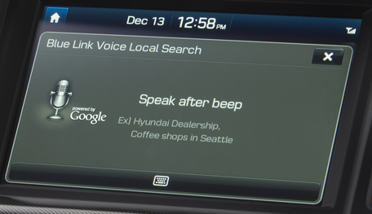

GENESIS INTELLIGENT ASSISTANT® APP
The Genesis Intelligent Assistant® is a proactive app for automobiles intended to save the driver time and provide an even higher level of convenience. The app combines Blue Link features, data from the vehicle, the owner’s smartphone, and the internet with multiple layers of intelligence. This allows the Genesis Intelligent Assistant app to send proactive notifications and recommendations to the Genesis owner in preparation for their drive.
Genesis owners will no longer need to remember to remote start their car on a hot or cold day. The Genesis Intelligent Assistant app will remind them via their smartphone.



Genesis Intelligent Assistant Functionality:
- By providing the app their commuting details and access to their smartphone’s calendar, owners can have the app automatically estimate appropriate departure times and send reminders for any upcoming appointments that require a drive
  - Departure reminder messages are determined by up-to-the-minute commute times from the user’s current location to the destination, accounting for traffic
  - Temperature outside the vehicle is determined via zip code prior to the estimated departure time. If the temperature is above or below the default level, the user will receive a notification, asking if they would like to remote start their vehicle for heating or cooling.
  - Recommendations for gas stations are provided, allowing the user to select a station and send the location to the vehicle’s navigation system.
- Vehicle health status will also be communicated through the user’s smartphone when an action is required. These notifications allow the customer to schedule service for their Genesis directly from the app.
- Many additional Blue Link features are included within the app, making it a single, integrated solution for all of the driver’s vehicle needs
- The Genesis Intelligent Assistant app is a framework for the future with additional proactive functionality progressively available to provide the customer with the ultimate luxuries of time and convenience

hyundai blue link google glass® app
Genesis demonstrates the Google Glass app as part of how wearable technology and Blue Link fit into a customer’s lifestyle. The app currently contains the core Blue Link functions as building blocks for future activities. Partnering with Station Digital Media and Covisint, Hyundai plans to expand the app features, building on the concept of “Time as the Ultimate Luxury” and leveraging the proactive functionality of the Genesis Intelligent Assistant app.
Released in limited numbers to early customers known as “Explorers,” Google Glass is a computerized, lightweight headset that can project text and images for the wearer to see on a special optical display. Google Glass Explorers can perform functions through voice commands, swipes or taps on a thin touchpad along the side of the frame.
Through the new app, Hyundai owners will be able to use Google Glass to access Blue Link’s vehicle safety, service and infotainment features. The Google Glass Blue Link app includes a host of popular functions at launch, including:
- Remote vehicle start
- Remote door lock/unlock
- Remote Find My Car (search for your vehicle location to receive directions to it)
- Point-of-Interest search sent to the Hyundai navigation system
- Search for a gas station to send to your car
- Call roadside assistance
- Talk to a Blue Link agent
- Locate nearby dealers

NEXT-GENERATION INFOTAINMENT SYSTEM
The Genesis next-generation infotainment system features:
- Integration with Apple’s Siri-powered “Eyes Free” mode
  - Functionality allows owners of compatible vehicles to perform a variety of in-car tasks without taking their eyes off the road.
- SD Navigation
- Pandora® integration with smartphone
- SoundHound® integration with internal modem
- SiriusXM® Audio – 6 presets (record, play, pause, back)
- SiriusXM® Travel Link and Traffic
  - Sports scores and schedules
  - Stock ticker
  - Movie times
  - Fuel prices
  - Weather/alerts
- Advanced voice recognition
- Screen-swipe technology
- Music, video, image storage

HYUNDAI ASSURANCE CONNECTED CARE POWERED BY BLUE LINK®
Hyundai’s telematics services program, Assurance Connected Care, is standard for three years on all 2015 Genesis sedans equipped with Blue Link. This innovative ownership program provides Hyundai owners with proactive safety and car care services via the Hyundai Blue Link telematics system. These services include Automatic Collision Notification, Enhanced Roadside Assistance, Automatic Diagnostic Trouble Code Notification, Monthly Vehicle Health Report and in-vehicle Car Care maintenance scheduling.
Hyundai also recently introduced an all-new mobile application for the Blue Link telematics platform. This mobile app allows subscribers to remotely access various optional Blue Link features and services through compatible mobile devices. Completely redesigned, the app has been significantly enhanced from the previous version and boasts a new user experience, faster navigation and innovative new features. Google Android and Apple iOS users can download the app from Google Play or Apple iTunes, respectively. A BlackBerry version is also available.
Blue Link is an innovative telematics solution that brings seamless connectivity for safety, service and infotainment capabilities and is offered in three packages: Assurance, Essentials and Guidance. More details regarding Hyundai Blue Link are available at www.HyundaiBlueLink.com.

HYUNDAI MOTOR AMERICA
Hyundai Motor America, headquartered in Costa Mesa, Calif., is a subsidiary of Hyundai Motor Co. of Korea. Hyundai vehicles are distributed throughout the United States by Hyundai Motor America and are sold and serviced through more than 820 dealerships nationwide. All Hyundai vehicles sold in the U.S. are covered by the Hyundai Assurance program, which includes the 5-year/60,000-mile fully-transferable new vehicle limited warranty, Hyundai’s 10-year/100,000-mile powertrain limited warranty and five years of complimentary Roadside Assistance. Hyundai Assurance includes Assurance Connected Care that provides owners of Hyundai models equipped with the Hyundai Blue Link telematics system with proactive safety and car care services complimentary for three years. These services include Automatic Collision Notification, Enhanced Roadside Assistance, Vehicle Diagnostic Alert, Monthly Vehicle Health Report and in-vehicle service scheduling.

For more details on Hyundai Assurance, please visit www.HyundaiAssurance.com

Please visit our media website at www.hyundainews.com and our blog at www.hyundailikesunday.com

Hyundai Motor America on Twitter | YouTube | Facebook

