“TRIP FLIP”
Season 3 Episode Highlights

(Listed in alphabetical order)

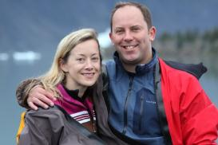
Alaska
Travelers: Caren & Dan – Married
Hometown: Richmond, Virginia
Adventures: Dogsledding with an Iditarod dog team, glacier paddle boarding, survival training, glacier ice climbing, wild salmon fishing and more

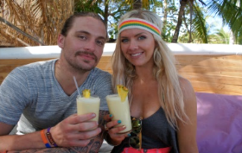
Costa Rica (*SEASON PREMIERE* – EPISODE 2)
Travelers: Kimi & Gabe – Dating
Hometown: Boise, Idaho
Adventures: Whitewater rafting on the Naranjo River, overnight in a jungle tree house, gyrocopter tour, 90-mph face first zip line, Envision Festival and more

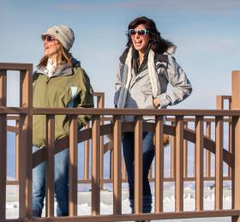
Idaho (*SEASON PREMIERE*)
Travelers: Angela & Sara – Friends
Hometown: Orlando, Florida
Adventures: Snake River Base jumping, sturgeon fishing, skijoring (skiing by horse), Snow Box Derby, rock crawling and more

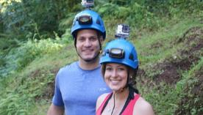
Kauai, Hawaii
Travelers: Aisling & Mark – Dating
Hometown: North Andover, Massachusetts & New York, New York
Adventures: Swimming with sharks, helicopter to Jurassic Park Falls (Manawaiopuna Falls), nighttime paddle boarding, camping in a stingray tent, wild boar hunting and more

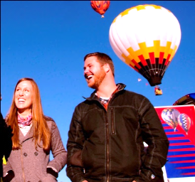
New Mexico
Travelers: Sarah & Levi – Engaged
Hometown: Orlando, Florida
Adventures: A visit to the ‘Breaking Bad’ car wash and mock meth lab bust, hot air ballooning at the Albuquerque Balloon Festival, mountain biking, MMA training, a spontaneous wedding and more

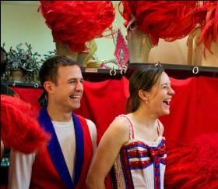
Paris, France
Travelers: Heather & Craig – Newlyweds
Hometown: Commerce City, Colorado
Adventures: Amphicar driving in the Seine River, Moulin Rouge show and backstage experience, dinner in the dark, hide-and-go-seek and wine tasting in a private castle and more

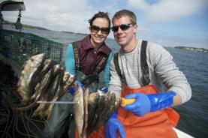
Portland, Oregon & Portland, Maine
Travelers: Sue & Brandon – Married
Hometown: Portland, Tennessee
Adventures: Waterfall jumping, Zoobombing (downhill biking), competing in the Lumberjack Olympics, spending the night in a lighthouse, cross-country private jet ride, shark fishing and more

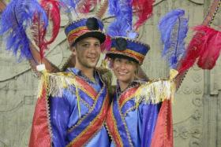
Rio de Janeiro, Brazil
Travelers: Adnan & Kristin – Dating
Hometown: Boulder, Colorado
Adventures: Helicopter tour around Rio’s famed Christ the Redeemer statue, wakeboarding, dancing in the Sambodromo Parade, paragliding, playing soccer in a mountainside favela with local kids and more

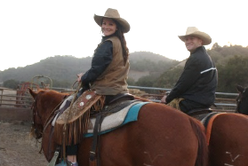
San Francisco/Los Angeles, California
Travelers: Lindsey & Scott – Newlyweds
Hometown: Tampa, Florida
Adventures: San Francisco to Los Angeles adventure, sequoia tree bungee jumping, dune buggies, cattle herding, surfing with a pro and more
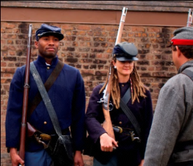
Savannah, Georgia
Travelers: Beth & Jamar – Dating
Hometown: Anchorage, Alaska
Adventures: Vintage race car driving, inflatable blob balloon launch, gator wrangling, ATV mud bog soccer, Civil War re-enactment and more

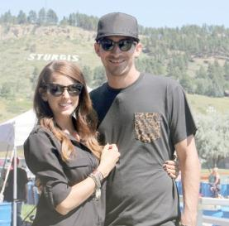
Sturgis, South Dakota/Motorcycle Road Trip
Travelers: Allison & Brinton – Newlyweds
Hometown: Mesa, Arizona
Adventures: Skydiving, motorcycle road trip, buffalo hunting on the Crow Indian Reservation, motorcycle racing at the Jack Pine Gypsy racetrack, stunt ride show and more

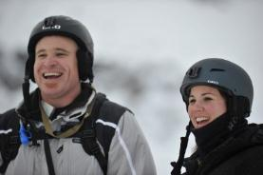
Swiss Alps, Switzerland
Travelers: Leann & Adam – Married
Hometown: Madison, Georgia
Adventures: Heli-skiing, night tobogganing, curling, overnight in an igloo, glacier canyon swing and more

**Additional “Trip Flip” locations include Florida – Details TBD**

# # #

