The Causeway Coastal Route

Contents
- About the Causeway Coastal Route
- Press releases
- Route highlights
- Fast facts about the Causeway Coastal Route
- Story ideas
- Video links
- Images
- Useful links

About the Causeway Coastal Route
Welcome to what is rightfully known as ‘One of the World’s great road journeys’: The Causeway Coastal Route. This route weaves along an epic coastal stretch of Northern Ireland between the cities of Belfast and Derry~Londonderry. The route takes in a rich tapestry of rolling hills, crumbling castles and epic coastal stretches punctuated by towering sea cliffs and golden beaches.

Press releases
- USAToday.com - Angling in Northern Ireland Features a range of angling locations within the Causeway Coast and Glens region: http://goo.gl/pe7YR8
- BBC.co.uk - Surfer rides Giant's Causeway Wave. Watch video footage here: http://goo.gl/CIjWUE

YourGolfTravel.com - Features Royal Portrush, County Antrim as one of the top 20 courses you can play: http://goo.gl/5WhtQ8

Guardian.co.uk - The UK's Best Beaches, including beaches on the Causeway Coastal Route http://goo.gl/y9qpCs

World Travel Guide – Overview of Northern Ireland's Coastal Route http://goo.gl/HDPO4d

Causeway Coastal Route highlights

The Giant’s Causeway
Steeped in myth and legend, the Giant’s Causeway is one of the most spectacular landscapes on the planet. Roughly 40,000 hexagonal columns blanket the area, petering out into the ocean. Legend holds that two warring giants caused the Causeway, but the reality of intense geological pressures is no less epic. This is a sight to behold.

Game of Thrones
The Causeway Coastal Route is home to several key locations from the smash hit TV series Game of Thrones. George RR Martin’s epic fantasy tale needed a location that could match the storyline for drama. Visit famous locations from the show and step into the real life Westeros.

Carrick-a-Rede Rope Bridge
If you’re looking for a rush, you’ve found it. The Carrick-a-Rede Rope in County Antrim connects to rocky islands along the coast. Spanning a chasm 23meters deep, the old adage ‘don’t look down’ springs to mind. But don’t worry, it couldn’t be safer. Open your eyes and stunning coastal views of Rathlin Island and the Larrybane Headland will be your reward. Mark this in the ‘must-do’ category.

Dunluce Castle
As well as being surrounded by tales of whaling banshees, sieges and battles, Dunluce Castle is possibly the most picturesque castle in the world. Perched precariously against a sea cliff, an entire section of the castle once fell into the ocean! With stunning sea vistas and a tragic romantic history, a visit to Dunluce is too good to miss.

Mussenden Temple
Sitting handsomely atop a 120foot high sea cliff, Mussenden Temple was built in 1785 and looks like a relic of ancient Greece or Rome. A bracing coastal walk to Mussenden Temple reveals glorious views over Downhill Strand and Castlerock beach.

Giro d’Italia 2014
The Giro d’Italia is one of the most famous cycling races in the world. It began in Italy in 1909 and has taken place annually ever since (barring during the two World Wars). This year the race begins in May 2014 in Belfast. The choice of an Irish Grande Partenza is historic. The famous landscapes of the Causeway Coastal Route, Northern and Southern Ireland will be on view via the global television broadcast the Giro achieves.
While on the island of Ireland the Giro d’Italia will go through three stages. They are:
- Stage 1 Belfast to Belfast
- Stage 2 Causeway Coastal Route to Belfast
- Stage 3 Armagh to Dublin
For more information on the Giro D’Italia see: http://www.girostart2014.com/

Causeway Coastal Route: fast facts

The route
- The Causeway Coastal Route is 120 miles long or 193km.
- One of the world’s great road journeys
- The Causeway Coastal Route stretches from Belfast city to the city of Derry~Londonderry
- The HBO TV series Game of Thrones is filmed in several locations along the Causeway Coastal Route.
- Key location for 2014 Giro d’italia Grande Partenza

Belfast
- The most famous ship in the world, Titanic, was built in Belfast City.
- Titanic Belfast is the largest Titanic attraction in the world.
- The exterior of Titanic Belfast is modelled on the hulls of four ships.

The Giant’s Causeway
- The Giant’s Causeway is an official UNESCO World Heritage Site
- There are roughly 40,000 hexagonal columns on the Giant’s Causeway.
- The Giant’s Causeway once featured in the artwork for a Led Zepplin C.D.

Derry~Londonderry
- Derry~Londonderry is one of the only entirely walled cities in Europe.
- The walls surrounding Derry~Londonderyy were built in the 17th century.
- Derry~Londonderry is the second largest city in Northern Ireland.

Other highlights along the route
- Glenariff Forest Park is located in Glenariff, one of County Antrim’s famous nine glens and known as the Queen of the Glens for its outstanding natural beauty.
- According to legend St Patrick once worked as a shepherd on Slemish Mountain, County Antrim.
- An entire section of County Antrim’s Dunluce Castle once broke off and fell into the ocean.
- The Old Bushmills Distillery in County Antrim is the oldest operating licensed distillery in the world.
- During WWII Allied troops stayed at the Bushmills Distillery.
- The Carrick-a-Rede rope bridge links the mainland to the tiny island of Carrick-a-Rede off the coast of County Antrim.
- Rathlin Island off the coast of County Antrim is just six miles long, one mile wide, and home to about 70 people.
- Mussenden Temple in County Londonderry was built in 1785 and was modelled on the Temple of Vesta, in Tivoli near Rome.

Things to do along the way
- Angling
- Cycling
- Horse riding
- Golf
- Walking
- Water sports

Festivals along the Causeway Coastal Route

Belfast Festival at Queens
For over 50 years Belfast Festival at Queens has been lighting up the city with music, dance, drama, poetry, literature, comedy and visual arts. The festival attracts the biggest names in the world– everyone from Laurence Olivier to Jimi Hendrix has taken part. http://www.belfastfestival.com/

Belfast Nashville Songwriters Festival
The Belfast Nashville Songwriters' Festival is a celebration of the art of song writing and with more than one hundred artists performing over 10 days in 50 events, Belfast will come alive to the sound of singer-songwriters from Northern Ireland and around the world. http://www.belfastnashville.com/

City of Derry Jazz Festival 2014
The City of Derry Jazz and Big Band Festival takes place each year over the May Bank Holiday weekend and in 2014 organisers Derry City Council promise a programme, jam packed with festival favourites along with some of the biggest stars and newest names on the jazz scene. http://www.cityofderryjazzfestival.com/

Banks of the River Foyle Halloween Festival
A spectacular Halloween festival along the banks of the River Foyle. Carnival rides, festive foods and fun for all the family.
http://campaign.derrycity.gov.uk/default.aspx

Story ideas

Game of Thrones
How you can visit the real-world Westeros - Game of Thrones locations on/near the Causeway Coastal Route.

Myths and legends of Northern Ireland
Link to three day itinerary available on http://www.causewaycoastandglens.com/Myths-and-Legends-Tour.T1104.aspx

Epic Ireland
Explore some of Ireland’s most spectacular scenes, from the Giant’s Causeway to Dunluce Castle along the Causeway Coastal Route.

Historic Northern Ireland
Historic visitor attractions such as Dunluce Castle, Mussenden Temple, Magilligan Martello Tower and Glenarm Castle Estate and Walled Gardens.

Video links
- Explore the Causeway Coast of Glens: Explore more of the Causeway Coast and Glens: http://www.youtube.com/watch?v=Qq78EyTDSKQ
- Discover Northern Ireland Causeway Coastal Route: http://www.youtube.com/watch?v=ihIrYWmFDKY

Images

Tourism Ireland images:
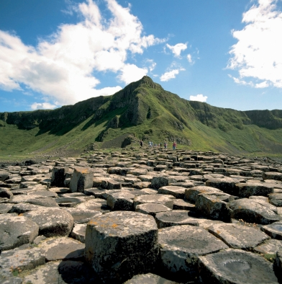
small_A0205_Giants-causeway
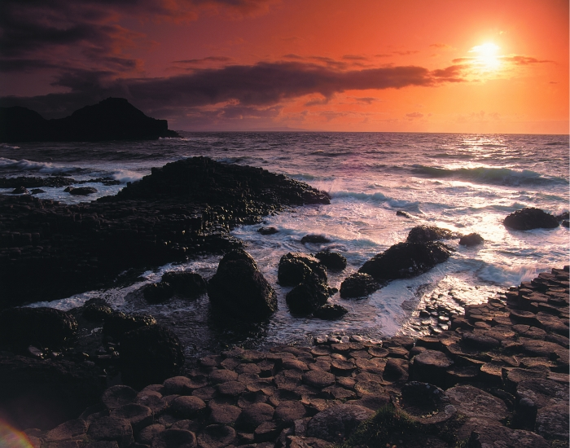
small_ccg_120310_001_giants-causeway

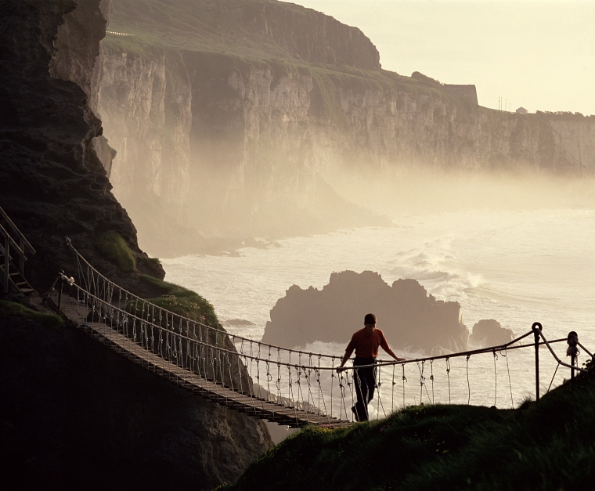
small_ch_120310_050_carrick-a-rede

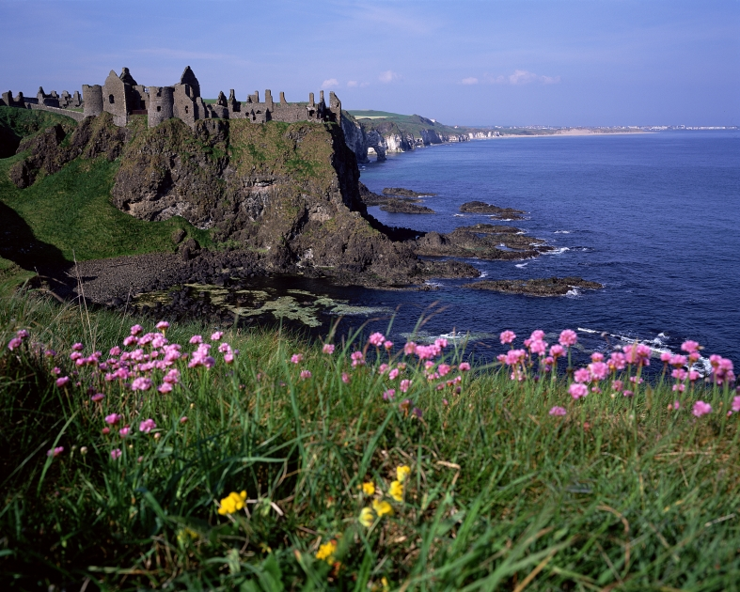
small_ch_120310_059_Dunluce-castle
Note: More images available from Tourism Ireland and Northern Ireland Tourist Board

Useful Links:
- http://www.causewaycoastandglens.com
- https://www.facebook.com/CausewayCoastandGlens

