Electronic Press Kit_US

The Wild Atlantic Way

Contents

- Press releases
- Event highlights
- Fast facts about the Wild Atlantic Way
- Story ideas
- Video links
- Images

About The Wild Atlantic Way

The Wild Atlantic Way will be Ireland’s biggest tourism story for 2014. Stretching 2,500km from County Cork on the south coast, to Donegal in the northwest, the Wild Atlantic Way is the longest coastal touring route in the world.

Taking in seven counties and three provinces (Ulster, Connaught and Munster) the route is defined by its spectacular Atlantic views, a generous scattering of islands and swathes of dramatic coastal scenery including cliffs and peninsulas.

The Wild Atlantic Way can be driven, walked or cycled and avoids main roads and highways, keeping the route more local and closer to the communities who live there.

Press releases

- Failte Ireland: Final Route for the Wild Atlantic Way unveiled

- Failte Ireland: Local Communities invited to get behind Wild Atlantic Way

Wild Atlantic Way Highlights

- The Old Head of Kinsale, County Cork
- Mizen Head, County Cork
- Dursey Island, County Cork
- The Blasket Islands, County Kerry
- The Aran Islands, County Galway
- Galway City
- Cliffs of Moher, County Clare
- Fanad Head, County Donegal
- The Inishowen Peninsula, County Donegal
- Malin Head, County Donegal
- Slieve League Cliffs, County Donegal
- Downpatrick Head, County Mayo

Wild Atlantic Way: Fast facts

The Route
- The Wild Atlantic Way runs 2,500km in length along the West coast of Ireland.
- The Wild Atlantic Way is the longest designated coastal route in the world.
- It begins in the Inishowen Peninsula in County Donegal and ends in Kinsale, County Cork.
- The route takes in 7 counties. They are Cork, Kerry, Limerick (briefly), Clare, Mayo, Sligo and Donegal.
The Counties
- County Cork is the largest county on the island of Ireland.
- County Kerry has won the All Ireland Senior Football Championship more times than any other county.
- County Limerick is the 2014 City of Culture.
- County Clare is home to the mighty Cliffs of Moher, which have featured in various big-budget Hollywood movies including The Princess Bride and Harry Potter and The Half Blood Prince.
- County Mayo is home to Croagh Patrick, the mountain where St Patrick once fasted for 40 days.
- County Sligo is home to Benbulben Mountain and is also the home county of the brothers W.B Yeats (poet and Nobel Laureate) and Jack B. Yeats (the artist).
- Ballyshannon in County Donegal was the birthplace of famous guitarist Rory Gallagher. A festival is held in his memory there every year.
- Along the Wild Atlantic Way are 16 stand-out experiences known as ‘Signature Discovery Points’. They are:

- Malin Head, County Donegal
- Fanad Head, County Donegal
- Sliabh/Slieve League Cliffs, County Donegal
- Mullaghmore, County Sligo
- Downpatrick Head, County Mayo
- Keem Strand, County Mayo
- Killary Harbour, County Galway
- Derrigimlagh Bog, County Galway
- The Aran Islands, County Galway
- Cliffs of Moher, County Clare
- Loop Head, County Clare
- Skellig Michael, County Kerry
- The Blasket Islands, County Kerry
- Dursey Island, County Cork
- Mizen Head, County Cork
- The Old Head of Kinsale, County Cork

Things to do along the way
- Angling
- Cycling
- Horse riding
- Golf
- Walking
- Water sports

Festivals along The Wild Atlantic Way

Puck Fair: Killorglin, County Kerry (Aug 10-12, 2014)

Held in the modestly sized town of Killorglin, this annual festival sees a goat crowned King. A human Queen, is also chosen, among a broad range of family-centred events. The event in 2013 marked the festival’s 400th year.

Dingle Food Festival: Dingle, County Kerry (TBC)

Considered one of the finest food festivals in the country, the Dingle Food Festival was founded in 2007 and hosts the Blas Na hÉireann (Taste of Ireland, in English) awards which sees a range of producers awarded gold, silver and bronze medals in over 30 categories. The festival also includes a Taste Trail where visitors purchase ‘taste tickets’ allowing them samples of food in associated venues.

Lisdoonvarna, County Clare (Sep 2014)

Held in the spa town of Lisdoonvarna, this eccentric annual festival is run by Ireland’s most noted ‘matchmaker’ Willie Daly (Daly claims to be born on 1 April, 1943, but can’t be sure as the priest who recorded the date was ‘very fond of the drink’). In its 157th year, 2013, the festival openly welcomed the LGBT community to take part.

Cape Clear Storytelling Festival (TBC)

Cape Clear island lies 8 miles off the County Cork coast and is Ireland’s most southernmost populated island. In 2014, the festival will celebrate its 19th year of bringing world-renowned Irish and international storytellers to Cape Clear.

Westport Food Festival (TBC)

Named the best place to live in Ireland in 2012 by the Irish Times and its readership, Westport’s reputation as a holiday destination is reinforced each summer by its food festival. A festival village, like cooking demonstrations and a Best of Westport Tasting Tour are some of the highlights.

Listowel Writer’s Week: Listowel, County Kerry (28 May – 1 June 2014)

A lively exchange of literary ideas, guest appearances and author workshops, the Listowel Writes’ week will enter its 43rd year in 2014. The current president of the festival is the Man Booker Prize Winner, Colm Toíbín.

Rory Gallagher International Tribute Festival: Ballyshannon, County Donegal (29 May – 14 June)

Both County Donegal (where he was born) and County Donegal (where he spent much of his childhood and teenage years) lay claim to the genius of Rory Gallagher, but it is in the former where the most large-scale festival in his honour is held. A bronze statue of the guitarist stands in the town where the festival takes place over three days and includes free open air concerts and rock pub sessions.

Story ideas

The comic and the coast

For years of his adult family life, Charlie Chaplin holidayed with his family in the coastal County Kerry town of Waterville. That legacy is continued with a comedy festival in his name and honour in the very town where he spent countless summers with his wife and children.

The Island Authors

The Great Blasket Island is the largest of a stunning series of islands of the coast of Kerry. This remarkable island has been home to some of Ireland’s favourite authors. What is it about this island that inspires such literary greatness? We investigate.

The Best of the West

The visit and explore the most epic sites and scenes along the Wild Atlantic Way from the Old Head of Kinsale in Cork, the Blasket Islands off the coast of Kerry, Fanad Head in Donegal and places in between. Find the best places to eat, drink and experience the best of the West.

The Wild Atlantic Way: An Island Odyssey

From the Blasket Island off the coast of Kerry, to the Aran Islands, Inishbofin and Arranmór off the coast of Donegal, The Wild Atlantic Way offers a chance to explore Ireland’s islands. Each island has its own unique character and style. As different as each island is, though, cosy pubs with traditional Irish music sessions, ancient ruins and friendly locals are traits share by all.

Video Links
Tourism Ireland: US final 30 sec, which aired on TV 26th December:
https://www.mpctv.com/shared.pl?a=1077b5J8H&b=50001
Click on Full screen icon on media player once loaded

Failte Ireland: Commercial overview of the Wild Atlantic Way (3:08)

Synopsis: A visually impressive video with voice-over of the Wild Atlantic way and some of the key locations along the route.

Failte Ireland: People of the Wild Atlantic Way (1:35)

Synopsis: An introduction to some of the producers, tour guides and tourism-related business who live and work on the Wild Atlantic Way. Includes local recommendations as to what makes the route unique.

Useful Links:

Failte Ireland: Secrets of the Wild Atlantic Way (PDF)

Features an extensive overview of the main highlights of the Wild Atlantic Way; features maps of the sections along with ‘secrets’ (highlights) for each region and contact information for national and regional tourist offices both abroad and in Ireland.

Tourism Ireland (Ireland.com): Wild Altantic Way itineraries

Includes 8 extensive itineraries (5 extended linear and three more modest epicentres) including countless highlights, background on the key destinations and suggestions for accommodation and things to do in the areas.

Tourism Ireland images:

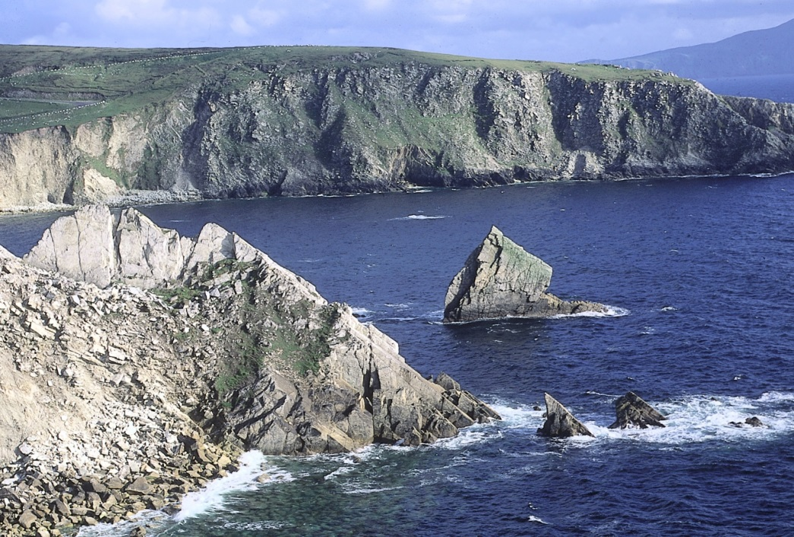
Achill Island, County Mayo

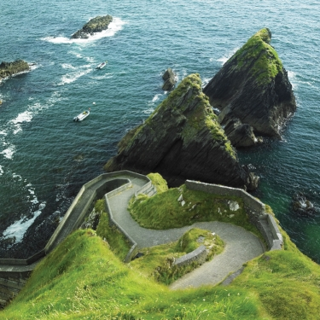
Dingle, County Kerry

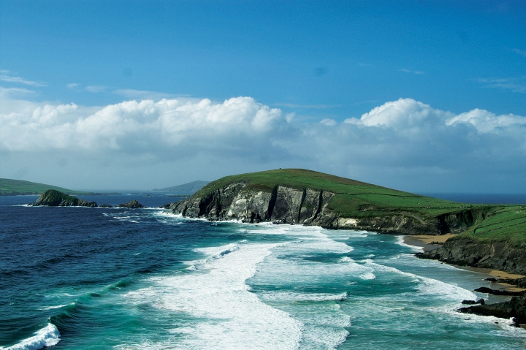
Coumeenole Beach, County Kerry

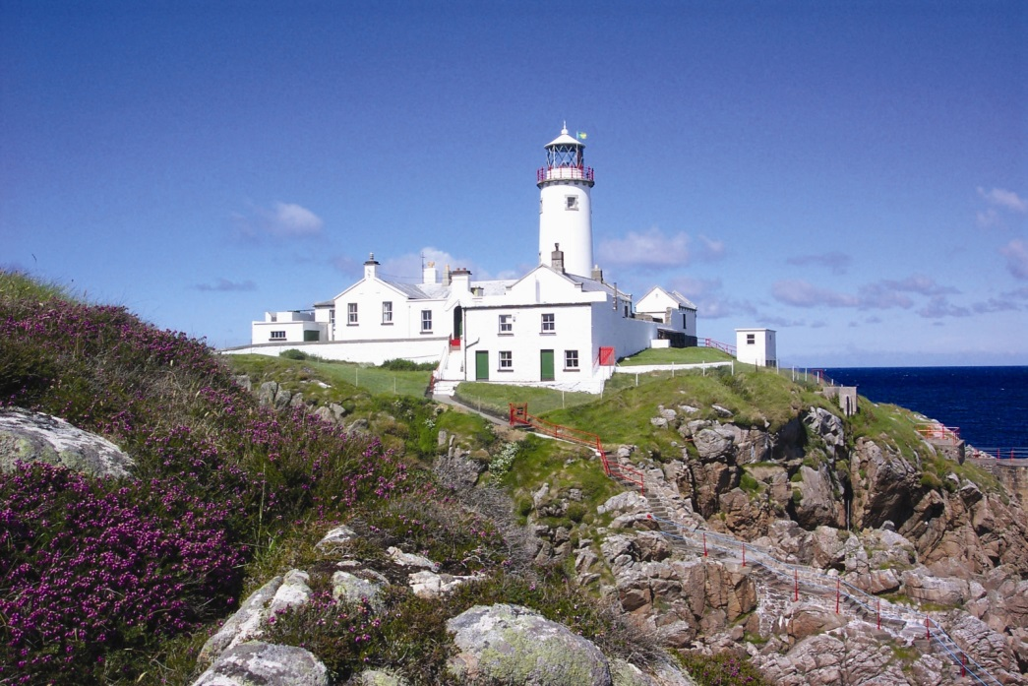
Fanad Lighthouse, County Donegal

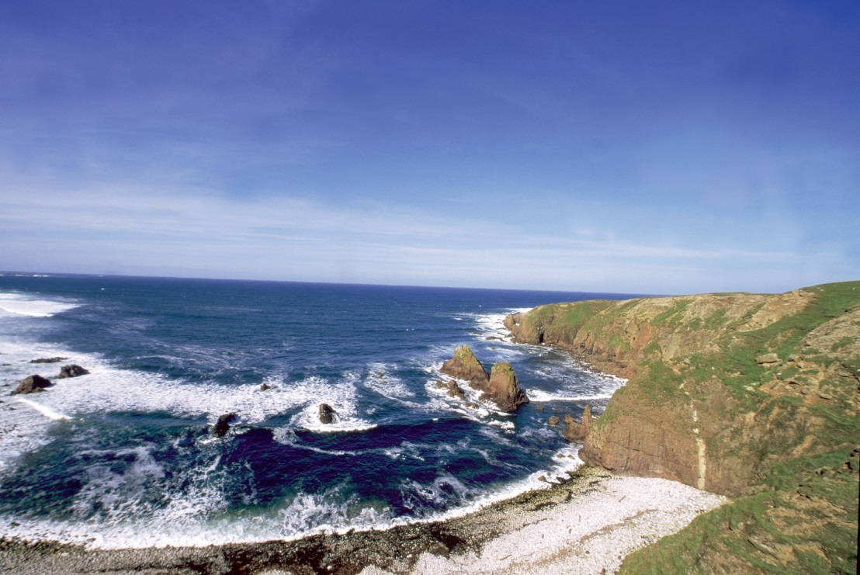
Bunglass, County Donegal

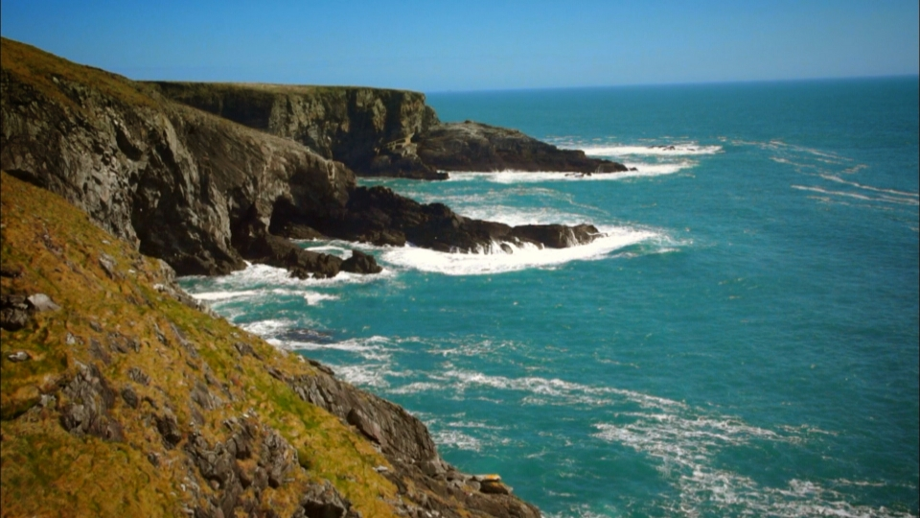
Mizen Head, County Cork

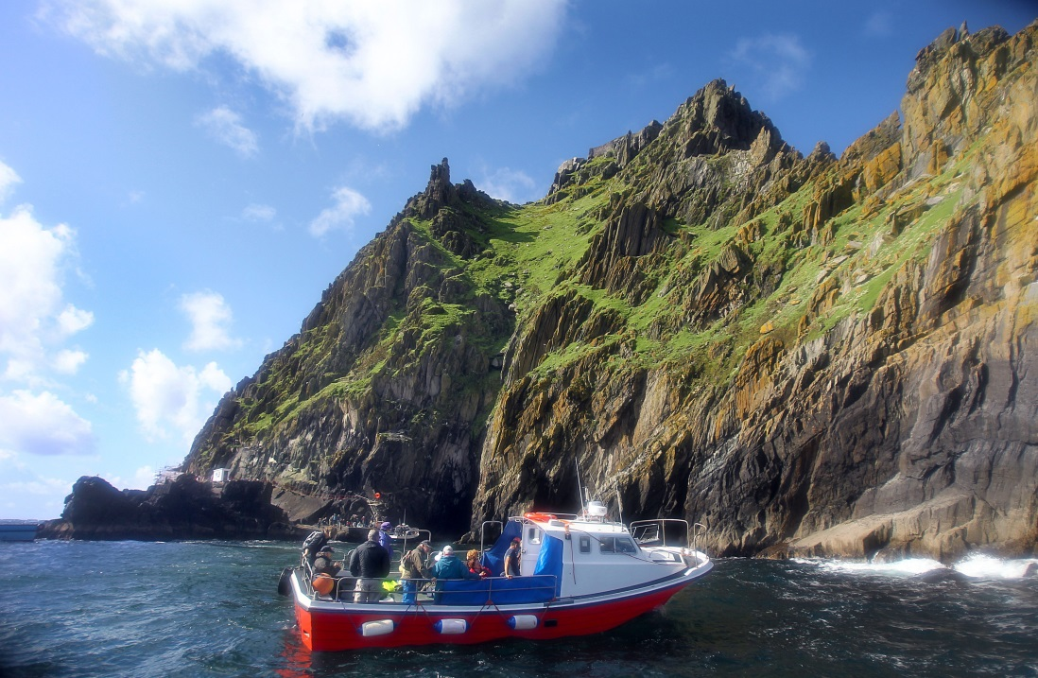
Skellig Island, County Kerry

***ENDS***

