Electronic Press Kit_US

Limerick City of Culture

Contents
- About Limerick City of Culture 2014
- Press releases
- Event highlights
- Fast facts about Limerick City of Culture and Limerick
- Story ideas
- Video links
- Images
- Useful links

About Limerick City of Culture
2014 is a very special year for Limerick. This ancient city by the Shannon is Ireland’s very first City of Culture and the party is already in full swing. Picture food festivals in medieval buildings, pop-up exhibitions in the middle of Victorian parks, museums in old schoolrooms, circuses in warehouses… culture lining the very streets.
Limerick City of Culture gathers the creativity, imagination, quirkiness, history, storytelling, food, legends, crafts and dreams of a whole country together in one remarkable city. A true celebration of what the Irish are all about. So if you ever wanted to get to know the real Ireland, then Limerick City of Culture will show you the best it has to offer.

Press releases

Limerick lights up as Ireland’s first City of Culture (January 2014)
The historic city of Limerick is Ireland’s inaugural City of Culture for 2014, and with over 200 performances and exhibitions lined up it looks set to put on quite a show.
International, national and local acts will present a varied programme of cultural expression including street events, visual art, music, Secret Limerick, food, fashion and craft, children’s events, architecture and sport.
The year of cultural celebration kicked off in January with a performance of Riverdance, composed by Limerick-born Bill Whelan, and which is celebrating its 20th anniversary this year.
Another highlight of the City of Culture year will take place in March (13–22) when the city hosts the Irish premiere of the sell-out London show, Fuerza Bruta.
This dance-circus-theatre fusion features astonishing visual effects, including the image of a man bursting full throttle through a series of moving walls, and a watery world suspended just above the audience’s heads.
The all-standing show promises to deliver sensory overload and is billed as a theatrical experience of edgy non-stop entertainment.
In June, Ireland’s most famous flautist, Sir James Galway will perform with the RTÉ National Symphony Orchestra, just one of a number of heavyweights from the world of music that will perform in Limerick during the year.
On a different musical note, Cranberries musician Noel Hogan will participate in ‘Pigtown Fling’, which will tour the city in a music bus throughout 2014 to encourage and support local musicians to create original work (‘Pigtown’ is one of Limerick’s nicknames, referring to the city’s thriving bacon curing industry.)
While 2014 is sure to be Limerick’s year in the cultural spotlight, there are many reasons to visit the city at any time.
One of these is the imposing medieval King John’s Castle, which sits in the heart of Limerick City and has recently undergone a multi-million euro makeover.
The 800-year-old castle now boasts a new visitor experience, which presents the dramatic history and archaeology of the site in an exciting, modern and multi-sensory way.
Another must-see visitor attraction is the Frank McCourt Museum, which celebrates the work of this Pulitzer Prize winner. McCourt spent much of his youth in Limerick, an experience that inspired his famous autobiographical novel, Angela’s Ashes.
Limerick is also a city that worships sport, and was designated European City of Sport 2011.
Rugby fans should not miss a visit to Thomond Park Stadium, the home of Munster rugby.
A tour of the stadium includes a visit to the Munster Experience Museum, which tells the history of the stadium, and a visit to the Munster Interactive Museum, a spectacular hands-on experience.

New Year heralds Limerick City of Culture epic (December 2013)
A New Year’s Eve carnival will call ‘show time’ on the most varied and all-embracing year of cultural expression ever staged in Ireland, as the city of Limerick prepares to take on the mantle of the first national City of Culture.
The carnival will ring in a cultural outpouring all through 2014 as a phalanx of leading and critically acclaimed international, national and local acts stand by to deliver a landmark programme of unparalleled cultural expression and performance.
The televised New Year’s Eve extravaganza will feature a Procession of Light; complete with illuminated floats, carnival, drama and community performers, and will meander through the city to the majestic King John’s Castle on the banks of the River Shannon.
It will include a concert, with tens of thousands of spectators set to be treated to a midnight fireworks and special effects spectacular.
The City of Culture launch event will set up a year of theatre, drama, sport, literary and artistic endeavour across 13 different themes and featuring a number of Irish premieres as well as specially commissioned pieces.
Highlights will include the 20th anniversary world tour of the Irish dance spectacular Riverdance, which kicks off at the University of Limerick Arena on 16-19 January.
One of Limerick’s most favourite sons, actor Richard Harris, will be honoured as part of a series of film festivals in February, May, September and November, while acclaimed Belfast-born flautist Sir James Galway will perform at the UL Concert Hall on 21 June with the RTÉ Symphony Orchestra.
Other highlights include summer performances by the NoFit State Circus, the UK’s leading contemporary circus company, performed in their iconic big-top tent.
An Irish premiere of Faust, the Irish Chamber Orchestra performing in the Milk Market with Ballet Ireland, a ‘People’s Museum’, and a Proms in the Park style event and the Irish premiere of Fuerza Bruta, complete with mind-blowing visual effect, are also on offer.
The programme also includes a food festival, a children’s festival, a digital youth media festival and much more.
Further marquee acts for large scale outdoor performances will be announced in the coming weeks and months.
Chairman of Limerick National City of Culture 2014 Pat Cox said: “Our programme aims to unlock and reveal Limerick’s cultural potential, to turn the city into a year-long national stage, hosting acts, arts and events from the intensely local and community-based to international acts which will perform for the first time ever in Ireland.
“The edgy, urban and contemporary will blend with the traditional to reveal the rich cultural diversity and heritage of the city."
Up to one million people expected to participate in events throughout the year.
Venues will include established and well-known stages throughout Limerick as well as street theatre and pop-up urban platforms.

Event highlights

The Táin – January to July
Urban artists come together to develop an indigenous Hip Hop – urban adaptation of the Irish epic tale set in the first century.

Limerick Craft Hub – Year long
The Craft Hub will showcase the work of local craftspeople and open its studios to the public to give them a greater understanding of the work and skill involved in making handcrafted items.

Limerick and the limerick: The Missing Link - Spring
As part of the City of Culture celebrations, Limerick reclaims the Limerick verse which owes so much to the people and the city and presents compelling evidence that links Limerick with the limerick.

Craft Council ‘Celebration’ of Lace - March
A contemporary lace exhibition will showcase Ireland’s rich and diverse lace heritage reaching back to the 1800s. A lace master class, creative workshops and demonstrations will also form part of the project.

Craft’s Person of the Month at the Hunt Museum – Year long
Each month a small sample of artist/craftworker pieces will be on display to the public in the Hunt Museum Foyer.

Fuerta Bruza - March
Much anticipated immersive, acrobatic show, which has earned an international reputation as an “outstanding rave” since it was first performed in Buenos Aires in 2005.

The National Antique and Art Fair - March
Limerick will be the place to be if you want to be part of this huge gathering of Ireland’s antique and art dealers.

The People’s Museum – Year long
This museum, located in a Georgian House, has been created by the communities of Limerick to tell the people’s history through newspapers, photographs, audio and paintings.

Genealogy Day - March
A unique one day event makes Limerick ancestral research records and expertise available to the public for free.

Richard Mosse’s The Enclave – March to May
Richard Mosse’s award-winning video project is an attempt to rethink conventional war photography. His film captures the complexities of a war-torn region in the Democratic Republic of the Congo in the unsettling pink and purple hues of infrared cameras.

Limerick Food Festival - April
A festival celebrating Limerick’s local ingredients, quality markets, restaurants, cafes and artisan producers.

Denis Tricot - Rendez-vous de Terre et Mer - May
French artist Denis Tricot gently transforms the Shannon riverside with his elegant sculptures into a temporary art gallery.

'Gospel Rising' Festival - May
O Happy Day! Get ready for the single biggest gospel music event that Limerick has ever seen.

Proms in the Park - Summer
An outdoor music concert for the family, this event will take place in County Limerick and promises to be a magical summer evening as you picnic on the lawns listening to some of the best musical talent in the country.

James Galway – June
Ireland’s internationally renowned flautist Sir James Galway performs a new work by Grammy-winning Riverdance composer Bill Whelan.

NoFit State Circus – BiANCO – Summer
BiANCO is seductive, thrilling and enchanting, and is the new spectacular by NoFit State, the UK’s leading contemporary circus company, performed in their iconic big-top tent.

Is Your Horse Outside? - August
Paying tribute to Limerick’s history and relationship with horses, this project will see large sculptural horses developed and painted by groups across the city, culminating in a large horse parade and sculptural trail.

Faust - Autumn
A wild adaptation of this iconic tale - over 100 actors and musicians conjure up a world beyond imagination, accompanied by industrial music, pantomime and remarkable staging.

Pop-Up Museum - No.4 Rutland Street – June to August
This early Georgian house will be brought back to life as a Pop-Up Museum showcasing not only Limerick’s Georgian Heritage but the history of the house itself – formerly Glynn's family butcher shop.

Melodica - Macnas – June to July
One of Ireland’s most celebrated theatre and carnival companies present Melodica, the story of a young and desolate musical inventor, an outlaw who embarks upon a journey in search of his home, his soul and his freedom. The show takes place both indoors and outdoors.

International Sports Literature Festival - October
For the first time ever Limerick National City of Culture 2014 will host a literature festival dedicated to sports.

Limerick City of Culture 2014: fast facts

Limerick City of Culture
- Limerick is Ireland’s first ever national City of Culture.
- Over 200 performances to take place to mark Limerick City of Culture, with additional big name acts to be revealed over coming weeks and months.
- The City of Culture celebrations will transform Limerick into one of Ireland’s leading tourist destinations, with almost one million people expected to participate in events throughout the year.

Limerick history
- Older than London! Limerick was granted its first charter and mayor by the English King John I in 1197 - a full decade before London!
- King John’s Castle on the banks of the Shannon in Limerick city was built in the 13th century on the orders of the English King John (the evil king from the Robin Hood tales).
- After a €5.7m refurbishment, King John’s Castle has added interactive displays, costumed actors and hands-on exhibits. You can even try on a medieval costume, brandish a Norman sword, or shoot a squash ball from a canon!
- One of Limerick’s most famous landmarks is the Treaty Stone. According to lore, the treaty that ended the second Siege of Limerick and a bitter war between William III and King James II was signed on this very stone 1691.
- Limerick’s thriving bacon industry gave it one of its nicknames, ‘Pigtown’.
- Ancient Limerick was divided into two sections, Irishtown and Englishtown. You can still see the ruins of the walls that surrounded those sections of the city.

Limerick places
- Limerick’s Milk Market is Ireland’s oldest weekly market. The quadrangle was built in 1792 as an extension to the old city walls and has served as the hub for the sale of local produce ever since.
- Limerick’s St John's Cathedral has the highest spire in Ireland at 308 feet and 3 inches from the base of the tower to the top of the Cross.
- The Cathedral of St Mary Blessed Virgin is Limerick’s oldest building, founded in 1168 on the site of a palace donated by Donal Mór O'Brien, King of Munster.
- Michael Flannery’s Pub claims to have the largest Irish whiskey collection in the mid-west and is an ideal place to enjoy an Irish whiskey tasting.

Limerick and its people
- Oscar-nominated actor Richard Harris, star of Camelot, Gladiator and the Harry Potter films, was a Limerick man. You can find a statue depicting Harris as King Arthur on Bedford Row in the city.
- The Irish President himself, Michael D Higgins – a Limerick man by birth – has recited his poetry in the White House, the city’s oldest pub and haunt of poets, writers and wits.
- Pulitzer Prize winning author, Frank McCourt wrote Angela's Ashes about his childhood in Limerick and the city has honoured him with the Frank McCourt Museum, in his former school.
- Internationally renowned artist John Shinnors was born in Limerick and has worked almost all his life in his native city.
- Chart-topping group The Cranberries formed in Limerick in the early 1990s and went on to score big hits with songs such as Linger, Dreams and Zombie.
- The great-grandfather of former US President, John F. Kennedy, Thomas Fitzgerald (the man who gave the family the ‘F’ in their name), hails from the east Limerick village of Bruff.
- We can’t claim him as a Limerick man but US President, Bill Clinton did visit the city in 1998.

Limerick and the arts
- At the Limerick City Gallery of Art you can see works by some of the greats of the Irish art world, including Jack B Yeats (brother of the poet WB Yeats), Paul Henry, Nathaniel Hone and Eva Hamilton.
- Limerick’s Hunt Museum has one of Ireland’s greatest private collections of art and antiquities, as well as attractions that range from Stone Age Ireland and Ancient Egypt to drawings by Picasso.
- Limerick is famous for its Georgian streetscapes and No. 2 Pery Square is one of the best examples for this type of architecture. The beautifully restored house and garden are open to the public and a must for visitors to Limerick.

Sporting Limerick
- Rugby is hugely popular in Limerick, and a highlight of any visit to Limerick is a trip to the famous Munster rugby team’s home ground at Thomond Park.
- In 2010 Limerick hosted the Special Olympics Ireland Games.
- Limerick's sporting heritage was marked in 2011 when Limerick was designated as European City of Sport.

Story ideas

Introducing Limerick City of Culture
Everyone’s welcome! As Ireland’s first ever City of Culture, Limerick is creating a year-long extravaganza of events, exhibitions, concerts and fairs. So no matter what your interests, your travel dates or your budget, this city has something that’s right for you!

St Patrick’s Day
Limerick always celebrates St Patrick’s Day in style but this year, as Ireland’s City of Culture, they’ll be doing it in style! From street festivals full of colour and imagination, to a championship of international marching bands – Limerick is the place to be on St Patrick’s Day.

Events
Top 10 events in Limerick’s City of Culture programme – can be tailored by category, audience or time, depending on requirements.

History
Right in the heart of medieval Limerick city, King John’s Castle (built on the orders of the English King John of Robin Hood fame) is playing a central role in the year-long celebrations of Limerick City of Culture.

Literature
During its year as Ireland’s City of Culture, Limerick is going to be honouring its many talented writers past and present, from Pulitzer Prize-winner Frank McCourt, author of Angela’s Ashes, to Irish President (and published poet) Michael D Higgins.

Genealogy
President John F Kennedy found his roots in Limerick and as the city celebrates its role as Ireland’s first national City of Culture, it’s welcoming home sons and daughters from all over the world to join the party.

Video

Fuerza Bruta
http://www.youtube.com/watch?v=Gj1BrmPNASM

A song for Limerick
http://www.youtube.com/watch?v=4hSXUIea0tM

Images

Limerick City of Culture images
Emma Gorman is supplying a Dropbox link to Limerick City of Culture official images.

Tourism Ireland Limerick images
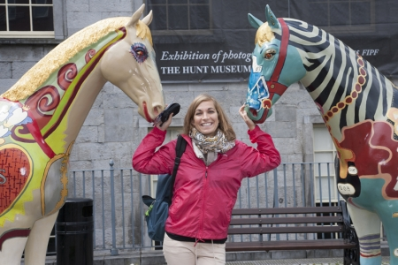
Limerick_City_Street_Ambassadors_7976_03_october_2012

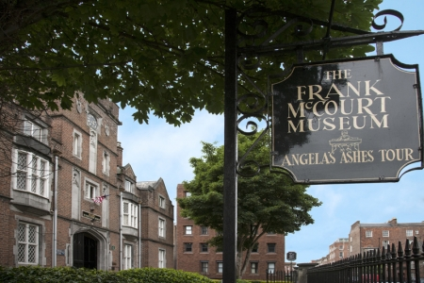
Frank_McCourt_Museum_Limerick_819_Edit_03_october_2012

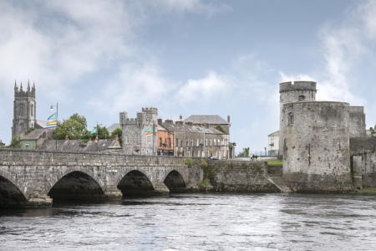
Limerick_City_03_october_2012_093.jpg

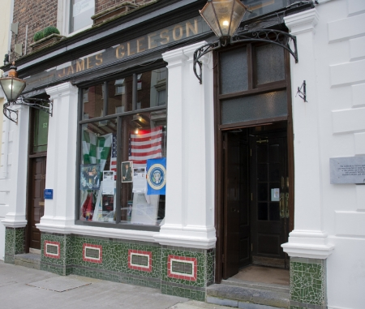
The_Whitehouse_Bar_Limerick_City_14_03_october_2012_123

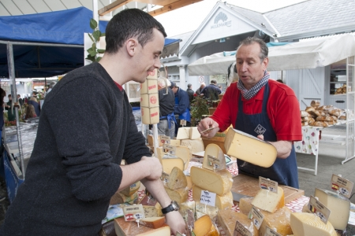
Milk_Market_Limerick_City_7864_03_october_2012_103.jpg

Fáilte Ireland Limerick images
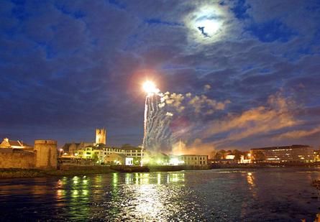
1004773

Useful links
http://limerickcityofculture.ie/
https://www.facebook.com/LimerickCityofCulture
https://twitter.com/Limerick2014 #Limerick2014
http://www.limerick.ie/media/Experience%20Limerick%20Map.pdf
http://www.ireland.com/en-us/destinations/republic-of-ireland/limerick/limerick-city

