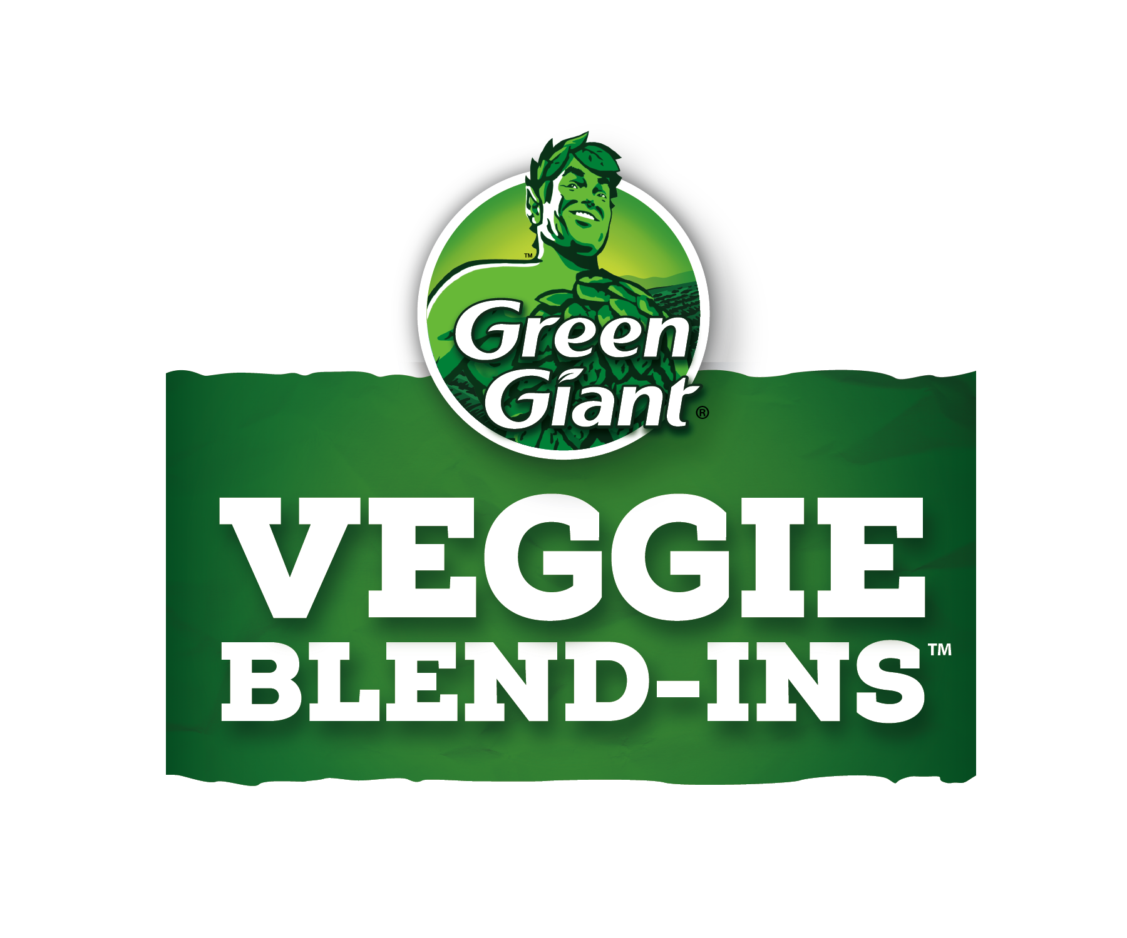
RECIPES

Super Strawberry Banana Smoothie – p. 2
Berry Me Alive Smoothie – p. 3
Rise and Shine Blueberry Muffins – p. 4
Up and At ‘Em Pancakes – p. 5
Super Tomato Soup – p. 6
Blend-In Burgers – p. 7
Qué Bueno Chicken Quesadillas – p. 8
Mighty Mac and Cheese – p. 9
Can’t See the Veggie Spaghetti – p. 10
Tacos with a Twist – p. 11
Don’t Be Silly Chili – p. 12
Epic Chocolate Cupcakes – p. 13
Brownies with a Boost – p. 14
OMG Chocolate Chip Cookies – p. 15

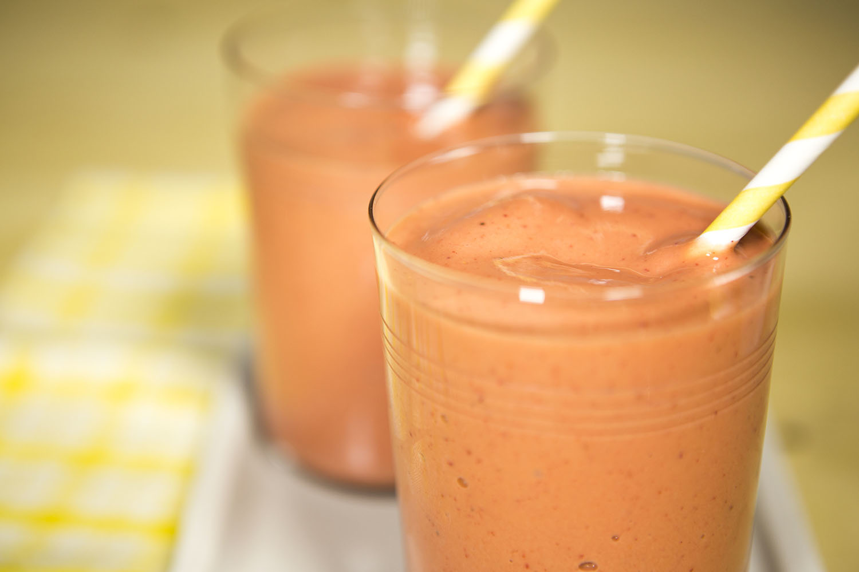

Super Strawberry Banana Smoothie

Ingredients

1 ½ cups frozen whole strawberries
1 frozen banana
1 container (5.3 oz) Yoplait® Greek 100 vanilla yogurt
1 pouch (4 oz) Green Giant™ Veggie Blend-Ins™ 100% carrot purée

Directions

- In blender, place all ingredients. Cover; blend on high speed about 1 minute or until smooth.
- Pour into glasses. Serve immediately.

3 servings

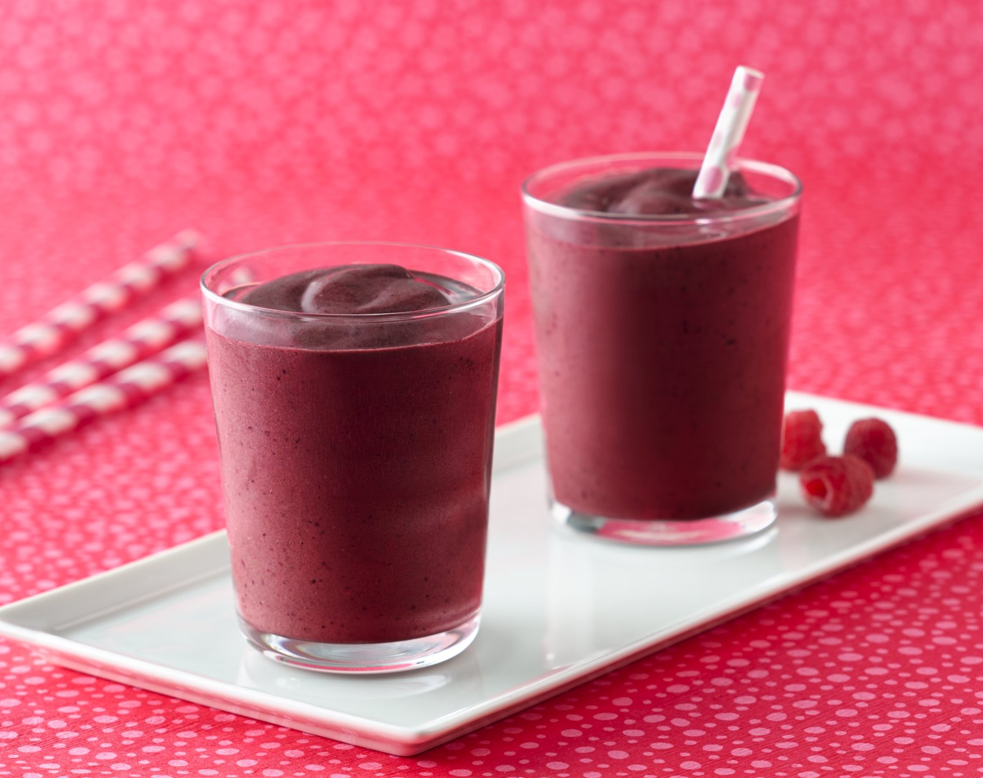

Berry Me Alive Smoothie

Ingredients

2 cups frozen mixed berries
1 pouch (4 oz) Green Giant™ Veggie Blend-Ins™ 100% spinach purée
¼ cup refrigerated 100% pomegranate juice
1 scoop chocolate protein powder (6 tablespoons)

Directions

- In blender, place all ingredients. Cover; blend on high speed until smooth.
- Pour into glasses. Serve immediately.

2 servings

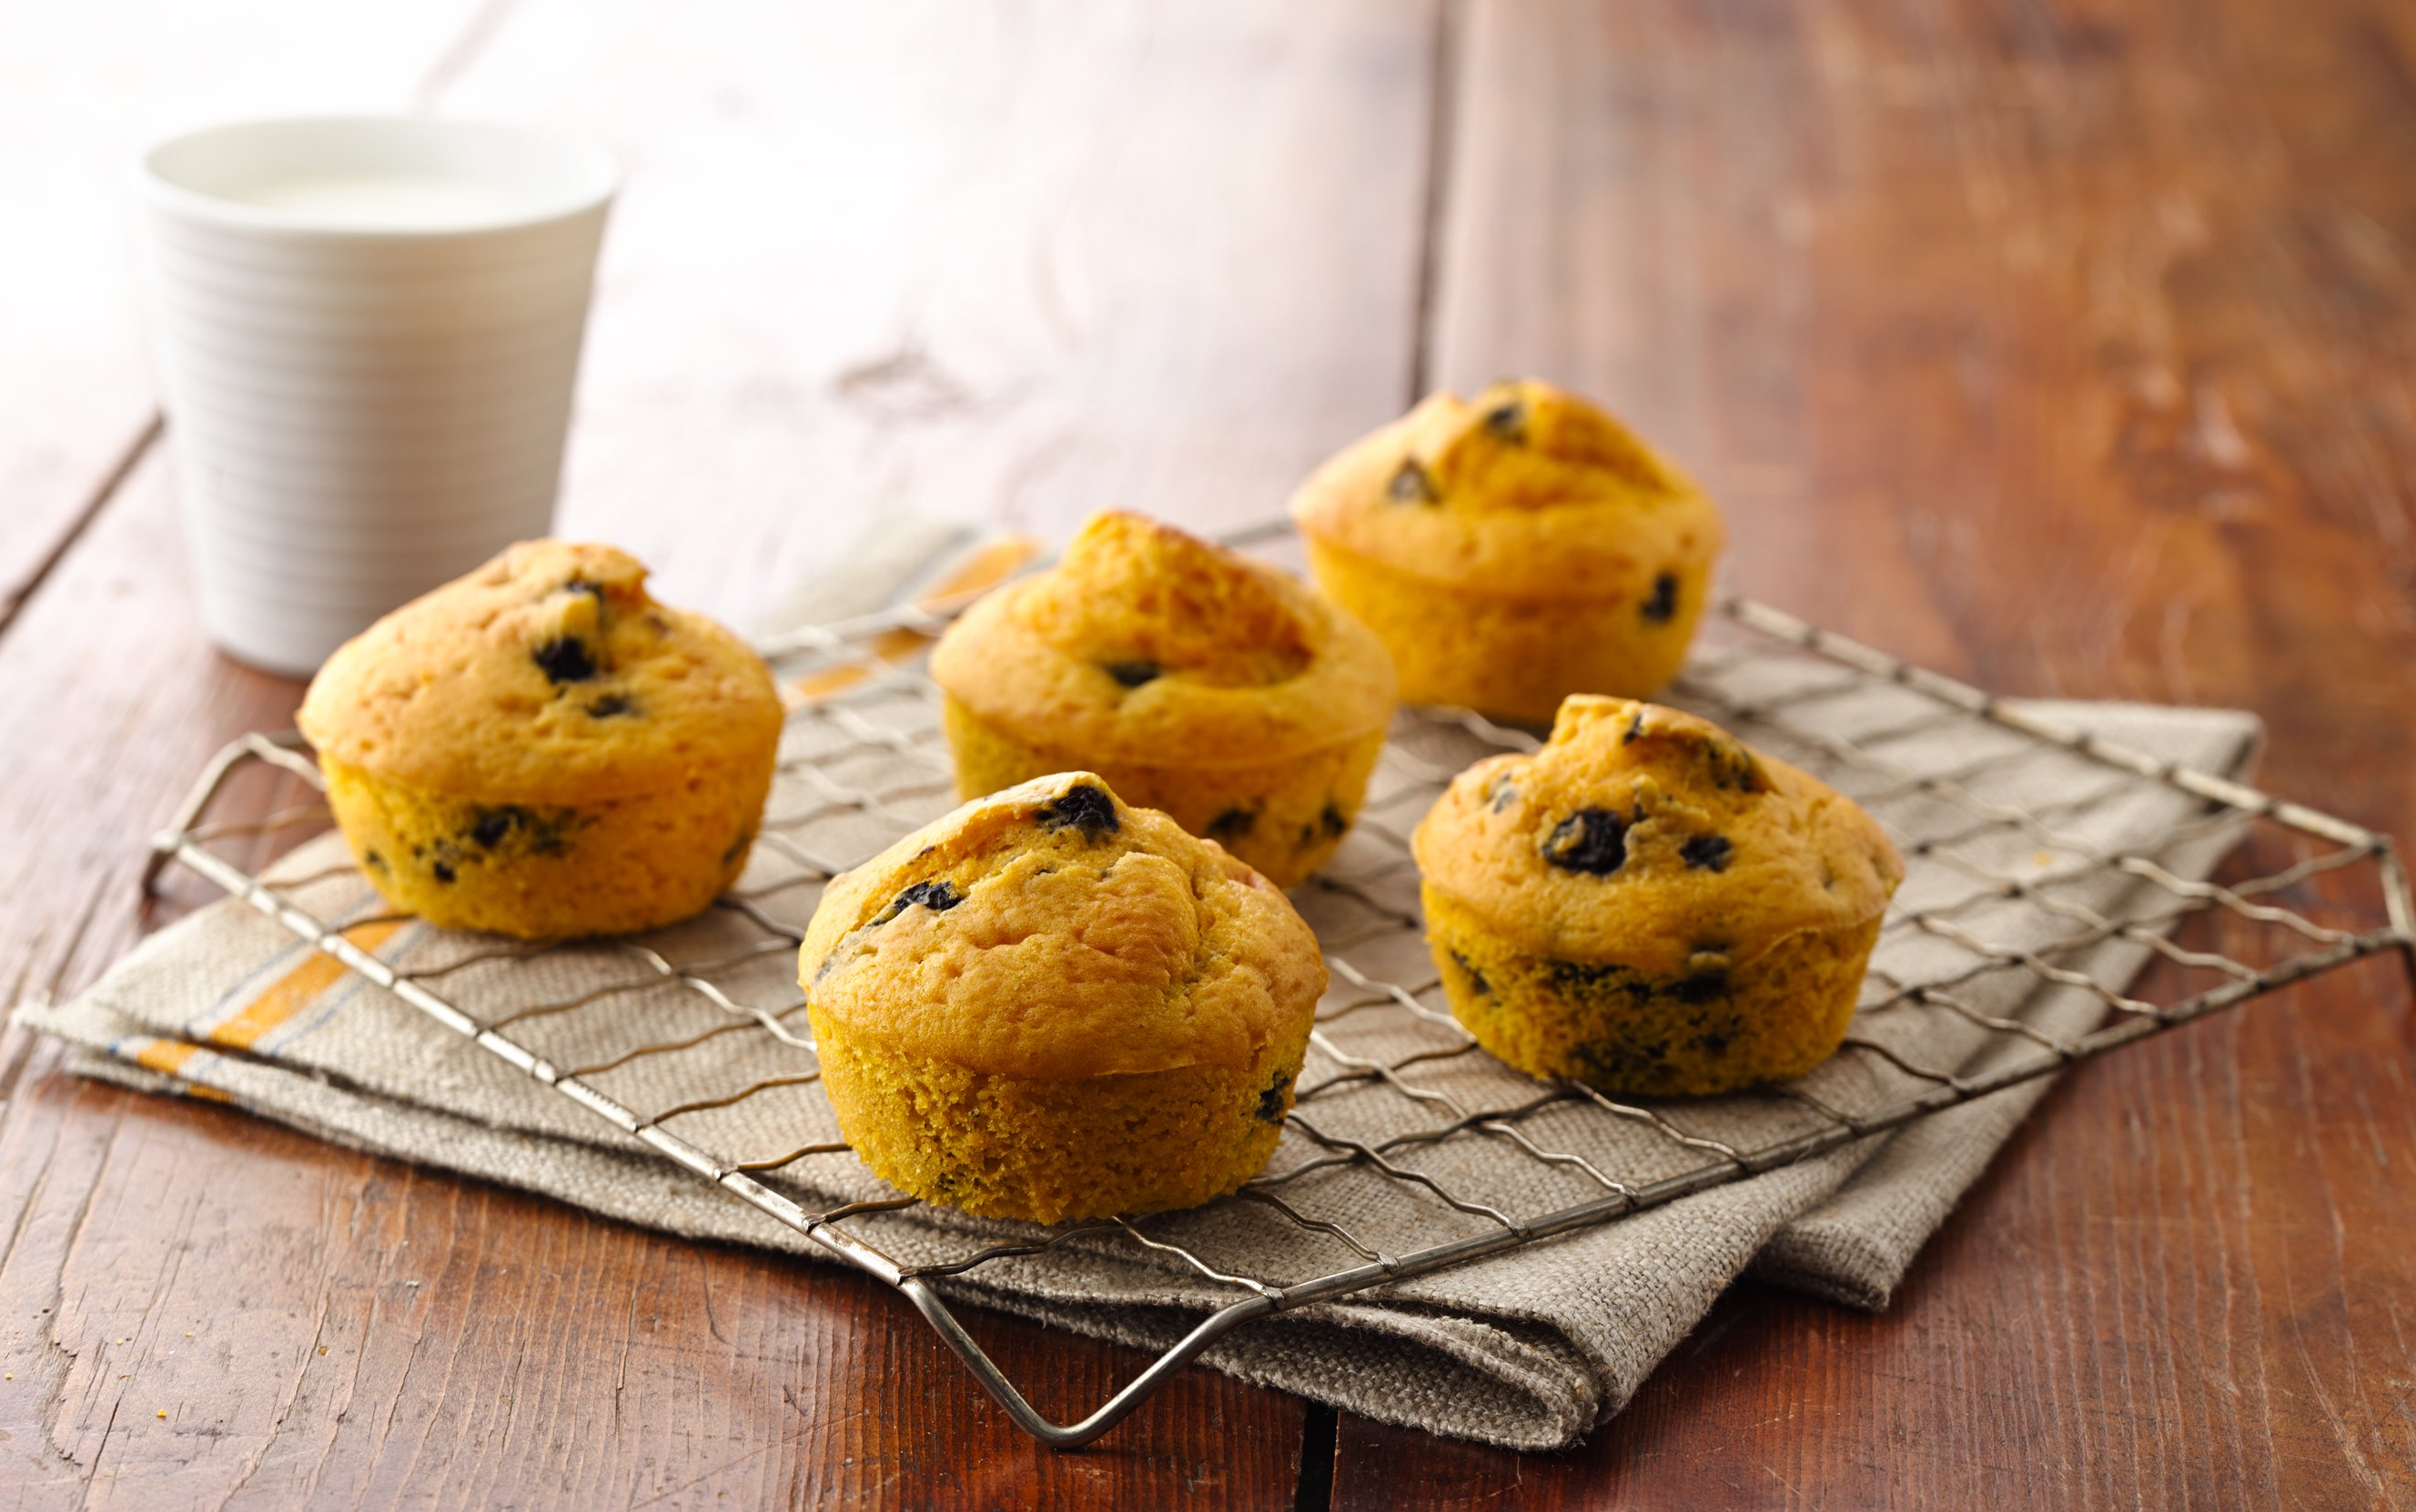

Rise and Shine Blueberry Muffins

Ingredients

1 box Betty Crocker® wild blueberry muffin mix
1 pouch (4 oz) Green Giant™ Veggie Blend-Ins™ 100% carrot purée
Water and eggs

Directions

1. Make blueberry muffins as directed on box - except substitute carrot purée for the oil.

12 muffins

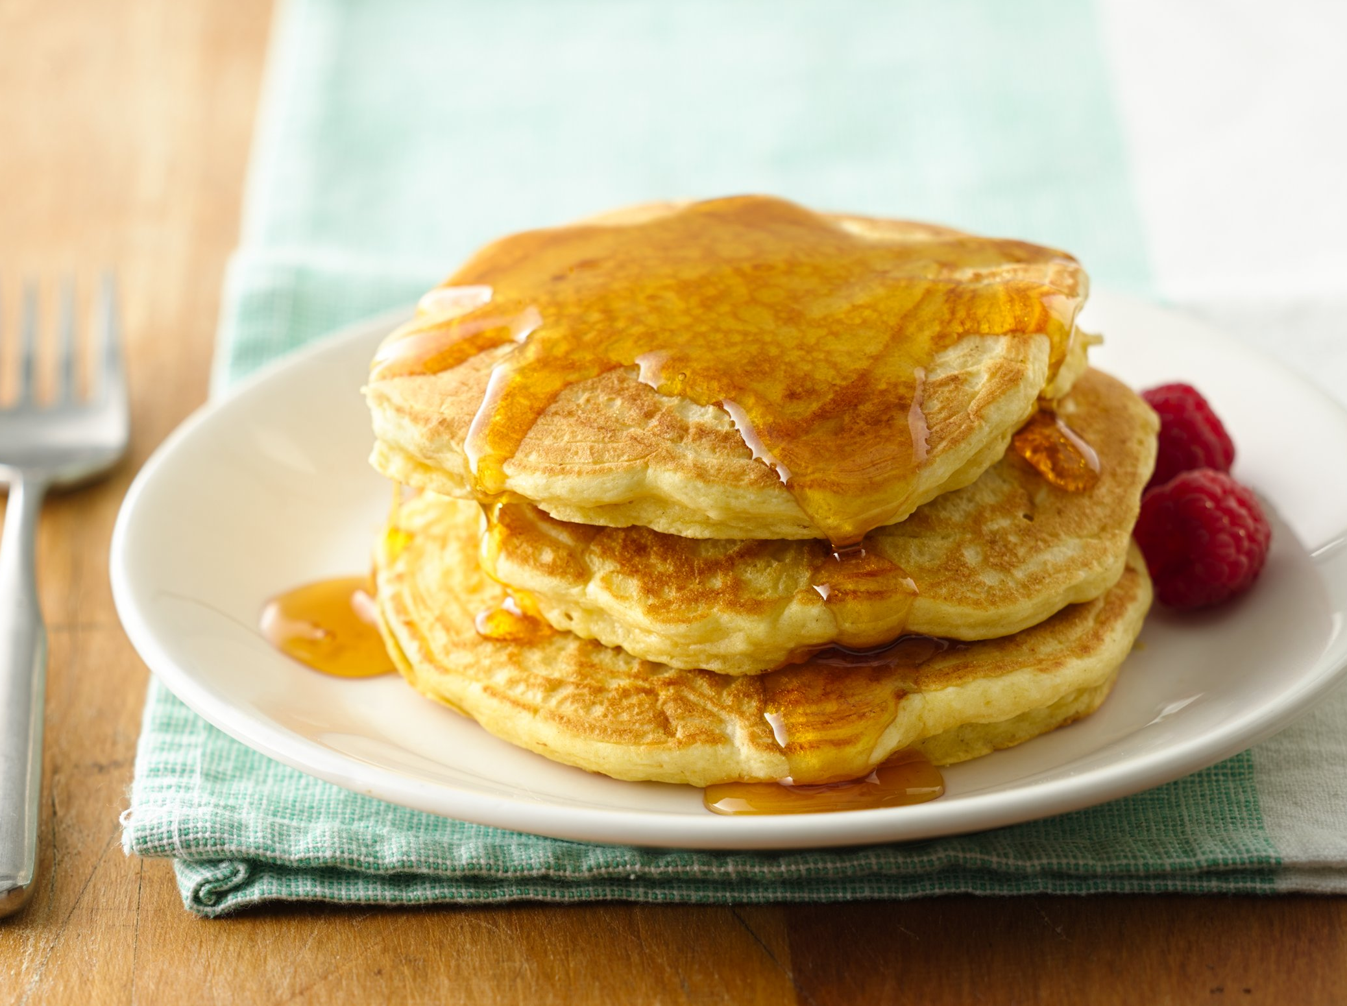

Up and At 'Em Pancakes

Ingredients

2 cups Original Bisquick® mix
Milk and eggs
1 pouch (4 oz) Green Giant™ Veggie Blend-Ins™ 100% butternut squash purée

Directions

1. Make pancakes as directed on Bisquick mix box - except stir in butternut squash purée with the milk.

8 servings

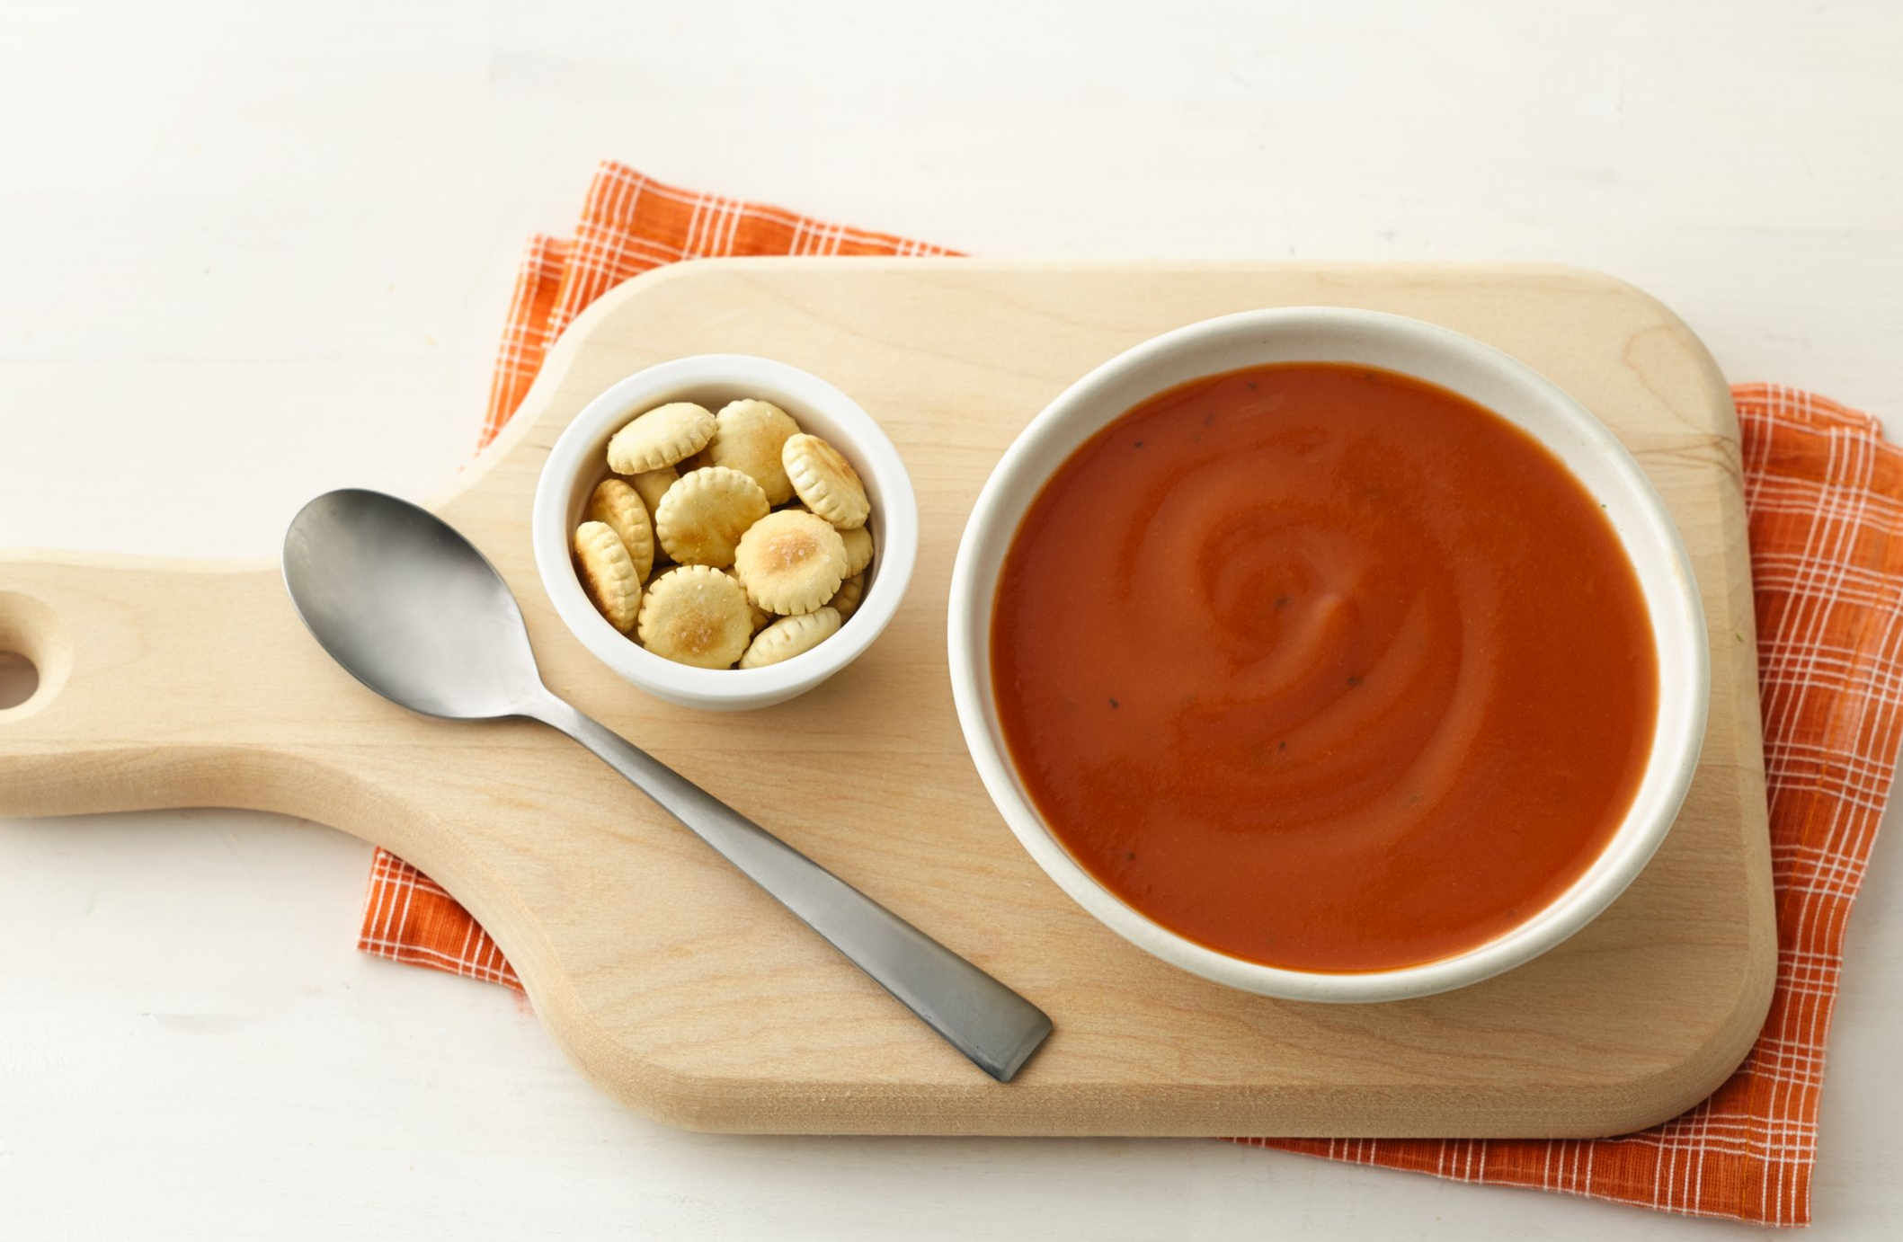

Super Tomato Soup

Ingredients

1 can ready-to-serve tomato-basil soup
1 pouch (4 oz) Green Giant™ Veggie Blend-Ins™ 100% carrot purée
Oyster crackers or cheese crackers, if desired

Directions

1. In 2-quart saucepan, mix soup and carrot purée. Heat over medium heat, stirring occasionally, until hot. Top each serving with crackers.

2 servings

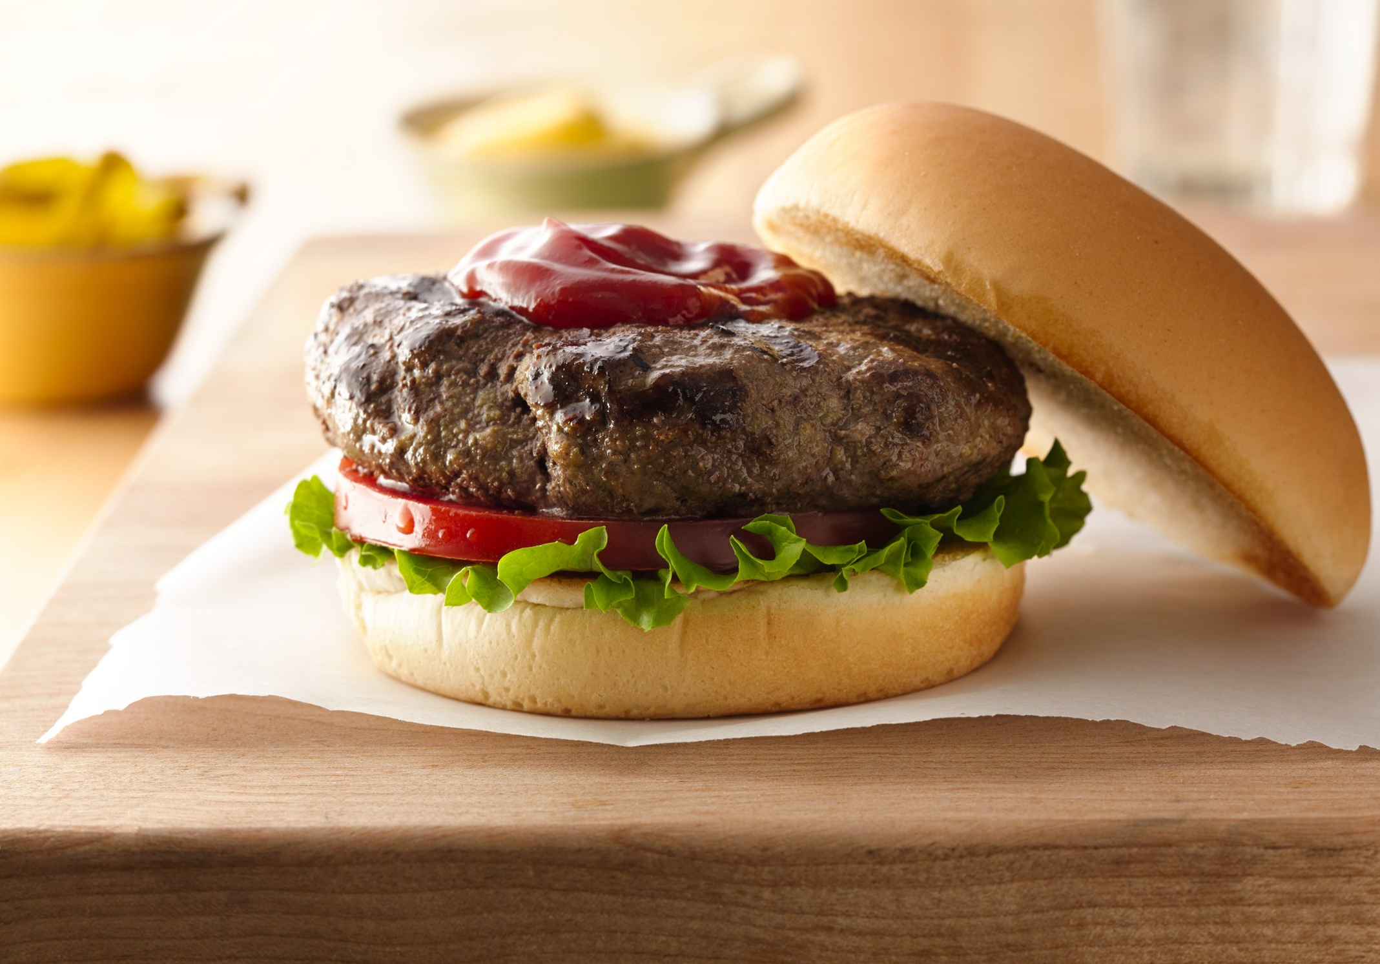

Blend-In Burgers

Ingredients

1 lb lean ground beef
1 pouch (4 oz) Green Giant™ Veggie Blend-Ins™ 100% spinach purée
1 egg
1/2 teaspoon salt
1/8 teaspoon pepper

Directions

1. Heat grill. In bowl, mix all ingredients. Shape mixture into 4 patties, ½ inch thick.
2. Place patties on grill over medium heat. Cover grill; cook 10-12 min, turning once, until meat thermometer inserted in center of patties reads 160°F.

4 servings

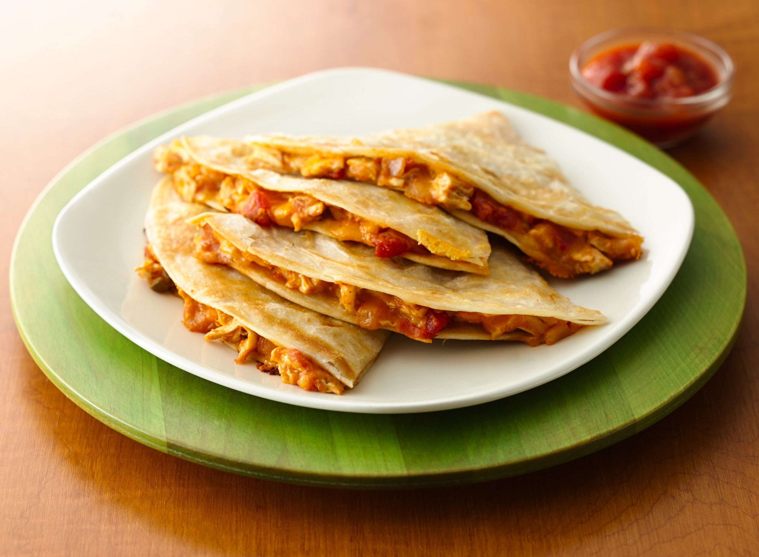

Qué Bueno Chicken Quesadillas

Ingredients

1½ cups shredded Cheddar cheese (6 oz)
1 cup diced cooked chicken
1/3 cup Old El Paso® Thick ‘n Chunky salsa
1 pouch (4 oz) Green Giant™ Veggie Blend-Ins™ 100% butternut squash purée
1 package (11 oz) Old El Paso® flour tortillas for burritos (8-inch; 8 tortillas)
Cooking spray

Directions

- In medium bowl, mix cheese, chicken, salsa and purée.
- Spray 1 side of 1 tortilla with cooking spray; place sprayed side down in 10-inch skillet. Spread with one-fourth of the chicken mixture. Top with another tortilla; spray top of tortilla with cooking spray.
- Cook over medium heat about 2 minutes or until golden brown. Carefully turn quesadilla over; cook another 1 to 2 minutes or until golden brown. Repeat with remaining tortillas and chicken mixture. To serve, cut quesadillas into wedges. Serve with sour cream and additional salsa, if desired.

4 servings

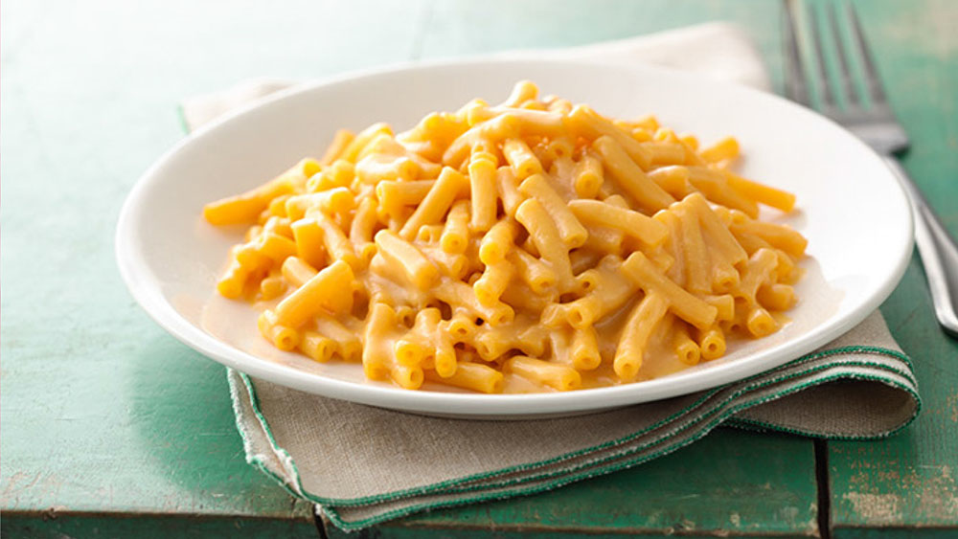

Mighty Mac and Cheese

Ingredients

1 box (7.25 oz) macaroni and cheese dinner
Milk and butter or margarine
1 pouch (4 oz) Green Giant™ Veggie Blend-Ins™ 100% butternut squash purée

Directions

1. Make macaroni and cheese dinner as directed on box - except stir in butternut squash purée with the milk.

3 servings

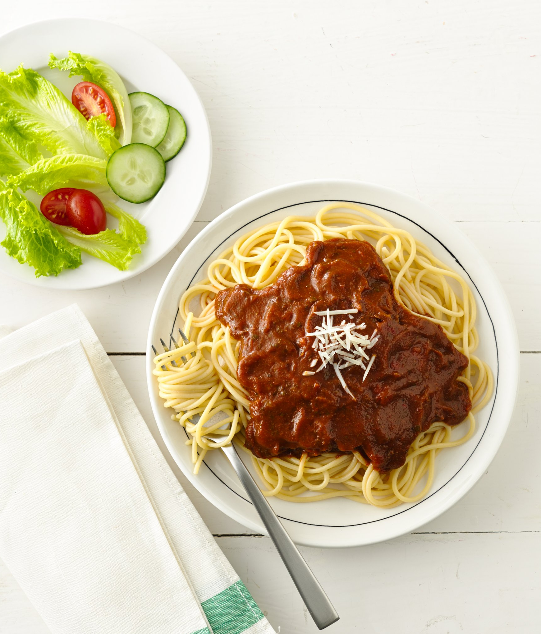

Can't See the Veggie Spaghetti

Ingredients

12 oz uncooked spaghetti
1 jar (24 oz) tomato pasta sauce
1 pouch (4 oz) Green Giant™ Veggie Blend-Ins™ 100% spinach purée

Directions

1. Cook and drain spaghetti as directed on package.
2. Meanwhile, in 2-quart saucepan, mix pasta sauce and spinach purée. Heat over medium heat, stirring occasionally. Serve over spaghetti.

6 servings

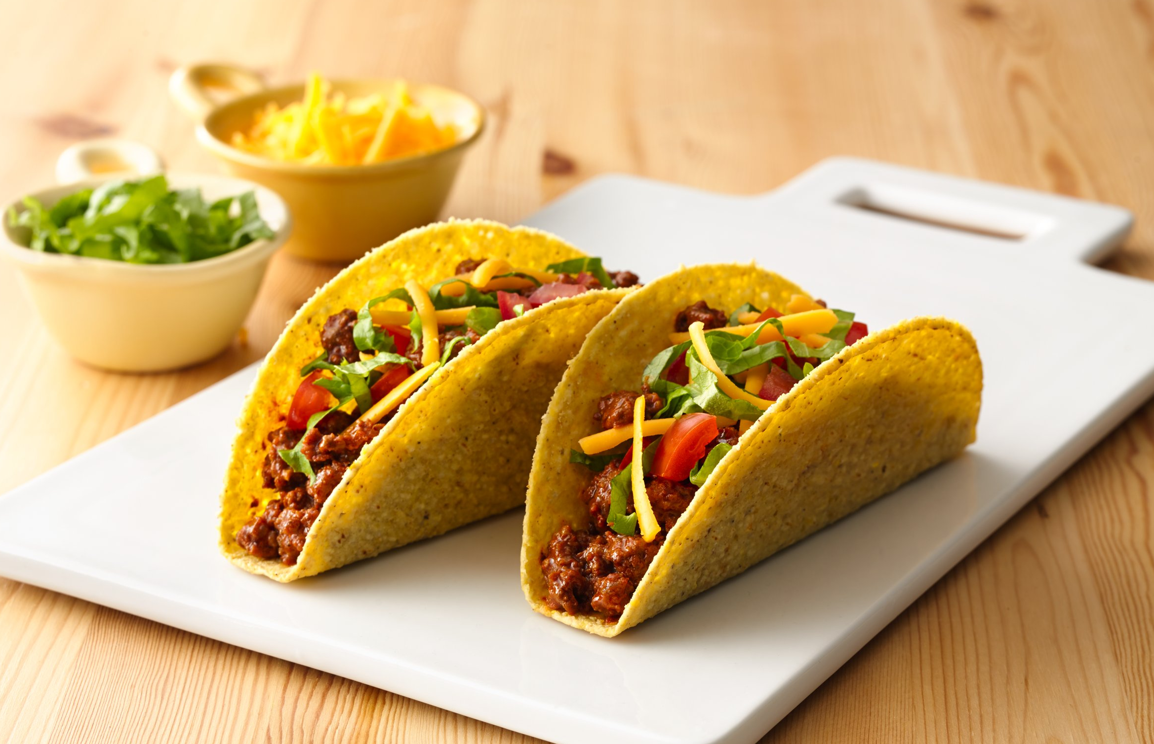

Tacos with a Twist

Ingredients

10 taco shells
1 lb lean ground beef
1 package (1 oz) taco seasoning mix
1 pouch (4 oz) Green Giant™ Veggie Blend-Ins™ 100% carrot purée

Directions

1. Heat taco shells as directed on box.
2. Make beef mixture as directed on taco seasoning mix pouch - except stir in carrot purée with the water.
3. Spoon beef mixture into taco shells.

5 servings

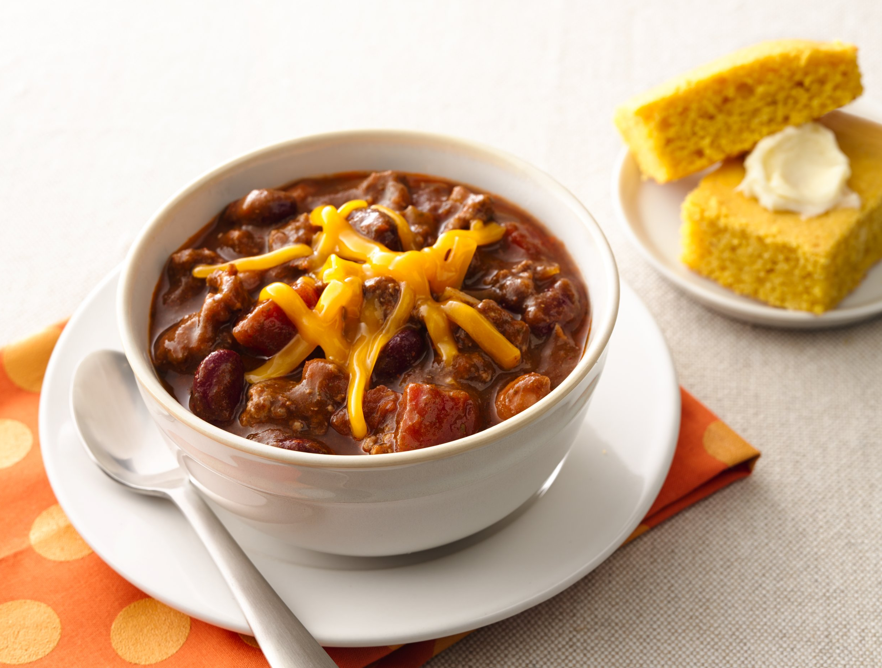

Don’t be Silly Chili

Ingredients

1 lb lean (at least 80%) ground beef
¾ cup chopped onion
1 pouch (4 oz) Green Giant™ Veggie Blend-Ins™ 100% spinach purée
1 can (15 or 16 oz) beans in chili seasoned sauce, undrained
1 can (15 oz) kidney beans, drained and rinsed
1 can (14.5 oz) diced tomatoes, undrained
1 can (8 oz) tomato sauce
2 teaspoons chili powder

Directions

- In 4 quart cooking pan or 12-inch skillet, cook beef and onion over medium heat 8 to 10 minutes, stirring occasionally, until beef is brown; drain.
- Stir in remaining ingredients; bring to a boil. Reduce heat to medium low; simmer 10 minutes stirring frequently.

6 servings

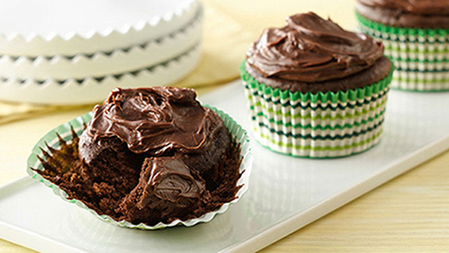

Epic Chocolate Cupcakes

Ingredients

1 package (15.25 oz) Betty Crocker® Super Moist® devil’s food cake mix
1 pouch (4 oz) Green Giant™ Veggie Blend-Ins™ 100% spinach purée
1 ¼ cups water
3 eggs
1 container (16 oz) Betty Crocker® Rich & Creamy vanilla or chocolate frosting

Directions

- Heat oven to 350°F. Place paper baking cup in each of 24 regular-size muffin cups.
- In large bowl, beat cake mix, purée, water and eggs with electric mixer on low speed 30 seconds, then on medium speed 2 minutes, scraping bowl occasionally. Divide batter evenly among muffin cups, filling about three-fourths full.
- Bake 18 to 20 minutes or until toothpick inserted in center comes out clean. Cool 10 minutes; remove from pans to cooling rack. Cool completely, about 30 minutes. Spread frosting on cupcakes.

24 servings

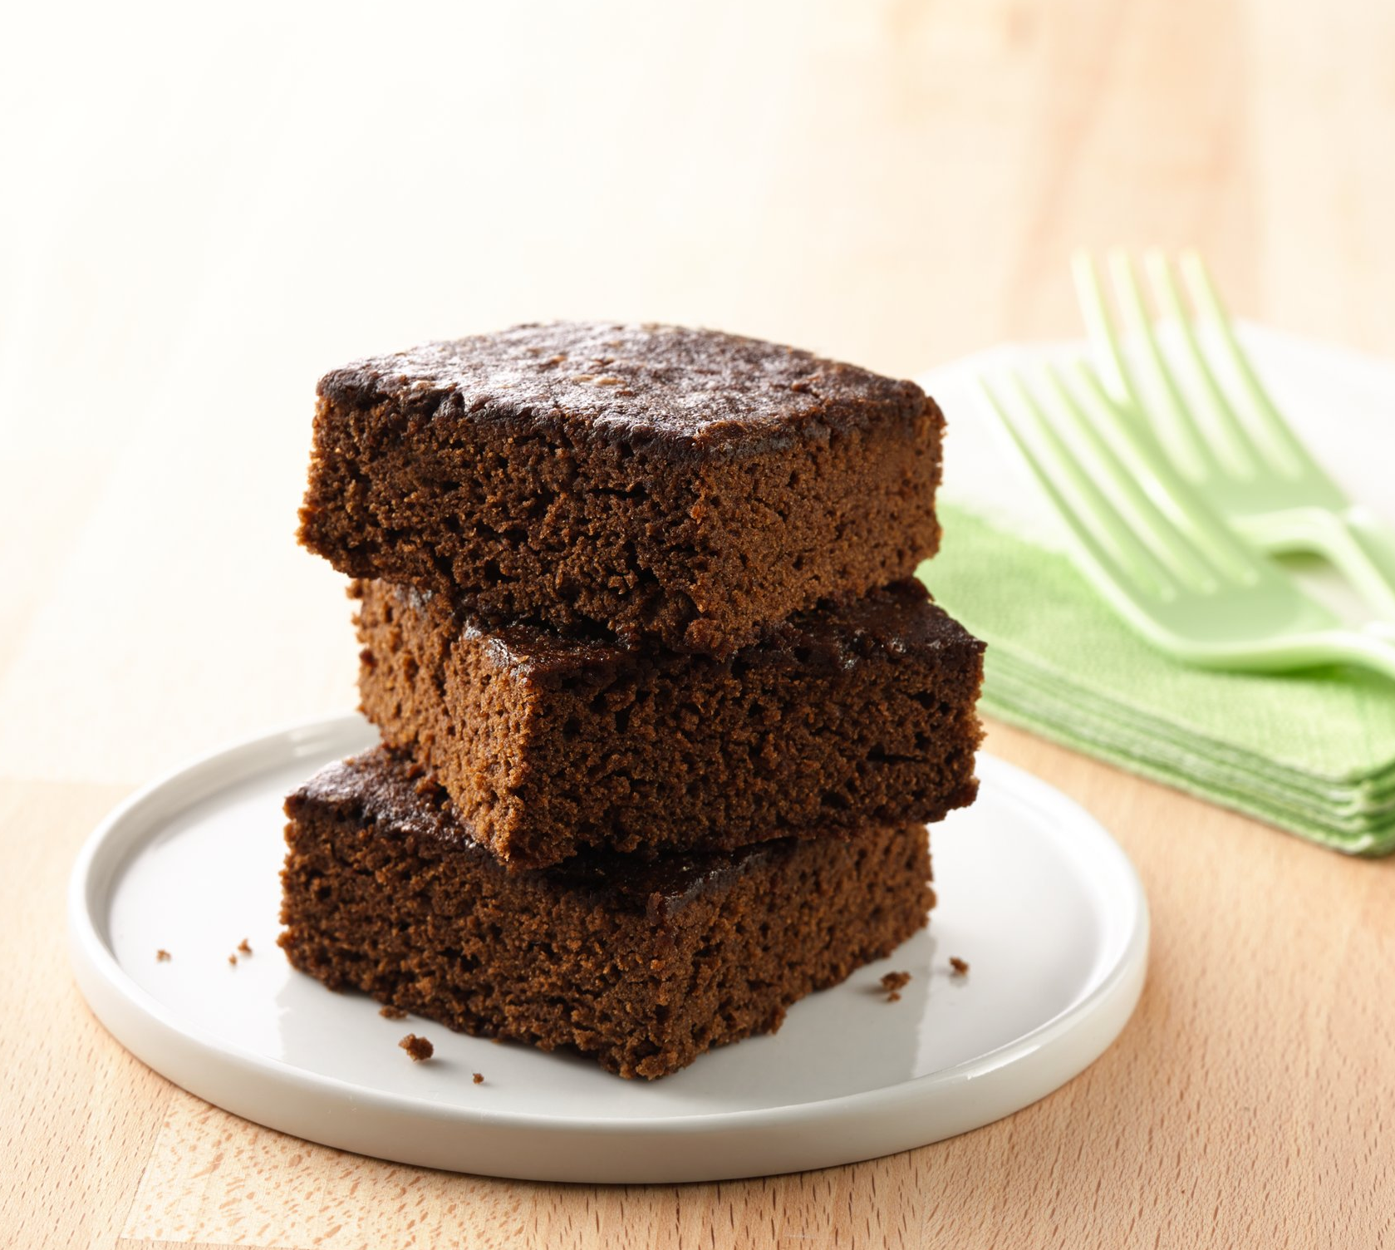

Brownies with a Boost

Ingredients

1 box (18.3 oz) Betty Crocker® family-size fudge brownie mix
1 pouch (4 oz) Green Giant™ Veggie Blend-Ins™ 100% spinach purée
1/3 cup vegetable oil
2 eggs

Directions

1. Make brownies as directed on box - except omit water and use spinach purée, 1/3 cup oil and the eggs.

24 servings

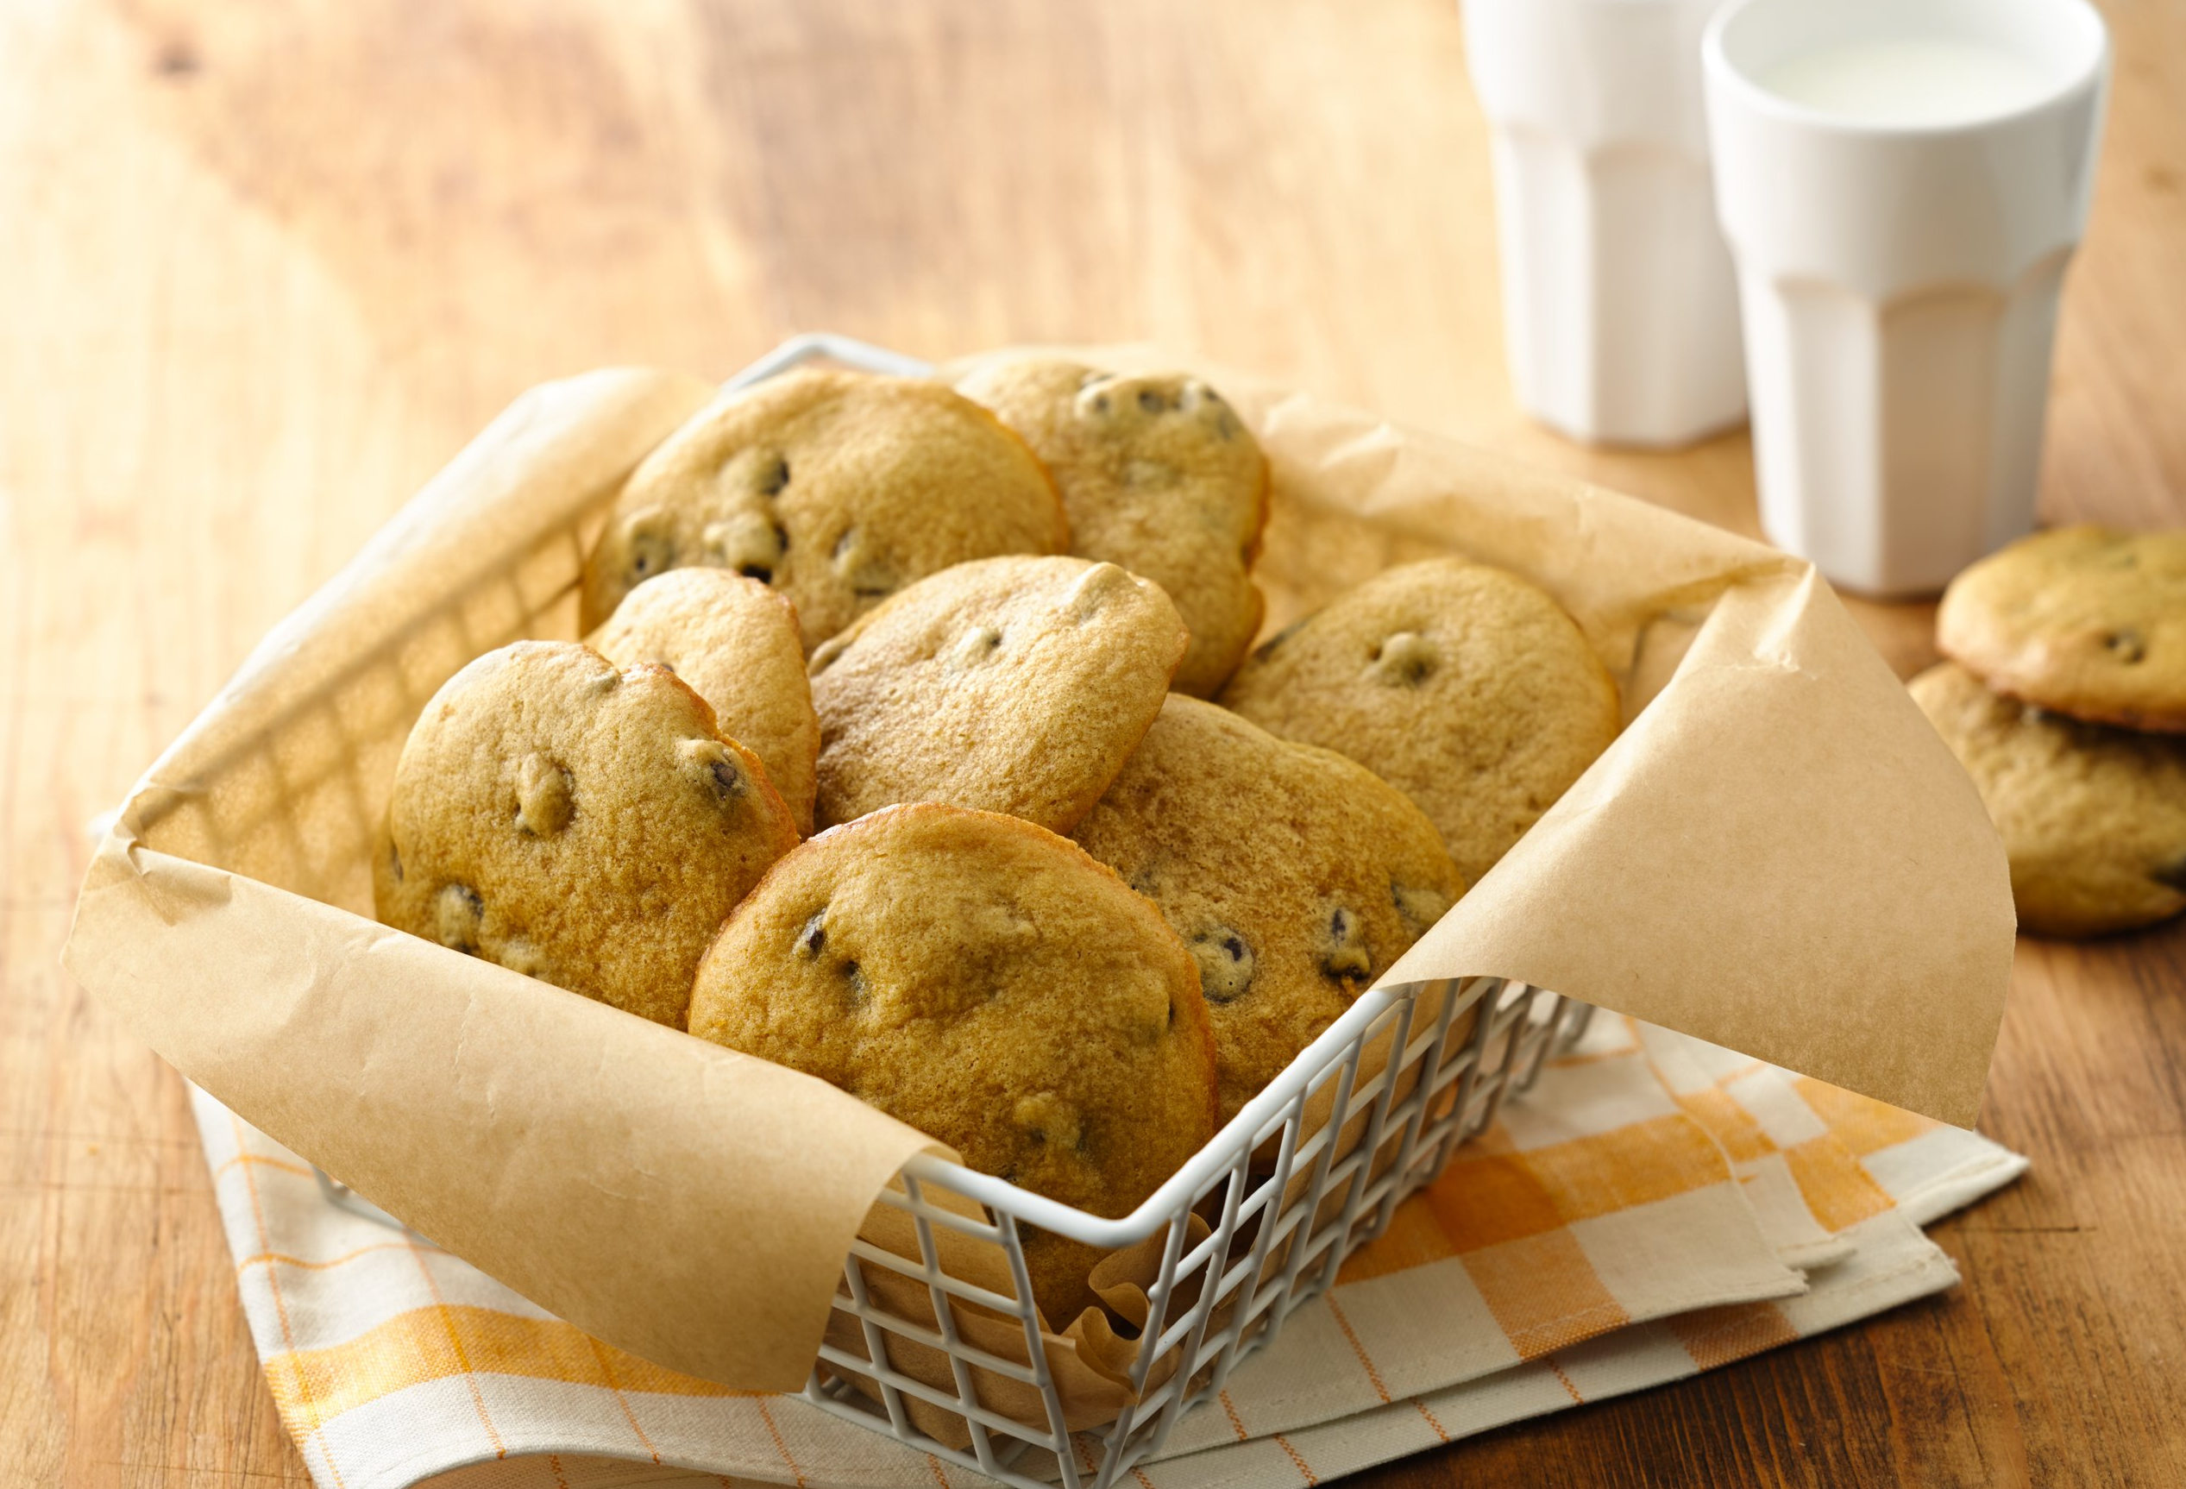

OMG Chocolate Chip Cookies

Ingredients

1 pouch Betty Crocker® chocolate chip cookie mix
1 pouch (4 oz) Green Giant™ Veggie Blend-Ins™ 100% butternut squash purée
1 egg

Directions

1. Make cookies as directed on cookie mix pouch - except substitute butternut squash purée for the butter.

2 dozen cookies

