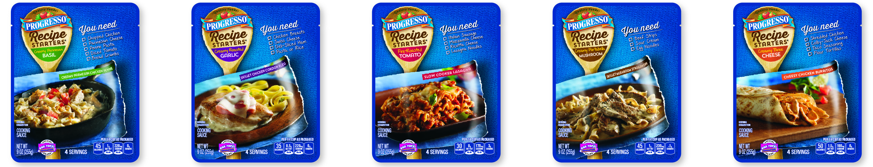

Progresso Recipe Starters Cooking Sauces

Now, families everywhere can prepare a home cooked dish every night of the week in 30 minutes or less with Recipe Starters cooking sauces from Progresso.

Easy to use, moms only need to add a few ingredients to create delicious dishes every night of the week that the family will love. From slow cooker to skillet to baked or broiled, Progresso Recipe Starters are the complete go-to cooking sauce that take some of the prep time out of cooking to give busy moms a head start to home cooked during busy weeknights.

Recipe Starters thick sauce provides a rich and concentrated, robust flavor. With an easy-to-use pouch design, all you have to do is just add your favorite protein, along with a few pantry or refrigerator items and you’ve got a delicious home-cooked dish the family will love.

Most of the easy-to-follow recipes from Recipe Starters require five or fewer ingredients, many of which moms may already have on-hand, and can be prepared in 30 minutes or less. Each pouch has a recipe favorite printed on it to get you started. For recipe ideas go to www.progresso.com/recipestarters.

Sauces 101
Sauces are an essential element in dishes prepared around the world, and nearly all, including Progresso Recipe Starters, can be traced back to one of the five classic “Mother” Sauces: Béchamel (white); Velouté (blonde); Tomato (red); Espagnole (brown); and Hollandaise (butter)

Varieties: Progresso Recipe Starters cooking sauces are available in five flavorful varieties:
- Creamy Roasted Garlic: Chicken stock, roasted garlic and a touch of cream
  - Recipe Ideas: Skillet Chicken Cordon Bleu or Slow Cooker Garlic Beef Roast
- Fire-Roasted Tomato: Medium-thick, tomato sauce, accompanied by flavors of roasted tomatoes and red bell peppers, basil and a touch of cream
  - Recipe Ideas: Slow Cooker Lasagna, Mini Meat Loaves with Tomato Sauce or Quick and Easy Italian Stuffed Peppers
- Creamy Parmesan Basil: Creamy, full-bodied and indulgent sauce that was inspired by alfredo and creamy pesto sauces
  - Recipe Ideas: Creamy Parmesan Chicken Penne or Parmesan Basil Shrimp Pasta
- Creamy Portabella Mushroom: Creamy, full-bodied and highly indulgent smooth sauce with Portabella mushrooms flavor. Body similar to medium béchamel. Dairy/mushroom is primary flavor base with herb/white wine top notes.
  - Recipe Ideas: Skillet Mushroom Stroganoff or Slow Cooker Creamy Chicken & Pasta
- Creamy Three Cheese: Creamy, full-bodied and highly indulgent with body similar to medium cheese sauce. Rich with a blend of yellow and white cheeses, and a savory touch of cracked pepper.
  - Recipe Ideas: Cheesy Chicken Burritos or Loaded Bacon Potato Pizza

2-2-2

Serving Size: A typical recipe makes 4 to 6 servings.

Distribution: Progresso Recipe Starters pouches are available nationally in the meal solutions section in the pasta aisle and/or soup aisle.

Price: Progresso Recipe Starters have a suggested retail price of $1.99 for a 9-ounce pouch. (4 servings)

###

