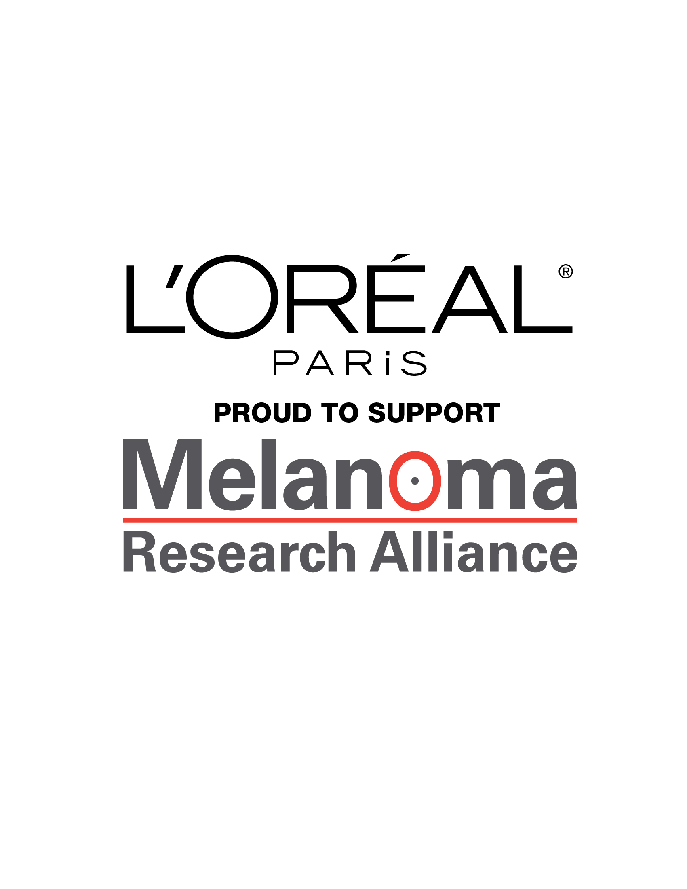 



**The L’Oréal Paris and Melanoma Research Alliance *It’s THAT Worth IT™* *Safe Sun Survey* Fact Sheet**

L’Oréal Paris and the Melanoma Research Alliance (MRA) reveal the results of the second annual ***It’s THAT Worth IT™* *Safe Sun Survey*** to kick off Skin Cancer Awareness Month. The survey assesses women’s perceptions of their sun care routine and habits, and grades their knowledge of melanoma, the deadliest form of skin cancer and one of the most common cancers in women under 40[1]. The ***It’s THAT Worth It™ Safe Sun Survey*** was commissioned by L’Oréal Paris, in partnership with MRA, to continue to raise awareness for ***It’s THAT Worth It*™**, a public health call-to-action that urges women of all skin tones to prevent melanoma by using sunscreen and to help save lives by supporting cutting-edge melanoma research for a cure. The survey results confirm the urgent need for more education and awareness on melanoma.

**Survey Scorecard**

* Key findings from the survey of 987 women include:
  + **52%** of women grade themselves a C or lower on their sun care habits.
  + More American women believe they merit an A grade when it comes to taking care of their teeth **(50%)** or eyes **(31%)** rather than suncare **(21%)**.
  + Women of all skin tones are at risk of melanoma, yet many African American women **(36% vs. 39% in 2013)** and Hispanic women **(23% vs. 31% in 2013)** continue to grade themselves a D or F for their suncare habits.
  + Almost all **(94%)** of women have heard of melanoma, and most believe that it’s a serious condition **(67%)** and a potentially deadly disease **(61%).**
  + Of those who know about melanoma, far fewer know that not reapplying sunscreen every two hours **(50%)** or having freckles or moles **(47%**) could increase a person’s chance of developing the disease.
  + Women’s dislike of using sunscreen has significantly increased from last year with more women citing texture (**15%** vs. **7**% and smell (**16% vs.** **10% in 2013)** of sunscreen as something they don’t enjoy.
  + **59%** of women know that wearing sunscreen regularly is an ideal routine.
  + Yet, less than three in 10 **(26%)** of women correctly note that they should be applying sunscreen **100%** of the time.
  + Nearly two in 10 women **(19%)** rarely or never wear sunscreen at all.
  + **50%** of Hispanic women gave themselves a grade of C or lower when it comes to sunscreen vs. **57%** in 2013.
  + This year, significantly more Hispanic women **(12% vs. 5%)** admit they don’t like the way most sunscreens make their skin look.
  + Less than two in ten **(17%)** Hispanic women think that melanoma is in their future.
  + Fewer than four in ten **(35%)** of Hispanic women actually wear sunscreen on a regular basis.
  + Only **(7%)** of African American women believe it’s possible for them to ever develop melanoma.
  + Only one in five **(20%)** African American women are aware that sunscreen should really be worn 100 percent of the time.
  + Only **(25%)** of African American women actually wear sunscreen daily
  + The belief that melanoma can be a deadly disease actually declined among African American women **(43% vs. 58% in 2013)** and Hispanic women **(52%).**

***I DO IT™* Video**

* L’Oréal Paris unveiled the ***I DO IT™*** video on *ItsTHATworthit.org,* featuring the campaign’s celebrity ambassadors Eva Longoria, Lea Michele, Aimee Mullins, Skin Cancer Survivor Diane Keaton – and 33-Year-Old L'Oréal Paris Executive and Melanoma Survivor Danielle Macaluso.
* The video shows how they *do it* by wearing sunscreen every day and asks consumers to wear sunscreen and join the movement.

**Join the *It’s THAT Worth It™*** **Thunderclap**

* You can join the cause to help raise awareness of melanoma by visiting **ItsTHATworthit.org** to join the Thunderclap, a global social movement that will amplify a collective message around the world through social media in support of melanoma prevention and research.
  + The Thunderclap will take place on May 20, 2014 at 5:00PM EDT.
  + L'Oréal Paris will make a donation to MRAof $1 for each supporter who signs up for the Thunderclap and $1 for each L’Oréal Paris Advanced Suncare product sold in the U.S. – up to $250,000 in 2014 (the State of Mississippi is excluded from the campaign).
* As of today, the Thunderclap has reached 66 percent of the goal for supporters; the Thunderclap will not be heard unless the goal is reached.

**L’Oréal Paris and MRA Partnership**

* The ***It’s THAT Worth It™*** campaign is part of a three-year collaboration that began in May 2013 when L’Oréal Paris committed to donate $750,000 to MRA to fund the new L’Oréal Paris-MRA Team Science Award, led by internationally renowned cancer researcher Dr. Meenhard Herlyn, D.V.M., D.Sc., The Wistar Institute, Philadelphia, Pa.
* The donation will fund research that explores melanoma susceptibility, development and progression.
* This campaign will continue to educate the public, especially young women, on the importance of using sunscreen as the first line of defense against melanoma and to fuel further research for a cure.

**L’Oréal Paris is a Leader in Skincare and Suncare R&D**

* L’Oréal Paris’ support of MRA complements its extensive work in advancing the state of the art in skincare and suncare research and development.
* L’Oréal Paris’ research on the effects of ultraviolet radiation on skin has led the company to develop safe and effective sun protection products for all skin tones.
* L’Oréal Paris' Advanced Suncare line is tested on all ethnicities, and includes patented UVA/UVB protection; a non-whitening formula that blends invisibly on all skin tones; and a non-greasy texture that people want to reapply. In short, the kinds of sunscreens people want to apply frequently, which helps to keep them better protected from melanoma and other skin cancers.
  + L’Oréal Paris’ Advanced Suncare Collection offers 13 products, including a lightweight tinted face lotion, non-alcoholic lotion sprays, ultra-water resistant, lightweight lotions and easy-to-use dry oil sprays.

**About Melanoma Research Alliance (MRA)**

* MRA is a public charity formed in 2007 under the auspices of the Milken Institute, with the generous founding support of Debra and Leon Black. MRA has dedicated more than $51 million to research seeking to better prevent, diagnose, and treat melanoma, the most deadly type of skin cancer. The organization plans to award another $9 million in research grants later this year.
* Due to the ongoing support of its founders, 100% of every dollar MRA raises goes to support its melanoma research program.
  + The organization is poised to build on recent momentum in the field, accelerating the pace of scientific discovery and translation in order to eliminate suffering and death due to melanoma.
  + MRA’s ability to fund wide-ranging research in melanoma is amplified by unique multi-faceted collaborations and partnerships with individuals, private foundations and corporations.
* The MRA name and logo are used with its permission which in no way constitutes an endorsement, express or implied, of any company or product.

**Additional Information**

* For more information about ***It’s THAT Worth It™*** campaign, please visit **ItsTHATworthit.org**.

**Survey Methodology**

* This survey was conducted online within the United States by Kelton Global on behalf of L’Oréal Paris from April 3 – 9, 2014, among 505 nationally representative American women, 311 African-American women and 311 Hispanic women, all ages 18 and older.
* For the sample of nationally representative American women, the chances are 95 in 100 that a survey result does not vary, plus or minus, by more than 4.4 percentage points from the result that would be obtained if interviews had been conducted with all persons in the universe represented by the sample. The margin of error for any subgroups will be slightly higher.

1. American Cancer Society. Cancer Facts & Figures 2013.

   [Http://www.cancer.org/acs/groups/content/@epidemiologysurveilance/documens/doucment/acs pc-036845.pdf](Http://www.cancer.org/acs/groups/content/@epidemiologysurveilance/documens/doucment/acs%20pc-036845.pdf). Accessed January 31, 2013.