SHANE GREEN
Global Hospitality Consultant, Founder & President of SGE International

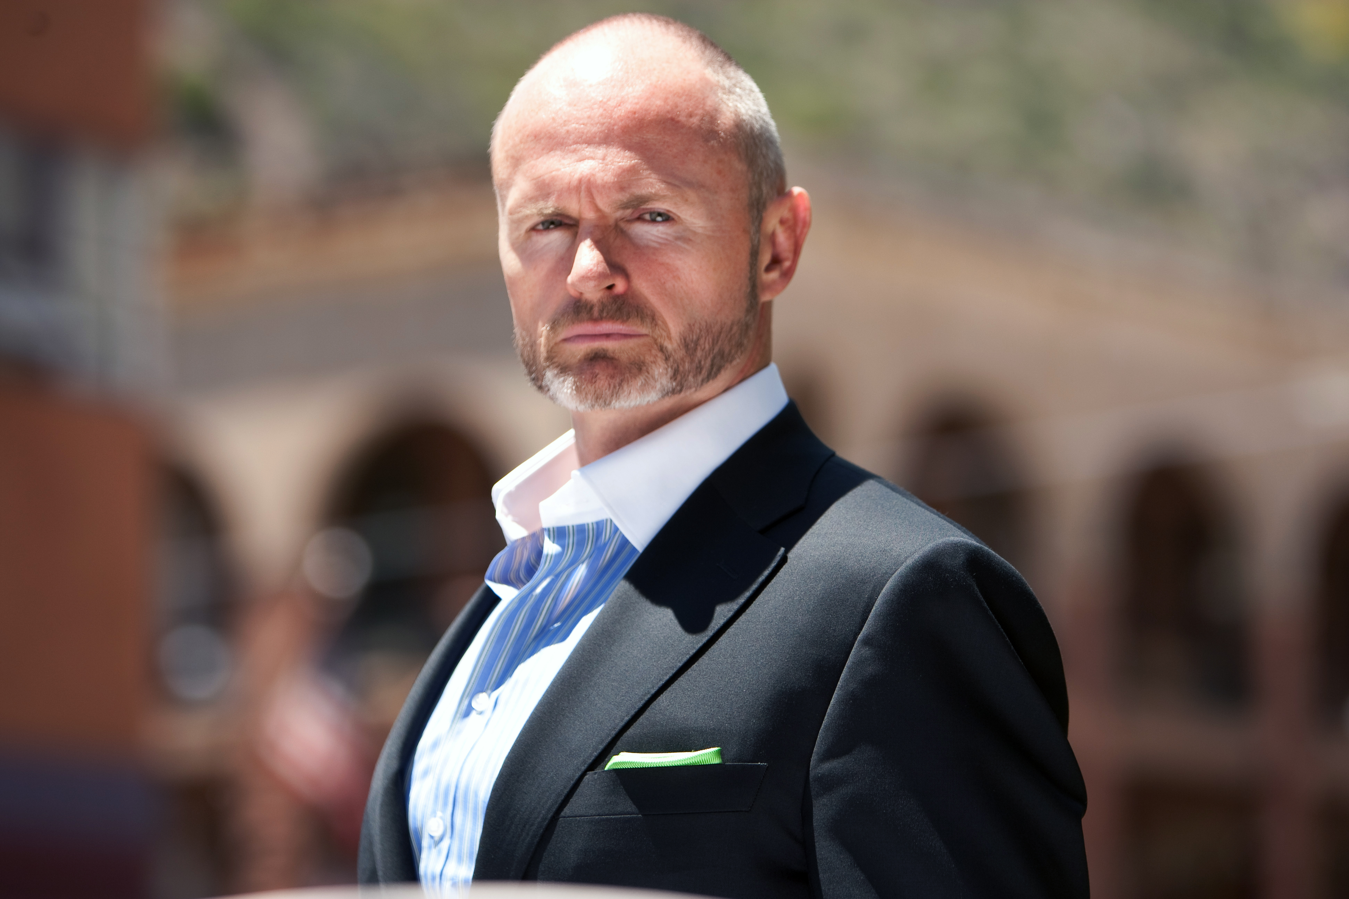

Series: “Resort Rescue”
Hometown: Las Vegas, NV

With over 20 years of experience consulting for the hotel and hospitality industry, Shane Green brings his expertise to Travel Channel as host of the new original series, “Resort Rescue.” With the help of hidden cameras, he uncovers problems within hotels and resorts that are right under the property owners' noses. Sitting in the control room, Green and the owners watch multiple camera feeds as he exposes bad customer service, out-of-control guests and dysfunctional employee-owner dynamics. In doing so, Green brings their issues to light, gives them an action plan and follows up to check on their progress.

As the founder and president of Shane Green Enterprises International (SGEi), Green ensures that all projects consistently achieve the highest standards of excellence. He personally has a hand in every SGEi endeavor to guarantee expectations are exceeded and deadlines are met.

From cultural transformations and business openings to repositioning efforts and customized training sessions, Green has established himself as an expert consultant in the hospitality industry, as well as in all modern luxury-facing businesses. SGEi’s client roster includes some of the most recognizable hotel brands in the world, including W Hotels, Hilton Chicago, The Cosmopolitan of Las Vegas, BMW, the NBA, Christie’s Auction House, Cisco Systems, Siemens and NetJets, Inc.

Green’s career has been distinguished by a series of consulting, speaking and cultural engagements that serve to enrich his clients’ companies with a modern, specialized approach to today’s workforce, as well as to today’s consumer. Prior to founding SGEi, Green worked for The Ritz-Carlton hotel group. This first-hand experience aids in his ability to develop highly-customized training and learning experiences for his clients. Green is widely known as a culture hacker, because of his ability to re-code teams from the inside, out. His distinctive, multicultural background has created an ambiance of diversity and global thinking at SGEi, which serves the interests of SGEi’s global clients.

Green holds a Bachelor of Science in Business Administration with an emphasis in Marketing and Social Psychology from Canterbury University in his native country, New Zealand.

# # #

