ANDREW ZIMMERN
James Beard Award-winning TV personality, Chef, Food Writer, Teacher

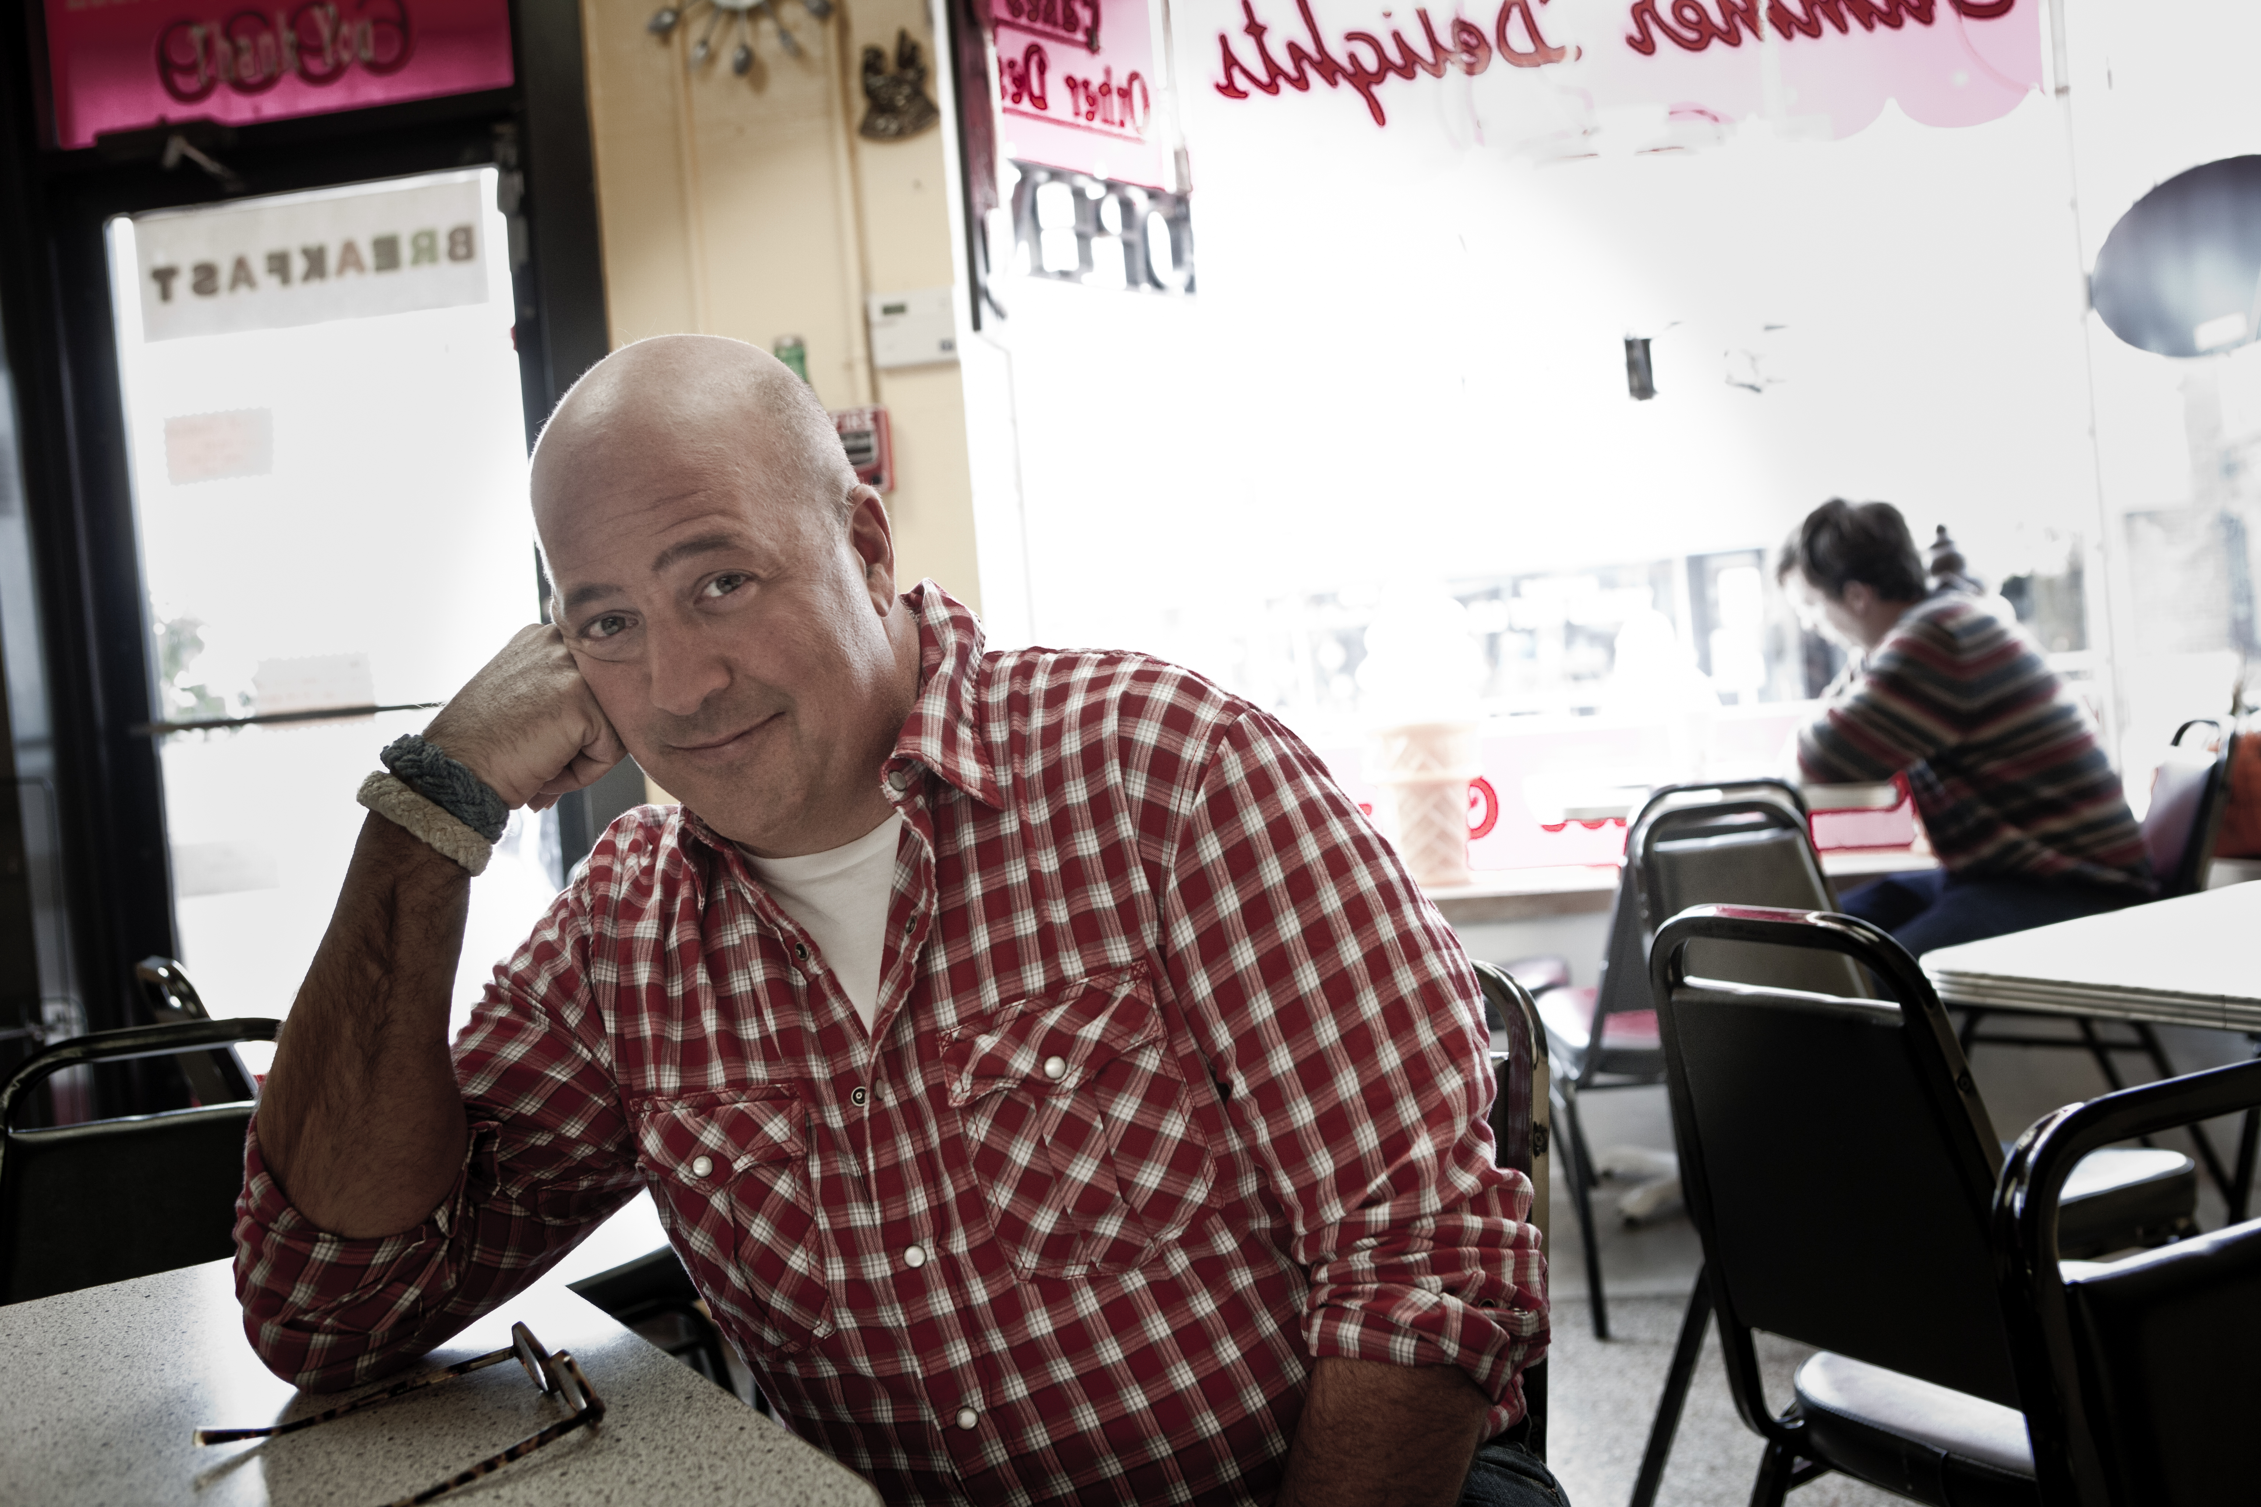

Series: “Bizarre Foods America”
Hometown: Minneapolis, MN

Andrew Zimmern is a three-time James Beard Award-winning TV personality, chef, food writer, teacher and is regarded as one of the most versatile and knowledgeable personalities in the food world. He is the creator, host and co-executive producer of Travel Channel's hit series, “Bizarre Foods with Andrew Zimmern,” “Andrew Zimmern’s Bizarre World” and “Bizarre Foods America with Andrew Zimmern.” In “Bizarre Foods with Andrew Zimmern” and “Andrew Zimmern's Bizarre World,” he travels the globe exploring food – from world-class restaurants to street carts and jungle markets, it's all about discovering and sharing the authentic experience. In “Bizarre Foods America with Andrew Zimmern,” he explores the unusual foods and cultures in America’s own backyard. In his latest series, “Bizarre Foods: Delicious Destinations,” the widely-recognized host continues his search for the most interesting dishes across the globe – taking viewers on an international journey to iconic cities for a taste of their quintessential, not-to-be missed dishes.

In 2013, Zimmern won his third James Beard Award for ‘Outstanding Personality/Host.’ He received his first award in 2010 for ‘Television Food Personality,’ and his second in 2012 for ‘Television Program on Location.’ He is a seven-time Beard Award nominee. His online series, “Toyota’s Appetite for Life,” received an Effie in 2010. “Bizarre Foods” also took home two CableFax awards in 2009, one for ‘Best Television Program: Food,’ and another for ‘Best Online Extras’ for his Travel Channel web series, “Bizarre Foods in the Kitchen.”

Zimmern is a contributing editor at Food & Wine Magazine, an award-winning monthly columnist at Minneapolis-St. Paul Magazine and a senior editor at Delta Sky Magazine. As a freelance journalist, his work has appeared in numerous national and international publications.

Zimmern has served as a corporate and product spokesperson for Target, Cascal, Pepto Bismol, Toyota and Travel Leaders. He is the author of The Bizarre Truth (Broadway Books, 2009), Andrew Zimmern's Bizarre World of Food: Brains, Bugs and Blood Sausage (Delacorte, 2011), and Andrew Zimmern’s Field Guide to Exceptionally Weird, Wild, and Wonderful Foods: An Intrepid Eater’s Digest (Feiwel & Friends, 2012).

In 2012, Zimmern launched his first food truck, AZ Canteen, which evolved from his experiences visiting hundreds of food trucks and street stalls around the world.
# # #

