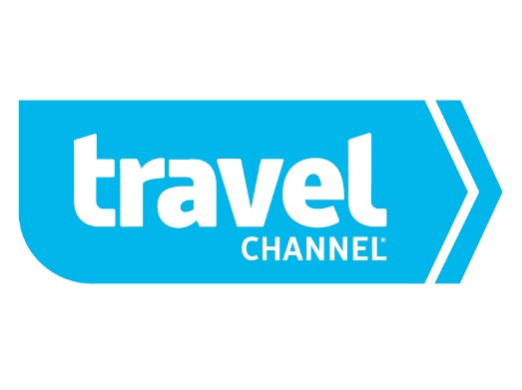

FOR IMMEDIATE RELEASE:

TRAVEL CHANNEL’S ANDREW ZIMMERN GIVES VIEWERS
A TASTY LOOK AT FOODS THAT DEFINE GLOBAL LOCATIONS
ON NEW SERIES ‘BIZARRE FOODS: DELICIOUS DESTINATIONS‘

Discover the Not-to-Miss Dishes From Iconic Cities Including
Florence, Tokyo, New York, Zurich and More -
Premieres Monday, January 26 at 9:00 P.M. ET/PT

CHEVY CHASE, MD (December 19, 2014) – Curious culinarian and James Beard Award-winning chef Andrew Zimmern continues his search for the most interesting dishes across the globe in the new original series “Bizarre Foods: Delicious Destinations,” premiering with back-to-back episodes on Monday, January 26 at 9:00 p.m & 9:30 p.m. ET/PT. The 13-episode series, an extension of the popular “Bizarre Foods” franchise, takes viewers on an international journey to iconic cities around the world for a taste of their quintessential, not-to-be missed dishes. From melt in your mouth chocolate in Zurich to decadent gelato in Florence, savory paella in Barcelona to creamy clam chowder in Boston, the half-hour weekly series is an exploration of iconic foods, where they came from, how they are made, and the right way to eat them.

Zimmern puts it this way, “For years now I have wanted to make a show that tells the world in simple, easily digested terms what the classic 5 or 6 foods are in the world’s great cities. If you go to Paris or Tokyo, these would be the must-eat dishes that you have to try before leaving and perhaps more importantly, why. The food literacy in America is rising. The history and sociology lessons standing behind these foods are entertaining and help bridge the culture gaps.”

The premiere episode of “Bizarre Foods: Delicious Destinations,” airing at 9:00 p.m. ET/PT, explores the ancient city of Athens, Greece and some of its most recognizable food, beginning with gyros and souvlaki. Along with a third generation restaurant owner, Zimmern guides viewers through the unique preparation of classic dishes, and reveals how the Greek have perfected these timeless recipes. Next, Zimmern stops at Krinos bakery for deliciously deep-fried Greek doughnuts called loukamades, followed by a look at the story behind spanakopita – a multi-cultural mash-up of flakey dough with spinach and feta filling. The art of making spanakopita is such a highly-regarded skill in Athens that a professional guild exists for the chefs who have perfected it! Zimmern goes on to find koulouri, a Greek culinary necessity similar to a bagel; dolmades, delicately stuffed grape leaves; and of course, Greek yogurt, which is anything but what viewers see on grocery store shelves here in America.

In the second episode, airing at 9:30 p.m. ET/PT, Zimmern discovers the delectable delicacies of Paris. At Bistrot Paul Bert in the trendy 11th Arrondissement neighborhood, the restaurant serves up the most indulgent steak frites. Croque-monsieur, the simple Parisian ham and cheese sandwich, becomes a crunchy, melty masterpiece at Café La Palette – rumored to be a favorite spot of Picasso and Hemingway. Zimmern showcases other French finds including authentic artisan baguettes from Moulin de la Vierge, the finest buttery croissants at Gerard Mulot’s pastry shop, the best light wafer macarons with flavorful fillings by pâtissier Arnaud Larher, and the traditional sweet and savory crepes at Ti Jos.

Visiting cities such as London, Munich, Hong Kong, New Orleans and more, Zimmern takes viewers into the kitchens where generations of chefs prepare and serve the cities’ most beloved dishes.

“Bizarre Foods: Delicious Destinations” is produced by Tremendous Entertainment for Travel Channel. Andrew Zimmern is an executive producer. For Tremendous!, the executive producers are Colleen Needles Steward, Shannon Keenan Demers, Kristin Graham and David Barsky. For Travel Channel, the executive producer is David E. Gerber.

TRAVEL CHANNEL (http://www.TravelChannel.com) is a multiplatform travel lifestyle brand with the core mission of providing inspiring and compelling programming that takes viewers beyond their everyday destinations, making the unfamiliar familiar, whether it's around the world or around the block. A dual feed network that is also available in HD, Travel Channel is the world’s leading travel media brand, and is available in over 94 million U.S. cable homes. Owned and operated by Scripps Networks Interactive (NYSE: SNI), Travel Channel has offices in Chevy Chase, MD, and New York, NY. Scripps Networks Interactive (NYSE: SNI) also owns and operates HGTV, DIY Network, Food Network, Cooking Channel and Great American Country.

# # #

Media Contacts:
For Travel Channel:
Rick Gomes, Rick.Gomes@travelchannel.com, 301.244.7563

FerenComm on behalf of Travel Channel:
Caragh Fisher, caraghf@ferencomm.com, 212.983.9898

