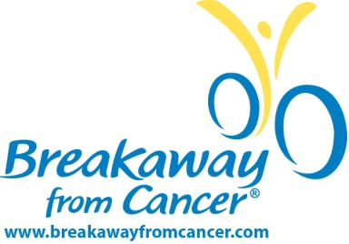

May x, 2016

Dear Public Service Director,

Nearly every family is touched by cancer. In 2016 alone, it is estimated that almost 1.7 million Americans will be diagnosed with cancer.

One person alone can’t beat cancer – it takes a team. Founded in 2005, Breakaway from Cancer® aims to increase awareness of important resources available to those impacted by cancer – from prevention to survivorship.

The Breakaway from Cancer partners – Prevent Cancer Foundation, Cancer Support Community, Patient Advocate Foundation and National Coalition for Cancer Survivorship – collectively offer a broad range of support services to people affected by cancer, complementing those provided by a patient’s team of healthcare professionals.

We are proud to partner with Patrick Dempsey on this Public Service Announcement. By joining forces, we communicate that when faced with cancer, education, resources and help are essential.

We ask that you please take a few minutes to review the enclosed spots and consider airing them to support Breakaway from Cancer’s mission to provide access to free resources. This Public Service announcement has no end date.

Thank you for your consideration.

Sincerely,
Breakaway from Cancer Team

American Cancer Society. Cancer Statistics 2016

