RACINE, WISC., July 27, 2016: This mosquito season OFF!® is helping to equip families with the latest expert information on mosquito protection by launching the Mosquito Minute. An interactive, multimedia educational tool, the Mosquito Minute offers a series of one-minute podcasts, along with other informational resources, in which the experts from the SC Johnson Entomology Research Center dispel many of the misconceptions about mosquito protection, share their expertise and offer practical tips and tricks for mosquito bite prevention.

Experience the interactive Multimedia News Release here: http://www.multivu.com/players/English/7854231-sc-johnson-mosquito-minute/

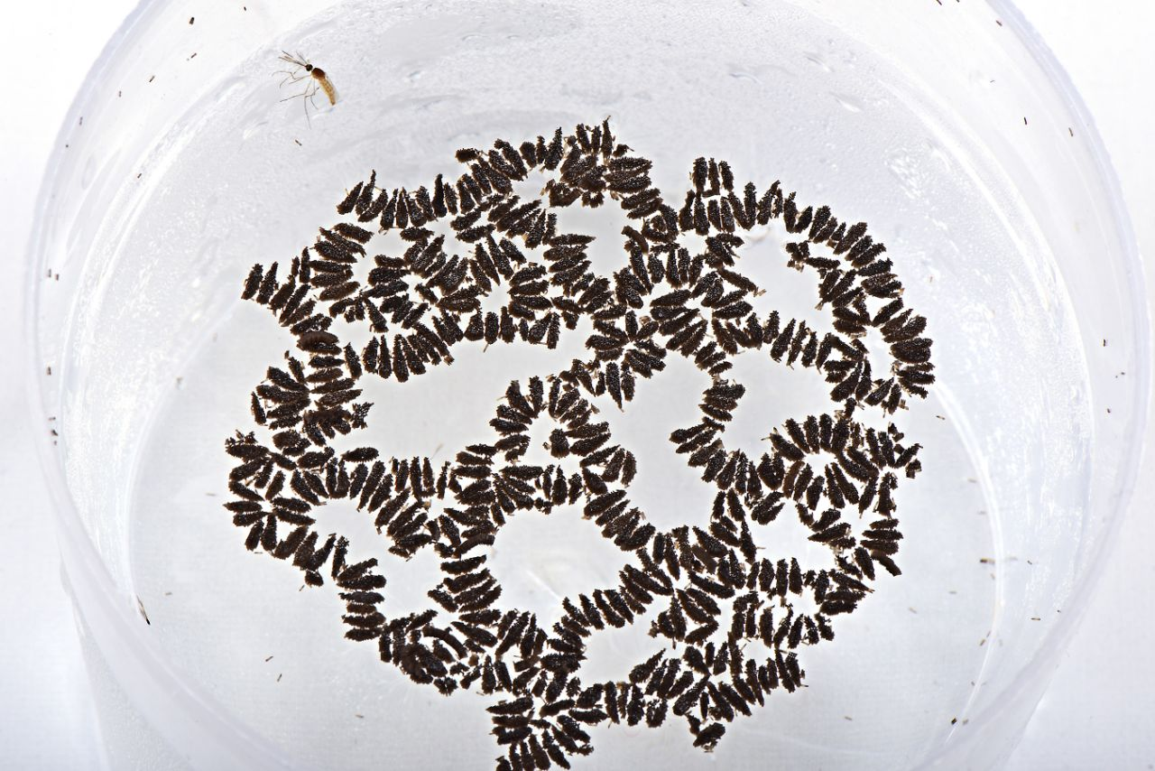
Mosquito Eggs

Backed by Research
OFF!® has been supported by 60 years of pest control expertise at the world’s largest privately held, urban entomology research facility. The SC Johnson Entomology Research Center houses about 20 species of insects, including four species of mosquitoes, such as Aedes aegypti as well as Aedes albopictus.

With increased concerns about mosquito bites, it’s important that consumers can easily access accurate and reliable information about mosquitoes. That’s why SC Johnson has created the Mosquito Minute, a series of downloadable audio installments which will help families learn relevant facts this mosquito season.

About the Mosquito Minute
Featuring tips and expert resources from OFF!®, the Mosquito Minute is a hub of accessible and practical information about how families can protect themselves from mosquitoes.

- Look for Regular Updates: Follow weekly updates from the experts at OFF!®
- Get Informed: Check out fact sheets with mosquito protection tips and tricks
- Access Additional Resources: Download high-resolution images
- Get Started: Check out the first episode here, where the experts set the record straight on the most common misconceptions about personal repellents
For more information on how to protect your family from mosquitoes, follow OFF!® on: Facebook.com/OFF and Instagram.com/OFFoutdoors.

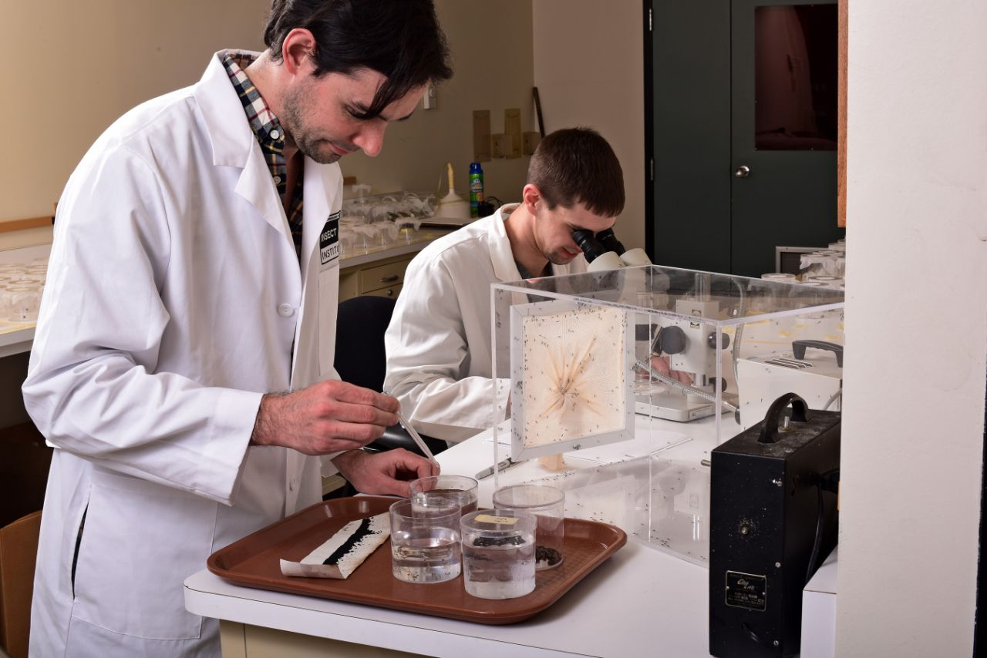
SC Johnson Entomologists

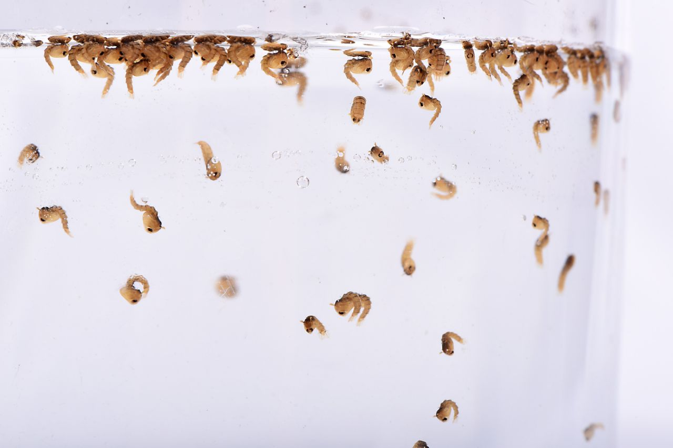
Mosquito Pupae

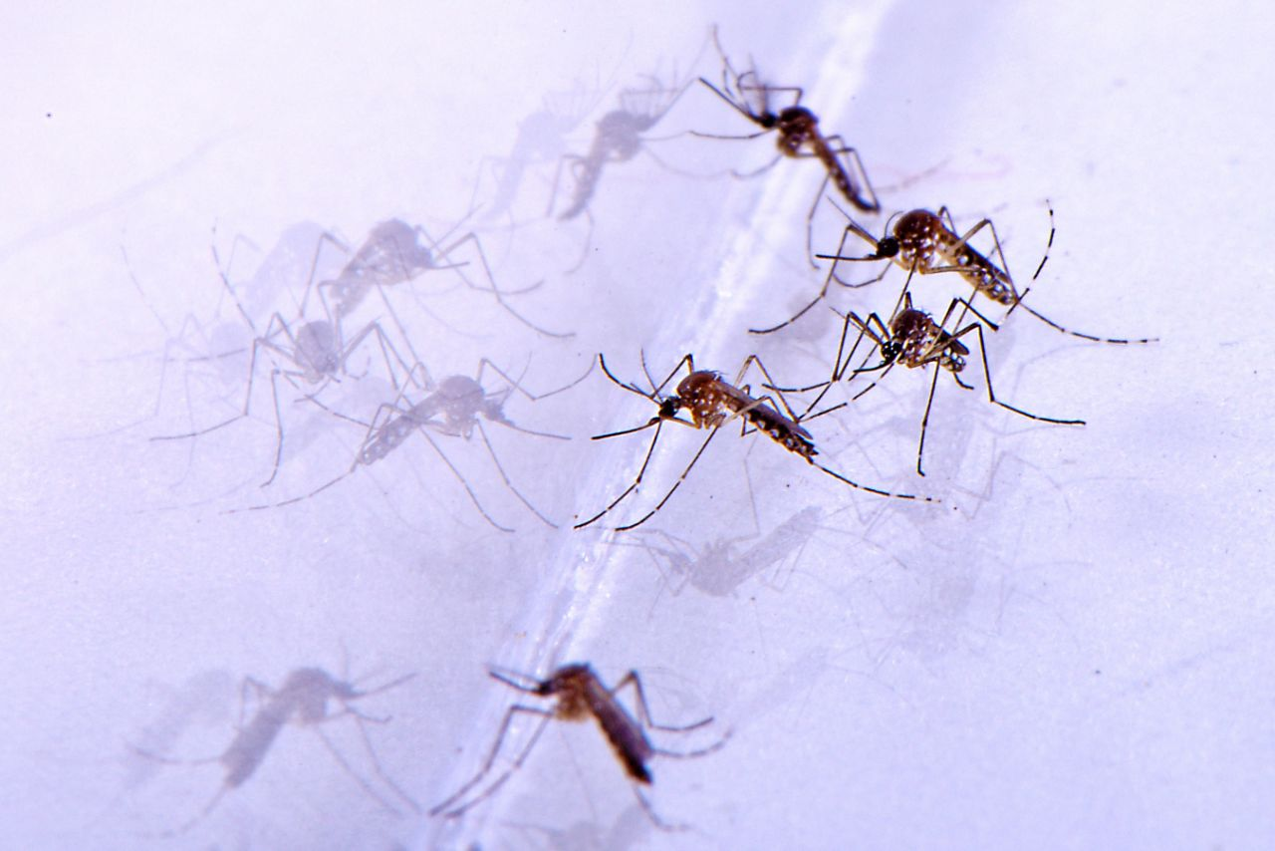
Adult Aedes aegypti Mosquitoes

Researcher Examines Aedes Aegypti

OFF!® Personal Repellents

###

