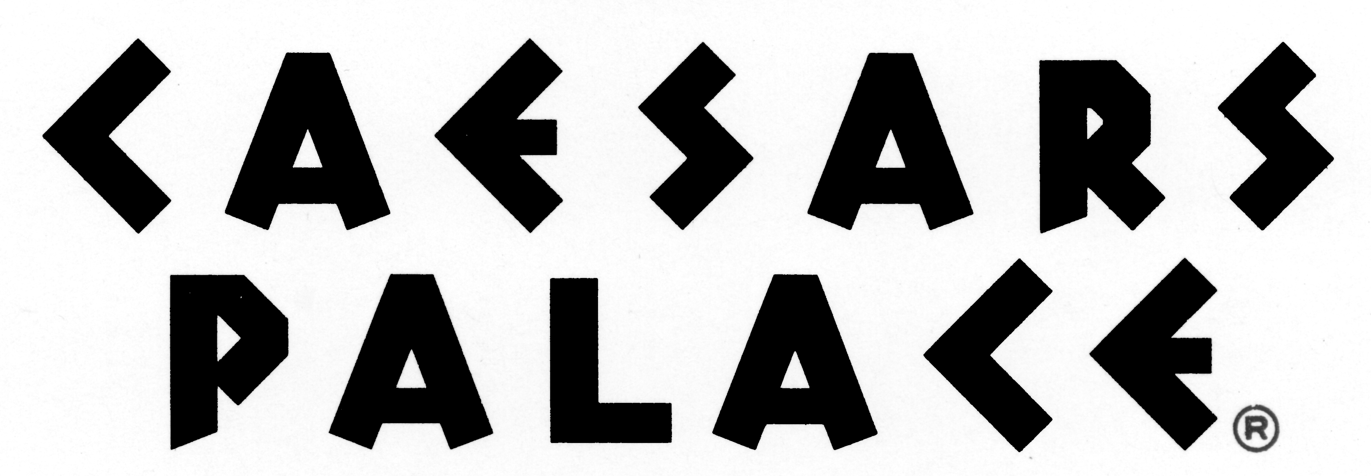
FOR IMMEDIATE RELEASE
September 14, 2011

CAESARS PALACE TO OPEN OCTAVIUS TOWER,
ROOMS ON SALE SEPTEMBER 15
Hotel’s sixth tower marks completion of $860 million expansion of
Caesars Palace, bringing a luxurious hotel experience to Las Vegas Strip

LAS VEGAS – Today, Caesars Palace announced plans to open the Octavius Tower, a 668-room hotel tower including 60 suites and six luxury villas. The resort’s sixth tower will offer a unique luxurious resort experience with a private entrance, separate hotel lobby and direct access to the Garden of the Gods pool oasis and gardens. Rooms will go on sale Thursday, September 15, for guest arrivals beginning January 2, 2012.

The Octavius Tower marks a major milestone in the two-year renaissance of Caesars Palace, which began in March 2011 with the return of Celine Dion and encompasses the recent launch of Rod Stewart at the Colosseum and opening of Central Michel Richard, by its namesake award-winning chef. Newly announced projects also include the return of Elton John (to open September 28), Old Homestead Steakhouse (to open winter 2011), Nobu Hotel, Restaurant and Lounge (to open summer 2012) and Shania Twain’s Colosseum headlining residency (to premiere December 2012).

“We couldn’t be more pleased with the timing for the opening of Octavius Tower,” said Gary Selesner, regional president of Caesars Palace. “With very high hotel occupancy over the last six months and the unqualified success of the Augustus Tower - Octavius’ sister tower - we look forward to offering our guests the new luxury rooms along with an elevated service experience in both towers.”

Spacious guest rooms, starting at 550 square-feet, will offer a modern, luxurious décor incorporating earthy shades of browns, grays, taupes and beiges, offset with pops of green and splashes of deep red. Designed by Michael Medeiros of KNA Design, the rooms will feature marble floors and stylish patterned carpets that complement dark wood furnishings and brushed chrome fixtures. King-sized beds with sleek headboards, plush pillow top mattresses and luxurious Anichini™ linens will provide ultimate comfort, while living areas create an inviting ambiance with plush velvet sofas, contemporary chairs and chic stone tables. Dark wood desks with granite overlays offer an ample workspace with custom cabinetry containing a premium mini bar. Accommodations will also include framed 42-inch flat panel, high-definition television screens, convenient media hubs with multiple outlets for easy connectivity, and bedside docking stations with iPod capabilities.

An innovative application for iPad/iPod Touch devices will offer guests direct accessibility to communicate with room service, housekeeping, reservations and front desk services. Additional Octavius Tower’s amenities will include nightly turn-down service, upon request, and in-room coffee service.

Marble-tiled bathrooms will feature contemporary striped wall coverings, oversized whirlpool bathtubs and enclosed glass showers with multiple shower heads. Flat screen televisions will be set above granite double vanities stocked with luxurious Gilchrest & Soames bath amenities.

The opening of the Octavius Tower marks the completion of the $860 million Caesars Palace expansion. Construction for the Octavius Tower began in 2008 with the erection of the tower’s exterior along with three luxury villas which opened in September 2009. The build-out also included the Garden of the Gods pool and garden expansion (completed in March 2010), the addition of 263,000-square-feet of convention and meeting space (completed in July 2009), and the renovation of the Forum Tower (completed in October 2008).

About Caesars Palace:
Reigning in the heart of the Las Vegas Strip, Caesars Palace is the world's best known resort-casino, celebrating the grandeur that was Rome in an 85-acre destination location that sets the standard for entertainment, dining and luxury. Ranking among the world's top luxury resorts Caesars Palace features 3,300 hotel guest rooms and suites, 23 diverse restaurants and cafes, five-acre Garden of the Gods pools and gardens, 50,000 square foot Qua Baths & Spa and 300,000 square feet of premium meeting and convention space. The 4,300-seat Colosseum sits just steps from celebrity chef restaurants and the acclaimed Forum Shops at Caesars and spotlights world class entertainers such as Celine Dion, Jerry Seinfeld, Rod Stewart Elton John (returning September 28, 2011) and Shania Twain (premiering December 2012.)

Caesars Palace, along with all Caesars Entertainment Las Vegas resorts, including Planet Hollywood Resort & Casino, Paris Las Vegas, Flamingo Las Vegas, Harrah’s, Bally’s, Rio All-Suite Hotel & Casino, Imperial Palace and Bill’s Gamblin’ Hall & Saloon, proudly prohibits adding hidden resort fees to hotel guest room rates. Find Caesars Palace on Facebook and follow on Twitter.

This release includes “forward-looking statements” intended to qualify for the safe harbor from liability established by the Private Securities Litigation Reform Act of 1995. You can identify these statements by the fact that they do not relate strictly to historical or current facts. These statements contain words such as “may,” “will,” “project,” “might,” “expect,” “believe,” “anticipate,” “intend,” “could,” “would,” “estimate,” “plan,” “continue” or “pursue,” or the negative or other variations thereof or comparable terminology. In particular, they include statements relating to, among other things, future actions, new projects, strategies, future performance, the outcomes of contingencies. These forward-looking statements are based on current expectations and projections about future events. Investors are cautioned that forward-looking statements are not guarantees of future performance or results and involve risks and uncertainties that cannot be predicted or quantified and, consequently, the actual performance and actions of Caesars Palace and Caesars Entertainment Corporation and its subsidiaries may differ materially from those expressed or implied by such forward-looking statements.

Such risks and uncertainties include, but are not limited to, the following factors: the effects of local and national economic, credit and capital market conditions on the economy in general, and on the gaming and hotel industries in particular affect the project; construction factors related to the project, including delays, increased costs of labor and materials, availability of labor and materials, zoning issues, and building permit issues; the ability to timely and cost-effectively integrate the project into our operations at Caesars Palace; changes in laws, including increased tax rates, smoking bans, regulations, third-party relations and approvals related to the project and Caesars Palace; and our ability to recoup costs of the capital investment of this project through higher revenues

Any forward-looking statements are made pursuant to the Private Securities Litigation Reform Act of 1995 and, as such, speak only as of the date made. Caesars disclaims any obligation to update the forward-looking statements. You are cautioned not to place undue reliance on these forward-looking statements, which speak only as of the date stated, or if no date is stated, as of the date of this press release.

Media Contacts:
Celena Haas
Director of Public Relations
Caesars Entertainment – Las Vegas Region
702-400-3687
chaas@caesars.com

Leslie Thuet
Public Relations Manager
Caesars Entertainment – Las Vegas Region
702-281-7616
lthuet@caesars.com

