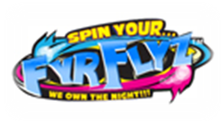
FyrFlyz™
This summer kids will “own the night” with one of the most widely-anticipated toys of 2011 – FyrFlyz™, the revolutionary new spinning toy that puts the power to create an amazing light show in kids’ very own hands. Since being introduced at the Hong Kong, Nuremburg, and New York Toy Fairs earlier this year, FyrFlyz are creating a sensation worldwide and are hitting the U.S. market this summer.
FyrFlyz™  FyrFlyz™ is a revolutionary new spinning toy that puts the power to create an amazing light show in kids’ very own hands. Each FyrFlyz toy is a precision balanced instrument designed to spin on its axis. Simply by swinging the connected two strings and applying tension or allowing slack, kids create a continuous movement (figure eights, rings, etc.). The fun begins when the lights go out and the FyrFlyz multi-color LED lights turn the movement into an amazing light show that kids can play themselves or show their friends.  Kids can spin their FyrFlyz to create a wide array of tricks: they can turn them sideways to create slick Sydwynders, pull tight to create whizzing Black Holes or loosen the strings to make Shooting Stars – the more they spin, the more unique their tricks. As kids develop their skills, there are no boundaries to what their imaginations can create.  Tips on tricks can be found at http://www.fyrflyz.com/. Tricks include spinning Sydwynders, whizzing Black Holes, Shooting Stars, Saturn Rings, Spinning Stars, Small and Large Orbits, Flaming Disc, Flywheels, Waveraves, Sun Blasts, Hotspots, Fyrwheels, Tyrtracks, Moon Crators.  FyrFlyz are constructed of a Uni-body translucent, colored plastic shell featuring multi-color LED lights at each end with soft, safety tips. Colored strings equipped with double safety grip handles are attached to the shell to manipulate the spinning movement. An on/off switch activates the light that is powered by two replaceable button-cell batteries. FyrfFlyz, retailing for under $10 each, will be available in a variety of light colors making them a collectible for ages 8 and up. | ARP  $8.99  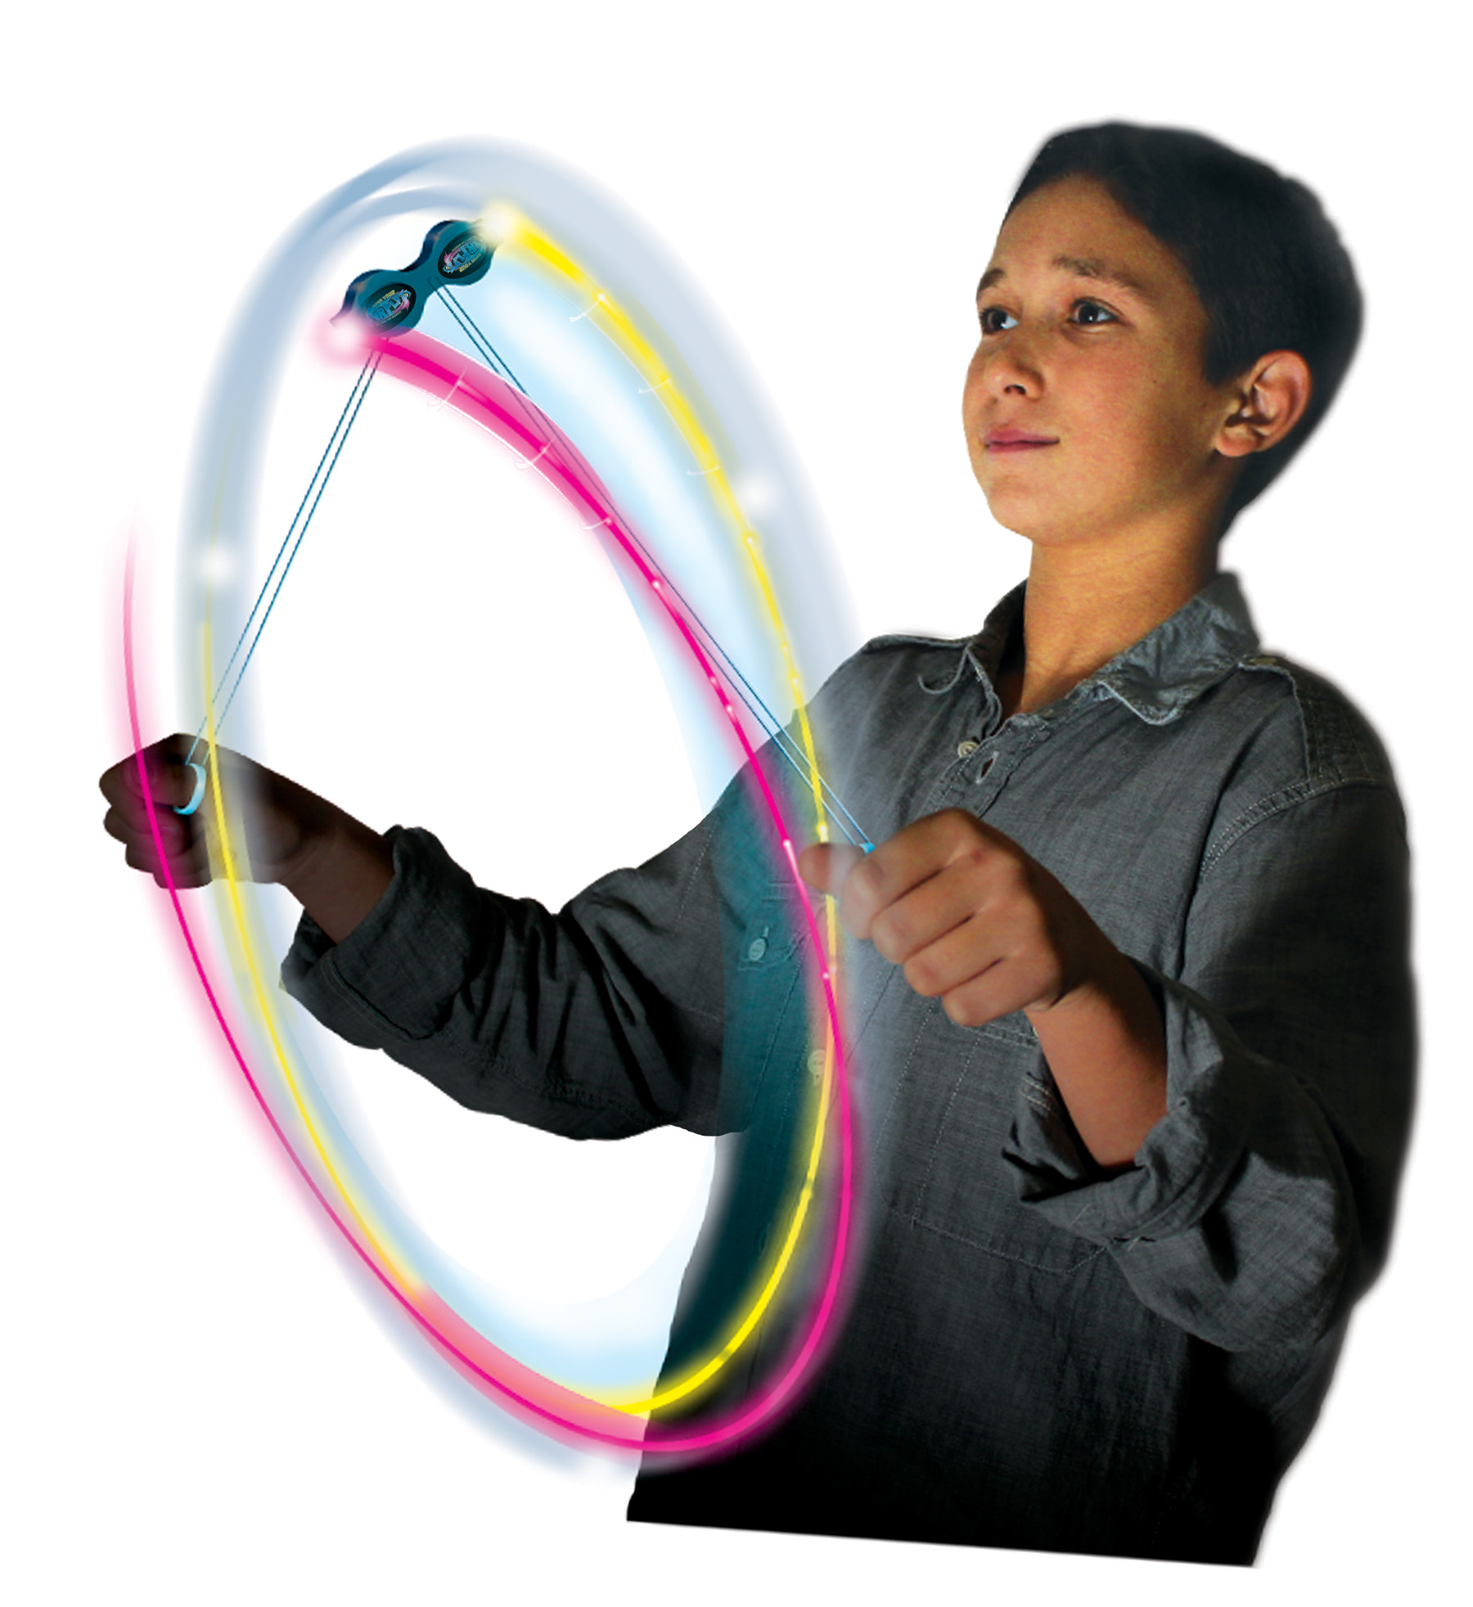  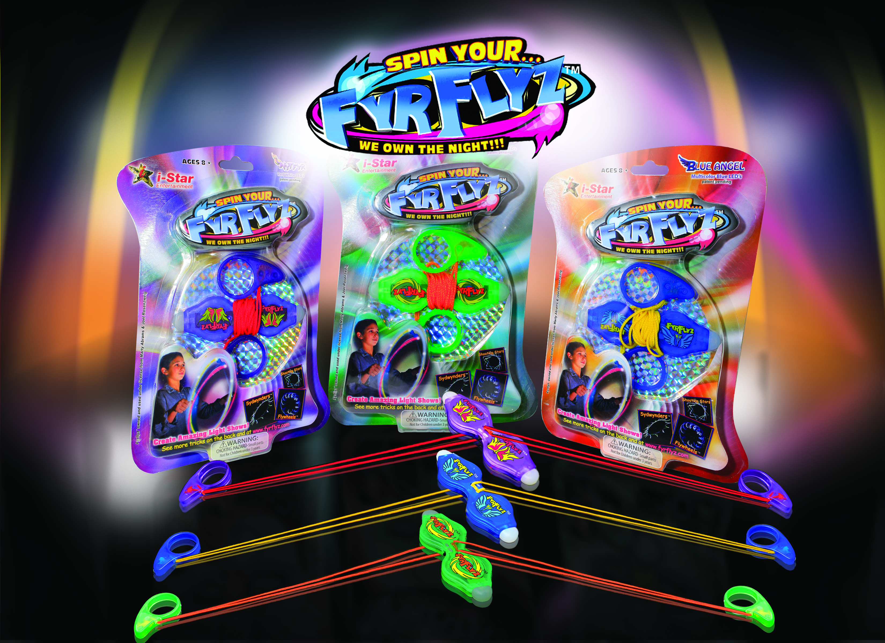 | Age  8+ | Availability  Now
Background:
FyrFlyz were created by i-Star Entertainment President Joel Rosenzweig and CEO Marty Abrams, who has been the driving force behind a number of successful product launches over the past 35 years including Magna Doodle, Micronauts (the precursor to Transformers), and Sky Dancers. The company has earned a reputation for identifying, creating and bringing to market some of the hottest and most innovative products for kids, tweens and teens. The introduction of FyrFlyz will deliver a one-of–a-kind entertainment experience for fans of all ages.

For more information about FyrfFlyz, please visit http://www.fyrflyz.com/. “Like” FyrFlyz on facebook, “Follow” FyrFlyz on Twitter and kids can post their videos on FyrFlyz’ You Tube channel.

Contacts: Lauren Lorenzo

Freeman Public Relations
973/470-0400, ext. 46
llorenzo@freemanpr.com


11 Middle Neck Road, Suite 200
Great Neck, N.Y. 11021
Tel: 516-439-4420 fax: 516-439-4419

I-Star Entertainment

