QUAKER® WARM & CRUNCHY GRANOLA
FACT SHEET

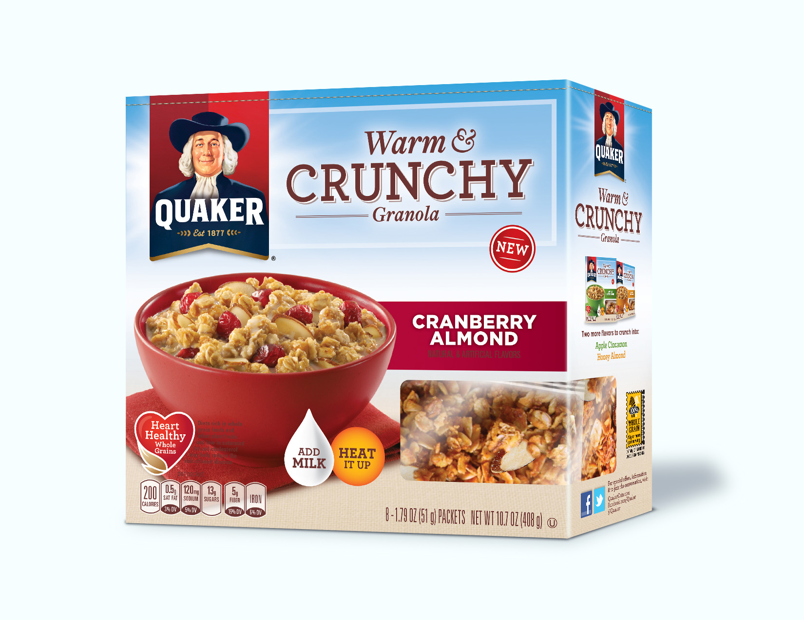
Quaker Warm & Crunchy Granola
- Today’s fast-paced lifestyle can leave people drained. And in moments of weakness, they can fall into the trap of making poor choices to replenish themselves.

- Quaker Warm & Crunchy Granola is a first-of-its-kind hot cereal that delivers both the warm, wholesome goodness of Quaker Oatmeal and the satisfying crunch of multigrain granola.

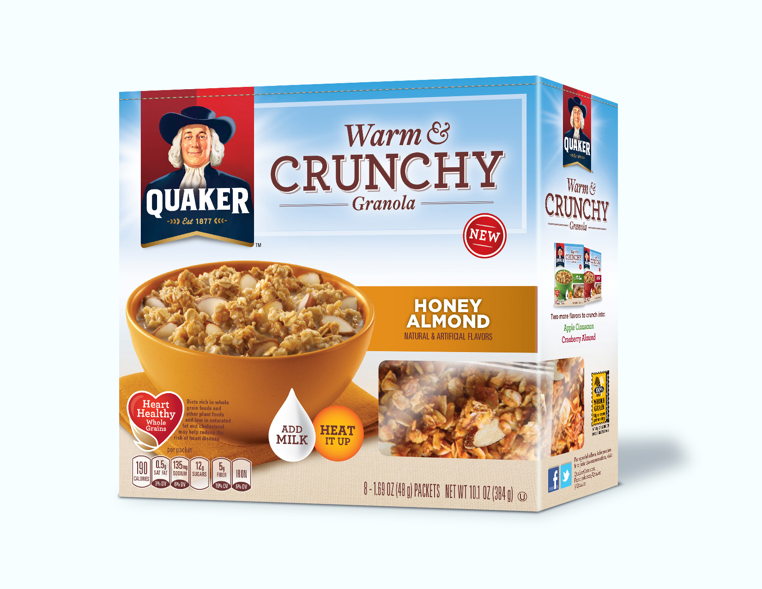
- When heated with milk, Quaker Warm & Crunchy Granola provides a flavorful breakfast experience that offers at least as much fiber and whole grains as a serving of Original Quaker Instant Oatmeal.

- Quaker Warm & Crunchy Granola will be available nationwide in early 2014 and comes in three delicious flavors to taste the crunchy side of oatmeal:
  - Apple Cinnamon
  - Honey Almond
  - Cranberry Almond

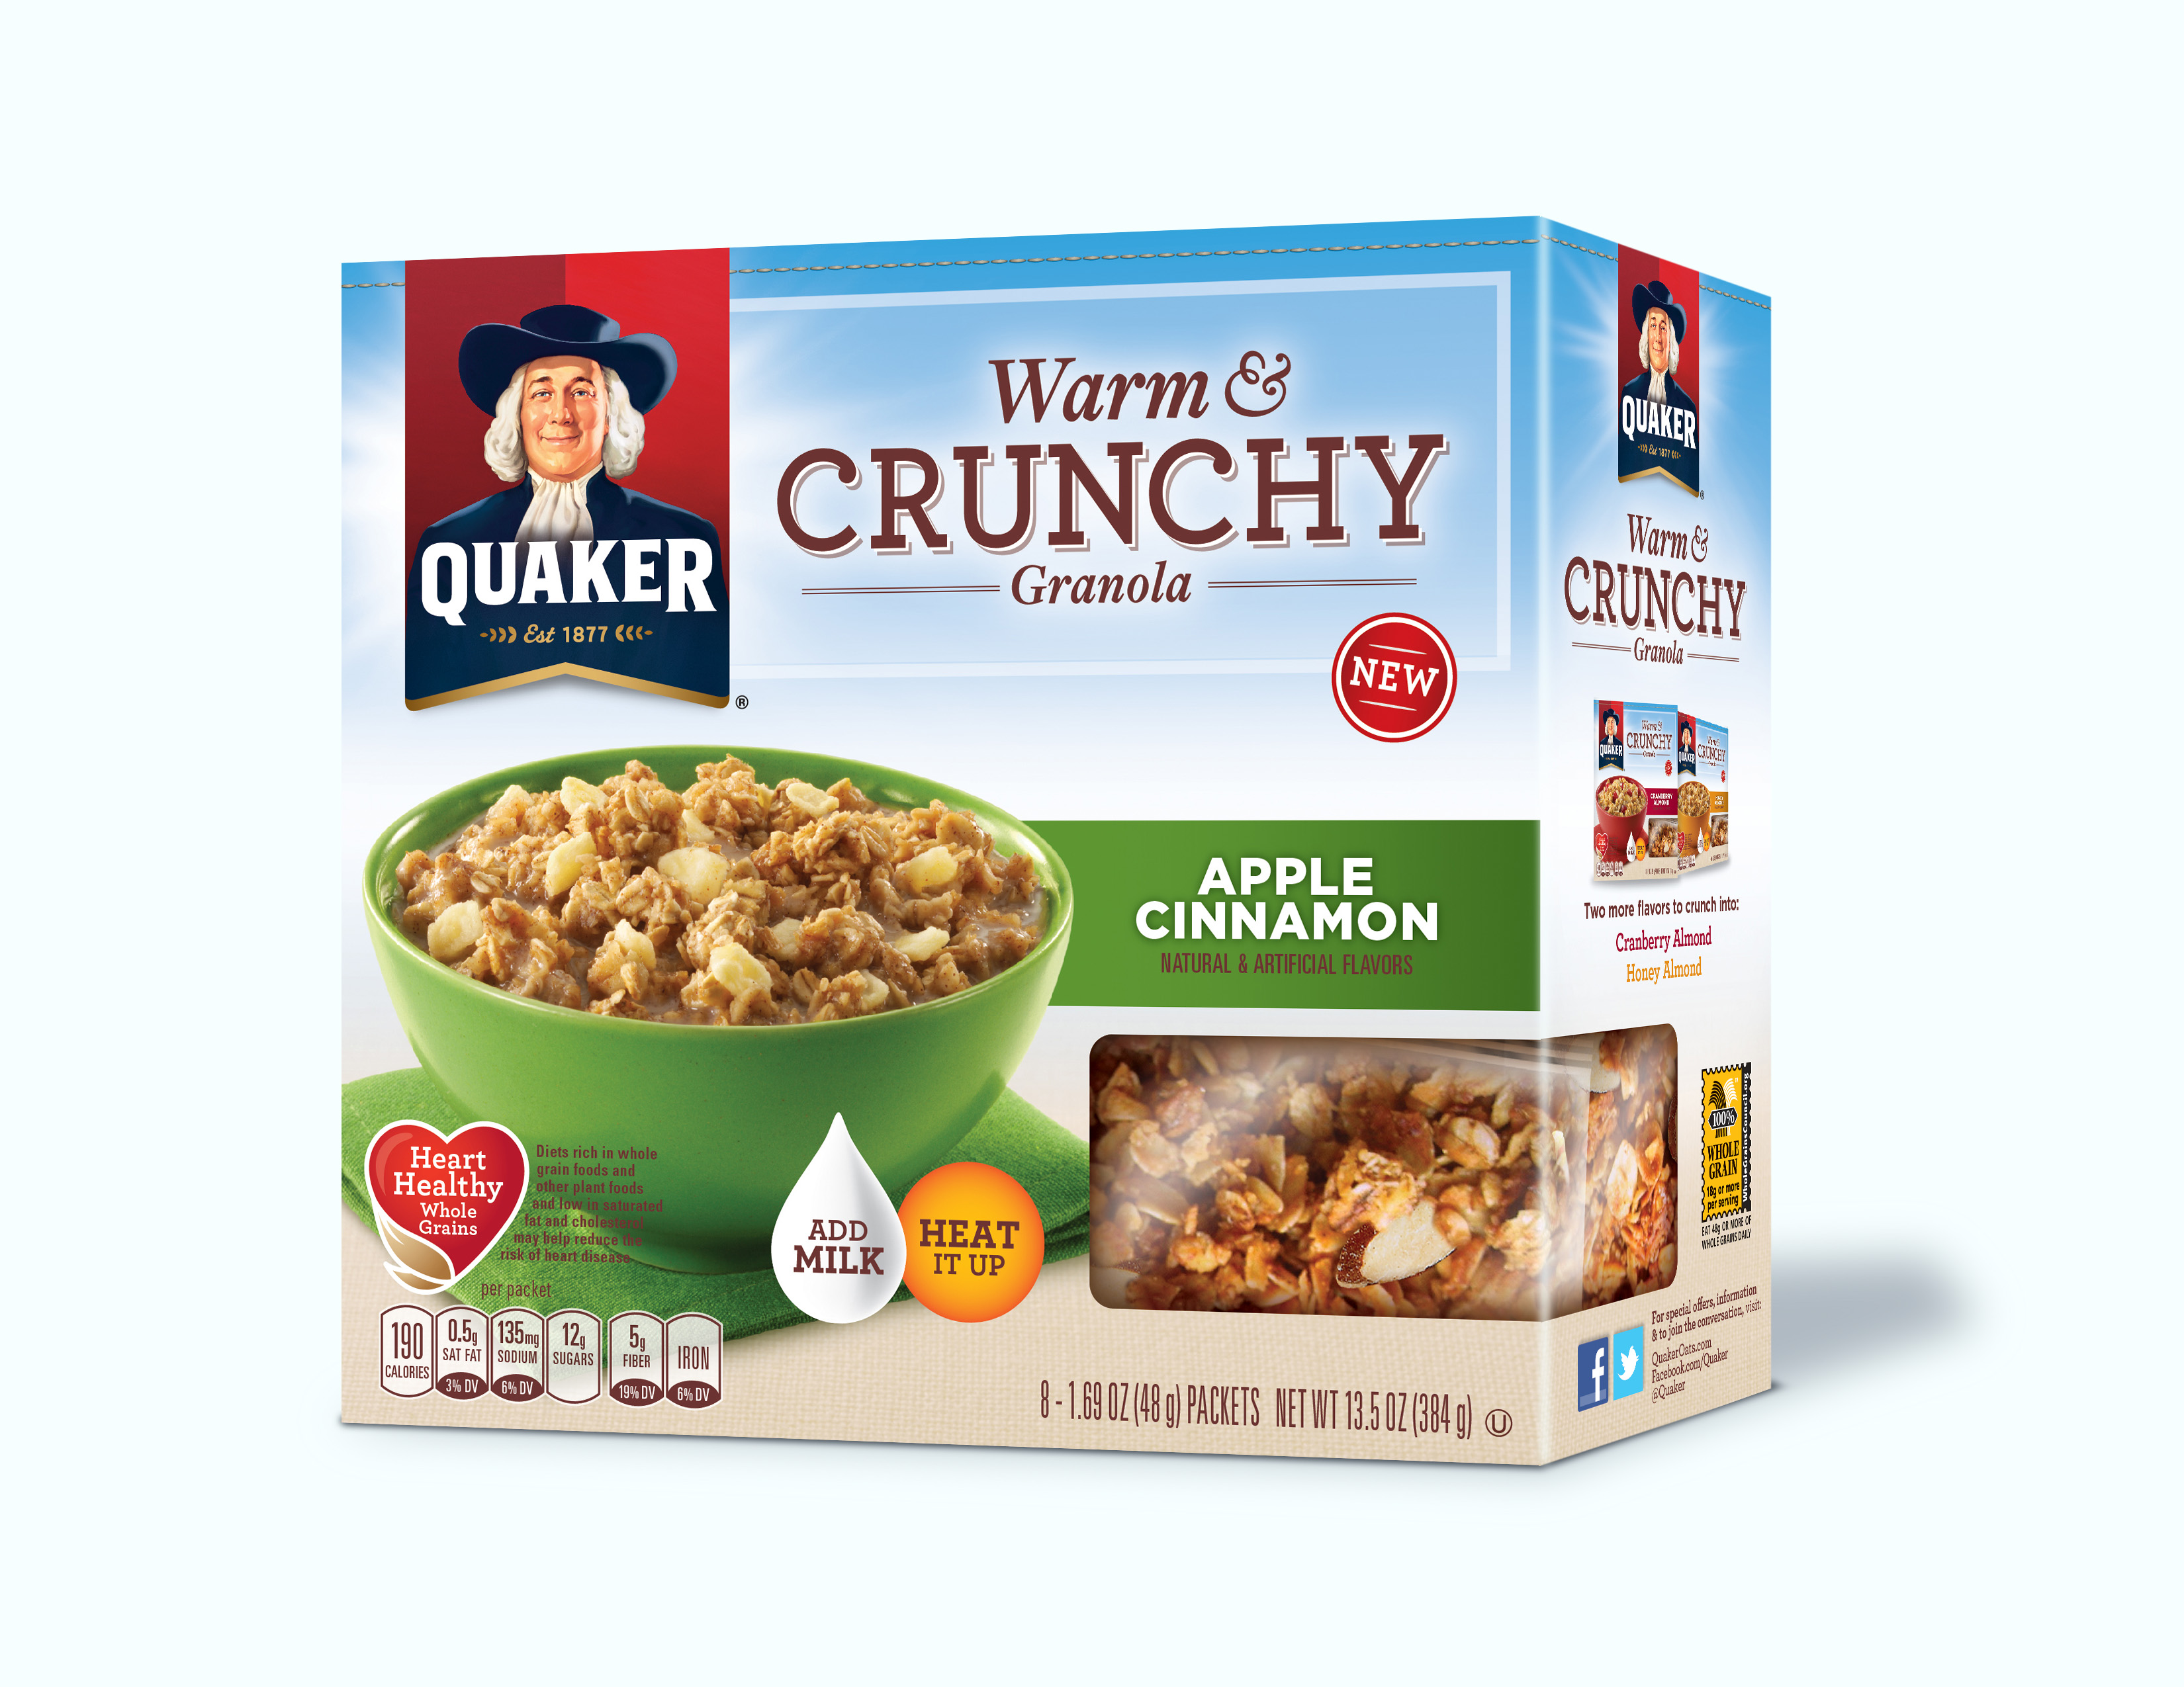
- Simply add milk and microwave for 25 seconds. The granola stays crunchy even after heating.
  - Thicken to your liking by adding more or less milk prior to heating

- Each box contains eight, individually-packaged servings of Quaker Warm & Crunchy Granola and has a suggested retail price of $3.99.

Nutrition Information
- Each serving offers 32 grams of whole grains
- Each flavor is a good source of fiber (4 grams) and is low in saturated fat (contains 3.5-4.5 grams total fat per serving)

About Warm & Crunchy Granola
For more information on Quaker Warm & Crunchy, please visit www.quakeroats.com or www.Facebook.com/Quaker.

About The Quaker Oats Company
The Quaker Oats Company, headquartered in Chicago, is a unit of PepsiCo, Inc., one of the world's largest consumer packaged goods companies. For more than 130 years, Quaker's brands have served as symbols of quality, great taste and nutrition. Holding leadership positions in their respective categories, Quaker® Oats, Quaker® Rice Cakes and Quaker Chewy® Granola Bars are consumer favorites. For more information, please visit www.QuakerOats.com, www.Facebook.com/Quaker or follow us on Twitter @Quaker.

Contacts:

Jody Menaker
Quaker Oats
312.821.3264
jody.menaker@pepsico.com
Kate Licht
Zeno Group
212.299.8989 kate.licht@zenogroup.com

Apple Cinnamon Cranberry Almond Honey Almond


